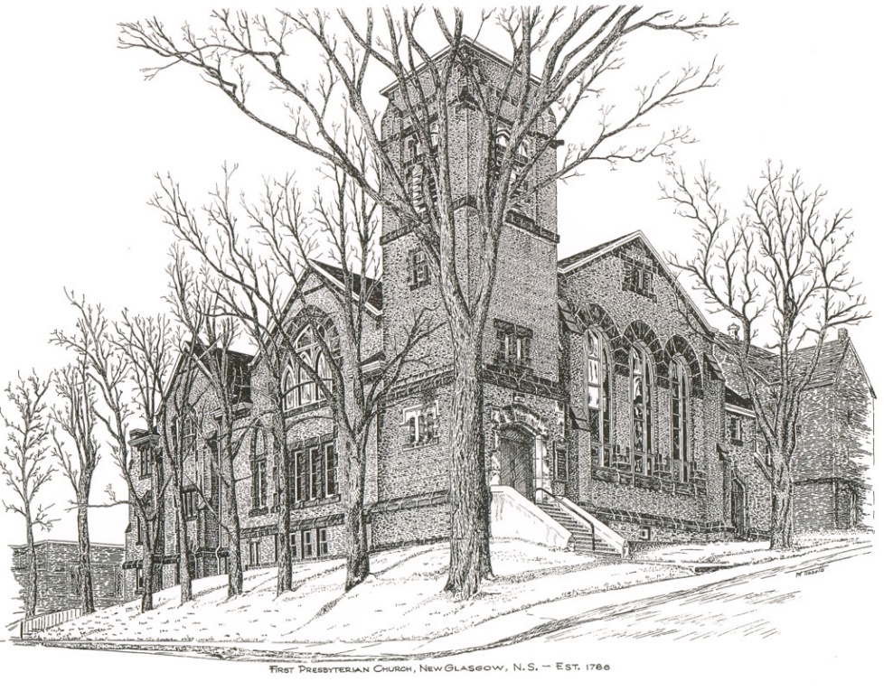

FIRST PRESBYTERIAN CHURCH
208 MacLean St., New Glasgow, NS
902-752-5691
First.church@ns.aliantzinc.ca
Reverend Andrew MacDonald
902-331-0322
yick96@hotmail.com

July 7th, 2024
7th Sunday after Pentecost

THE APPROACH

**Please rise**
Musical Prelude
Welcome and Announcements

**Lighting the Christ Candle: Please rise
One: In the beginning was the Word, and the Word was with God, and the Word was God. He was in the beginning with God. All things were made through him, and without him was not any thing made that was made. In him was life, and the life was the light of men. The light shines in the darkness, and the darkness has not overcome it.
All: Arise, shine, for your light has come, and the glory of the Lord has risen upon you. For behold, darkness shall cover the earth, and thick darkness the peoples; but the Lord will arise upon you, and his glory will be seen upon you. (Light the candle)

One: Let us now prepare our hearts to worship almighty God.

**Musical Introit - #575 - "Lead me, Lord"
Lead me, Lord, lead me in your righteousness;
make your way plain before my face,
for it is you, and you, God only,
who makes me dwell in safety.
**Call to Worship
**Hymn #435 – “All things bright and beautiful”

CHORUS
All things bright and beautiful,
all creatures great and small,
all things wise and wonderful,
in love God made them all.

1 Each little flower that opens,
each little bird that sings,
God made their glowing colours;
God made their tiny wings.

2 The cold wind in the winter,
the pleasant summer sun,
the ripe fruits in the garden,
God made them, every one.

3 The rocky mountain splendour,
the haunting curlew’s call,
the great lakes and the prairies,
the forests in the fall.

4 God gave us eyes to see them,
and lips that we might tell
how great is God almighty
who has made all things well.

Prayer of Adoration, Confession and the Lord’s Prayer

Our Father which art in heaven, Hallowed be thy name.

Thy kingdom come, thy will be done in earth,

as it is in heaven.

Give us this day our daily bread.

And forgive us our debts, as we forgive our debtors.

And lead us not into temptation, but deliver us from evil:

For thine is the kingdom, and the power, and the glory,

forever. Amen.

Assurance of Pardon
Passing the Peace
**Hymn 761 - “Who’s goin’ to tell the story”

1 Who’s goin’ to tell the story? You and I!
Tell of the Lord’s great glory? You and I!
Who’s goin’ to let the whole world know?
Help his disciples grow and multiply? You and I!

2 Who’s goin’ to bring the kingdom? You and I!
Who’s goin’ to spread the gospel? You and I!
Who’s goin’ to do the kindly deed?
Comfort the one in need and help supply? You and I!

3 Jesus came to bring us good news,
sent to earth by God above!
And the good news that he brought us
is the word of love!

4 Who’s goin’ to feed the hungry? You and I!
Care for the sick and lonely? You and I!
Who’s goin’ to let the whole world see
people can live in harmony? Let’s try! You and I!

Children’s Time
Prayer of Illumination
First Lesson: 2 Samuel 5:1-5, 9-10
Epistle Lesson: 2 Corinthians 12:2-10
Responsive Psalm 148
ONE: Praise the Lord! Praise the Lord from the heavens; praise him in the heights! Praise him, all his angels; praise him, all his host!
ALL: Praise him, sun and moon; praise him, all you shining stars! Praise him, you highest heavens, and you waters above the heavens!
ONE: Let them praise the name of the Lord, for he commanded and they were created. He established them for ever and ever; he fixed their bounds, which cannot be passed.
ALL: Praise the Lord from the earth, you sea monsters and all deeps, fire and hail, snow and frost, stormy wind fulfilling his command!
ONE: Mountains and all hills, fruit trees and all cedars!
Wild animals and all cattle, creeping things and flying birds!
ALL: Kings of the earth and all peoples, princes and all rulers of the earth! Young men and women alike, old and young together!
ONE: Let them praise the name of the Lord, for his name alone is exalted; his glory is above earth and heaven.
ALL: He has raised up a horn for his people, praise for all his faithful, for the people of Israel who are close to him. Praise the Lord!
**Gloria Patri
Glory be to the Father
and to the Son, and to the Holy Ghost!
As it was in the beginning is now and ever shall be.
World without end. Amen, amen.
Gospel Lesson: Mark 6:1-13
Anthem: “Awesome God”
Sermon: "May Christ dwell within!"
**Reaffirmation of Faith (Apostles Creed)

I believe in God, the Father Almighty, maker of Heaven and earth; and in Jesus Christ, His only Son, Our Lord, who was conceived by the Holy Ghost, born of the Virgin Mary,
suffered under Pontius Pilate, was crucified, died, and was buried. He descended into Hell. On the third day He arose again from the dead; He ascended into Heaven, and sits
at the right hand of God, the Father Almighty; from thence He shall come to judge the quick and the dead.
I believe in the Holy Ghost, the holy Catholic Church,
the communion of saints, the forgiveness of sins, the resurrection of the body, and the life everlasting. Amen.

**Hymn: #485 – “Savior, like a shepherd lead us”

1 Saviour, like a shepherd lead us:
much we need your tender care;
in your pleasant pastures feed us;
for our use your folds prepare:
blessed Jesus, blessed Jesus!
You have bought us; yours we are.
Blessed Jesus, blessed Jesus!
You have bought us; yours we are.

2 We are yours; in love befriend us;
be the guardian of our way;
keep your flock from sin, defend us;
seek us when we go astray:
blessed Jesus, blessed Jesus!
Hear your children when we pray.
Blessed Jesus, blessed Jesus!
Hear your children when we pray.

3 Let us always seek your favour;
let us always do your will.
Jesus Christ our only Saviour,
with yourself our spirits fill:
blessed Jesus, blessed Jesus!
You have loved us, love us still.
Blessed Jesus, blessed Jesus!
You have loved us, love us still.

Offertory
**Doxology #79

Praise God from whom all blessings Flow. Praise Him all creatures here below. Praise Him above Ye Heavenly Host. Praise Father, Son, and Holy Ghost. Amen.

Offertory Prayer
**Hymn: #325 – “Eternal Father, strong to save”
1 Eternal Father, strong to save,
whose arm hath bound the restless wave,
who bade the mighty ocean deep
its own appointed limits keep:
oh hear us when we cry to thee
for those in peril on the sea.

2 O Christ, whose voice the waters heard
and hushed their raging at thy word,
who walked upon the foaming deep
and calm amid the storm did sleep:
oh hear us when we cry to thee
for those in peril on the sea.

3 O Holy Spirit, who did brood
upon the waters dark and rude,
and bade their angry tumult cease,
and gave, for wild confusion, peace:
oh hear us when we cry to thee
for those in peril on the sea.

4 O Trinity of love and power,
our kindred shield in danger’s hour;
from rock and tempest, fire and foe,
protect them whereso’er they go;
then evermore shall rise to thee
glad hymns of praise from land and sea.

**Benediction
**Coral Response: “Go Now in Peace” (Don Besig)
Go now in peace Never be afraid God will go with you each hour of every day
Go now in faith Steadfast, strong, and true. Know He will guide you in all you do.
Go now in love, And show you believe Reach out to others So all the world can see.
God will be there Watching from above Go now in peace, In faith, and in love, Amen, amen, amen.
Recessional

ANNOUNCEMENTS

All are welcome at First Presbyterian Church. We hope you experience the love of God and of this congregation as we worship, celebrate, and serve one another.
Today, we welcome our friends from St. Andrew’s Presbyterian Church, “The Kirk”, who will be worshipping with us for the month of July. Thank you for joining us today.

PASTORAL CARE:
In order to provide support to the people of First Church, when you or a loved one is sick or in hospital, we encourage you to contact the church (902-752-5691), Reverend Andrew (902-331-0322) or Cathy Lewis, Chair of the Pastoral Care Team (902-759-9649), to inform us directly. It is also important that you inform the hospital that you would welcome a visit from your minister and/or your Elder.
UPCOMING EVENTS
Chair Yoga - Chair Yoga is being offered here at First Church, in the Upper Hall, Wednesdays 1-2p.m. For more information contact Monica Beltram at info@monicafit.ca

MILESTONES
Congratulations to Fran and Clark Savage as they celebrate 52 years of marriage tomorrow, Monday, July 8th. Best Wishes!

SCRIPTURE READERS & USHERS:
Scripture Reader: Clarice Campbell
Ushers: Main Door (Office) - Chet Fleming
James St. – Ruth-Anne MacIntosh
MacLean St. (Main Entrance steps) – Ellen Jardine
EARLY CHRISTIAN EDUCATORS: Lynne Ann and Lois MacLellan

Mission Statement: But he’s already made it plain how to live, what to do, what God is looking for in men and women. It’s quite simple. Do what is fair and just to your neighbor, be compassionate and loyal in your love, and don’t take yourself too seriously – take God seriously. Micah 6: 8-The Message

