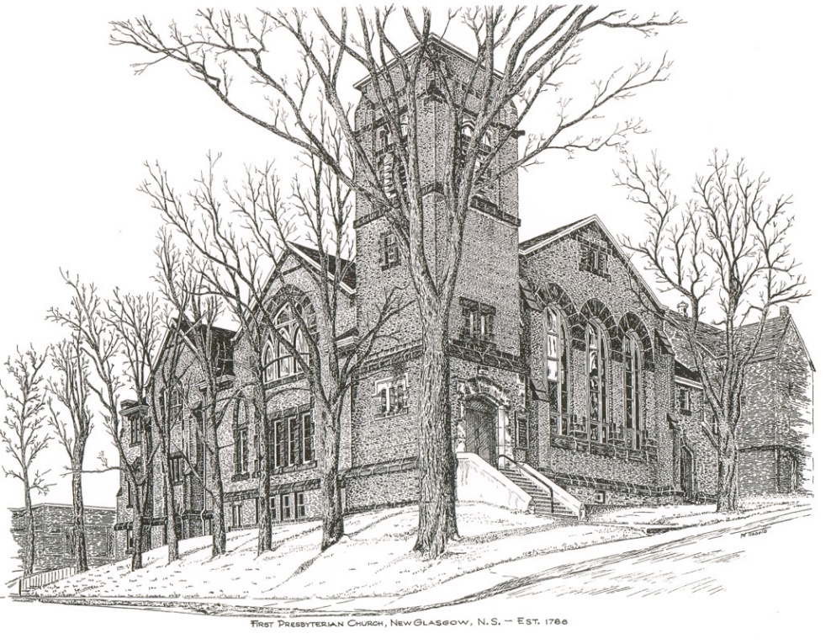

FIRST PRESBYTERIAN CHURCH
208 MacLean St., New Glasgow, NS
902-752-5691
First.church@ns.aliantzinc.ca
Reverend Andrew MacDonald
902-331-0322
yick96@hotmail.com

September 1st, 2024
15th Sunday after Pentecost
THE APPROACH

**Please rise**
Musical Prelude
Welcome and Announcements
One: Let us now prepare our hearts to worship almighty God.
**Musical Introit - #310 - "Bring Many Names" vs. 1
Bring many names, beautiful and good;
Celebrate in parable and story, holiness in glory,
Living, loving God:
Hail and hosanna,
Bring many names!
**Entry of the Bible: Please Rise
**Lighting the Christ Candle: Please rise

**Call to Worship
**Hymn #530 – “I come with Joy”
1 I come with joy, a child of God,
forgiven, loved and free,
the life of Jesus to recall
in love laid down for me,
in love laid down for me.

2 I come with Christians far and near
to find, as all are fed,
the new community of love
in Christ's communion bread,
in Christ's communion bread.
3 As Christ breaks bread, and bids us share,
each proud division ends.
The love that made us, makes us one,
and strangers now are friends,
and strangers now are friends.
4 The Spirit of the risen Christ,
unseen, but ever near,
is in such friendship better known,
alive among us here,
alive among us here.
5 Together met, together bound
by all that God has done,
we'll go with joy, to give the world
the love that makes us one,
the love that makes us one.

Prayer of Adoration, Confession and the Lord’s Prayer

Our Father which art in heaven, Hallowed be thy name.

Thy kingdom come, thy will be done in earth,

as it is in heaven.

Give us this day our daily bread.

And forgive us our debts, as we forgive our debtors.

And lead us not into temptation, but deliver us from evil:

For thine is the kingdom, and the power, and the glory,

forever. Amen.

Assurance of Pardon
Passing the Peace
**Hymn 457 - “Now Thank We All Our God!”
- Now thank we all our God
with heart and hands and voices,
who wondrous things has done,
in whom his world rejoices;
who from our mothers' arms
has blessed us on our way
with countless gifts of love,
and still is ours today.
- O may this bounteous God
through all our life be near us,
with ever joyful hearts
and blessed peace to cheer us,
to keep us in his grace,
and guide us when perplexed,
and free us from all ills
of this world in the next.
- All praise and thanks to God
the Father now be given,
the Son and Spirit blest,
who reign in highest heaven
the one eternal God,
whom heaven and earth adore;
for thus it was, is now,
and shall be evermore.
Children’s Time
Prayer of Illumination
First Lesson: Deuteronomy 4:1-2, 6-9
Epistle Lesson: James 1:17-27
Responsive Psalm 15
ONE: O Lord, who may abide in your tent? Who may dwell on your holy hill?
ALL: Those who walk blamelessly, and do what is right, and speak the truth from their heart
ONE: who do not slander with their tongue, and do no evil to their friends,
ALL: nor take up a reproach against their neighbours; in whose eyes the wicked are despised,
ONE: but who honour those who fear the Lord; who stand by their oath even to their hurt;
ALL: who do not lend money at interest, and do not take a bribe against the innocent.
ONE: Those who do these things shall never be moved.
**Gloria Patri
Glory be to the Father
and to the Son, and to the Holy Ghost!
As it was in the beginning is now and ever shall be.
World without end. Amen, amen.

Gospel Lesson: Mark 7:1-8, 14-15, 21-23
Anthem: “I will Call Upon The Lord!”
Sermon: "Be doers of the Word!"
**Reaffirmation of Faith (Apostles Creed)

I believe in God, the Father Almighty, maker of Heaven and earth; and in Jesus Christ, His only Son, Our Lord, who was conceived by the Holy Ghost, born of the Virgin Mary,
suffered under Pontius Pilate, was crucified, died, and was buried. He descended into Hell. On the third day He arose again from the dead; He ascended into Heaven, and sits
at the right hand of God, the Father Almighty; from thence He shall come to judge the quick and the dead.
I believe in the Holy Ghost, the holy Catholic Church,
the communion of saints, the forgiveness of sins, the resurrection of the body, and the life everlasting. Amen.

**Hymn: #763 – “To Show by Touch and Word”
- To show by touch and word devotion to the earth,
To hold in full regard all life that comes to birth
We need, O God, the will to find
The good you had of old in mind.

- Renew our minds to choose the things that matter most,
Our hearts to long for truth till pride-of-self is lost.
For every challenge that we face,
We need your guidance and grace.

- Let love from day to day be yardstick, rule and norm,
And let our lives portray your word in human form.
Now come with us that we may have
Your wits about us where we live.

Offertory
**Doxology #79
Praise God from whom all blessings Flow. Praise Him all creatures here below. Praise Him above Ye Heavenly Host. Praise Father, Son, and Holy Ghost. Amen.

Offertory Prayer

Prayers of the People: (The People Respond)
ONE: Lord, in your Mercy,
ALL: Hear our prayer.

**Hymn: #652 – “Forth In Thy Name”
1 Forth in thy name, O Lord, I go
My daily labour to pursue;
Thee, only thee, resolved to know,
In all I think, or speak or do.

2 The task thy wisdom hath assigned
Oh let me cheerfully fulfil;
In all my works thy presence find,
And prove thy good and perfect will.

3 Thee may I set at my right hand,
Whose eyes my inmost substance see,
And labour on at they command,
And offer all my works to thee.

4 Give me to bear thy easy yoke,
And every moment watch and pray,
And still to things eternal look,
And hasten to thy glorious day.

**Benediction
**Coral Response: “Go Now in Peace” (Don Besig)
Go now in peace Never be afraid God will go with you each hour of every day
Go now in faith Steadfast, strong, and true. Know He will guide you in all you do.
Go now in love, And show you believe Reach out to others So all the world can see.
God will be there Watching from above Go now in peace, In faith, and in love, Amen, amen, amen.
Recessional

ANNOUNCEMENTS

All are welcome at First Presbyterian Church. We hope you experience the love of God and of this congregation as we worship, celebrate, and serve one another. Please let yourself know to us by signing our guest book.

PASTORAL CARE
In order to provide support to the people of First Church, when you or a loved one is sick or in hospital, we encourage you to contact the church (902-752-5691), Reverend Andrew (902-331-0322) or Cathy Lewis, Chair of the Pastoral Care Team (902-759-9649), to inform us directly. It is also important that you inform the hospital that you would welcome a visit from your minister and/or your Elder.

UPCOMING EVENTS
Anniversary Sunday – Sunday September 15, 2024 we will be celebrating our Anniversary Sunday. This year we will be celebrating our 238th anniversary as a congregation and 110th year of the building of this Sanctuary. We are pleased to have Rev. Dr. Morley Shaw as our guest preacher. There will also be a service of Kirking the Tartan so please wear or bring some of your favorite or family tartans. The Sacrament of Communion will also be celebrated.
Chair Yoga - Chair Yoga is being offered here at First Church, in the Upper Hall, Wednesdays and Fridays 10:30-11:30a.m. For more information contact Monica Beltram at info@monicafit.ca
SCRIPTURE READERS & USHERS:
Scripture Reader: Sharon Mason
Ushers: Main Door (Office) - Chet Fleming
James St. – Ruth-Anne MacIntosh
MacLean St. (Main Entrance steps) – Ellen Jardine
EARLY CHRISTIAN EDUCATORS: Lynne Ann and Lois MacLellan

Mission Statement: But he’s already made it plain how to live, what to do, what God is looking for in men and women. It’s quite simple. Do what is fair and just to your neighbor, be compassionate and loyal in your love, and don’t take yourself too seriously – take God seriously. Micah 6: 8-The Message

Church Finances
The Managers and Trustees wish to inform the congregation that church offerings have continued to decline over the past several months. While it is expected offerings do decline during the summer months, this is now a regular occurrence. This is largely due to our congregation getting smaller and smaller. Fundraising along with ongoing efforts to reduce expenses have helped to support our financial situation but obviously not to the extent necessary.
As a result, the Trustees, in response to requests from the Church Treasurer, have transferred funds from church investments in order to meet these current and ongoing financial obligations. Such transfers have now occurred more than once.
This past week, $30,000 has been transferred to the church operating account to see us through the summer months. This information is provided to illustrate the seriousness of our current financial status as our investments will not last forever.
As always, your ideas and thoughts on this matter are welcomed. So, feel free to share by contacting the Minister or members of the Board of Managers or Trustees.

