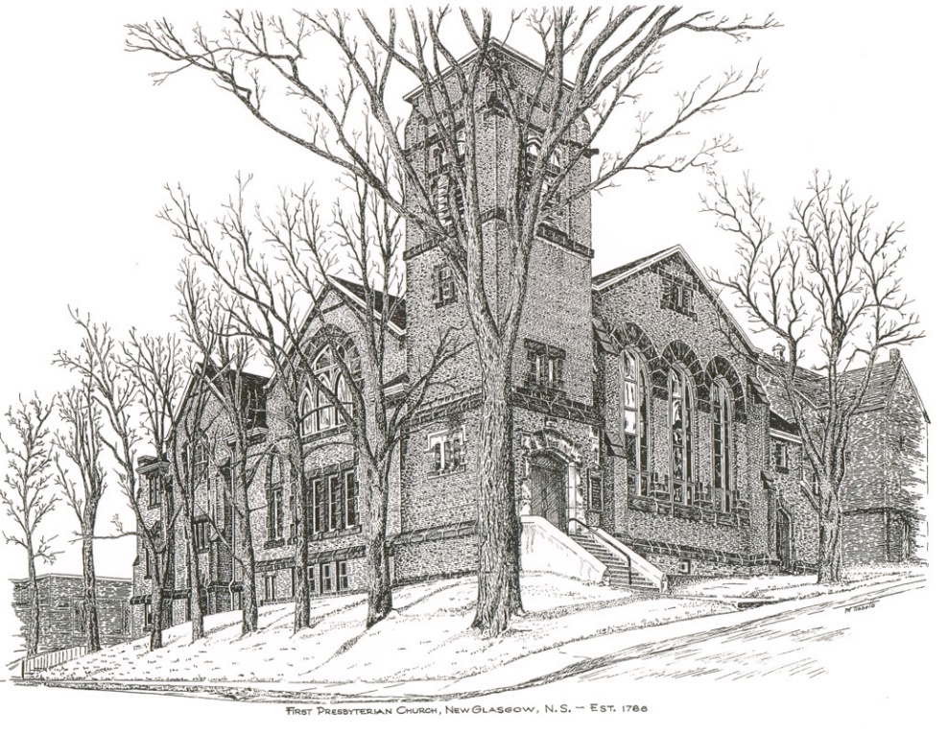

FIRST PRESBYTERIAN CHURCH
208 MacLean St., New Glasgow, NS
902-752-5691
First.church@ns.aliantzinc.ca
Reverend Andrew MacDonald
902-331-0322
yick96@hotmail.com

September 22nd, 2024
18th Sunday after Pentecost

THE APPROACH

**Please rise**
Musical Prelude
Welcome and Announcements
One: Let us now prepare our hearts to worship almighty God.
**Entry of the Bible: Please rise
**Lighting the Christ Candle: Please rise
**Call to Worship
Introit – 310 – “Bring many names” vs. 4
4 Old, aching God, gray with endless care,
calmly piercing evil’s new disguises,
glad of good surprises,
wiser than despair:
hail and hosanna,
old, aching God!

**Hymn #490 – “God of grace and God of glory” vs. 1,2,4,5

1 God of grace and God of glory,
on thy people pour thy power;
crown thine ancient church’s story;
bring its bud to glorious flower.
Grant us wisdom, grant us courage
for the facing of this hour,
for the facing of this hour.

2 Lo! the hosts of evil round us,
scorn thy Christ, assail his ways!
From the fears that long have bound us,
free our hearts to love and praise.
Grant us wisdom, grant us courage
for the living of these days,
for the living of these days.

4 Set our feet on lofty places;
gird our lives that they may be
armoured with all Christ-like graces,
pledged to set all captives free.
Grant us wisdom, grant us courage,
that we fail not them nor thee,
that we fail not them nor thee.

5 Save us from weak resignation
to the evils we deplore;
let the search for thy salvation
be our glory evermore.
Grant us wisdom, grant us courage,
serving thee whom we adore,
serving thee whom we adore.

Prayer of Adoration and Confession

Our Father which art in heaven, Hallowed be thy name.

Thy kingdom come, thy will be done in earth,

as it is in heaven.

Give us this day our daily bread.

And forgive us our debts, as we forgive our debtors.

And lead us not into temptation, but deliver us from evil:

For thine is the kingdom, and the power, and the glory,

forever. Amen.

Assurance of Pardon
Passing the Peace
**Hymn #348 - “Tell me the stories of Jesus” vs. 1-3,5

- Tell me the stories of Jesus I love to hear;
Things I would ask Him to tell me if He were here;
Scenes by the wayside, tales of the sea,
Stories of Jesus, tell them to me.

- First let me hear how the children stood round His knee, And I shall fancy His blessing resting on me;
words full of kindness, deeds full of grace,
all in the love light of Jesus’ face.

3 Tell me about the disciples from far and near,
and I will listen among them eager to hear.
Whose loaves and fishes did Jesus bless,
showing the people God’s tenderness?

5 Into the city I’d follow the children’s band,
waving a branch of the palm tree high in my hand;
one of his heralds, yes, I would sing
loudest hosannas: Jesus is King!

Children’s Time
Prayer of Illumination
First Lesson: Jeremiah 11:18-20
Epistle Lesson: James 3:13-4:3

Responsive Psalm 54
ONE: Save me, O God, by your name, and vindicate me by your might. Hear my prayer, O God; give ear to the words of my mouth.
ALL: For the insolent have risen against me, the ruthless seek my life; they do not set God before them.
ONE: But surely, God is my helper; the Lord is the upholder of my life. He will repay my enemies for their evil. In your faithfulness, put an end to them.
ALL: With a freewill-offering I will sacrifice to you; I will give thanks to your name, O Lord, for it is good. For he has delivered me from every trouble, and my eye has looked in triumph on my enemies.

**Gloria Patri
Glory be to the Father
and to the Son, and to the Holy Ghost!
As it was in the beginning is now and ever shall be.
World without end. Amen, amen.

Gospel Lesson: Mark 9:30-37
Anthem
Sermon: "Who is the greatest?"

**Reaffirmation of Faith (Apostles Creed)

I believe in God, the Father Almighty, maker of Heaven and earth; and in Jesus Christ, His only Son, Our Lord, who was conceived by the Holy Ghost, born of the Virgin Mary,
suffered under Pontius Pilate, was crucified, died, and was buried. He descended into Hell. On the third day He arose again from the dead; He ascended into Heaven, and sits
at the right hand of God, the Father Almighty; from thence He shall come to judge the quick and the dead.
I believe in the Holy Ghost, the holy Catholic Church,
the communion of saints, the forgiveness of sins, the resurrection of the body, and the life everlasting. Amen.

**Hymn: #296 – “The clay-stained hands of love” vs. 1-4 Tune 661

- The clay-stained hands of love
created human form.
Praise love that made us from the earth,
the love with clay-stained hands.

- The healing hands of love
gave speech and sight and strength.
Praise love that came to touch and heal,
the love with healing hands.

- The wounded hands of love
showed life had conquered death.
Praise love that came in servant form,
the love with wounded hands.

- The hidden hands of love
are building up the church.
Praise love that works with living stone,
the love with hidden hands.

Offertory
**Doxology #79
Praise God from whom all blessings Flow. Praise Him all creatures here below. Praise Him above Ye Heavenly Host. Praise Father, Son, and Holy Ghost. Amen.

Offertory Prayer
Prayers of the People: The people respond
ONE: Lord, in your mercy.
ALL: Hear our prayer.
**Hymn: #585 – “Christ, you call us all to service”
- Christ, you call us all to service
call us all who follow you;
plant in us a deep commitment
all your work and will to do.
Fire a passion for your justice;
in us kindle love of peace;
help us heal the brokenhearted;
to the captive bring release.

- Teach us how to work together,
brother, sister, side by side,
equal partners in the struggle,
in the cause of truth allied.
To each one some gift is given –
man or woman, young or old;
help us use each skill and talent,
your great purpose to unfold.

- Let us be a servant people,
reconciling, ending strife,
seeking ways more just of sharing
and or ordering human life.
Fill us with a glowing vision
of this world as it should be;
send us forth to change that vision
into blest reality.
**Benediction - Go Now in Peace (Don Besig)
Go now in peace Never be afraid
God will go with you each hour of every day

Go now in faith Steadfast, strong, and true.
Know He will guide you in all you do.

Go now in love, And show you believe
Reach out to others So all the world can see.

God will be there Watching from above
Go now in peace, In faith, and in love
Amen, amen, amen.
Recessional

* * * * * * * * * * * * *
Minister: Rev. Andrew MacDonald (c) 902-331-0322
Organist: Clare Grieves
Office hours: Tues. to Fri. – 10 -1pm
Rev. MacDonald office hours -Tues. to Thurs. 10-2 or by appointment

Mission Statement: But he’s already made it plain how to live, what to do, what God is looking for in men and women. It’s quite simple. Do what is fair and just to your neighbor, be compassionate and loyal in your love, and don’t take yourself too seriously – take God seriously. Micah 6: 8-The Message
ANNOUNCEMENTS

All are welcome at First Presbyterian Church. We hope you experience the love of God and of this congregation as we worship, celebrate, and serve one another.
PASTORAL CARE
In order to provide support to the people of First Church, when you or a loved one is sick or in hospital, we encourage you to contact the church (902-752-5691), Reverend Andrew (902-331-0322) or Cathy Lewis, Chair of the Pastoral Care Team (902-759-9649), to inform us directly. It is also important that you inform the hospital that you would welcome a visit from your
UPCOMING EVENTS
This afternoon – 2:30 p.m. – We will be worshipping with the residents of Riverview Residential this afternoon. All welcome.

Sun., Sept. 29th – We will celebrate Holy Communion. Following service, we will have a “Thanking Party” in honour of Ella Russell and the Circle of Friends for their years of dedication to First Church.

If you missed it – Rev. Grant Johnston is leading a study group Tuesdays from 7:00-8:30p.m. called “An Introduction to the Bible: A Study on Paul’s Letters to the Corinthians”. Offered at First Presbyterian Church, Stellarton, (a second group to meet on Wednesday evenings at another location), these sessions are for those who would like a better understanding of these important letters. If there is enough interest, an afternoon class on Tuesdays or Wednesdays might be possible. For more information or to register, contact Rev. Grant Johnston, Course Leader: grant.johnston@live.com, or call or text: (905) 867-1914. Participants will receive a complimentary copy of the New Testament, Good News version.

Fri., Sept 27th & Sat., Sept. 28th –“Pictou County Pilgrimage Walk”- Join us for a 2 day walking pilgrimage from Westville to Pictou, visiting historic and holy sites along the way – a “Camino” in our own county. For details see “Pictou County Pilgrimage Walk” on Facebook or contact us at 902-396-4851. Sponsored by the Salvation Army.

Fri., Sept 27th, Plan to attend a Variety Concert at Middle River Church, Rocklin. Free will admission. Fudge & water will be for sale.

RESERVE THE DATE - Sun., Dec. 1st - 3pm. - Middle River Church, Rocklin will be holding an Old Fashion Christmas Concert, lots of old time Christmas carols and songs. More info to follow ....

Wed. and Fri. mornings – 10:30-11:30 a.m. - Chair Yoga is being offered at First Church, in the Upper Hall. For more information contact Monica Beltram at info@monicafit.ca
CONGRATULATIONS!!
Justin Savage, a long-time employee of Sobeys, recently received a service award pin recognizing his 25 years of service to the company. Congratulations from all of us Justin!!
SCRIPTURE READERS & USHERS:
Reader: Lynne Ann MacLellan
Ushers: Main Door (Office) - David Johnstone
James St. – Ruth-Anne MacIntosh
MacLean St. (Main Entrance steps) – Ellen Jardine

EARLY CHRISTIAN EDUCATORS: Lynne Ann and Lois MacLellan

