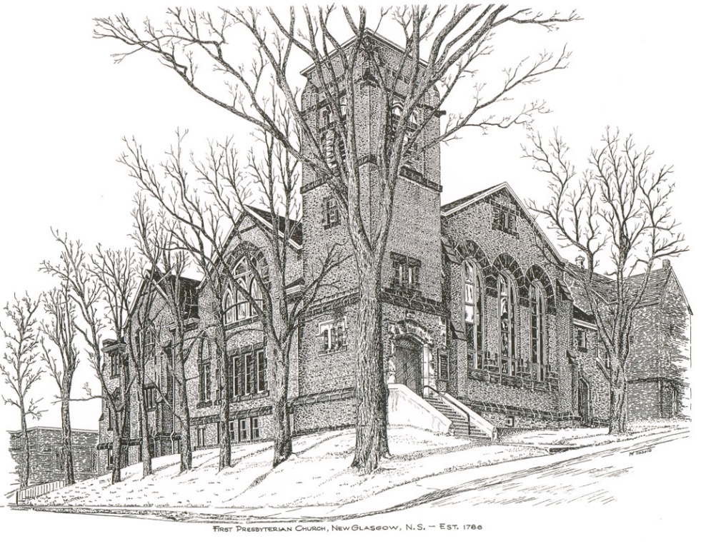

FIRST PRESBYTERIAN CHURCH
208 MacLean St., New Glasgow, NS
902-752-5691
First.church@ns.aliantzinc.ca
Reverend Andrew MacDonald
902-331-0322
yick96@hotmail.com

October 6th, 2024
20th Sunday after Pentecost
World Communion Day

THE APPROACH

**Please rise**
Musical Prelude
Welcome and Announcements
One: Let us now prepare our hearts to worship almighty God.
**Entry of the Bible: Please rise
**Lighting the Christ Candle: Please rise
**Call to Worship
Introit – #422 – “Sing a new song unto the Lord” vs. 1
CHORUS:
Sing a new song unto the Lord;
let your song be heard from mountains’ height.
Sing a new song unto the Lord,
singing hallelujah!

1 For God’s people dance for joy.
Oh come before the Lord,
play for the Lord on glad tambourines,
and let your trumpet sound.

**Hymn #412 – “Come, let us sing to the Lord our song”

- Come, let us sing to the Lord our song:
we have stood silently too long;
surely the Lord deserves our praise,
so joyfully thank God for our days.

- O thirsty soul, come drink at the well;
God’s living waters will never fail.
Surely the Lord will help you to stand,
strengthened and comforted by God’s hand.

- You dwell among us and cause us to pray,
and walk with each other following your way;
our precious brothers and sisters will grow
in the fulfilling love they know.

- Deserts shall bloom and mountains shall sing
to the desire of all living things.
Come, all you creatures, high and low;
let your praises endlessly flow.

Prayer of Adoration and Confession

Our Father which art in heaven, Hallowed be thy name.

Thy kingdom come, thy will be done in earth,

as it is in heaven.

Give us this day our daily bread.

And forgive us our debts, as we forgive our debtors.

And lead us not into temptation, but deliver us from evil:

For thine is the kingdom, and the power, and the glory,

forever. Amen.

Assurance of Pardon
Passing the Peace
**Hymn #631 - “Jesus’ hands were kind hands”

- Jesus’ hands were kind hands, doing good to all,
healing pain and sickness, blessing children small,
washing tired feet and saving those who fall;
Jesus’ hands were kind hands, doing good to all.

- Take my hands, Lord Jesus, let them work for you;
make them strong and gentle, kind in all I do.
Let me watch you, Jesus, till I’m gentle too,
till my hands are kind hands, quick to work for you.

Children’s Time
Prayer of Illumination
First Lesson: Genesis 2:18-24
Epistle Lesson: Hebrews 1:1-4, 2:5-12
Responsive Psalm 8
ONE: O Lord, our Sovereign, how majestic is your name in all the earth! You have set your glory above the heavens. Out of the mouths of babes and infants you have founded a bulwark because of your foes, to silence the enemy and the avenger.
ALL: When I look at your heavens, the work of your fingers, the moon and the stars that you have established; what are human beings that you are mindful of them, mortals that you care for them?
ONE: Yet you have made them a little lower than God,
and crowned them with glory and honour. You have given them dominion over the works of your hands; you have put all things under their feet, all sheep and oxen,
and also the beasts of the field, the birds of the air, and the fish of the sea, whatever passes along the paths of the seas.
ALL: O Lord, our Sovereign, how majestic is your name in all the earth!
**Gloria Patri #684
Glory to the Father,
and to the Son, and to the Holy Spirit;
as it was in the beginning,
is now, and will be forever.
Amen, amen, amen.

Gospel Lesson: Mark 10:2-16
Anthem – “Abba, Abba, hear us we cry”
Sermon: “Lower than the Angels!”
**Reaffirmation of Faith (Apostles Creed)

I believe in God, the Father Almighty, maker of Heaven and earth; and in Jesus Christ, His only Son, Our Lord, who was conceived by the Holy Ghost, born of the Virgin Mary,
suffered under Pontius Pilate, was crucified, died, and was buried. He descended into Hell. On the third day He arose again from the dead; He ascended into Heaven, and sits
at the right hand of God, the Father Almighty; from thence He shall come to judge the quick and the dead.
I believe in the Holy Ghost, the holy Catholic Church,
the communion of saints, the forgiveness of sins, the resurrection of the body, and the life everlasting. Amen.

**Hymn: #642 – “O Master, let me walk with thee”

1 O Master, let me walk with thee
in lowly paths of service free;
tell me thy secrets; help me bear
the strain of toil, the fret of care.

2 Help me the slow of heart to move
by some clear winning word of love;
teach me the wayward feet to stay,
and guide me in the homeward way.

3 Teach me thy patience, still with thee
in closer, dearer company,
in work that keeps faith sweet and strong,
in trust that triumphs over wrong.

4 in hope that sends a shining ray
far down the future’s broadening way,
in peace that only thou canst give,
with thee, O Master, let me live.

Offertory

**Doxology #79
Praise God from whom all blessings Flow. Praise Him all creatures here below. Praise Him above Ye Heavenly Host. Praise Father, Son, and Holy Ghost. Amen.

Offertory Prayer
Prayers of the People
**Hymn: #799 – “God is here! As we your people meet”

1 God is here! As we your people
meet to offer praise and prayer,
may we find in fuller measure
what it is in Christ we share.
Here, as in the world around us,
all our varied skills and arts
wait the coming of the Spirit
into open minds and hearts.

2 Here are symbols to remind us
of our life-long need of grace;
here are table, font and pulpit,
here the cross has central place.
Here in honesty of preaching,
here in silence, as in speech,
here, in newness and renewal,
God the Spirit comes to each.

3 Here our children find a welcome
in the Shepherd’s flock and fold;
here, as bread and wine are taken,
Christ sustains us as of old.
Here the servants of the Servant
seek in worship to explore
what it means in daily living
to believe and do adore.

4 Sovereign god of Church and Kingdom,
in an age of change and doubt
keep us faithful to the gospel;
help us work your purpose out.
Here, in this day’s dedication,
all we have to give, receive;
we, who cannot live without you,
we adore you; we believe.

**Benediction - Go Now in Peace (Don Besig)
Go now in peace Never be afraid
God will go with you each hour of every day

Go now in faith Steadfast, strong, and true.
Know He will guide you in all you do.

Go now in love, And show you believe
Reach out to others So all the world can see.

God will be there Watching from above
Go now in peace, In faith, and in love
Amen, amen, amen.
Recessional

* * * * * * * * * * * * *
Minister: Rev. Andrew MacDonald (c) 902-331-0322
Organist: Clare Grieves
Office hours: Tues. to Fri. – 10 -1pm
Rev. MacDonald office hours -Tues. to Thurs. 10-2 or by appointment

Mission Statement: But he’s already made it plain how to live, what to do, what God is looking for in men and women. It’s quite simple. Do what is fair and just to your neighbor, be compassionate and loyal in your love, and don’t take yourself too seriously – take God seriously. Micah 6: 8-The Message

ANNOUNCEMENTS

All are welcome at First Presbyterian Church. We hope you experience the love of God and of this congregation as we worship, celebrate, and serve one another.
PASTORAL CARE
In order to provide support to the people of First Church, when you or a loved one is sick or in hospital, we encourage you to contact the church (902-752-5691), Reverend Andrew (902-331-0322) or Cathy Lewis, Chair of the Pastoral Care Team (902-759-9649), to inform us directly. It is also important that you inform the hospital that you would welcome a visit from your minister and/or your Elder.
UPCOMING EVENTS
Mon. Oct. 7th – 6:30 p.m. – The Board of Managers will meet.

Tues. Oct. 8th – 6:30 p.m. – Session will meet.


Thanksgiving Sun., Oct 13th - We will be decorating the sanctuary for Thanksgiving and welcome food items that will be donated to the Food Bank. If you would like to contribute, please leave your items on the communion table at the front of the church.

Sun., Oct. 20th – We will be worshipping with the congregation of the St. Andrew’s Presbyterian Church, the “Kirk”, for their Anniversary Service.

Sun., Oct. 20^{th -} 2:00 p.m. – Salem Presbyterian Church, Greenhill, will celebrate their 175th Anniversary, guest speaker David Sutherland. Music provided by Brenda Bowden and her community choir. Please wear your clan tartan. A piper will be in attendance to welcome you. Lunch to follow.

Sun., Oct. 20th – 4:00 p.m. – Shaun McLean and guests will host a concert in support of “Palliative Care” here at First Presbyerian.
RESERVE THE DATE - Sun., Dec. 1st - 3pm. - Middle River Church, Rocklin will be holding an Old Fashion Christmas Concert, lots of old time Christmas carols and songs. More info to follow ....

REQUEST FOR DONATIONS – We are in need of donations of paper products, in particular paper towel, Kleenex etc. Any donations are appreciated.

Wed. and Fri. mornings – 10:30-11:30 a.m. - Chair Yoga is being offered at First Church, in the Upper Hall. For more information contact Monica Beltram at info@monicafit.ca

SCRIPTURE READERS & USHERS:
Reader: Kevin Reid
Ushers: Main Door (Office) – John Zinck
James St. – Ruth-Anne MacIntosh
MacLean St. (Main Entrance steps) – Gary & Jackie Ross

EARLY CHRISTIAN EDUCATORS: Lynne Ann and Lois MacLellan

