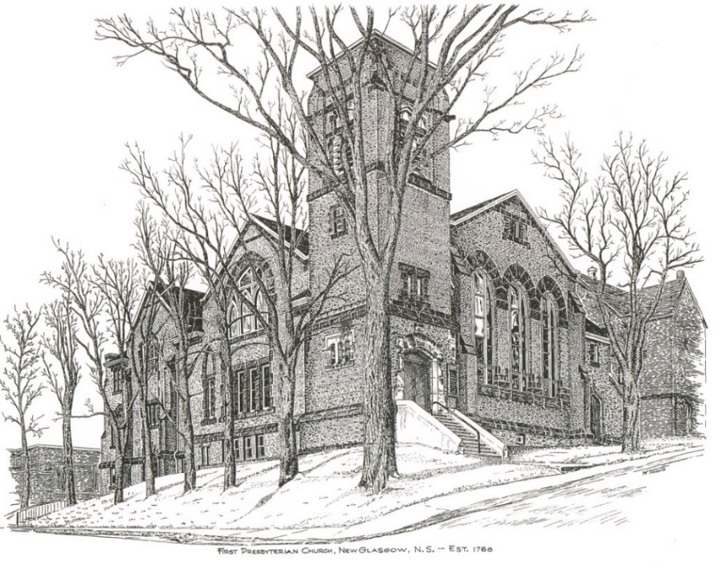

FIRST PRESBYTERIAN CHURCH
208 MacLean St., New Glasgow, NS
902-752-5691
First.church@ns.aliantzinc.ca
Reverend Andrew MacDonald
902-331-0322
yick96@hotmail.com

January 12th , 2025
3rd Sunday after Christmas
First Sunday after the Epiphany

THE APPROACH

**Please rise**
Musical Prelude
Welcome and Announcements
One: Let us now prepare our hearts to worship almighty God.
**Entry of the Bible: Please rise
Lighting of the Christ Candle
Introit – #797 – “Shall we gather at the river” vs. 1

1 Shall we gather at the river,
where bright angel feet have trod,
with its crystal tide forever
flowing from the throne of God?

Yes, we’ll gather at the river,
the beautiful, the beautiful river,
gather with the saints at the river
that flows from the throne of God.

**Call to Worship

**Hymn #176 – “Songs of thankfulness and praise” vs.1,3,5
1 Songs of thankfulness and praise
Jesus, Lord, to you we raise,
God revealed by guiding star
to the sages from afar,
branch of royal David’s stem,
in your birth at Bethlehem:
anthems be to you addressed,
God in Christ made manifest.

2 God revealed at Jordan’s stream
God’s beloved Son supreme,
and at Cana, wedding guest,
in your power manifest,
God revealed in works divine,
changing water into wine:
anthems be to you addressed,
God in Christ made manifest.

3 God revealed in making whole
weakening limbs and fainting soul,
God revealed in valiant fight
quelling all the devil’s might,
God revealed in gracious will,
ever bringing good from ill,
anthems be to you addressed,
God in Christ made manifest.

5 Grant us grace to see you, Lord,
mirrored in your holy word;
may we imitate you still
and obey your perfect will,
that we like to you may be,
at your great Ephipany:
may your glory be confessed,
God in Chist made manifest.

Prayer of Adoration and Confession

Our Father which art in heaven, Hallowed be thy name.

Thy kingdom come, thy will be done in earth,

as it is in heaven.

Give us this day our daily bread.

And forgive us our debts, as we forgive our debtors.

And lead us not into temptation, but deliver us from evil:

For thine is the kingdom, and the power, and the glory,

forever. Amen.

Assurance of Pardon
Passing the Peace
** Children’s Hymn #476 – “Amigos de Cristo/Friends of the Lord”

Refrain:
Amigos de Cristo;
we’re friends of the Lord;
amigos de Cristo;
we’re friends of the Lord,
for we’ve been forgiven,
and we’ve been restored;
amigos de Cristo;
and we’re friends of the Lord.

- Friends of the covenant
renewed each morn;
baptized and loving it,
we’ve been reborn.
Gift of the dove is ours forevermore.
Amigos de Cristo;
we’re friends of the Lord.

- Born of a family
the young and old,
we’ll be on hand to see
new life unfold.
We understand the need to be made whole.
Amigos de Cristo;
we’re friends of the Lord.

Children’s Time
Prayer of Illumination
First Lesson: Isaiah 43:1-7
Epistle Lesson: Acts 8:14-17

Responsive Psalm 29
ONE: Ascribe to the Lord, O heavenly beings, ascribe to the Lord glory and strength. Ascribe to the Lord the glory of his name; worship the Lord in holy splendour.
ALL: The voice of the Lord is over the waters; the God of glory thunders, the Lord, over mighty waters. The voice of the Lord is powerful; the voice of the Lord is full of majesty.
ONE: The voice of the Lord breaks the cedars; the Lord breaks the cedars of Lebanon. He makes Lebanon skip like a calf, and Sirion like a young wild ox.
ALL: The voice of the Lord flashes forth flames of fire. The voice of the Lord shakes the wilderness; the Lord shakes the wilderness of Kadesh.
ONE: The voice of the Lord causes the oaks to whirl, and strips the forest bare; and in his temple all say, ‘Glory!’
ALL: The Lord sits enthroned over the flood; the Lord sits enthroned as king for ever. May the Lord give strength to his people! May the Lord bless his people with peace!
**Gloria Patri #684
Glory to the Father,
and to the Son, and to the Holy Spirit;
as it was in the beginning,
is now, and will be forever.
Amen, amen, amen.

Gospel Lesson: Luke 3:15-17, 21-22
Anthem – “Were you there on that Christmas morn”
Sermon: “Passing through the waters!”

**Reaffirmation of Faith (Apostles Creed)

I believe in God, the Father Almighty, maker of Heaven and earth; and in Jesus Christ, His only Son, Our Lord, who was conceived by the Holy Ghost, born of the Virgin Mary,
suffered under Pontius Pilate, was crucified, died, and was buried. He descended into Hell. On the third day He arose again from the dead; He ascended into Heaven, and sits
at the right hand of God, the Father Almighty; from thence He shall come to judge the quick and the dead.
I believe in the Holy Ghost, the holy Catholic Church,
the communion of saints, the forgiveness of sins, the resurrection of the body, and the life everlasting. Amen.

**Hymn: #401 – “O Spirit of the living God” vs. 1-3,5
1. O Spirit of the living God,
in all the fullness of thy grace,
whereever human foot hath trod,
descend on our rebellious race.
2. Give tongues of fire and hearts of love,
to preach the reconciling word;
give power and unction from above,
whene'er the joyful sound is heard.
3. Be darkness, at thy coming, light,
confusion order, in thy path;
souls without strength inspire with might;
bid mercy triumph over wrath.
5. Baptize the nations: far and nigh
the triumphs of the cross record;
the name of Jesus glorify,
till every kindred call him Lord.
Offertory
**Doxology #79

Praise God from whom all blessings Flow. Praise Him all creatures here below. Praise Him above Ye Heavenly Host. Praise Father, Son, and Holy Ghost. Amen.

Offertory Prayer
Prayers of the People:
ONE: Our hearts kneel before you, oh God.
**Hymn: #183 – “Christ, when for us you were baptized”
1 Christ, when for us you were baptized,
God’s spirit on you came,
as peaceful as a dove, and yet
as urgent as a flame.

2 God called you the beloved Son,
called you the servant true:
sent you the kingdom to proclaim,
God’s holy will to do.

3 Straightway and steadfast until death
you then obeyed the call,
freely as Son of Man to serve
and give your life for all.

4 Baptize us with your Spirit, Lord;
your cross on us be signed,
that likewise in God’s service we
may perfect freedom find.

**Benediction - Go Now in Peace (Don Besig)
Go now in peace Never be afraid
God will go with you each hour of every day

Go now in faith Steadfast, strong, and true.
Know He will guide you in all you do.

Go now in love, And show you believe
Reach out to others So all the world can see.

God will be there Watching from above
Go now in peace, In faith, and in love
Amen, amen, amen.
Recessional

ANNOUNCEMENTS

All are welcome at First Presbyterian Church. We hope you experience the love of God and of this congregation as we worship, celebrate, and serve one another.

PASTORAL CARE:
In order to provide support to the people of First Church, when you or a loved one is sick or in hospital, we encourage you to contact the church (902-752-5691), Reverend Andrew (902-331-0322) or Cathy Lewis, Chair of the Pastoral Care Team (902-759-9649), to inform us directly. It is also important that you inform the hospital that you would welcome a visit from your minister and/or your Elder.

An In-memorium donation has been received in loving memory of Donald Johnstone from Edna Fraser & Chet Fleming.
In memorium donations have been received in loving memory of Gary Baudoux from Ellen Jardine and Allan & Anne Rumley.

UPCOMING EVENTS

Today – 12:15 p.m. – Session will meet after service.

Sun.., Jan. 19th - 12:15 p.m. – The Board of Managers will meet after service.

We send birthday wishes to Ralph Foote who celebrates his birthday today, Jan. 12th. Happy birthday Ralph!!

SCRIPTURE READERS & USHERS:
Reader: Jennifer Thibeau
Ushers: Main Door (Office) – Brent MacQuarrie
James St. – Ruth-Anne MacIntosh
MacLean St. (Main Entrance steps) – Ellen Jardine
Early Christian Educators: Lynne Ann & Lois MacLellan

* * * * * * * * * * * * *
Minister: Rev. Andrew MacDonald (c) 902-331-0322
Organist: Clare Grieves
Office hours: Tues. to Fri. – 10 -1pm
Rev. MacDonald office hours -Tues. to Thurs. 10-2 or by appointment

Mission Statement: But he’s already made it plain how to live, what to do, what God is looking for in men and women. It’s quite simple. Do what is fair and just to your neighbor, be compassionate and loyal in your love, and don’t take yourself too seriously – take God seriously.
Micah 6: 8-The Message

