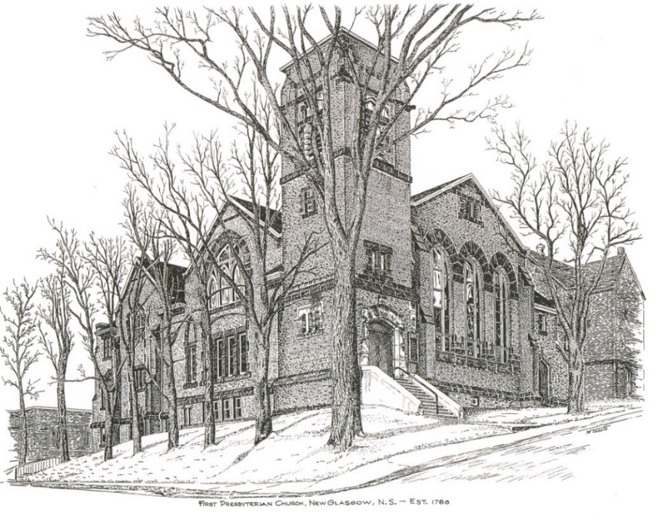

FIRST PRESBYTERIAN CHURCH
208 MacLean St., New Glasgow, NS
902-752-5691
First.church@ns.aliantzinc.ca
Reverend Andrew MacDonald
902-331-0322
yick96@hotmail.com

February 9th , 2025
Fifth Sunday after the Epiphany

THE APPROACH

**Please rise**
Musical Prelude
Welcome and Announcements
One: Let us now prepare our hearts to worship almighty God.
**Entry of the Bible: Please rise
Lighting of the Christ Candle
Introit – “Make a joyful noise” vs. 3 (Linnea Good)
Chorus
Make a joyful noise all the earth!
Worship your God with gladness.
Make a joyful noise all the earth.
Come to this place with with a song!

Ages through endless ages,
Seasons of endless years,
the love of our Maker ever shall endure.
Worship your God with a song!

**Call to Worship
**Hymn #753 – “You walk along our shoreline”
- You walk along our shoreline
where land meets unknown sea.
We hear your voice of power,
“Now come and follow me.
And if you still will follow
through storm and wave and shoal,
then I will make you fishers
but of the human soul.”

- You call us, Christ, to gather
the people of the earth.
We cannot fish for only
those lives we think have worth.
We spread your net of gospel
across the water’s face,
our boat a common shelter
for all found by your grace.

3. We cast our net, O Jesus
we cry the kingdom’s name;
we work for love and justice;
we learn to hope through pain.
You call us, Lord, to gather
God’s daughters and God’s sons,
to let your judgement heal us
so that all may be one.

Prayer of Adoration and Confession

Our Father which art in heaven, Hallowed be thy name.

Thy kingdom come, thy will be done in earth,

as it is in heaven.

Give us this day our daily bread.

And forgive us our debts, as we forgive our debtors.

And lead us not into temptation, but deliver us from evil:

For thine is the kingdom, and the power, and the glory,

forever. Amen.
Assurance of Pardon
Passing the Peace
** Children’s Hymn #579 – “Oh, I know the Lord’s laid his hand on me (African spiritual)”

Refrain:
Oh, I know the Lord, I know the Lord,
I know the Lord's laid his hands on me.
Oh, I know the Lord, I know the Lord,
I know the Lord's laid his hands on me.
1. Did ever you see the like before?
I know the Lord's laid his hands on me;
King Jesus preach ing to the poor!
I know the Lord's laid his hands on me.
(Refrain)
2. Oh, wasn't that a happy day
I know the Lord's laid his hands on me;
when Jesus washed my sins away!
I know the Lord's laid his hands on me.
(Refrain)
3. Some seek the Lord and don't seek him right;
I know the Lord's laid his hands on me;
they fool all day and pray at night,
I know the Lord's laid his hands on me.
(Refrain)
4. My Lord's done just what he said;
I know the Lord's laid his hands on me;
he's healed the sick and raised the dead;
I know the Lord's laid his hands on me.
(Refrain)
Children’s Time
Prayer of Illumination

First Lesson: Isaiah 6:1-13 Page 524
Epistle Lesson: 1 Corinthians 15:1-11 Page 877
Responsive Psalm 138
ONE: I give you thanks, O Lord, with my whole heart; before the gods I sing your praise; I bow down towards your holy temple and give thanks to your name for your steadfast love and your faithfulness; for you have exalted your name and your word above everything.
ALL: On the day I called, you answered me, you increased my strength of soul.
ONE: All the kings of the earth shall praise you, O Lord, for they have heard the words of your mouth. They shall sing of the ways of the Lord, for great is the glory of the Lord.
ALL: For though the Lord is high, he regards the lowly; but the haughty he perceives from far away.
ONE: Though I walk in the midst of trouble, you preserve me against the wrath of my enemies; you stretch out your hand, and your right hand delivers me.
ALL: The Lord will fulfil his purpose for me; your steadfast love, O Lord, endures for ever. Do not forsake the work of your hands.

**Gloria Patri #684
Glory be to the Father,
and to the Son, and to the Holy Ghost;
as it was in the beginning,
is now, and ever shall be, world without end.
Amen, amen.

Gospel Lesson: Luke 5:1-11 Page 786
Anthem – Spiritual Medley – Brent MacQuarrie - Trumpet
Sermon: "Come closer"

**Reaffirmation of Faith (Apostles Creed)

I believe in God, the Father Almighty, maker of Heaven and earth; and in Jesus Christ, His only Son, Our Lord, who was conceived by the Holy Ghost, born of the Virgin Mary,
suffered under Pontius Pilate, was crucified, died, and was buried. He descended into Hell. On the third day He arose again from the dead; He ascended into Heaven, and sits
at the right hand of God, the Father Almighty; from thence He shall come to judge the quick and the dead.
I believe in the Holy Ghost, the holy Catholic Church,
the communion of saints, the forgiveness of sins, the resurrection of the body, and the life everlasting. Amen.

**Hymn: #100 – “I’ll praise you, Lord” vs. 1,2,4 (Tune 598)

- I’ll praise you, Lord, with heart content and joyful;
before the world, I’ll tell your righteous ways;
I will bow down towards your holy temple,
exalt your name and sing your worthy praise.

- Beyond the skies you set your timeless kingdom;
your word shall last; your throne shall never fall;
the lords of earth will marvel at your wisdom
and kneel before the mighty Lord of all.

4. Forever you will keep your face towards us;
your mercy and your love will never cease.
Then come fulfil in us your mighty purpose,
and grant to your creation perfect peace.

Offertory

**Doxology #79
Praise God from whom all blessings Flow. Praise Him all creatures here below. Praise Him above Ye Heavenly Host. Praise Father, Son, and Holy Ghost. Amen.

Offertory Prayer
Prayers of the People

**Hymn: #634 - “Will you come and follow me” vs. 1,2,4,5
1 Will you come and follow me
if I but call your name?
Will you go where you don’t know
and never be the same?
Will you let my love be shown;
will you let my name be known;
will you let my life be grown
in you and you in me?

2 Will you leave yourself behind
if I but call your name?
Will you care for cruel and kind
and never be the same?
Will you risk the hostile stare
should your life attract or scare?
Will you let me answer prayer
in you and you in me?

4 Will you love the “you” you hide
if I but call your name?
Will you quell the fear inside
and never be the same?
Will you use the faith you’ve found
to reshape the world around,
through my sight and touch and sound
in you and you in me?

5 Lord, your summons echoes true
when you but call my name.
Let me turn and follow you
and never be the same.
In your company I’ll go
where your love and footsteps show.
Thus I’ll move and live and grow
in you and you in me.

**Benediction - Go Now in Peace (Don Besig)
Go now in peace Never be afraid
God will go with you each hour of every day

Go now in faith Steadfast, strong, and true.
Know He will guide you in all you do.

Go now in love, And show you believe
Reach out to others So all the world can see.

God will be there Watching from above
Go now in peace, In faith, and in love
Amen, amen, amen.
Recessional

* * * * * * * * * * * * *
Minister: Rev. Andrew MacDonald (c) 902-331-0322
Organist: Clare Grieves
Office hours: Tues. to Fri. – 10 -1pm
Rev. MacDonald office hours -Tues. to Thurs. 10-2 or by appointment.

* * * * * * * * * * * * * * * * * * *
ANNOUNCEMENTS

All are welcome at First Presbyterian Church. We hope you experience the love of God and of this congregation as we worship, celebrate, and serve one another.

UPCOMING EVENTS
TODAY –
- 12:15 p.m. - Session will meet this afternoon after service.
- 2:30 p.m. – We will worship with the residents of Riverview Residential.

Annual Meeting & Reports – Please submit your reports as soon as possible. Thank you to those who have already submitted your reports. The Annual Meeting is tentatively scheduled to be held Sunday, March 23rd after service.

Sun., Mar. 16th (time to be announced) - The Geddie Committee is hosting a Mystery Event in Pictou. Hints about the event will be posted on their social media during the first two weeks of Feb. Mark the afternoon of Mar. 16th on your calendar; it’s going to be a fun, family-friendly event to support and promote Camp Geddie!

Food Bank Donations: All donations to the Food Bank are gratefully accepted. “Coffee Hour Sunday” (the 3rd Sunday of the month) is also “Food Bank Sunday” at First Church. The following is a list of items that are helpful and appreciated at the Food Bank:

- Pasta of any kind and Kraft dinner
- Canned or boxed milk
- Canned vegetables
- Canned soup
- Spices including salt and pepper
- Tea bags and instant coffee
- Sugar
- Canned fish or meat
- Hamburger Helper (no name brand is as good as the name brands)
- Peanut butter
- Jams
- Butter, margarine
- Eggs
- Cake mixes (frosting if possible)
- Cereal and oatmeal
- Dish detergent
- Hygiene, including feminine hygiene products
- Toilet tissue and Kleenex
- Cash donations allow the Food Bank staff to take advantage of sales, especially meats and dairy products

This week we send birthday wishes to Marion MacNeil and Bill MacDonald who celebrate their birthdays on Valentine’s Day! We also wish Lee Searle a Happy Birthday; Lee will celebrate her birthday Sat., Feb. 15th. Happy Birthday to all of you!!

SCRIPTURE READERS & USHERS:
Reader: Kevin Reid
Ushers: Main Door (Office) – Fran Savage
James St. – Ruth-Anne MacIntosh
MacLean St. (Main Entrance steps) – Ellen Jardine
EARLY CHRISTIAN EDUCATORS: Lynne Ann & Lois MacLellan

