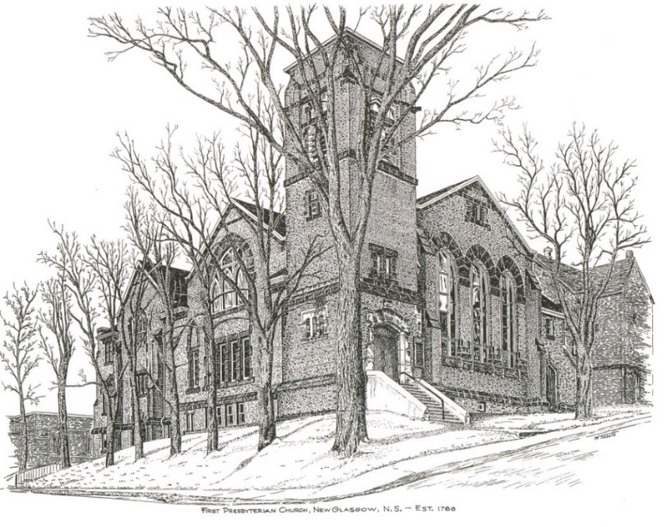

FIRST PRESBYTERIAN CHURCH
208 MacLean St., New Glasgow, NS
902-752-5691
First.church@ns.aliantzinc.ca
Reverend Andrew MacDonald
902-331-0322
yick96@hotmail.com

January 26th , 2025
Third Sunday after the Epiphany

THE APPROACH

**Please rise**
Musical Prelude
Welcome and Announcements
One: Let us now prepare our hearts to worship almighty God.
**Entry of the Bible: Please rise
Lighting of the Christ Candle
Introit – “Make a joyful noise” vs. 1 (Linnea Good)

Chorus
Make a joyful noise all the earth!
Worship your God with gladness.
Make a joyful noise all the earth.
Come to this place with with a song!

- Know that your God has made you.
Know it’s to God we belong.
And come to this place with joyfulness and praise.
Worship your God with a song!

**Call to Worship
**Hymn #497 – “Word of God, across the ages”
1 Word of God, across the ages
comes your message to our life,
source of hope, forever present
in our toil and fears and strife,
constant witness to God’s mercy,
still our grace, whate’er befall,
guide unfailing, strength eternal,
offered freely to us all.

2 Story of our wondrous journey
from the shadows of the night,
garnered truth of sage and prophet,
guiding forward into light,
words and deeds of Christ our teacher,
pointing to the life and way,
still appealing, still inspiring,
in the struggles of our day.

3 In the tongues of all the peoples
may the message bless and heal,
as devout and patient scholars
more and more its depth reveal.
Bless, O God, to wise and simple,
all your truth of ageless worth,
till all lands receive the witness
and your knowledge fills the earth.

Prayer of Adoration and Confession

Our Father which art in heaven, Hallowed be thy name.

Thy kingdom come, thy will be done in earth,

as it is in heaven.

Give us this day our daily bread.

And forgive us our debts, as we forgive our debtors.

And lead us not into temptation, but deliver us from evil:

For thine is the kingdom, and the power, and the glory,

forever. Amen.

Assurance of Pardon
Passing the Peace
** Children’s Hymn #427 – “In the presence of your people”

In the presence of your people
I will praise your name,
for alone you are holy,
enthroned on the praises of Israel.
Let us celebrate your goodness
and your steadfast love;
may your name be exalted
here on earth and in heaven above.

Children’s Time
Prayer of Illumination

First Lesson: Nehemiah 8: 1-3, 5-6, 8-10
Epistle Lesson: 1 Corinthians 12: 12-31a

Responsive Psalm 19
ONE: The heavens are telling the glory of God; and the firmament proclaims his handiwork. Day to day pours forth speech, and night to night declares knowledge. There is no speech, nor are there words; their voice is not heard; yet their voice goes out through all the earth, and their words to the end of the world.
ALL: In the heavens he has set a tent for the sun, which comes out like a bridegroom from his wedding canopy, and like a strong man runs its course with joy. Its rising is from the end of the heavens, and its circuit to the end of them; and nothing is hidden from its heat.
ONE: The law of the Lord is perfect, reviving the soul; the decrees of the Lord are sure, making wise the simple; the precepts of the Lord are right, rejoicing the heart; the commandment of the Lord is clear, enlightening the eyes; the fear of the Lord is pure, enduring for ever; the ordinances of the Lord are true and righteous altogether. More to be desired are they than gold, even much fine gold; sweeter also than honey, and drippings of the honeycomb.
ALL: Moreover by them is your servant warned; in keeping them there is great reward.
But who can detect their errors? Clear me from hidden faults.
ONE: Keep back your servant also from the insolent; do not let them have dominion over me.
Then I shall be blameless, and innocent of great transgression.
ALL: Let the words of my mouth and the meditation of my heart be acceptable to you, O Lord, my rock and my redeemer.
**Gloria Patri #684
Glory to the Father,
and to the Son, and to the Holy Spirit;
as it was in the beginning,
is now, and will be forever.
Amen, amen, amen.

Gospel Lesson: Luke 4:14-21
Anthem – “When I look into your Holiness” (W. and C. Perrin)

Sermon: "One Body, One Church, One Lord"

**Reaffirmation of Faith (Apostles Creed)

I believe in God, the Father Almighty, maker of Heaven and earth; and in Jesus Christ, His only Son, Our Lord, who was conceived by the Holy Ghost, born of the Virgin Mary,
suffered under Pontius Pilate, was crucified, died, and was buried. He descended into Hell. On the third day He arose again from the dead; He ascended into Heaven, and sits
at the right hand of God, the Father Almighty; from thence He shall come to judge the quick and the dead.
I believe in the Holy Ghost, the holy Catholic Church,
the communion of saints, the forgiveness of sins, the resurrection of the body, and the life everlasting. Amen.

**Hymn: #480 – “In Christ there is no east or west”
1 In Christ there is no east or west,
in him no south or north,
but one great fellowship of love
throughout the whole wide earth.

2 In Christ shall true hearts everywhere
their high communion find;
his service is the golden cord
close binding humankind.

3 Join hands, companions in the faith,
Whate’er your race may be!
Who loves and serves the living God
is surely kin to me.

4 In Christ now meet both east and west;
in him meet south and north;
all Christly souls are one in him,
throughout the whole wide earth.

Offertory

**Doxology #79

Praise God from whom all blessings Flow. Praise Him all creatures here below. Praise Him above Ye Heavenly Host. Praise Father, Son, and Holy Ghost. Amen.

Offertory Prayer
Prayers of the People

**Hymn: #374 - “Oh for a thousand tongues to sing”
1 Oh for a thousand tongues to sing
my great Redeemer’s praise,
the glories of my God and King,
the triumphs of God’s grace.

2 Jesus, the name that charms our fears,
and bids our sorrows cease -
‘tis music in the sinner’s ears;
‘tis life and health and peace.

3 He speaks, and listening to his voice
new life the dead receive;
the mournful, broken hearts rejoice;
the humble poor believe.

4 Hear him, you deaf; you voiceless ones,
your tongues again employ;
you blind, behold your Saviour comes,
and leap, you lame, for joy!

5 My gracious Master and my God,
assist me to proclaim,
and spread through all the earth abroad
the honors of thy name.

**Benediction - Go Now in Peace (Don Besig)
Go now in peace Never be afraid
God will go with you each hour of every day

Go now in faith Steadfast, strong, and true.
Know He will guide you in all you do.

Go now in love, And show you believe
Reach out to others So all the world can see.

God will be there Watching from above
Go now in peace, In faith, and in love
Amen, amen, amen.
Recessional

* * * * * * * * * * * * *
Minister: Rev. Andrew MacDonald (c) 902-331-0322
Organist: Clare Grieves
Office hours: Tues. to Fri. – 10 -1pm
Rev. MacDonald office hours -Tues. to Thurs. 10-2 or by appointment

ANNOUNCEMENTS

All are welcome at First Presbyterian Church. We hope you experience the love of God and of this congregation as we worship, celebrate, and serve one another.

PASTORAL CARE:
In order to provide support to the people of First Church, when you or a loved one is sick or in hospital, we encourage you to contact the church (902-752-5691), Reverend Andrew (902-331-0322) or Cathy Lewis, Chair of the Pastoral Care Team (902-759-9649), to inform us directly. It is also important that you inform the hospital that you would welcome a visit from your minister and/or your Elder.
UPCOMING EVENTS
MEETINGS - There are no meetings scheduled this week.

Annual Meeting & Reports – It’s that time of year! Please submit your reports as soon as possible. Thank you to those who have already submitted your reports.

Donation ideas for the Food Bank:

All donations to the Food Bank are gratefully accepted. First Church chose “Coffee Hour Sunday” (the 3rd Sunday of the month) as “Food Bank Sunday”. The following is a list of ideas for items that are really helpful and appreciated at the Food Bank:

- Pasta of any kind and Kraft dinner
- Canned or boxed milk
- Canned vegetables
- Canned soup
- Spices including salt and pepper
- Tea bags and instant coffee
- Sugar
- Canned fish or meat
- Hamburger Helper (no name brand is as good as the name brands)
- Peanut butter
- Jams
- Butter, margarine
- Eggs
- Cake mixes (frosting if possible)
- Cereal and oatmeal
- Dish detergent
- Hygiene, including feminine hygiene products
- Toilet tissue and Kleenex
- Cash donations allow the Food Bank staff to take advantage of sales, especially meats and dairy products

SCRIPTURE READERS & USHERS:
Reader: Brent MacQuarrie
Ushers: Main Door (Office) – Brent MacQuarrie
James St. – Ruth-Anne MacIntosh
MacLean St. (Main Entrance steps) – Ellen Jardine
EARLY CHRISTIAN EDUCATORS: Lynne Ann & Lois MacLellan

Mission Statement: But he’s already made it plain how to live, what to do, what God is looking for in men and women. It’s quite simple. Do what is fair and just to your neighbor, be compassionate and loyal in your love, and don’t take yourself too seriously – take God seriously. Micah 6: 8-The Message

