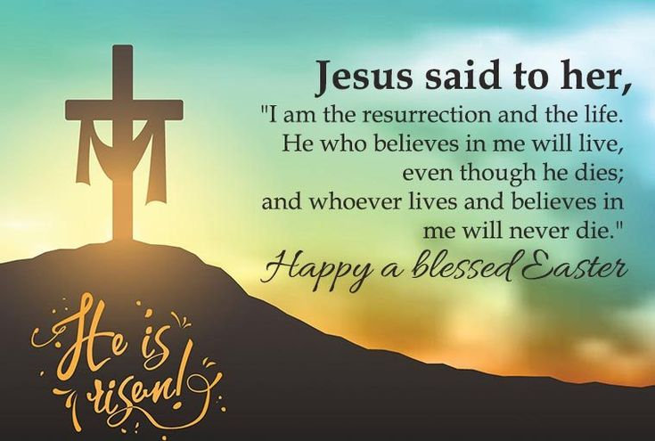

**FIRST PRESBYTERIAN CHURCH**

**208 MacLean St., New Glasgow, NS**

**902-752-5691**

[**First.church@ns.aliantzinc.ca**](mailto:First.church@ns.aliantzinc.ca)

**Reverend Andrew MacDonald**

**902-331-0322**

[**yick96@hotmail.com**](mailto:yick96@hotmail.com)

**April 20th, 2025**

**Easter Sunday**

**Communion Sunday**

**THE APPROACH**

**Musical Prelude**

**Welcome and Announcements**

**Entry of the Bible: Please Rise**

**Lighting the Christ Candle**

**Introit - 260** "Alleluia, hallelujah, give thanks to the risen Lord" vs. 1

REFRAIN: Alleluia, alleluia

Give thanks to the risen Lord

Alleluia, alleluia

give praise to his name.

1 Jesus is Lord of all the earth;

he is the King of creation:

**Call to Worship**



**Prayer of Adoration, Confession and Assurance of Pardon**

Our Father which art in heaven, Hallowed be thy name.

Thy kingdom come, thy will be done in earth,

as it is in heaven.

Give us this day our daily bread.

And forgive us our debts, as we forgive our debtors.

And lead us not into temptation, but deliver us from evil:

For thine is the kingdom, and the power, and the glory,

forever. Amen.

**Passing the Peace**

**Hymn**  **#254** – “Jesus is Risen from the grave” vs. 1,4,5,7

1. Jesus is risen from the grave;

Jesus is risen from the grave;

Jesus is risen from the grave. Hallelujah!

1. Jesus was seen by Mary;

Jesus was seen by Mary;

Jesus was seen by Mary. Hallelujah!

1. Peter will soon be smiling;

Peter will soon be smiling;

Peter will soon be smiling. Hallelujah!

1. Thomas will stop his doubting;

Thomas will stop his doubting;

Thomas will stop his doubting. Hallelujah!

1. Jesus will meet his people;

Jesus will meet his people;

Jesus will meet his people. Hallelujah!

1. Jesus is here in bread and wine;

Jesus will meet his people;

Jesus will meet his people. Hallelujah!

1. Jesus will live forever;

Jesus will live forever;

Jesus will live forever. Hallelujah!

**Sacrament of Baptism**

**Prayer of Illumination**

**First Lesson:** Isaiah 65:17-25 - p. 575

**Second Lesson:**   1 Corinthians 15:1-1 – p. 877

**Gloria Patri**

Glory be to the Father,  
and to the Son, and to the Holy Ghost;  
as it was in the beginning,  
is now, and ever shall be, world without end.  
Amen, amen.

**Gospel Lesson:** Luke 24:1-12 - p. 808

**Anthem**

**Sermon:** *“*A new beginning”

**Hymn: #262 -** “Come to us, beloved stranger”

1 Come to us, beloved Stranger,

as you came that Easter day.

Walk with us to our Emmaus,

for we need you still today.

Come to us when we are broken,

when our dearest hopes are lost,

speak to us the prophets’ message

you fulfilled upon the cross.

2 Stay with us and give us blessing,

that our hopes again may rise.

Offer us your broken body;

open our unseeing eyes.

Come to us, god’s love embodied;

touch our hearts with burning flame.

Risen Christ, once dead, now living,

come to us through joy, through pain.

3 We would never fail to see you

as you walk with us each day.

As a friend and not a stranger

you would join us on our way.

Help us trust that through your mercy

we can doubt and fear transcend,

and to others be a blessing.

Keep us faithful till life’s end!

**Offertory Prayer**

**HOLY COMMUNION**

**Invitation to the Lord’s Supper**

**The Invitation**

**Communion Hymn** **#258-** “Thine is the glory” vs. 1-2

1 Thine be the glory, risen, conquering son,

endless is the victory thou o’er death hast won;

angels in bright raiment rolled the stone away,

kept the folded grave clothes, where the body lay

REFRAIN:

Thine be the glory, risen, conquering son,

endless is the victory thou o’er death has won

2 Lo! Jesus meets us, risen from the tomb;

lovingly he greets us, scatters fear and gloom;

let the church with gladness hymns of triumph sing,

for her Lord now liveth; death hast lost its sting.

**Affirmation of Faith - Apostle’s Creed**

I believe in God, the Father Almighty, maker of Heaven and earth; and in Jesus Christ, His only Son, Our Lord, who was conceived by the Holy Ghost, born of the Virgin Mary,  
suffered under Pontius Pilate, was crucified, died, and was buried. He descended into Hell. On the third day He arose again from the dead; He ascended into Heaven, and sits  
at the right hand of God, the Father Almighty; from thence He shall come to judge the quick and the dead.  
I believe in the Holy Ghost, the holy Catholic Church,  
the communion of saints, the forgiveness of sins, the resurrection of the body, and the life everlasting. Amen

**Great Prayer of Thanksgiving:** BoP #564

The Lord be with you.

**And also with you.**

Lift up you hearts.

**We lift them up to the Lord.**

Let us give thanks to the Lord our God.

**It is right to give God thanks and praise.**

Prayer ending with

*. . . we join with the whole creation*

*to lift our hearts in joyful praise.*

**Holy, Holy, Holy Lord,**

**God of power and might,**

**heaven and earth are full of your glory.**

**Hosanna in the highest.**

**Blessed is he who comes**

**in the name of the Lord.**

**Hosanna in the highest.**

Prayer ending with

*. . . proclaim the mystery of the faith*

**Christ has died.**

**Christ is risen.**

**Christ will come again.**

Prayer ending with … and the people say

**Amen.**

**The Sacrament of Holy Communion**

**Communion Hymn #258 -**“Thine is the glory” vs. 3

3 No more we doubt thee, glorious prince of life,

life is nought without thee: aid us in our strife;

make us more than conquerors,

through thy deathless love:

bring us safe through Jordan to thy home above.

**\*\*Benediction** - Go Now in Peace (Don Besig)

Go now in peace never be afraid God will go with you each hour of every day

Go now in faith steadfast, strong, and true. Know He will guide you in all you do.

Go now in love, and show you believe reach out to others

So all the world can see.

God will be there watching from above go now in peace,

In faith, and in love, Amen, amen, amen.

**Recessional**

**ANNOUNCEMENTS**

All are welcome at First Presbyterian Church. We hope you experience the love of God and of this congregation as we worship, celebrate, and serve one another.

**OUR CONDOLENCES:**

The congregation extends sincere condolences to our friend, Sheila Dempster and her family on the loss of Sheila’s Mom, Violet (Vi) Hatt. Vi passed away, Thursday, April 10th.

**Message from Sheila:**

Thank you to Rev. Andrew and the members of First Church for their presence at Mom's Celebration of Life, phone calls and expressions of sympathy.  It was very much appreciated.

Sheila Dempster and family

**BAPTISM & TRANSFERS OF MEMBERSHIP:**

Today we welcome into the family of Christ:

* Jack Alan Hector Murray, son of Christena and Craig Murray.

We also welcome by Transfer of Membership:

* Christena Murray, Craig Murray, Matthew Murray, Jennifer Murray and Marilyn MacKean

**UPCOMING EVENTS**

**Meetings:**

* **After service today –** To celebrate the new members who joined our church today, we will be serving cake and tea/coffee after service. Please join us if you can.
* **Wed., Apr. 23rd - 5-6p.m.** – The Brass Quintet will meet to practice for the Hymn Sing.
* **Sat., Apr. 26th – 2:00 p.m.** – The sanctuary will be open for rehearsals and sound checks in preparation for the hymn sing.
* **Sat., Apr. 26th – 1:00-3:00 p.m. – “Spring Social at the Kirk” –** Bake sale and quilt raffle; lunch will be served. $5.00/person.
* **Sun., Apr. 27th – 3:00p.m. – Memorial Hymn Sing** – The Worship & Music team need your help preparing the tea/coffee next Sunday afternoon and request donations of refreshments to be served following the Hymn Sing. If you can help in any way, please contact Jennifer Thibeau or Sharon Mason (752-0724), or add your name to the sign-up sheet posted in the Upper Hall today.
* **Sat., Apr. 26th – 10am-2pm** – Bethel Presbyterian Church, Pictou Landing, is hosting a Quilt show, craft sale, and dessert and tea at the church hall. Admission $5.00/person. All welcome!
* **Sun., May 4th – 7:00p.m**. – St. Andrew’s Presbyterian Church, Westville, is hosting an “Evening of Music. Music by the Cheery Chimes, New Glasgow First Presbyterian Church Choir, Brass United Quintet and other special music.
* **May 8-10 inclusive, 7:00 p.m.** – Shaun McLean and friends are hosting their annual “Mother’s Day/Spring Show” at Shaun’s Place, 135 Provost St., New Glasgow. Doors open at 6:15 p.m. Cost - $40/person. For tickets, call Shaun at 902-921-0400 or email: [shaunnovascotia@hotmail.com](mailto:shaunnovascotia@hotmail.com)

**Camp Geddie – “Geddie Prayer Partners”**

* We have received a request from Helena Human, Executive Director of Camp Geddie, requesting our assistance in writing cards to the staff of Camp Geddie again this summer. The names and positions of the staff will be provided by Helena. The request is to have 2 cards for staff training (one each weekend), then 8 cards for each camp and a final letter at the end of the summer. They do not need to be written all at once but can be written throughout the summer to make it easier. As most of us know, there’s nothing nicer than receiving a card or letter when you’re away from home. If this is something you would consider, please contact Rev. Andrew or Jane so we can pass it on to Helena.

**SCRIPTURE READERS & USHERS:**

**Reader:**

**Ushers**: Main Door (Office) – Chet Fleming

James St. – Ruth-Anne MacIntosh

MacLean St. (Main Entrance steps) – Ellen Jardine

**EARLY CHRISTIAN EDUCATORS:** Lynne Ann & Lois MacLellan