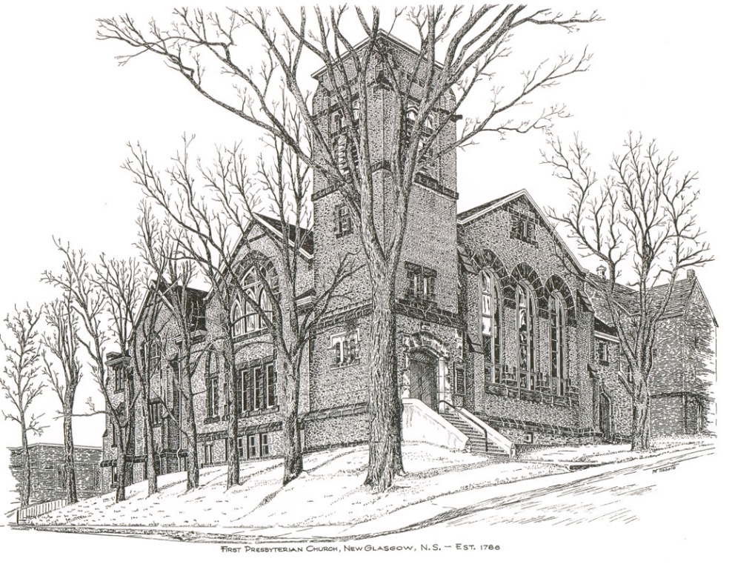

FIRST PRESBYTERIAN CHURCH
208 MacLean St., New Glasgow, NS
902-752-5691
First.church@ns.aliantzinc.ca
Reverend Andrew MacDonald
902-331-0322
yick96@hotmail.com

June 29^{th,}, 2025
Third Sunday after Pentecost &
Communion Sunday

THE APPROACH

**Please rise**
Musical Prelude
Welcome and Announcements
One: Let us now prepare our hearts to worship almighty God.
**Entry of the Bible: Please rise
**Lighting the Christ Candle: Please rise
Introit –
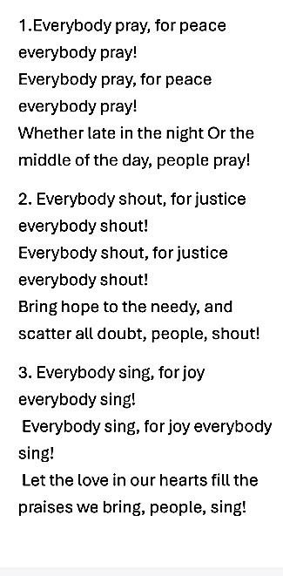
**Call to Worship
**Hymn #436 - “God we praise you for the morning” vs.1-4

1 God, we praise you for the morning;
hope springs forth with each new day,
new beginning, prayer and promise,
joy in work and in play.

2 God, we praise you for creation,
mountains, seas and prairie land.
Waking souls find joy and healing
in your bountiful hand.

3 God, we praise you for compassion,
all the loving that you show;
human touching, tears and laughter,
help your children to grow.

4 God, we praise you for your Spirit,
Comforter and daily friend;
restless searcher, gentle teacher,
strength and courage you send.

Prayer of Adoration and Confession

Our Father which art in heaven, Hallowed be thy name.

Thy kingdom come, thy will be done in earth,

as it is in heaven.

Give us this day our daily bread.

And forgive us our debts, as we forgive our debtors.

And lead us not into temptation, but deliver us from evil:

For thine is the kingdom, and the power, and the glory,

forever. Amen.
Assurance of Pardon
Passing the Peace
**Hymn #634 - “Will you come and follow me” vs.1-3,5
1 Will you come and follow me
if I but call your name?
Will you go where you don’t know
and never be the same?
Will you let my love be shown;
will you let my name be known;
will you let my life be grown
in you and you in me?

2 Will you leave yourself behind
if I but call your name?
Will you care for cruel and kind
and never be the same?
Will you risk the hostile stare
should your life attract or scare?
Will you let me answer prayer
in you and you in me?

3 Will you let the blinded see
if I but call your name?
Will you set the prisoner free
and never be the same?
Will you kiss the leper clean,
and do such as this unseen,
and admit to what I mean
in you and you in me?

5 Lord, your summons echoes true
when you but call my name.
Let me turn and follow you
and never be the same.
In your company I’ll go
where your love and footsteps show.
Thus I’ll move and live and grow
in you and you in me.

Children’s Time
Prayer of Illumination
First Lesson: 2 Kings 2:1-2, 6-14 - p.272
Epistle Lesson: Galatians 5:1, 13-25 - p.888
Responsive Psalm 16

ONE: Protect me, O God, for in you I take refuge. I say to the Lord, ‘You are my Lord; I have no good apart from you.’
ALL: As for the holy ones in the land, they are the noble, in whom is all my delight.

ONE: Those who choose another god multiply their sorrows; their drink-offerings of blood I will not pour out or take their names upon my lips.
ALL: The Lord is my chosen portion and my cup;
you hold my lot. The boundary lines have fallen for me in pleasant places; I have a goodly heritage.
ONE: I bless the Lord who gives me counsel; in the night also my heart instructs me.
ALL: I keep the Lord always before me; because he is at my right hand, I shall not be moved.
ONE: Therefore my heart is glad, and my soul rejoices; my body also rests secure. For you do not give me up to Sheol, or let your faithful one see the Pit.
ALL: You show me the path of life. In your presence there is fullness of joy; in your right hand are pleasures for evermore.
**Gloria Patri
Glory be to the Father,
and to the Son, and to the Holy Ghost;
as it was in the beginning,
is now, and ever shall be, world without end.
Amen, amen.
Gospel Lesson: Luke 9:51-62 – p.792
Anthem –
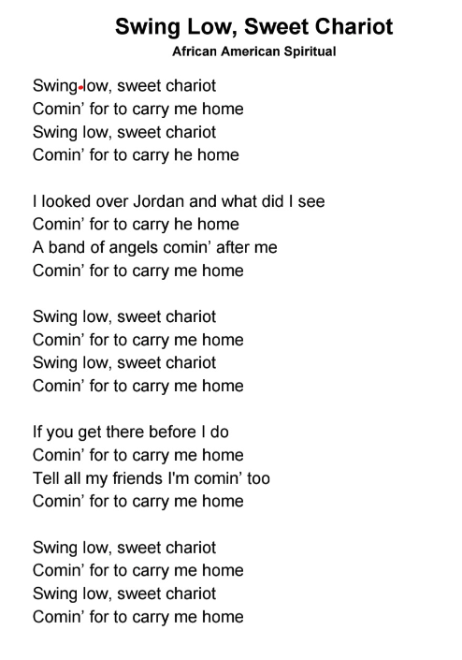
Sermon: "Don't look back!"
Offertory
**Doxology
Praise God from whom all blessings Flow. Praise Him all creatures here below. Praise Him above Ye Heavenly Host. Praise Father, Son, and Holy Ghost. Amen.

Offertory Prayer
**Hymn: #767– “Lord, speak to me” vs.1,3,5
1 Lord, speak to me, that I may speak
in living echoes of your tone;
as you have sought, so let me seek
your erring children lost and lone.

2 Oh lead me, Lord, that I may lead
the wandering and the wavering feet;
oh feed me, Lord, that I may feed
your hungering ones with manna sweet.

3 Oh teach me, Lord, that I may teach
the precious truths that you impart,
and wing my words, that they may reach
the hidden depths of many a heart.

5 Oh use me, Lord, use even me
just as you will, and when, and where,
until at last your face I see,
your rest, your joy, your glory share.

HOLY COMMUNION

Invitation to the Lord’s Supper
The Invitation
Communion Hymn #563-
“Let us talents and tongues employ” vs. 1-2

Let us talents and tongues employ,
reaching out with a shout of joy:
bread is broken, the wine is poured,
Christ is spoken and seen and heard.
Jesus lives again; earth can breathe again.
Pass the Word around: loaves abound!
Christ is able to make us one,
at his table he set the tone,
teaching people to live to bless,
love in word and in deed express.
Jesus lives again; earth can breathe again.
Pass the Word around: loaves abound!
Affirmation of Faith - Apostle’s Creed

I believe in God, the Father Almighty, maker of Heaven and earth; and in Jesus Christ, His only Son, Our Lord, who was conceived by the Holy Ghost, born of the Virgin Mary,
suffered under Pontius Pilate, was crucified, died, and was buried. He descended into Hell. On the third day He arose again from the dead; He ascended into Heaven, and sits
at the right hand of God, the Father Almighty; from thence He shall come to judge the quick and the dead.
I believe in the Holy Ghost, the holy Catholic Church,
the communion of saints, the forgiveness of sins, the resurrection of the body, and the life everlasting. Amen.

Great Prayer of Thanksgiving: BoP #564

The Lord be with you.
And also with you.
Lift up you hearts.
We lift them up to the Lord.
Let us give thanks to the Lord our God.
It is right to give God thanks and praise.

Prayer ending with
. . . we join with the whole creation
to lift our hearts in joyful praise.

Holy, Holy, Holy Lord,
God of power and might,
heaven and earth are full of your glory.
Hosanna in the highest.

Blessed is he who comes
in the name of the Lord.
Hosanna in the highest.

Prayer ending with
. . . proclaim the mystery of the faith

Christ has died.
Christ is risen.
Christ will come again.

Prayer ending with … and the people say

Amen.

The Sacrament of Holy Communion
Communion Hymn #563-
“Let us talents and tongues employ” vs. 3

Jesus calls us in, sends us out
bearing fruit in a world of doubt,
gives us love to tell, bread to share:
God (Immanuel) everywhere!
Jesus lives again; earth can breathe again.
Pass the Word around: loaves abound!
**Benediction - Go Now in Peace (Don Besig)
Go now in peace Never be afraid
God will go with you each hour of every day

Go now in faith Steadfast, strong, and true.
Know He will guide you in all you do.

Go now in love, And show you believe
Reach out to others So all the world can see.

God will be there Watching from above
Go now in peace, In faith, and in love
Amen, amen, amen.
Recessional
ANNOUNCEMENTS

All are welcome at First Presbyterian Church. We hope you experience the love of God and of this congregation as we worship, celebrate, and serve one another.

PASTORAL CARE: In order to provide support to the people of First Church, when you or a loved one is sick or in hospital, we encourage you to contact the church (902-752-5691), Reverend Andrew (902-331-0322) or Cathy Lewis, Chair of the Pastoral Care Team (902-759-9649), to inform us directly. It is also important that you inform the hospital that you would welcome a visit from your minister and/or your Elder.
UPCOMING FIRST CHURCH EVENTS
The church will be closed for the month of July for vacation. Sunday services will resume Sunday, August 3rd.

Reminder – Please spread the word about our new service - “Downtown Ministries - A Contemporary Service of Prayer, Meditation, Fellowship and Music”, every Sunday at 6:00p.m.

SCRIPTURE READERS & USHERS:
Reader: Jennifer Thibeau
Ushers: Main Door (Office) – Ian Semple
James St. – Ruth-Anne MacIntosh
MacLean St. (Main Entrance steps) – Ellen Jardine
EARLY CHRISTIAN EDUCATORS: Lynne Ann & Lois MacLellan

