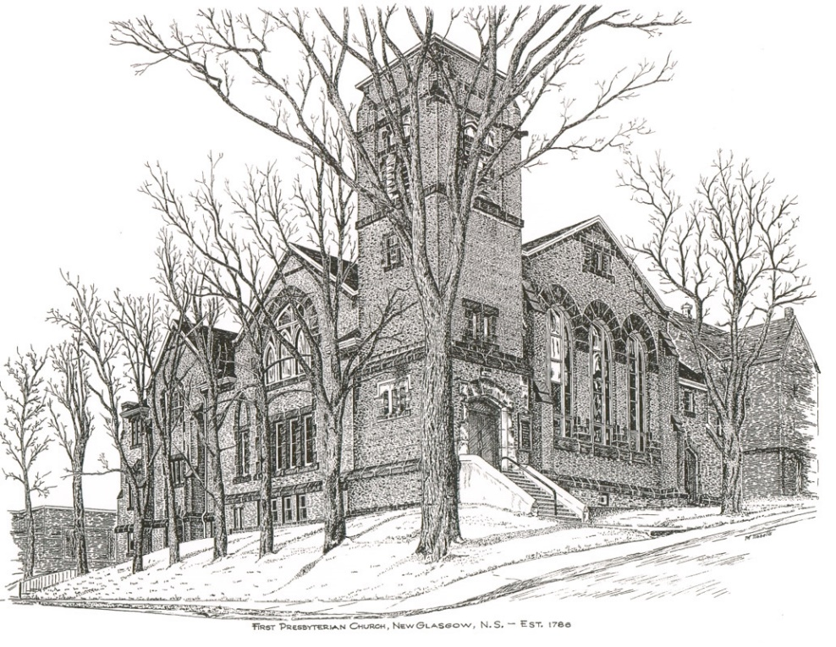

FIRST PRESBYTERIAN CHURCH
208 MacLean St., New Glasgow, NS
902-752-5691
First.church@ns.aliantzinc.ca
Reverend Andrew MacDonald
902-331-0322
yick96@hotmail.com

September 14th, 2025
14th Sunday after Pentecost
239th Anniversary Service &
Communion Sunday

THE APPROACH

**Please rise**
Musical Prelude – The Alcorn Family – “Fishers of Men” by George Durning
Welcome and Announcements
One: Let us now prepare our hearts to worship almighty God.
**Entry of the Bible: Please rise
**Lighting the Christ Candle: Please rise
Introit – It’s A Great Church

It’s a great church where God is alive
It’s a great church where God is alive
It’s a great church where God is alive
Hallelujah! Hallelujah!

It’s a great day our God is alive.
It’s a great day our God is alive.
It’s a great day our God is alive.
Hallelujah! Hallelujah!

**Call to Worship
**Hymn #774 – “God forgave my sin/Freely, freely”
1 God forgave my sin in Jesus’ name,
I’ve been born again in Jesus’ name,
and in Jesus’ name I come to you
to share his love as he told me to.

Chorus He said:
Freely, freely, you have received;
freely, freely give.
Go in my name and because you believe
Others will know that I live.

2 All power is given in Jesus’ name,
in earth and heaven in Jesus’ name,
and in Jesus’ name I come to you,
to share his power as he told me to.

Prayer of Adoration and Confession – Rev. Andrew

Our Father which art in heaven, Hallowed be thy name.

Thy kingdom come, thy will be done in earth,

as it is in heaven.

Give us this day our daily bread.

And forgive us our debts, as we forgive our debtors.

And lead us not into temptation, but deliver us from evil:

For thine is the kingdom, and the power, and the glory,

forever. Amen.

Passing the Peace
**Hymn #765 - “We’ve a story to tell the nations”
1 We've a story to tell to the nations,
that shall turn their hearts to the right,
a story of truth and mercy,
a story of peace and light,
a story of peace and light.
Refrain:
For the darkness shall turn to dawning,
and the dawning to noonday bright,
and Christ's great kingdom shall come on earth,
the kingdom of love and light.
2 We've a song to be sung to the nations,
that shall lift their hearts to the Lord,
a song that shall conquer evil,
and shatter the spear and sword,
and shatter the spear and sword. [Refrain]
3 We've a message to give to the nations,
that the Lord who reigneth above
has sent us His Son to save us,
and show us that God is love,
and show us that God is love. [Refrain]
4 We've a Savior to show to the nations,
who the path of sorrow has trod,
that all of the world's great peoples
may come to the truth of God,
may come to the truth of God! [Refrain]

Children’s Time
Prayer of Illumination
First Lesson: Psalm 133
Epistle Lesson: Philippians 2:1-11
**Gloria Patri
Glory be to the Father
and to the Son, and to the Holy Ghost!
As it was in the beginning is now and ever shall be.
World without end. Amen, amen.

Gospel Lesson: John 17:1,10-11,15-25
Anthem – Jodie Miller - “Let there be peace on earth” by Sy Miller & Jill Jackson
Sermon- Rev. Dr. Joon Ki Kim
**Hymn: #34 – “God be merciful to me” Tune 676
1. God be merciful to me;
on thy grace I rest my plea.
Plenteous in compassion thou,
blot out my transgressions now;
my transgressions I confess;
grief and guilt my soul oppress;
I have sinned against thy grace
and provoked thee to thy face.
2. Wash me, wash me pure within;
cleanse, oh cleanse me from my sin;
I confess thy judgements just;
speechless, I thy mercy trust.
Thou alone my Saviour art;
teach thy wisdom to my heart;
make me pure, thy grace bestow;
make me thus thy mercy know.
3. Gracious God, my heart renew,
make my spirit right and true;
from my sins oh hide thy face,
blot them out in boundless grace.
Cast me not away from thee:
let thy Spirit dwell in me;
thy salvation's joy impart;
steadfast make my willing heart.
Offertory
**Doxology #79
Praise God from whom all blessings Flow. Praise Him all creatures here below. Praise Him above Ye Heavenly Host. Praise Father, Son, and Holy Ghost. Amen.

Offertory Prayer
HOLY COMMUNION

Invitation to the Lord’s Supper
The Invitation
Communion Hymn #543- “O my Lord, I see thee” vs. 1-3

1 Here, O my Lord, I see thee face to face;
here would I touch and handle things unseen,
here grasp with firmer hand eternal grace,
and all my weariness upon thee lean.

2 Here would we feed upon the bread of God,
here drink with thee the royal wine of heaven;
here would we lay aside each earthly load,
here taste afresh the calm of sin forgiven.

3 This is the hour of banquet and of song;
this is the heavenly table for us spread;
here let us feast, and, feasting, still prolong
this fellowship in thee, our living bread.

Affirmation of Faith - Apostle’s Creed

I believe in God, the Father Almighty, maker of Heaven and earth; and in Jesus Christ, His only Son, Our Lord, who was conceived by the Holy Ghost, born of the Virgin Mary,
suffered under Pontius Pilate, was crucified, died, and was buried. He descended into Hell. On the third day He arose again from the dead; He ascended into Heaven, and sits
at the right hand of God, the Father Almighty; from thence He shall come to judge the quick and the dead.
I believe in the Holy Ghost, the holy Catholic Church,
the communion of saints, the forgiveness of sins, the resurrection of the body, and the life everlasting. Amen.

Great Prayer of Thanksgiving: BoP #564

The Lord be with you.
And also with you.
Lift up you hearts.
We lift them up to the Lord.
Let us give thanks to the Lord our God.
It is right to give God thanks and praise.

Prayer ending with
. . . we join with the whole creation
to lift our hearts in joyful praise.

Holy, Holy, Holy Lord,
God of power and might,
heaven and earth are full of your glory.
Hosanna in the highest.

Blessed is he who comes
in the name of the Lord.
Hosanna in the highest.

Prayer ending with
. . . proclaim the mystery of the faith

Christ has died.
Christ is risen.
Christ will come again.

Prayer ending with … and the people say

Amen.
The Sacrament of Holy Communion
Communion Hymn #543- “O my Lord, I see thee” vs. 4,5

4 Too soon we rise; the symbols disappear.
The feast, though not the love, is past and gone;
the bread and wine remove, but thou art here,
nearer than ever, still our shield and sun.

5 We have no help but thine, nor do we need
another arm but thine to lean upon;
it is enough, O Lord, enough indeed;
our strength is in thy might, thy might alone.

**Benediction - Go Now in Peace (Don Besig)
Go now in peace Never be afraid
God will go with you each hour of every day

Go now in faith Steadfast, strong, and true.
Know He will guide you in all you do.

Go now in love, And show you believe
Reach out to others So all the world can see.

God will be there Watching from above
Go now in peace, In faith, and in love
Amen, amen, amen.
Recessional
Postlude – Andrew Alcorn - “Allegro” by Thomas Albinoni
ANNOUNCEMENTS

All are welcome at First Presbyterian Church. We hope you experience the love of God and of this congregation as we worship, celebrate, and serve one another.

PASTORAL CARE: In order to provide support to the people of First Church, when you or a loved one is sick or in hospital, we encourage you to contact the church (902-752-5691), Reverend Andrew (902-331-0322) or Cathy Lewis, Chair of the Pastoral Care Team (902-759-9649), to inform us directly. It is also important that you inform the hospital that you would welcome a visit from your minister and/or your Elder.

Today, we extend our love and sincere sympathies to the family and friends of Russell MacIntosh. A longtime member and elder of First Church, Russell took on many roles and was relied on for his wisdom, guidance and mentorship. He was a true gentleman and will be greatly missed by all of us.

UPCOMING FIRST CHURCH EVENTS
- There are no meetings scheduled this week.
- Reminder – Please spread the word about our Sunday evening service - “Downtown Ministries - A Contemporary Service of Prayer, Meditation, Fellowship and Music”. These services take place every Sunday at 6:00p.m., everyone welcome!
- Sign Restoration Project – We have reached our goal for the restoration of the church sign; to date we have raised $910.00. Thank you very much for your support of this project!

EVENTS YOU MAY BE INTERESTED IN…

Today, 3 p.m. – Please plan to attend the 167th anniversary service of Middle River Church, 59 E Fraser Crossroad, Rocklin. Music will be provided by Hannah’s Boys and James and Samuel Lawrence. Refreshments will be served following the service.

Fri., Sept. 19-21st – AMS General Society Annual Meeting – If you plan to attend the meetings, including the banquet, please register with Shirley Forbes, the Registrar, by Sept. 1st. The registration form is located on the back cover of the May/June “Message”.

Tues., Sept. 23rd, 9-12:00p.m. – First Church will host a special meeting and workshop of the Pictou Presbytery, entitled “Narratives of Hope and Possibility” led by the Rev. Dr. Patricia Dutcher-Walls, Moderator of the 2024 General Assembly of the Presbyterian Church in Canada. For more information contact Rev. Andrew.


Happy Birthday!!

Today we wish Clarice Campbell a very Happy Birthday! Clarice will celebrate her birthday Tues., Sept. 16th.

SCRIPTURE READERS & USHERS:

Reader: Sharon Mason
Ushers: Main Door (Office) – Sandra Arthur
James St. – Ruth-Anne MacIntosh
MacLean St. (Main Entrance steps) – Ellen Jardine
EARLY CHRISTIAN EDUCATORS: Lynne Ann & Lois MacLellan

NOTICE – PLEASE ENSURE ALL NOTICES FOR THE BULLETIN ARE SUBMITTED TO THE OFFICE BY WEDNESDAY EVENINGS.

