September 7th, 2025
Thirteenth Sunday after Pentecost

THE APPROACH

**Please rise**
Musical Prelude
Welcome and Announcements
One: Let us now prepare our hearts to worship almighty God.
**Entry of the Bible: Please rise
**Lighting the Christ Candle: Please rise
Introit:
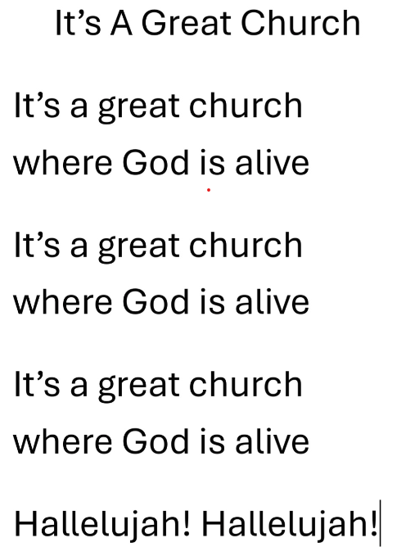
**Call to Worship
**Hymn #634 – “Will you call and follow me” vs.1,2,4,5
1 Will you come and follow me
if I but call your name?
Will you go where you don’t know
and never be the same?
Will you let my love be shown;
will you let my name be known;
will you let my life be grown
in you and you in me?

2 Will you leave yourself behind
if I but call your name?
Will you care for cruel and kind
and never be the same?
Will you risk the hostile stare
should your life attract or scare?
Will you let me answer prayer
in you and you in me?

3 Will you let the blinded see
if I but call your name?
Will you set the prisoner free
and never be the same?
Will you kiss the leper clean,
and do such as this unseen,
and admit to what I mean
in you and you in me?

4 Will you love the “you” you hide
if I but call your name?
Will you quell the fear inside
and never be the same?
Will you use the faith you’ve found
to reshape the world around,
through my sight and touch and sound
in you and you in me?

5 Lord, your summons echoes true
when you but call my name.
Let me turn and follow you
and never be the same.
In your company I’ll go
where your love and footsteps show.
Thus I’ll move and live and grow
in you and you in me.

Prayer of Adoration and Confession

Our Father which art in heaven, Hallowed be thy name.

Thy kingdom come, thy will be done in earth,

as it is in heaven.

Give us this day our daily bread.

And forgive us our debts, as we forgive our debtors.

And lead us not into temptation, but deliver us from evil:

For thine is the kingdom, and the power, and the glory,

forever. Amen.

Assurance of Pardon
Passing the Peace
**Childrens’ Hymn - #449-“Lord, listen to your children praying” X2
Lord, listen to your children praying;
Lord, send your spirit in this place;
Lord, listen to your children praying,
Send us love; send us power; send us grace!

Children’s Time
Prayer of Illumination
First Lesson: Deuteronomy 30:15-20 – p. 153
Epistle Lesson: Philemon 1-21 – p. 909
Responsive Psalm 1
ONE: Happy are those who do not follow the advice of the wicked, or take the path that sinners tread, or sit in the seat of scoffers;
but their delight is in the law of the Lord, and on his law they meditate day and night.
ALL: They are like trees planted by streams of water, which yield their fruit in its season, and their leaves do not wither.
In all that they do, they prosper.
ONE: The wicked are not so, but are like chaff that the wind drives away. Therefore the wicked will not stand in the judgement.
ALL: Nor sinners in the congregation of the righteous; for the Lord watches over the way of the righteous, but the way of the wicked will perish.
**Gloria Patri
Glory be to the Father,
and to the Son, and to the Holy Ghost;
as it was in the beginning,
is now, and ever shall be, world without end.
Amen, amen.

Gospel Lesson: Luke 14 25-33 – p. 798
Anthem – “My love colours outside the lines”
Sermon: "Blessings and Curses!"
**Reaffirmation of Faith (Apostles Creed)

I believe in God, the Father Almighty, maker of Heaven and earth; and in Jesus Christ, His only Son, Our Lord, who was conceived by the Holy Ghost, born of the Virgin Mary,
suffered under Pontius Pilate, was crucified, died, and was buried. He descended into Hell. On the third day He arose again from the dead; He ascended into Heaven, and sits
at the right hand of God, the Father Almighty; from thence He shall come to judge the quick and the dead.
I believe in the Holy Ghost, the holy Catholic Church,
the communion of saints, the forgiveness of sins, the resurrection of the body, and the life everlasting. Amen.

**Hymn #101-“You are before me, Lord” vs.1,3,5 – Tune 794

- You are before me, Lord, You are behind.
And over me You have spread out Your hand;
Such knowledge is too wonderful for me,
Too high to grasp, to great to understand.

- Then from Your Spirit where, Lord, shall I go;
And from Your presence where, Lord, shall I fly?
If I ascend to heaven You are there,
and still are with me if in hell I lie.

- If I should take my flight into the dawn,
If I should dwell on ocean's farthest shore,
Your mighty hand will rest upon me still,
And Your right hand will guard me evermore.

- If I should say, "Let darkness cover me,
And I shall hide within the veil of night,"
Surely the darkness is not dark to You;
The night is as the day, the darkness light.

- Search me, O God, search me and know my heart;
Try me, O God, my mind and spirit try;
Keep me from any path that gives You pain,
And lead me in the everlasting way.

Offertory
Offertory Prayer
Prayers of the People: The People Respond
ONE: Fill our lives with what matters, O God
ALL: Fill our lives with you.

**Doxology
Praise God from whom all blessings Flow. Praise Him all creatures here below. Praise Him above Ye Heavenly Host. Praise Father, Son, and Holy Ghost. Amen.

**Hymn - #645 – “Follow me, the Master said”
1 Follow me, the Master said:
we will follow Jesus.
By his word and Spirit led,
we will follow Jesus.
Still for us he lives to plead,
at the throne will intercede,
offers help in time of need;
we will follow Jesus.

2. Should the world and sin oppose,
we will follow Jesus.
He is greater than our foes;
we will follow Jesus.
On his promise we depend;
he will hear us and defend,
help and keep us to the end;
we will follow Jesus.

3. Though the way may dark appear,
we will follow Jesus.
He will make our pathway clear;
we will follow Jesus.
In our daily round of care,
as we plead with God in prayer,
with the cross which we must bear,
we will follow Jesus.

4. Ever keep the end in view;
we will follow Jesus.
All his promises are true;
we will follow Jesus.
When this earthly course is run,
and the Master says, Well done!
life eternal we have won;
we will follow Jesus.

**Benediction - Go Now in Peace (Don Besig)
Go now in peace Never be afraid
God will go with you each hour of every day

Go now in faith Steadfast, strong, and true.
Know He will guide you in all you do.

Go now in love, and show you believe
Reach out to others So all the world can see.

God will be there Watching from above
Go now in peace, In faith, and in love
Amen, amen, amen.
Recessional

ANNOUNCEMENTS

All are welcome at First Presbyterian Church. We hope you experience the love of God and of this congregation as we worship, celebrate, and serve one another.

PASTORAL CARE: In order to provide support to the people of First Church, when you or a loved one is sick or in hospital, we encourage you to contact the church (902-752-5691), Reverend Andrew (902-331-0322) or Cathy Lewis, Chair of the Pastoral Care Team (902-759-9649), to inform us directly. It is also important that you inform the hospital that you would welcome a visit from your minister and/or your Elder.
UPCOMING FIRST CHURCH EVENTS
- Today, 2:30 p.m. – We will worship with the residents of Ivy’s Terrace. Everyone welcome!
- Mon., Sept. 8th – 6:30p.m. – The Board of Managers will meet.
- Tues., Sept. 9th – 6:30p.m. – Session will meet.
- Sun., Sept. 14th – We will celebrate the 239th anniversary of our church, including Holy Communion. Coffee/tea and cake will be served following the service.

Sign Restoration Project – We have reached our goal for the restoration of the church sign; to date we have raised $810.00. Thank you very much for your support of this project!
Reminder – Please spread the word about our Sunday evening service - “Downtown Ministries - A Contemporary Service of Prayer, Meditation, Fellowship and Music”. These services will resume in September, every Sunday at 6:00p.m.

EVENTS YOU MAY BE INTERESTED IN…

Sat., Sept. 13th - 2-4p.m. - We are co-hosting a tea with the Town of New Glasgow, celebrating the Town’s 150th anniversary. The tea will take place here at First Presbyterian Church. We hope you will join us and if possible, we’re asking for donations of sandwiches and sweets.
Sun., Sept. 14th, 3p.m. – Please plan to attend the 167th anniversary service of Middle River Church, 59 E Fraser Crossroad, Rocklin. Music will be provided by Hannah’s Boys and James and Samuel Lawrence. Refreshments will be served following the service.

Fri., Sept. 19-21st – AMS General Society Annual Meeting – If you plan to attend the meetings, including the banquet, please register with Shirley Forbes, the Registrar, by Sept. 1st. The registration form is located on the back cover of the May/June “Message”.



Today we send belated birthday wishes to Barrie Fraser. Barrie celebrated his birthday Wed., Sept. 3rd. We also send birthday wishes to Laura Mcumber who will celebrate her birthday tomorrow, Sept. 8th. Last but not least, we extend our best wishes to Judy Marshall. Judy will celebrate her birthday Sat., Sept. 13th. Best wishes to all of you!!

SCRIPTURE READERS & USHERS:

Reader: Kevin Reid
Ushers: Main Door (Office) – Sandra Arthur
James St. – Ruth-Anne MacIntosh
MacLean St. (Main Entrance steps) – Ellen Jardine
EARLY CHRISTIAN EDUCATORS: Lynne Ann & Lois MacLellan

