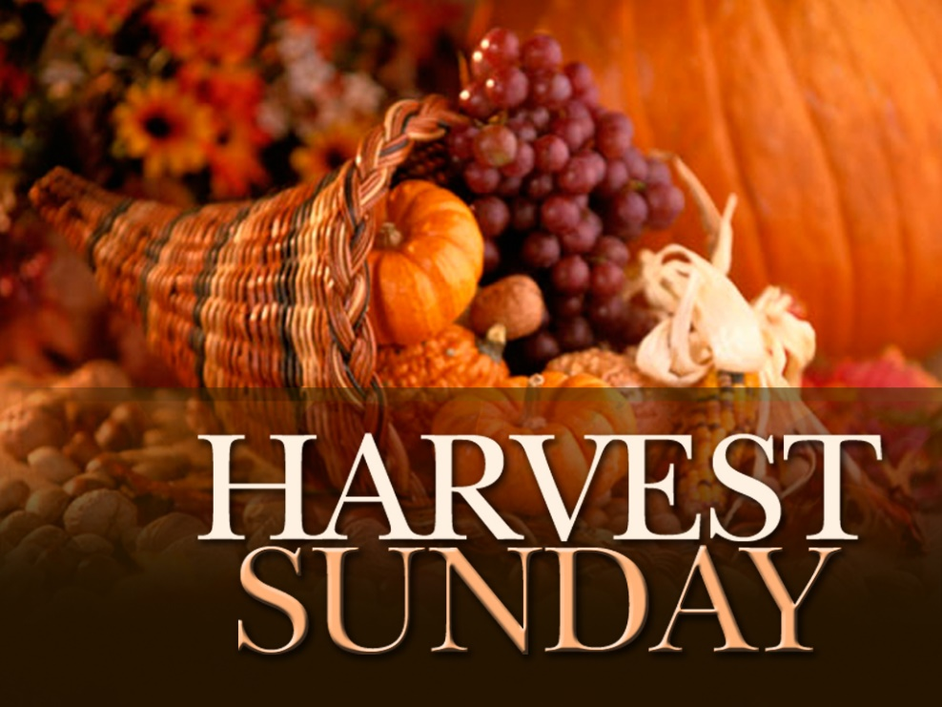

FIRST PRESBYTERIAN CHURCH
208 MacLean St., New Glasgow, NS
902-752-5691
First.church@ns.aliantzinc.ca
Reverend Andrew MacDonald
902-331-0322
yick96@hotmail.com

October 12th, 2025
Eighteenth Sunday after Pentecost
Harvest Sunday

THE APPROACH

**Please rise**
Musical Prelude
Welcome and Announcements
One: Let us now prepare our hearts to worship almighty God.
**Entry of the Bible: Please rise
**Lighting the Christ Candle: Please rise
Introit – Hymn #449 – “Lord, listen to your children praying” x2
Lord, listen to your children praying;
Lord, send your spirit in this place;
Lord, listen to your children praying,
Send us love; send us power; send us grace!
**Call to Worship
**Hymn #799 – “God is here! as we your people meet”vs.1-3

1 God is here! As we your people
meet to offer praise and prayer,
may we find in fuller measure
what it is in Christ we share.
Here, as in the world around us,
all our varied skills and arts
wait the coming of the Spirit
into open minds and hearts.

2 Here are symbols to remind us
of our life-long need of grace;
here are table, font and pulpit,
here the cross has central place.
Here in honesty of preaching,
here in silence, as in speech,
here, in newness and renewal,
God the Spirit comes to each.

3 Here our children find a welcome
in the Shepherd’s flock and fold;
here, as bread and wine are taken,
Christ sustains us as of old.
Here the servants of the Servant
seek in worship to explore
what it means in daily living
to believe and do adore.

Prayer of Adoration and Confession

Our Father which art in heaven, Hallowed be thy name.

Thy kingdom come, thy will be done in earth,

as it is in heaven.

Give us this day our daily bread.

And forgive us our debts, as we forgive our debtors.

And lead us not into temptation, but deliver us from evil:

For thine is the kingdom, and the power, and the glory,

forever. Amen.

Assurance of Pardon
Passing the Peace
**Children’s Hymn - #428 -“We love your house, O God” vs.1,2,4,5
- We love your house, O God,
the place where honour dwells;
the joy of your abode
all earthly joy excels.

- We love the house of prayer,
where you your servants greet,
for you, O Lord, are there,
and with your chosen meet.

4. We love to sing below
of mercies freely given,
but how we long to know
the triumph song of heaven.

5. Lord Jesus, give us grace
on earth to love you more,
in heaven to see your face,
and with your saints adore.

Children’s Time
Prayer of Illumination
First Lesson: Deuteronomy 26:1-11 p. 149
Epistle Lesson: Philippians 4:4-9 - p. 895
Responsive Psalm –Psalm 100
ONE: Make a joyful noise to the Lord, all the earth. Worship the Lord with gladness; come into his presence with singing.
ALL: Know that the Lord is God. It is he that made us, and we are his; we are his people, and the sheep of his pasture.
ONE: Enter his gates with thanksgiving, and his courts with praise. Give thanks to him, bless his name.
ALL: For the Lord is good; his steadfast love endures for ever, and his faithfulness to all generations.

**Gloria Patri
Glory be to the Father,
and to the Son, and to the Holy Ghost;
as it was in the beginning,
is now, and ever shall be, world without end.
Amen, amen.

Gospel Lesson: John 6:25-35 – p. 815
Anthem – “Like a Shepherd”
Sermon: "Giving thanks!"
**Reaffirmation of Faith (Apostles Creed)

I believe in God, the Father Almighty, maker of Heaven and earth; and in Jesus Christ, His only Son, Our Lord, who was conceived by the Holy Ghost, born of the Virgin Mary,
suffered under Pontius Pilate, was crucified, died, and was buried. He descended into Hell. On the third day He arose again from the dead; He ascended into Heaven, and sits
at the right hand of God, the Father Almighty; from thence He shall come to judge the quick and the dead.
I believe in the Holy Ghost, the holy Catholic Church,
the communion of saints, the forgiveness of sins, the resurrection of the body, and the life everlasting. Amen.

**Hymn #393 - “I’m not ashamed to own my Lord”
Tune 351
- I’m not ashamed to own my Lord,
or to defend his cause,
maintain the glory of his cross,
and honour all his laws.

- Jesus, my Lord! I know his name;
his name is all my boast;
nor will he put my soul to shame,
nor let my hope be lost.

- I know that safe with him remains,
protected by his power,
what I’ve committed to his trust
till the decisive hour.

- Then will he own his servant’s name
before his Father’s face,
and in the new Jerusalem
appoint my soul a place.

Offertory
Offertory Prayer
Prayers of the People: The People Respond
ONE: God of all goodness
ALL: Receive our Prayers

**Doxology
Praise God from whom all blessings Flow. Praise Him all creatures here below. Praise Him above Ye Heavenly Host. Praise Father, Son, and Holy Ghost. Amen.

**Hymn - #761 – “Who’s goin’ to tell the story”
1 Who’s goin’ to tell the story? You and I!
Tell of the Lord’s great glory? You and I!
Who’s goin’ to let the whole world know?
Help his disciples grow and multiply? You and I!

2 Who’s goin’ to bring the kingdom? You and I!
Who’s goin’ to spread the gospel? You and I!
Who’s goin’ to do the kindly deed?
Comfort the one in need and help supply? You and I!

3 Jesus came to bring us good news,
sent to earth by God above!
And the good news that he brought us
is the word of love!

4 Who’s goin’ to feed the hungry? You and I!
Care for the sick and lonely? You and I!
Who’s goin’ to let the whole world see
people can live in harmony? Let’s try! You and I!

**Benediction - Go Now in Peace (Don Besig)
Go now in peace Never be afraid
God will go with you each hour of every day

Go now in faith Steadfast, strong, and true.
Know He will guide you in all you do.

Go now in love, and show you believe
Reach out to others So all the world can see.

God will be there Watching from above
Go now in peace, In faith, and in love
Amen, amen, amen.
Recessional

ANNOUNCEMENTS

All are welcome at First Presbyterian Church. We hope you experience the love of God and of this congregation as we worship, celebrate, and serve one another.

PASTORAL CARE: In order to provide support to the people of First Church, when you or a loved one is sick or in hospital, we encourage you to contact the church office (902-752-5691) or Reverend Andrew (902-331-0322) to inform us. It is also important that you inform the hospital that you would welcome a visit from your minister and/or your Elder.
MEMORIAL DONATIONS
A memorial donation has been received in loving memory of Russell MacIntosh from Keith & Jane MacDonald.
CONDOLENCES

Our sincere condolences are sent to Cathy Lewis and her family on the loss of their beloved Mom, and valued member of First Church, Margie Fraser.

UPCOMING FIRST CHURCH EVENTS
Tues., Oct. 14th – 6:30p.m. – Session will meet.
Tonight - “Downtown Ministries - A Contemporary Service of Prayer, Meditation, Fellowship and Music”, we meet every Sunday at 6:00p.m., everyone welcome.

Sun., Oct. 19th – 11:15 a.m. – We will be worshipping with the Congregation of St. Andrew’s Presbyterian, “the Kirk”, as they hold their Anniversary Service.

Tues., Nov. 4th – 7:00 p.m. – We are hosting our 4th Annual Musical Variety Show. Free will offering, proceeds to the Church General Fund. Light lunch and time of fellowship to follow. Performers include: Community Mixed Chorus with Brenda Bowden, Justin & Keith, Eric MacNeil, Pam LeBlanc, Rev. Andrew, The Alcorn and others to be announced. . Please join us for an evening of great music and fellowship!

EVENTS YOU MAY BE INTERESTED IN…

Sat., Oct. 18, 9a.m.-1p.m. - Fall Craft Sale, at Bethel Church Hall, Pictou Landing. Everyone welcome.

Sun., Oct. 19th – 7:00 p.m. – Little Harbour Presbyterian Church is hosting Glen Soderholm in Concert. Please join us for an evening of inspirational music!

UPDATE - AN INTRODUCTION TO THE BIBLE: A Ten Session Study on the Gospel of Matthew at St. Andrew’s Presbyterian Church, New Glasgow (The Kirk) is ongoing, either Friday mornings, 10:00-11:30 a.m., or Friday afternoons 2:00-3:30 p.m. Contact Rev. Grant Johnston: grant.johnston@live.com, or text: (905) 867-1914.

SCRIPTURE READERS & USHERS:
Reader: Mark Thibeau
Ushers: Main Door (Office) – Sara Fullerton
James St. – Brent MacQuarrie
MacLean St. (Main Entrance steps) – Ellen Jardine
Early Christian Educators: Lynne Ann & Lois MacLellan

Mission Statement: But he’s already made it plain how to live, what to do, what God is looking for in men and women. It’s quite simple. Do what is fair and just to your neighbor, be compassionate and loyal in your love, and don’t take yourself too seriously – take God seriously. Micah 6: 8-The Message



