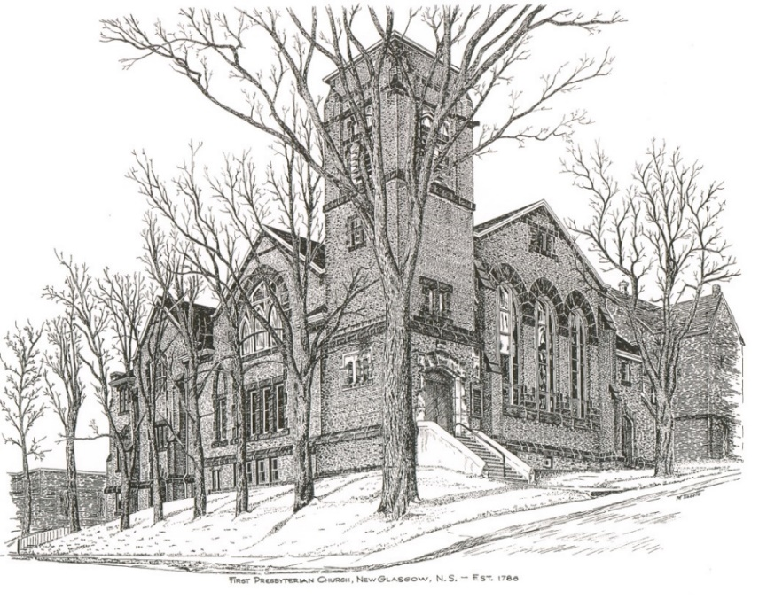

FIRST PRESBYTERIAN CHURCH
208 MacLean St., New Glasgow, NS
902-752-5691
First.church@ns.aliantzinc.ca
Reverend Andrew MacDonald
902-331-0322
yick96@hotmail.com

November 16th, 2025
Twenty-Third Sunday after Pentecost
Legacy Giving Sunday

THE APPROACH

**Please rise**
Musical Prelude
Welcome and Announcements
One: Let us now prepare our hearts to worship almighty God.
**Entry of the Bible: Please rise
**Lighting the Christ Candle: Please rise
Introit – Hymn #446B – “O Lord, hear my prayer (repeat twice)
**Call to Worship
**Hymn #769- “Lord of light, whose name and splendor” vs.1-3 (Tune 699)

1. Lord of light, whose name and splendour
far outshine the suns of space,
deign to make us your coworkers
in the kingdom of your grace;
use us to fulfil your purpose
in the gift of Christ your Son:
Abba, as in highest heaven
so on earth your will be done.
2. By the faithfulness of workers
serving you in every field;
by the courage where the radiance
of the cross is still revealed;
by the victories of meekness,
through reproach and suffering won:
Abba, as in highest heaven
so on earth your will be done.
3. Grant that knowledge, still increasing,
at your feet might humbly kneel;
with your grace our triumphs hallow,
with your charity our zeal;
lift all nations from the shadows
to the gladness of the sun:
Abba, as in highest heaven
so on earth your will be done.
Prayer of Adoration and Confession

Our Father which art in heaven, Hallowed be thy name.

Thy kingdom come, thy will be done in earth,

as it is in heaven.

Give us this day our daily bread.

And forgive us our debts, as we forgive our debtors.

And lead us not into temptation, but deliver us from evil:

For thine is the kingdom, and the power, and the glory,

forever. Amen.
Assurance of Pardon
Passing the Peace
**Children’s Hymn #703 - “Happy the home when God is there”
1 Happy the home when God is there,
and love fills every breast,
where one their wish, and one their prayer,
and one their heavenly rest.

2 Happy the home where Jesus name
is sweet on every ear,
where children early sing his fame,
and parents hold him dear.

3 Happy the home where prayer is heard
and praise is quick to rise,
where parents love the sacred word
that makes the simple wise.

4 Lord, let us in our home agree,
this blessed peace to gain;
unite our hearts in love to thee,
and love to all will reign.

Children’s Time
Prayer of Illumination
First Lesson: Isaiah 65:17-25 - p. 575
Epistle Lesson: 2 Thessalonians 3: 6-13 – p. 902
Responsive Psalm –Psalm 98
ONE: O sing to the Lord a new song, for he has done marvellous things. His right hand and his holy arm have gained him victory.
The Lord has made known his victory; he has revealed his vindication in the sight of the nations.
ALL: He has remembered his steadfast love and faithfulness to the house of Israel.
All the ends of the earth have seen the victory of our God.
ONE: Make a joyful noise to the Lord, all the earth; break forth into joyous song and sing praises. Sing praises to the Lord with the lyre, with the lyre and the sound of melody.
ALL: With trumpets and the sound of the horn make a joyful noise before the King, the Lord.
ONE: Let the sea roar, and all that fills it; the world and those who live in it. Let the floods clap their hands; let the hills sing together for joy at the presence of the Lord, for he is coming to judge the earth.
ALL: He will judge the world with righteousness, and the peoples with equity.

**Gloria Patri
Glory be to the Father,
and to the Son, and to the Holy Spirit;
as it was in the beginning,
is now, and will be, forever.
Amen, amen, amen.

Gospel Lesson: Luke 21:5-19 – p. 804
Anthem – “I’m goin up a yonder”
Sermon: "Former things shall not be remembered"
**Reaffirmation of Faith (Apostles Creed)

I believe in God, the Father Almighty, maker of Heaven and earth; and in Jesus Christ, His only Son, Our Lord, who was conceived by the Holy Ghost, born of the Virgin Mary,
suffered under Pontius Pilate, was crucified, died, and was buried. He descended into Hell. On the third day He arose again from the dead; He ascended into Heaven, and sits
at the right hand of God, the Father Almighty; from thence He shall come to judge the quick and the dead.
I believe in the Holy Ghost, the holy Catholic Church,
the communion of saints, the forgiveness of sins, the resurrection of the body, and the life everlasting. Amen.

**Hymn #782 - “Isaiah the prophet has written of old”
1 Isaiah the prophet has written of old
how God's earthly kingdom shall come.
Instead of the thorn tree the fir tree shall grow;
the wolf shall lie down with the lamb.
The mountains and hills shall break forth into song,
the peoples be led forth in peace;
for the earth shall be filled with the knowledge of God
as the waters cover the seas.
2 Yet nations still prey on the meek of the world,
and conflict turns parent from child.
Your people despoil all the sweetness of earth;
the brier and the thorn grow wild.
Lord, hasten to bring in your kingdom on earth,
when no one shall hurt or destroy,
when wisdom and justice shall reign in the land
and your people shall go forth in joy.
Offertory
Doxology
Praise God from whom all blessings Flow.
Praise Him all creatures here below.
Praise Him above Ye Heavenly Host.
Praise Father, Son, and Holy Ghost. Amen.

Offertory Prayer
Prayers of the People
**Hymn - #763 – “To show by touch and word”

- To show by touch and word devotion to the earth,
to hold in full regard all life that comes to birth
we need, O God, the will to find the good you had of old in mind.

- Renew our minds to choose the things that matter most,
our hearts to long for truth till pride-of-self is lost.
For every challenge that we face, we need your guidance and your grace.

- Let love from day to day be yardstick, rule and norm,
and let our lives portray your word in human form.
Now come with us that we may have your wits about us where we live.

**Benediction - Go Now in Peace (Don Besig)
Go now in peace Never be afraid
God will go with you each hour of every day

Go now in faith Steadfast, strong, and true.
Know He will guide you in all you do.

Go now in love, and show you believe
Reach out to others So all the world can see.

God will be there Watching from above
Go now in peace, In faith, and in love
Amen, amen, amen.
Recessional
Mission Statement: But he’s already made it plain how to live, what to do, what God is looking for in men and women. It’s quite simple. Do what is fair and just to your neighbor, be compassionate and loyal in your love, and don’t take yourself too seriously – take God seriously. Micah 6: 8-The Message
ANNOUNCEMENTS

All are welcome at First Presbyterian Church. We hope you experience the love of God and of this congregation as we worship, celebrate, and serve one another.

MEMORIAL & OTHER DONATIONS
A memorial donation has been received in loving memory of Marilyn MacLeod from her sisters Sheila MacMillan, Isabel Bonaparte, Bev Chennell and their families.
A generous donation has been received from the Jardine family for the use of the Lower Hall for Ellen’s 65th birthday celebration. “The show of love and support from Ellen’s church family was heartwarming.”
UPCOMING FIRST CHURCH EVENTS
Today:
- The service scheduled for Glen Haven Manor has been cancelled for today.
- We will have coffee time after service; please join us if you can.
Today – 3:00p.m. – First Presbyterian Church, Stellarton -
Sacred Song Service marking our 100th Anniversary. Music by: Janice and Andrew Alcorn, Amelia Parker, Klarissa Fairnsworth, Randy Gilby and his daughter Cecely Dakin, Sam Graham, Samual and James Lawrence and more. Everyone welcome. Refreshments to follow in Church Hall.

Thurs., Nov. 20th – 6:00p.m. – We will be decorating the church for Christmas. We need all the help we can get so please, join us if you can!
Sun., Nov. 23rd, 12:15 p.m. – The Worship & Music Committee will meet after service.
Sat, Nov. 22nd – 7:00 p.m. – We are hosting our 4th Annual Musical Variety Show. Free will offering; proceeds to the Church General Fund. Light lunch and time of fellowship to follow.

The list of performers has been updated to include: Lloyd MacLean, Alexandria Will, Ray Stewart, Heather Cameron and Kenny Stewart, Community Mixed Chorus with Brenda Bowden, Justin & Keith, Eric MacNeil, Pam LeBlanc, Rev. Andrew, The Alcorn Family. Please join us for an evening of great music and fellowship!

Sun., Nov. 30th – We are bringing back our Advent ‘pre-service’ music and morning refreshments. Starting us off will be Keith & Justin.

Sunday Evenings – 6:00p.m. - “Downtown Ministries - A Contemporary Service of Prayer, Meditation, Fellowship and Music”, meet every Sunday at 6:00p.m., everyone welcome.

EVENTS YOU MAY BE INTERESTED IN…
Request from Sheila Dempster: Local music group looking for someone to play guitar and/or fiddle. We go to the local nursing homes and are out 2, sometimes 3 times per week for approximately 1 hour. If you have the time and are interested, please call Sheila at 902-695-2295.
Sun., Nov. 30th – 2:30p.m. – Celebrate the spirit of Christmas as The Trinitarians present “Let Joy Ring Out”, an afternoon of your favourite Christmas choral pieces. Featuring handbells, violin, flute and vocal solos among others. Free will offering.

SCRIPTURE READERS & USHERS:
Reader: Brent MacQuarrie
Ushers: Main Door (Office) – Jane Williams
James St. – Cathy Lewis
MacLean St. (Main Entrance steps) – Ellen Jardine
EARLY CHRISTIAN EDUCATORS: Lynne Ann & Lois MacLellan

