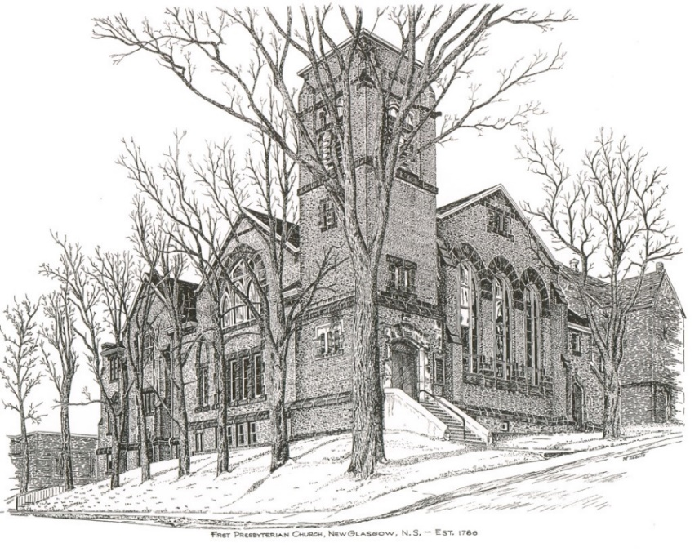

FIRST PRESBYTERIAN CHURCH
208 MacLean St., New Glasgow, NS
902-752-5691
First.church@ns.aliantzinc.ca
Reverend Andrew MacDonald
902-331-0322
yick96@hotmail.com

November 23rd, 2025
Reign of Christ

THE APPROACH

**Please rise**
Musical Prelude
Welcome and Announcements
One: Let us now prepare our hearts to worship almighty God.
**Entry of the Bible: Please rise
**Lighting the Christ Candle: Please rise
Introit – Hymn #446B – “O Lord, hear my prayer (repeat twice)
**Call to Worship
**Hymn #103- “O Lord, Thou art my God and King” vs.1,2,4
1 O Lord, thou art my God and King;
thee will I magnify and praise:
I will thee bless and gladly sing
unto thy holy name always.

2 Thee will I bless each day I rise,
and praise thy name, time without end;
much to be praised and great God is,
whose greatness none can comprehend.

4 Thy might shall be by all extolled;
thy glorious grace I will record;
with all my strength I will unfold
thy great and mighty acts, O Lord.

Prayer of Adoration and Confession

Our Father which art in heaven, Hallowed be thy name.

Thy kingdom come, thy will be done in earth,

as it is in heaven.

Give us this day our daily bread.

And forgive us our debts, as we forgive our debtors.

And lead us not into temptation, but deliver us from evil:

For thine is the kingdom, and the power, and the glory,

forever. Amen.

Assurance of Pardon
Passing the Peace
**Children’s Hymn #717 - “We cannot own the sunlit sky”
1 We cannot own the sunlit sky,
the moon, the wild-flowers growing,
for we are part of all that is
within life’s river flowing.
With open hands receive and share
the gifts of God’s creation,
that all may have abundant life
in every earthly nation.

2 When bodies shiver in the night,
and, weary, wait for morning,
when children have no bread but tears,
and war horns sound their warning,
God calls humanity to wake,
to join in common labour,
that all may have abundant life
in oneness with their neighbour.

3 God calls humanity to join
as partners in creating a future
free from want or fear,
life’s goodness celebrating.
That new world beckons from afar,
invites our shared endeavour,
that all may have abundant life
and peace endure forever.

Children’s Time
Prayer of Illumination
First Lesson: Jeremiah 23:1-6 – p. 598
Epistle Lesson: Colossians 1:10-20 – p. 896

Responsive Psalm 46
ONE: God is our refuge and strength, an ever-present help in trouble. Therefore we will not fear, though the earth give way and the mountains fall into the heart of the sea,
though its waters roar and foam and the mountains quake with their surging.
ALL: There is a river whose streams make glad the city of God, the holy place where the Most High dwells. God is within her, she will not fall; God will help her at break of day. Nations are in uproar, kingdoms fall; he lifts his voice, the earth melts.
ONE: The Lord Almighty is with us; the God of Jacob is our fortress. Come and see what the Lord has done, the desolations he has brought on the earth.
ALL: He makes wars cease to the ends of the earth. He breaks the bow and shatters the spear; he burns the shields with fire.
ONE: He says, “Be still, and know that I am God; I will be exalted among the nations, I will be exalted in the earth.”
ALL: The Lord Almighty is with us; the God of Jacob is our fortress.
**Gloria Patri
Glory be to the Father,
and to the Son, and to the Holy Spirit;
as it was in the beginning,
is now, and will be, forever.
Amen, amen, amen.

Gospel Lesson: Luke 23:32-43 – p. 807
Anthem – “When God dips His pen” – Cleavage Derricks
Sermon: "Faith of the dying thief!"

**Reaffirmation of Faith (Apostles Creed)

I believe in God, the Father Almighty, maker of Heaven and earth; and in Jesus Christ, His only Son, Our Lord, who was conceived by the Holy Ghost, born of the Virgin Mary,
suffered under Pontius Pilate, was crucified, died, and was buried. He descended into Hell. On the third day He arose again from the dead; He ascended into Heaven, and sits
at the right hand of God, the Father Almighty; from thence He shall come to judge the quick and the dead.
I believe in the Holy Ghost, the holy Catholic Church,
the communion of saints, the forgiveness of sins, the resurrection of the body, and the life everlasting. Amen.

**Hymn #752 - “Blest be the God of Israel”
1 Blest be the God of Israel,
who comes to set us free,
who visits and redeems us,
who grants us liberty.
The prophets spoke of mercy,
of rescue and release;
God shall fulfil the promise
to bring the gift of peace.

2 Now from the house of David
a child of grace has come,
a Saviour who will lead us
to our eternal home.
Before him goes his herald,
forerunner in the way,
the prophet of salvation,
the messenger of day.

3 On those who live in darkness
the sun begins to rise,
the dawning of forgiveness
upon the sinner’s eyes,
to guide the feet of pilgrims
along the paths of peace.
Oh bless our God and Saviour
with songs that never cease!

Offertory
Doxology
Praise God from whom all blessings Flow.
Praise Him all creatures here below.
Praise Him above Ye Heavenly Host.
Praise Father, Son, and Holy Ghost.
Amen.
Offertory Prayer
Prayers of the People
**Hymn - #691 – “My shepherd is the King of love” vs. 1,3,6
1 My shepherd is the King of love
whose goodness fails me never;
for all things good from God above
restore my soul forever.
3 Perverse and foolish oft I strayed,
but yet in love you sought me,
and on your shoulder gently laid,
and home, rejoicing, brought me.

6 And so through all the length of days
your goodness fails me never;
Good Shepherd, may I sing your praise
within your house forever!

**Benediction - Go Now in Peace (Don Besig)
Go now in peace Never be afraid
God will go with you each hour of every day

Go now in faith Steadfast, strong, and true.
Know He will guide you in all you do.

Go now in love, and show you believe
Reach out to others So all the world can see.

God will be there Watching from above
Go now in peace, In faith, and in love
Amen, amen, amen.
Recessional

ANNOUNCEMENTS

All are welcome at First Presbyterian Church. We hope you experience the love of God and of this congregation as we worship, celebrate, and serve one another.

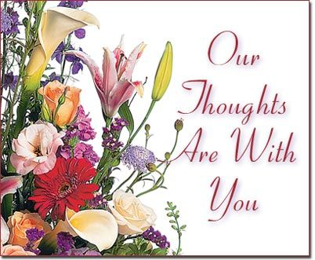

Today we extend our sincere condolences to Frances Kennedy and her daughters Margie Ann and Mary Beth on the loss of their beloved son and brother, Charlie. Charlie passed away on Nov. 7th. Frances has moved to Halifax to be closer to her daughters who request you keep Frances in your prayers.
UPCOMING FIRST CHURCH EVENTS
Today, 12:15 p.m. – The Worship & Music Committee will meet after service today.
Sun., Nov. 30th – We will be celebrating Holy Communion and will start off Advent with our ‘pre-service’ music and morning refreshments. Music will be provided by Keith & Justin.

Sunday Evenings – 6:00p.m. - “Downtown Ministries - A Contemporary Service of Prayer, Meditation, Fellowship and Music”, meet every Sunday at 6:00p.m., everyone welcome.

EVENTS YOU MAY BE INTERESTED IN…
Request from Sheila Dempster: Local music group looking for someone to play guitar and/or fiddle. We go to the local nursing homes and are out 2, sometimes 3 times per week for approximately 1 hour. If you have the time and are interested, please call Sheila at 902-695-2295.
Sun., Nov. 30th – 2:30p.m. – Celebrate the spirit of Christmas as The Trinitarians present “Let Joy Ring Out”, an afternoon of your favourite Christmas choral pieces. Featuring handbells, violin, flute and vocal solos among others. Free will offering.

Dec. 13th – Clyde MacDonald has written another book, proceeds in support of the MS Society. His book launch will be Dec. 13th; details to follow.


Celebrating birthdays this week are Ella Russell and Fannie Porter. Ella’s birthday is tomorrow, Nov. 24th. Fannie celebrates her birthday, Wed., Nov. 26th. Happy Birthday to both of you!!

THANK YOU
The Board of Managers would like to thank the following for their help in the organization of the Musical Variety Show last night:
- Andrew Alcorn for his technical assistance on the sound system
- The Session for the use of the sanctuary
- The volunteers who worked ahead of schedule to get the sanctuary decorated for the holiday season, making the venue bright and festive for the show
- Those who prepared luncheon for our fellowship time after the show
- The church office for their assistance on publicity, and
- Last, but certainly not least, the performers for offering their gifts of music.

SCRIPTURE READERS & USHERS:
Reader: Mark Thibeau
Ushers: Main Door (Office) – Jane Williams
James St. – Cathy Lewis
MacLean St. (Main Entrance steps) – Ellen Jardine
EARLY CHRISTIAN EDUCATORS: Lynne Ann & Lois MacLellan
Mission Statement: But he’s already made it plain how to live, what to do, what God is looking for in men and women. It’s quite simple. Do what is fair and just to your neighbor, be compassionate and loyal in your love, and don’t take yourself too seriously – take God seriously. Micah 6: 8-The Message

