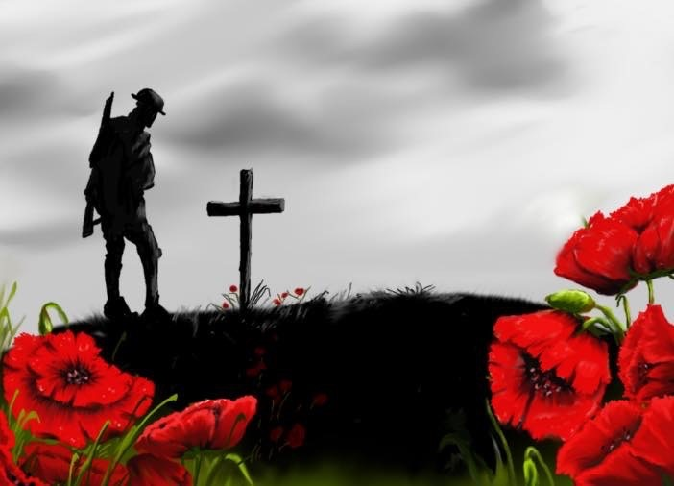

FIRST PRESBYTERIAN CHURCH
208 MacLean St., New Glasgow, NS
902-752-5691
First.church@ns.aliantzinc.ca
Reverend Andrew MacDonald
902-331-0322
yick96@hotmail.com

November 9th, 2025
Remembrance Sunday
Twenty-Second Sunday after Pentecost

THE APPROACH
Musical Prelude
Welcome and Announcements
**Entry of the Bible
**Lighting the Christ Candle
**National Anthem – “O Canada”
Call to Worship
**Hymn #794 – “Abide with me” vs. 1,4,5
1 Abide with me! Fast falls the eventide.
The darkness deepens, Lord, with me abide:
when other helpers fail and comforts flee,
help of the helpless, Oh abide with me.

4 I fear no foe with thee at hand to bless;
ills have no weight and tears no bitterness:
where is death’s sting?
Where, grave, thy victory?
I triumph still if thou abide with me.

5 Hold thou thy cross before my closing eyes,
shine through the gloom,
and point me to the skies;
heave’s morning breaks,
and earth’s vain shadows flee;
in life, in death, O Lord, abide with me.

In Flanders Fields
**Last Post Brent MacQuarrie
**2 Minutes of Silence
**Reveille Brent MacQuarrie
**Act of Remembrance
Roll of Honour
Prayer of Adoration, Confession and Lord’s Prayer

Our Father which art in heaven, hallowed be thy name.

Thy kingdom come, thy will be done in earth,

as it is in heaven.

Give us this day our daily bread.

And forgive us our debts, as we forgive our debtors.

And lead us not into temptation, but deliver us from evil:

For thine is the kingdom, and the power, and the glory,

forever. Amen.
Assurance of Pardon
Passing the Peace
**Hymn #736 – “For the healing of the nations” vs. 1-3
1 For the healing of the nations,
Lord, we pray with one accord,
for a just and equal sharing
of the things that earth affords.
To a life of love in action
help us rise and pledge our word.

2 Lead us forward into freedom,
from despair your world release,
that, redeemed from war and hatred,
all may come and go in peace.
Show us how through care and goodness
fear will die and hope increase.

3 All that kills abundant living,
let it from the earth be banned:
pride of status, race or schooling,
dogmas that obscure your plan.
In our common quest for justice
may we hallow brief life's span.

Children’s Time
Prayer of Illumination
First Lesson: Isaiah 25:6-10 – p.539
Epistle Lesson: Hebrews 9:24-28 – p.915
Responsive Psalm 121
ONE: I lift up my eyes to the hills—from where will my help come? My help comes from the Lord, who made heaven and earth.
ALL: He will not let your foot be moved; he who keeps you will not slumber. He who keeps Israel will neither slumber nor sleep.
ONE: The Lord is your keeper; the Lord is your shade at your right hand. The sun shall not strike you by day, nor the moon by night.
ALL: The Lord will keep you from all evil; he will keep your life. The Lord will keep your going out and your coming in from this time on and for evermore.
**Gloria Patri

Glory be to the Father, and to the Son, and to the Holy Ghost. As it was in the beginning, is now and ever shall be, world without end. Amen, amen.

Gospel Reading: John 15:12-21- p.824
Anthem – Amanda MacIntosh – “Be thou my vision”
Sermon: “Greater Love”
**Reaffirmation of Faith – Apostles’ Creed – Please rise

I believe in God, the Father Almighty, maker of Heaven and earth; and in Jesus Christ, His only Son, Our Lord, who was conceived by the Holy Ghost, born of the Virgin Mary,
suffered under Pontius Pilate, was crucified, died, and was buried. He descended into Hell. On the third day He arose again from the dead; He ascended into Heaven, and sits
at the right hand of God, the Father Almighty; from thence He shall come to judge the quick and the dead.
I believe in the Holy Ghost, the holy Catholic Church,
the communion of saints, the forgiveness of sins, the resurrection of the body, and the life everlasting. Amen.

**Hymn: #740 - “Make me a channel of your peace”
1 Make me a channel of your peace:
where there is hatred, let me bring your love;
where there is injury, your healing power,
and where there’s doubt, true faith in you.

2 Make me a channel of your peace:
where there’s despair in life, let me bring hope,
where there is darkness, only light;
and where there’s sadness, every joy.

3 O Spirit, grant that I may ever seek
so much to be consoled as to console,
to be understood as to understand,
to be loved as to love with all my soul.

4 Make me a channel of your peace.
It is in pardoning that we are pardoned,
in giving to all - that we receive,
and in dying that we’re born to eternal life.

Offertory
Doxology
Offertory Prayer
Prayers of the People
**Hymn: #325 - “Eternal Father, strong to save”
1 Eternal Father, strong to save,
whose arm hath bound the restless wave,
who bade the mighty ocean deep
its own appointed limits keep:
oh hear us when we cry to thee
for those in peril on the sea.

2 O Christ, whose voice the waters heard
and hushed their raging at thy word,
who walked upon the foaming deep
and calm amid the storm did sleep:
oh hear us when we cry to thee
for those in peril on the sea.

3 O Holy Spirit, who did brood
upon the waters dark and rude,
and bade their angry tumult cease,
and gave, for wild confusion, peace:
oh hear us when we cry to thee
for those in peril on the sea.

4 O Trinity of love and power,
our kindred shield in danger’s hour;
from rock and tempest, fire and foe,
protect them whereso’er they go;
then evermore shall rise to thee
glad hymns of praise from land and sea.

**Benediction
**Royal Anthem - “God Save The King”
**Recessional - Placing of the poppies in silence

* * * * * * * * * * * * *

Minister: Rev. Andrew MacDonald (c) 902-331-0322
Organist: Clare Grieves
Office hours: Tues. to Fri. – 10 -1pm
Rev. MacDonald -Tues. to Thurs. 10-2 or by appointment

Mission Statement: But he’s already made it plain how to live, what to do, what God is looking for in men and women. It’s quite simple. Do what is fair and just to your neighbor, be compassionate and loyal in your love, and don’t take yourself too seriously – take God seriously. Micah 6: 8-The Message

NAMES OF THE FALLEN
1914-1918
FIRST CHURCH
Fraser Betts William Herman Jenkins
Harry Cavanaugh Hal MacCulloch
Frederick Davis Alfred Sutherland MacIntosh
Margaret M. Fraser James Herbert MacIntosh
J. G. Laurier Fraser William Hayward MacIntosh
William Hays Grant Lillas MacKay
F. W. Henchecliffe, M.C. Roderick Porter
Robert Alexander Muir WilliamD. Stewart

WESTMINSTER CHURCH
William T. Beck Ian C. MacGregor
Millard Cameron Harcourt A. Murray
Isabel K. Cummings George Tas
Aubrey E. Grant John H. Rogers
Hugh Ross

NAMES OF THE FALLEN
1939 – 1945
FIRST CHURCH
Kitchener Langille George D. MacDougall
G. Hadley MacAulay Allister W. Porter
Osborne L. Bliss, D.F.C.

WESTMINSTER CHURCH
Dr. William Embree Cameron MacNeil
Jack Ross
ANNOUNCEMENTS

All are welcome at First Presbyterian Church. We hope you experience the love of God and of this congregation as we worship, celebrate, and serve one another.

PASTORAL CARE: In order to provide support to the people of First Church, when you or a loved one is sick or in hospital, we encourage you to contact the church office (902-752-5691) or Reverend Andrew (902-331-0322) to inform us. It is also important that you inform the hospital that you would welcome a visit from your minister and/or your Elder.
MEMORIAL DONATIONS
A memorial donation has been received in loving memory of former congregants, Vera and Arnold Campbell (parents), Glen Campbell (brother), and Katherine Stewart (aunt) from Karen (Campbell) Garner and her husband Jonathon.
UPCOMING FIRST CHURCH EVENTS
Today – 12:15p.m. – Session will meet after service.
Sat, Nov. 22nd – 7:00 p.m. – We are hosting our 4th Annual Musical Variety Show. Free will offering; proceeds to the Church General Fund. Light lunch and time of fellowship to follow.

The list of performers has been updated to include: Lloyd MacLean, Alexandria Will, Ray Stewart, Heather Cameron and Kenny Stewart, Community Mixed Chorus with Brenda Bowden, Justin & Keith, Eric MacNeil, Pam LeBlanc, Rev. Andrew, The Alcorn Family. Please join us for an evening of great music and fellowship!

Sunday Evenings – 6:00p.m. - “Downtown Ministries - A Contemporary Service of Prayer, Meditation, Fellowship and Music”, meet every Sunday at 6:00p.m., everyone welcome.

EVENTS YOU MAY BE INTERESTED IN…
Fri., Nov. 14th - 7:30 p.m., Trinity United - The Pictou County Palliative Care Society presents an evening of special music featuring Sarah and Dale Letcher, a dynamic duo (who perform regularly with ‘Big Fish’) sharing their music and connection with our community. Tickets are $30 in advance or available at the door the evening of the concert. Advance tickets may be purchased at the Trinity United office or by contacting Eoin Dewar, board member and event co-organizer, at 902-759-0524.
Sun., Nov. 30th – 2:30p.m. – Celebrate the spirit of Christmas as The Trinitarians present “Let Joy Ring Out”, an afternoon of your favourite Christmas choral pieces. Featuring handbells, violin, flute and vocal solos among others. Free will offering.

Study on the Gospel of Matthew : There are 5 sessions left in the study of the Gospel of Matthew at St. Andrew’s Presbyterian Church, New Glasgow (The Kirk), Friday mornings, 10:00-11:30 a.m., or Friday afternoons 2:00-3:30 p.m. No requirement to attend all sessions. If you are interested, contact Rev. Grant Johnston: grant.johnston@live.com, or text: (905) 867-1914.


We extend our best wishes to Sandy MacIntosh as he celebrates his birthday today. Have a wonderful day Sandy!

SCRIPTURE READERS & USHERS:
Reader: Clarice Campbell
Ushers: Main Door (Office) – Jane Williams
James St. – Cathy Lewis
MacLean St. (Main Entrance steps) – Ellen Jardine
EARLY CHRISTIAN EDUCATORS: Lynne Ann & Lois MacLellan

