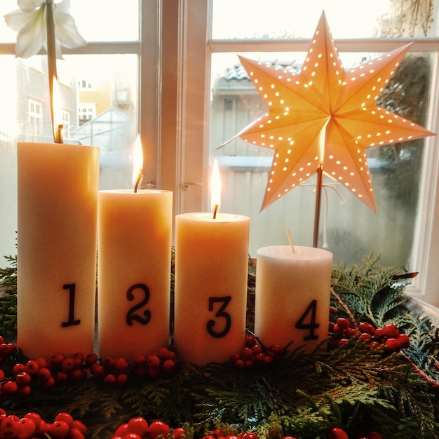

FIRST PRESBYTERIAN CHURCH
208 MacLean St., New Glasgow, NS
902-752-5691
First.church@ns.aliantzinc.ca
Reverend Andrew MacDonald
902-331-0322

December 14th, 2025
Third Sunday in Advent
“Joy”

THE APPROACH
**Please Rise**
Musical Prelude
Welcome and Announcements
**Entry of the Bible
**Musical Introit - "Advent Candlelight Carol" vs.3
Advent Candle burning bright through the night , shine your light of joy
Telling people ev’rywhere: soon the Savior comes, soon He will be here!
People gather and prepare in the night with the light of joy.
Call to Worship
**Hymn #109 – “All the earth is waiting” vs. 1-4
1 All earth is waiting
to see the Promised One,
and open furrows await the seed of God.
All the world, bound and struggling,
seeks true liberty;
it cries out for justice
and searches for the truth.

2 Thus says the prophet
to those of Israel:
“ virgin mother will bear Emmanuel”,
one whose name is God-with-us:
our Saviour shall be;
with him hope will blossom
once more within our hearts.

3 Mountains and valleys
will have to be made plain;
open new highways,
new highways for our Lord.
He is now coming closer,
so come all to see,
and open the doorways
as wide as wide can be.

4 In lowly stable
the Promised One appeared;
yet feel his presence
throughout the earth today,
for he lives in all Christians
and is with us now;
again, with his coming
he brings us liberty.

Prayers of Approach and the Lord’s Prayer

Our Father which art in heaven, hallowed be thy name.

Thy kingdom come, thy will be done in earth,

as it is in heaven.

Give us this day our daily bread.

And forgive us our debts, as we forgive our debtors.

And lead us not into temptation, but deliver us from evil:

For thine is the kingdom, and the power, and the glory,

forever. Amen.

Assurance of Pardon
Passing the Peace
**Hymn #155 – “That boy-child of Mary” vs. 1-3, 6
Refrain:
That boy child of Mary
was born in a stable,
a manger his cradle
in Bethlehem.
1. What shall we call him,
child of the manger?
What name is given
in Bethlehem?
(Refrain)
2. His name is Jesus,
God ever with us,
God given for us
in Bethlehem.
(Refrain)
3. How can he save us,
how can he help us,
born here among us
in Bethlehem?
(Refrain)
6. Gladly we praise him,
love and adore him,
give ourselves to him
of Bethlehem.
(Refrain)
Lighting the Advent Candle: “Joy” –
Kate Campbell and Brielle Himmelman

**Advent Hymn: #119 “Hope is A Star” vs. 1-3
1 HOPE is a star that shines in the night,
leading us on till the morning is bright

Chorus When God is a child
There’s joy in our song.
The last shall be first
and the weak shall be strong,
and none shall be afraid.

2 PEACE is a ribbon that circles the earth,
giving a promise of safety and worth.

3 JOY is a song that welcomes the dawn,
telling the world that the Saviour is born.

Children’s Time
Prayer of Illumination
First Lesson: Isaiah 35:1-10 p.547
Epistle Lesson: James 5:7-10 p.921
**Gloria Patri

Glory be to the Father, and to the Son, and to the Holy Ghost. As it was in the beginning, is now and ever shall be, world without end. Amen, amen.

Gospel Lesson: Matthew 11:2-11 p.745
Anthem
Sermon: “Joy!”
**Reaffirmation of Faith - Apostles Creed

I believe in God, the Father Almighty, maker of Heaven and earth; and in Jesus Christ, His only Son, Our Lord, who was conceived by the Holy Ghost, born of the Virgin Mary,
suffered under Pontius Pilate, was crucified, died, and was buried. He descended into Hell. On the third day He arose again from the dead; He ascended into Heaven, and sits
at the right hand of God, the Father Almighty; from thence He shall come to judge the quick and the dead.
I believe in the Holy Ghost, the holy Catholic Church,
the communion of saints, the forgiveness of sins, the resurrection of the body, and the life everlasting. Amen.

**Hymn: #144 - “Twas in the moon of wintertime” vs. 1-3

- ‘Twas in the moon of wintertime
when all the birds had fled,
that mighty Gitchi Manitou
sent angel choirs instead;
before their light the stars grew dim,
and wandering hunters heard the hymn:
Jesus your King is born, Jesus is born, in excelsis gloria.

- Within a lodge of broken bark
the tender Babe was found;
a ragged robe of rabbit skin
enwrapped his beauty round,
but as the hunter braves drew nigh,
the angel song rang loud and high:
Jesus your King is born, Jesus is born, in excelsis gloria.

- The earliest moon of wintertime
is not so round and fair
as was the ring of glory on
the helpless infant there.
The chiefs from far before him knelt
with gifts of fox and beaver pelt.
Jesus your King is born, Jesus is born, in excelsis gloria.
Call to the Offering
Doxology
Praise God from whom all blessings flow. Praise Him all creatures here below. Praise Him above Ye Heavenly Host. Praise Father, Son, and Holy Ghost. Amen.

Offertory Prayer
Prayers of the People- The People Respond
ONE: God who makes all things new,
ALL: Renew our life together.
**Hymn: #156 - “The angel Gabriel from heaven” vs. 1,3,4
1 The angel Gabriel from heaven came,
his wings as drifted snow, his eyes as flame;
All hail, said he, O lowly maiden Mary,
most highly favoured lady: Gloria!

3 Then gentle Mary meekly bowed her head,
To me be as it pleases God, she said,
my soul shall laud and magnify
God’s holy name,
most highly favored lady: Gloria!

4 Of her, Emmanuel, the Christ, was born
in Bethlehem, all on a Christmas morn,
and Christian folk throughout the world
will ever say:
most highly favored lady: Gloria!

Childrens’ Christmas Program
**Benediction
**Choral Response:
**Recessional
* * * * * * * * * * * * *

Minister: Rev. Andrew MacDonald (c) 902-331-0322
Organist: Clare Grieves
Office hours: Tues. to Fri. – 10 -1pm
Rev. MacDonald office hours -Tues. to Thurs. 10-2 or by appointment

Mission Statement: But he’s already made it plain how to live, what to do, what God is looking for in men and women. It’s quite simple. Do what is fair and just to your neighbor, be compassionate and loyal in your love, and don’t take yourself too seriously – take God seriously. Micah 6: 8-The Message

ANNOUNCEMENTS

All are welcome at First Presbyterian Church. We hope you experience the love of God and of this congregation as we worship, celebrate, and serve one another.

UPCOMING FIRST CHURCH EVENTS
Today:
- Session will meet after service.
- Please join us after service for a soup and sandwich lunch.
- We will worship with the residents of Riverview Residential at 2:30p.m.
Sunday Evenings – 6:00p.m. - “Downtown Ministries - A Contemporary Service of Prayer, Meditation, Fellowship and Music”, meet every Sunday at 6:00p.m., everyone welcome.

Christmas Memory Tree & Tree of Kindness – Thank you to all who have contributed to the Christmas Memory Tree and the Tree of Kindness. No surprise, both these initiatives have been well supported by the generosity of the congregation which is greatly appreciated.
EVENTS YOU MAY BE INTERESTED IN…
Sat., Dec. 20th – 7:00p.m. – Zion Presbyterian Church, East River Saint Mary’s, will present their annual “Evening of Music” featuring special guests and ending with the candlelight singing of “Let there by Peace”. Cider and cookies to follow.
SCRIPTURE READERS & USHERS:
Preservice Christmas music today: Brent MacQuarrie & Andrew Alcorn
Reader: Jennifer Thibeau
Ushers: Main Door (Office) – Sherry Green
James St. – John Zinck
MacLean St. (Main Entrance steps) – Ellen Jardine
EARLY CHRISTIAN EDUCATORS: Lynne Ann & Lois MacLellan

