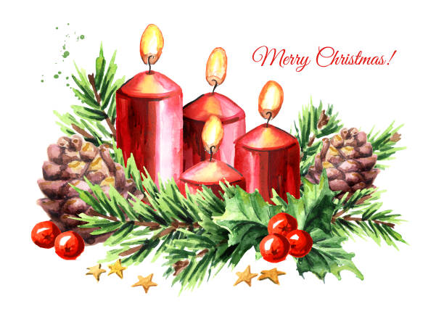

December 21st, 2025
Fourth Sunday in Advent
“Love”

THE APPROACH
**Please Rise**
Musical Prelude
Welcome and Announcements
**Entry of the Bible
**Musical Introit - "Advent Candlelight Carol" vs.4
Advent Candle burning bright through the night , shine your light of love
Telling people ev’rywhere: soon the Savior comes, soon He will be here! People gather and prepare in the night with the light of love.

Call To Worship
**Hymn #121 – “Long ago, prophets knew”
Long ago, prophets knew
Christ would come, born a Jew.
Come to make all things new;
Bear his People's burden,
Freely love and pardon.
Ring, bells, ring, ring, ring!
Sing, choirs, sing, sing, sing!
When he comes,
When he comes,
Who will make him welcome?

God in time, God in man,
This is God's timeless plan:
He will come, as a man,
Born himself of woman,
God divinely human.
Ring, bells, ring, ring, ring!
Sing, choirs, sing, sing, sing!
When he comes,
When he comes,
Who will make him welcome?

Journey ends! Where afar
Bethlem shines, like a star,
Stable door stands ajar.
Unborn Son of Mary,
Saviour, do not tarry!
Ring, bells, ring, ring, ring!
Sing, choirs, sing, sing, sing!
Jesus comes!
Jesus comes!
We will make him welcome!

Prayers of Approach and the Lord’s Prayer

Our Father which art in heaven, hallowed be thy name.

Thy kingdom come, thy will be done in earth,

as it is in heaven.

Give us this day our daily bread.

And forgive us our debts, as we forgive our debtors.

And lead us not into temptation, but deliver us from evil:

For thine is the kingdom, and the power, and the glory,

forever. Amen.

Assurance of Pardon
Passing the Peace
**Hymn #150 – “Jesus, our brother, kind and good” vs. 1,3-5

1. Jesus, our brother, kind and good,
was humbly born in a stable rude,
and the friendly beasts around him stood,
Jesus, our brother, kind and good.
3. 'I,' said the cow, all white and red,
'I gave him my manger for his bed;
I gave him hay to pillow his head;
I,' said the cow, all white and red.
4. 'I,' said the sheep, with curly horn,
'I gave him my wool for is blanket warm,
he wore my coat on Christmas mom;
I,' said the sheep, with curly horn.
5. 'I,' said the dove, from rafters high,
'I cooed him to sleep that he should not cry,
we cooed him to sleep, my mate and I;
I,' said the dove, from rafters high.
Lighting the Advent Candle: “Love” -
Amanda and Alena MacIntosh

**Advent Hymn: #119 “Hope is A Star” vs. 1-4
1 HOPE is a star that shines in the night,
leading us on till the morning is bright

Chorus When God is a child
There’s joy in our song.
The last shall be first
and the weak shall be strong,
and none shall be afraid.

2 PEACE is a ribbon that circles the earth,
giving a promise of safety and worth.

3 JOY is a song that welcomes the dawn,
telling the world that the Saviour is born.

4 LOVE is a flame that burns in our heart,
Jesus has come and will never depart.

Children’s Time
Prayer of Illumination
First Lesson: Isaiah 7:10-16 p.525
Epistle Lesson: Romans 1:1-7 p.861
**Gloria Patri

Glory be to the Father, and to the Son, and to the Holy Ghost. As it was in the beginning, is now and ever shall be, world without end. Amen, amen.

Gospel Lesson: Matthew 1:18-25 p.737
Anthem – “Christmas Lullaby”
Sermon: “Love!”
**Reaffirmation of Faith- Apostles Creed

I believe in God, the Father Almighty, maker of Heaven and earth; and in Jesus Christ, His only Son, Our Lord, who was conceived by the Holy Ghost, born of the Virgin Mary,
suffered under Pontius Pilate, was crucified, died, and was buried. He descended into Hell. On the third day He arose again from the dead; He ascended into Heaven, and sits
at the right hand of God, the Father Almighty; from thence He shall come to judge the quick and the dead.
I believe in the Holy Ghost, the holy Catholic Church,
the communion of saints, the forgiveness of sins, the resurrection of the body, and the life everlasting. Amen.

**Hymn: #158 - “The hands that first held Mary’s child” vs.1-3

- The hands that first held Mary’s child
were hard from working wood,
from boards they sawed and planed and filed
and splinters they withstood.
This day they gripped no tool of steel,
they drive no iron nail,
but cradled from the head to heel our Lord,
newborn and frail.

- When Joseph marveled at the size
of that small breathing frame,
and gazed upon those bright new eyes
and spoke the Infant’s name,
the angel’s words he once had dreamed
poured down from heaven’s height,
and, like the host of stars that beamed,
blest earth with welcome light.

- “This child shall be Emmanuel,
not God upon the throne
but God with us, Emmanuel,
as close as blood and bone.”
The tiny form in Joseph’s palms
confirmed what he had heard,
and from his heart rose hymns and psalms
for heaven’s human word.

Call to the Offering
Doxology
Praise God from whom all blessings flow. Praise Him all creatures here below. Praise Him above Ye Heavenly Host. Praise Father, Son, and Holy Ghost. Amen.

Offertory Prayer
Prayers of the People
**Hymn: #147 - Angels we have heard on high” vs. 1-3
1 Angels we have heard on high,
sweetly singing o’er the plains,
and the mountains in reply
echoing their joyous strains.

Gloria in excelsis Deo
Gloria in excelsis Deo

2 Shepherds, why this jubilee?
Why your joyous strains prolong?
What the gladsome tidings be
which inspire your heavenly song?

3 Come to Bethlehem and see
Christ whose birth the angels sing:
come, adore on bended knee,
Christ, the Lord, the newborn King.

**Benediction
**Choral Response:
**Recessional
************
ANNOUNCEMENTS

All are welcome at First Presbyterian Church. We hope you experience the love of God and of this congregation as we worship, celebrate, and serve one another.

PASTORAL CARE: In order to provide support to the people of First Church, when you or a loved one is sick or in hospital, we encourage you to contact the church office (902-752-5691) or Reverend Andrew (902-331-0322) to inform us. It is also important that you inform the hospital that you would welcome a visit from your minister and/or your Elder.
IN MEMORIAM DONATIONS

- A donation has been received in loving memory of Brad Smith and Pamela Smith Flanagan from Betty Smith and family.
- Donations have been received in loving memory of Melda and Roy MacGregor from Susan and Chuck Stallard and from Janet and Brian Hiscott.
- A donation has been received in loving memory of Phoebe Fraser from Keith and Jane MacDonald.
- A donation has been received in loving memory of Robert (Bob) Fraser from Edna Fraser and family.

UPCOMING FIRST CHURCH EVENTS
This evening – 8:15p.m.: “Blue Christmas”
Sunday Evenings – 6:00p.m. - “Downtown Ministries - A Contemporary Service of Prayer, Meditation, Fellowship and Music”, meet every Sunday at 6:00p.m., everyone welcome.

Thank you - Don Haggart and Diane Bagnell wish to thank the choir and congregation for their care, concern and best wishes. Thank you and Merry Christmas to all.

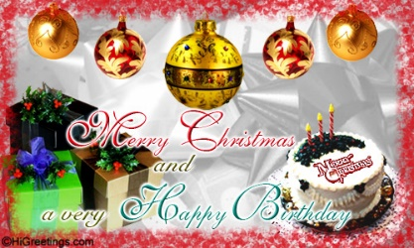
Birthday wishes are extended to Evie MacLellan and Keith Cruickshank who celebrate their birthdays on Christmas Day! Have a wonderful day!

SCRIPTURE READERS & USHERS:
Preservice Christmas music today: Clare & Kevin Murdock
Reader: Clarice Campbell
Ushers: Main Door (Office) – Albert & Cristal Van De Pol
James St. – John Zinck
MacLean St. (Main Entrance steps) – Ellen Jardine
EARLY CHRISTIAN EDUCATORS: Lynne Ann & Lois MacLellan

* * * * * * * * * * * * *
Minister: Rev. Andrew MacDonald (c) 902-331-0322
Organist: Clare Grieves
Office hours: Tues. to Fri. – 10 -1pm
Rev. MacDonald office hours -Tues. to Thurs. 10-2 or by appointment

Mission Statement: But he’s already made it plain how to live, what to do, what God is looking for in men and women. It’s quite simple. Do what is fair and just to your neighbor, be compassionate and loyal in your love, and don’t take yourself too seriously – take God seriously. Micah 6: 8-The Message

