

December 7th, 2025
Second Sunday in Advent
“Peace”

THE APPROACH
**Please Rise**
Musical Prelude
Welcome And Announcements
**Entry of the Bible
**Musical Introit –
- Advent candle burning bright through the night, Shine your light of hope Telling people ev’rywhere: soon the Savior comes, soon He will be here! People gather and prepare in the night with the light of hope.

- Advent Candle burning bright through the night, shine your light of peace
Telling people ev'rywhere:
Soon the Savior comes, soon He will be here
People gather and prepare in the night with the light of peace.

Call To Worship

**Hymn #115 – “Hail to the Lord’s Anointed” vs. 1,3-5
1 Hail to the Lord’s Anointed,
great David’s greater Son;
hail, in the time appointed,
his reign on earth begun!
He comes to break oppression,
to set the captives free,
to take away transgression
and rule in equity.

3 He shall come down like showers
upon the fruitful earth,
and love, joy, hope, like flowers,
spring in his path to birth.
Before him on the mountains
shall peace, the herald, go,
and righteousness, in fountains,
from hill to valley flow.

4 All powers shall bow before him,
and gold and incense bring;
all nations shall adore him,
his praise all people sing,
for he shall have dominion
o’er river, sea and shore,
far as the eagle’s pinion
or dove’s light wing can soar.

5 O’er every foe victorious,
Christ on his throne shall rest,
from age to age more glorious,
all-blessing and all-blest:
the tide of time shall never
his covenant remove;
his name shall stand forever -
that name to us is Love.

Prayers of Approach and the Lord’s Prayer

Our Father which art in heaven, hallowed be thy name.

Thy kingdom come, thy will be done in earth,

as it is in heaven.

Give us this day our daily bread.

And forgive us our debts, as we forgive our debtors.

And lead us not into temptation, but deliver us from evil:

For thine is the kingdom, and the power, and the glory,

forever. Amen.

Assurance of Pardon
Passing the Peace
**Hymn #151 – “Lo, how a Rose e’er blooming” vs. 1-3

1 Lo, how a Rose e’r blooming
from tender stem hath sprung,
of Jesse’s lineage coming,
as prophets long have sung
It came, a floweret bright,
amid the cold of winter,
when half-spent was the night.

2 Isaiah twas foretold it,
the Rose I have in mind;
with Mary we behold it,
the virgin mother kind.
To show God’s love aright,
she bore to us a Saviour,
when half-spent was the night.

3 This flower, whose fragrance tender
with sweetness fills the air,
dispels with glorious splendour
our darkness everywhere.
True flesh, yet very God,
from sin and death he saves us
and shares our every load.

Lighting the Advent Candle: “Peace” - Jennifer and Mark Thibeau

**Advent Hymn: #119 “Hope is a star” vs. 1, 2
1 HOPE is a star that shines in the night,
leading us on till the morning is bright

Chorus When God is a child
There’s joy in our song.
The last shall be first
and the weak shall be strong,
and none shall be afraid.

2 PEACE is a ribbon that circles the earth,
giving a promise of safety and worth.

Children’s Time
Prayer of Illumination
First Lesson: Isaiah 11:1-10 - p.529
Epistle Lesson: Romans 15:4-13 - p.867
**Gloria Patri

Glory be to the Father, and to the Son, and to the Holy Ghost. As it was in the beginning, is now and ever shall be, world without end. Amen, amen.

Gospel Lesson: Matthew 3:1-12 - p.738
Anthem – “Soon and Very Soon”
Sermon: “Peace!”
**Reaffirmation of Faith- Apostles Creed

I believe in God, the Father Almighty, maker of Heaven and earth; and in Jesus Christ, His only Son, Our Lord, who was conceived by the Holy Ghost, born of the Virgin Mary,
suffered under Pontius Pilate, was crucified, died, and was buried. He descended into Hell. On the third day He arose again from the dead; He ascended into Heaven, and sits
at the right hand of God, the Father Almighty; from thence He shall come to judge the quick and the dead.
I believe in the Holy Ghost, the holy Catholic Church,
the communion of saints, the forgiveness of sins, the resurrection of the body, and the life everlasting. Amen.

**Hymn: #128 - “There’s a voice in the wilderness crying”
1 There’s a voice in the wilderness crying,
a call from the ways untrod:
prepare in the desert a highway,
a highway for our God!
The valleys shall be exalted,
the lofty hills brought low;
make straight all the crooked places
where the Lord our God may go!

2 O Zion, that bringest good tidings,
go up to the heights and sing!
Proclaim to a desolate people
the coming of their King.
Like the flowers of the field they perish,
like grass our works decay,
the power and pomp of nations
shall pass like a dream away,

3 but the word of our God is steadfast;
the arm of the Lord is strong;
God stands in the midst of nations,
and soon will right the wrong.
God shall feed the flock like a shepherd,
the lambs will gently hold,
to pastures of peace will lead them,
and bring them safe to the fold.

Call to the Offering
Doxology
Offertory Prayer
Prayers of the People
**Hymn: #118 - “Hark the glad sound”
1 Hark the glad sound! The Saviour comes,
the Saviour promised long;
let every heart prepare a throne,
and every voice a song!

2 You come the prisoners to release
in Satan’s bondage held;
the gates of brass before you burst,
the iron fetters yield.

3 You come the broken heart to bind,
the wounded soul to cure,
to bring the treasures of God’s grace,
good tidings for the poor.

4 Our glad hosannas, Prince of Peace,
your welcome shall proclaim,
and heaven’s eternal arches ring
with your most honoured name.
**Benediction
**Choral Response:
**Recessional
* * * * * * * * * * * * *

Minister: Rev. Andrew MacDonald (c) 902-331-0322
Organist: Clare Grieves
Office hours: Tues. to Fri. – 10 -1pm
Rev. MacDonald office hours -Tues. to Thurs. 10-2 or by appointment

Mission Statement: But he’s already made it plain how to live, what to do, what God is looking for in men and women. It’s quite simple. Do what is fair and just to your neighbor, be compassionate and loyal in your love, and don’t take yourself too seriously – take God seriously. Micah 6: 8-The Message
ANNOUNCEMENTS

All are welcome at First Presbyterian Church. We hope you experience the love of God and of this congregation as we worship, celebrate, and serve one another.

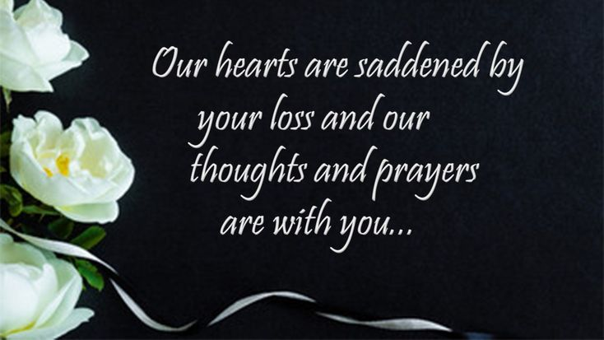
This week we lost our dear friend, Phoebe Fraser. An active Elder and member of First Church, Phoebe will be missed by all of us. We send our sincere condolences to all Phoebe’s family and friends.

UPCOMING FIRST CHURCH EVENTS
Sun., Dec. 14th – Please join us after service next week for a soup and sandwich lunch.
Christmas Memory Tree – Once again we honour loved ones with the ‘Christmas Memory Tree’. If you wish to purchase a ball(s) in memory or in honour of a loved one, forms are located in the sanctuary or the office. The deadline for submissions will be next Sun., Dec. 14th.
Advent Tree of Kindness – We also have the ‘Tree of Kindness’. “Ornaments” on the tree list items requested that will be collected from today to next Sun., Dec. 14th inclusive. All donations will then be delivered to Social Services for distribution to Income Assistance recipients. We thank you for any contribution you can make.
Sunday Evenings – 6:00p.m. - “Downtown Ministries - A Contemporary Service of Prayer, Meditation, Fellowship and Music”, meet every Sunday at 6:00p.m., everyone welcome.

Today, we send our birthday wishes to Jack Marshall who will celebrate his birthday Sat., Dec. 13th. Happy Birthday Jack!

EVENTS YOU MAY BE INTERESTED IN…

Tonight – 6:00 p.m. – Union Presbyterian Church, Thorburn, is hosting an “Old Fashioned Christmas” concert, featuring many local musicians including Shaun McLean and Ross McVicor, Ray Stewart with Jeannie and Dawn, Rev. Joon Ki Kim and others. Free will offering. Lunch served following the concert. Please join us if you can!
Sat., Dec. 13th, 10:00 a.m.-2:00 p.m. – “Last Minute, Second Chance Craft Sale” will be held at the Bethel Church Hall, Pictou Landing. Free will donation in support of the AMS Mission project, ‘Helping Hands’. Many unique gifts for all those on your Christmas list.
Sat., Dec. 13th, 2:00 p.m. – Clyde MacDonald has written another book, “Tragedies and Triumphs”. The book launch will take place at the New Glasgow Library, Aberdeen Business Centre. Proceeds from the book sales are in support of the MS Society.

SCRIPTURE READERS & USHERS:
Preservice Christmas music today: Amanda MacIntosh
Reader: Sharon Mason
Ushers: Main Door (Office) – Albert & Cristal Van de Pol
James St. – John Zinck
MacLean St. (Main Entrance steps) – Ellen Jardine
EARLY CHRISTIAN EDUCATORS: Lynne Ann & Lois MacLellan

