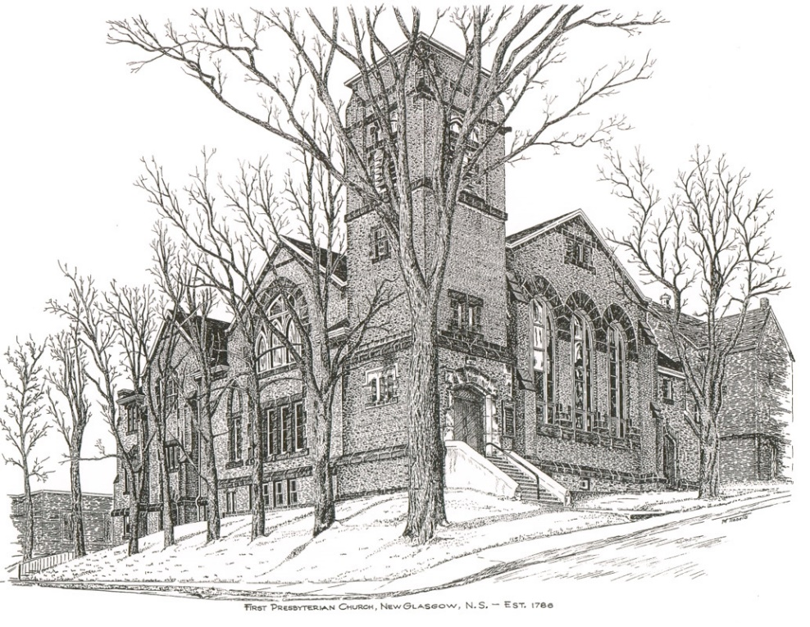

First Presbyterian Church
208 MacLean St., New Glasgow, NS
902-752-5691
first.church@ns.aliantzinc.ca
Reverend Grant Johnston
905-867-1914
grant.johnston@live.com
Order of Service
Sunday, January 11th, 2026
**Please Rise**
Musical Prelude
Welcome and Announcements
**Entry of the Bible and lighting of the Christ Candle
**Musical Introit – #514 – “Jesus, we are gathered”

Call to Worship
**#293 – “Come, thou almighty King”
1 Come, thou almighty King;
help us thy name to sing;
help us to praise.
Father, all glorious,
O’er all victorious,
come and reign over us, Ancient of Days.

2 Come, thou incarnate Word;
gird on thy mighty sword;
our prayer attend;
come , and thy people bless,
and give thy word success;
Spirit of holiness, on us descend.

3 Come, holy Comforter;
thy sacred witness bear
in this glad hour!
Thou who almighty art,
now rule in every heart,
and ne’er from us depart, Spirit of power.

4 To the great One-in-Three
eternal praises be
hence evermore!
His sovereign majesty
may we in glory see,
and to eternity love and adore.

Prayers of Approach and the Lord’s Prayer

Our Father which art in heaven, hallowed be thy name.

Thy kingdom come, thy will be done in earth,

as it is in heaven.

Give us this day our daily bread.

And forgive us our debts, as we forgive our debtors.

And lead us not into temptation, but deliver us from evil:

For thine is the kingdom, and the power, and the glory,

forever. Amen.

Assurance of Pardon
Passing of the Peace
**Hymn #348 – “Tell me the stories of Jesus” vs. 1,2 5
- Tell me the stories of Jesus I love to hear;
Things I would ask Him to tell me if He were here;
Scenes by the wayside, tales of the sea,
Stories of Jesus, tell them to me.

- First let me hear how the children stood round His knee, And I shall fancy His blessing resting on me;
words full of kindness, deeds full of grace,
all in the love light of Jesus’ face.

5 Into the city I’d follow the children’s band,
waving a branch of the palm tree high in my hand;
one of his heralds, yes, I would sing
loudest hosannas: Jesus is King!

Children’s Time
Prayer of Illumination
Responsive Psalm –
PSALM 29: 1-11 (GNT)
“The Voice of the Lord in the Storm”

LEADER: Praise the Lord, you heavenly beings; praise his glory and power.

PEOPLE: Praise the Lord’s glorious name; bow down before the Holy One when he appears.

LEADER: The voice of the Lord is heard on the seas; the glorious God thunders, and his voice echoes over the ocean.

PEOPLE: The voice of the Lord is heard in all its might and majesty.

LEADER: The voice of the Lord breaks the cedars, even the cedars of Lebanon.

PEOPLE: He makes the mountains of Lebanon jump like calves and makes Mount Hermon leap like a young bull.

LEADER: The voice of the Lord makes the lightning flash.

PEOPLE: His voice makes the desert shake; he shakes the desert of Kadesh.

LEADER: The Lord’s voice shakes the oaks and strips the leaves from the trees while everyone in his Temple shouts, “Glory to God!”

PEOPLE: The Lord rules over the deep waters; he rules as king forever.

LEADER: The Lord gives strength to his people and blesses them with peace.

First Lesson: Isaiah 42: 1-4
Epistle Lesson: Acts 10:34-43
**Gloria Patri

Glory be to the Father, and to the Son, and to the

Holy Ghost. As it was in the beginning, is now and ever shall be, world without end.

Amen, amen.

Gospel Lesson: Mark 1: 1-8
Anthem - "I just came to praise the Lord"
Sermon: “He will baptize you with the Holy Spirit! (Mark 1:8)
**Reaffirmation of Faith – Apostles Creed

I believe in God, the Father Almighty, maker of Heaven and earth; and in Jesus Christ, His only Son, Our Lord, who was conceived by the Holy Ghost, born of the Virgin Mary,
suffered under Pontius Pilate, was crucified, died, and was buried. He descended into Hell. On the third day He arose again from the dead; He ascended into Heaven, and sits
at the right hand of God, the Father Almighty; from thence He shall come to judge the quick and the dead.
I believe in the Holy Ghost, the holy Catholic Church,
the communion of saints, the forgiveness of sins, the resurrection of the body, and the life everlasting. Amen.

**Hymn #103 - “O Lord, thou art my God and King” vs. 1,3,5
1 O Lord, thou art my God and King;
thee will I magnify and praise:
I will thee bless and gladly sing
unto thy holy name always.

3 Thy saints shall praise thy glorious name;
thy mighty acts they shall declare;
thy wondrous works I will proclaim
and meditate on them with prayer.

5 Thy faithful shall make known the fame
of thy great goodness and shall bless
the splendor of thy glorious name,
praising aloud thy righteousness
Call to the Offering
Doxology
Praise God from whom all blessings flow. Praise Him all creatures here below. Praise Him above Ye Heavenly Host. Praise Father, Son, and Holy Ghost. Amen.

Offertory Prayer
Prayers of the People
**Hymn # 350 To God be the glory
1 To God be the glory,
who great things has done!
God so loved the world!
freely sending the Son,
who yielded his life an atonement for sin,
and opened the lifegate that all may go in.

CHORUS: Praise the Lord! Praise the Lord!
Let the earth hear God’s voice!
Praise the Lord! Praise the Lord!
Let the people rejoice!
Oh come to the Father
through Jesus the Son,
and give God the glory,
who great things has done.

2 Oh perfect redemption,
the purchase of blood
to every believer the promise of God,
that when the offender, repenting, believes,
through Jesus’ atonement, full pardon receives!

3 Great things god has taught us,
great things God has done
and great our rejoicing through Jesus the Son,
but purer and higher and greater will be
our wonder, our gladness, when Jesus we see!

**Benediction
**Choral Response:
Recessional

Mission Statement: But he’s already made it plain how to live, what to do, what God is looking for in men and women. It’s quite simple. Do what is fair and just to your neighbor, be compassionate and loyal in your love, and don’t take yourself too seriously – take God seriously. Micah 6: 8-The Message

ANNOUNCEMENTS

All are welcome at First Presbyterian Church. We hope you experience the love of God and of this congregation as we worship, celebrate, and serve one another.

PASTORAL CARE: In order to provide support to the people of First Church, when you or a loved one is sick or in hospital, we encourage you to contact the church office (902-752-5691) or your Elder to inform us. It is also important that you inform the hospital that you would welcome a visit from the minister and/or your Elder.

UPCOMING FIRST CHURCH EVENTS:
Meetings/events this week:

- Today – 12:15 p.m. - Session will meet today after service.
- Sun., Jan. 18th – 12:15 p.m. – The Board of Managers will meet after service.
- Sun., Jan. 18th – We will have coffee hour after service. If you are interested in hosting, please let Sharon know or contact Jane in the office. We hope you can join us. It is also “Food Bank Sunday”. We thank you for your contributions.

EVENTS YOU MAY BE INTERESTED IN:

An Introduction to the Bible: A ten-session study on “The Acts of the Apostles” will take place at St. Andrew’s Presbyterian Church, New Glasgow (The Kirk), beginning Friday, January 23, 2026, 10:00 – 11:30 a.m. or 2:00 – 3:30 p.m. To register, contact Rev. Grant Johnston: grant.johnston@live.com, or text/call: (905) 867-1914.
Fitness Classes:
- “Get Fit – 55 plus” - Classes will begin tomorrow, Mon., Jan. 12th, 10-11 a.m.
- “Chair yoga”: Classes will begin Wed., Jan. 14th, 10-11 a.m.

This week, we send birthday greetings to Ralph Foote who will celebrate his birthday tomorrow, Monday, January 12th. Happy Birthday Ralph!

SCRIPTURE READERS & USHERS:
Reader: Kevin Reid
Ushers: Main Door (Office) – Cathy Lewis
James St. – Jackie and Gary Ross
MacLean St. (Main Entrance steps) – Ellen Jardine
Early Christian Educators: Lynne Ann & Lois MacLellan

