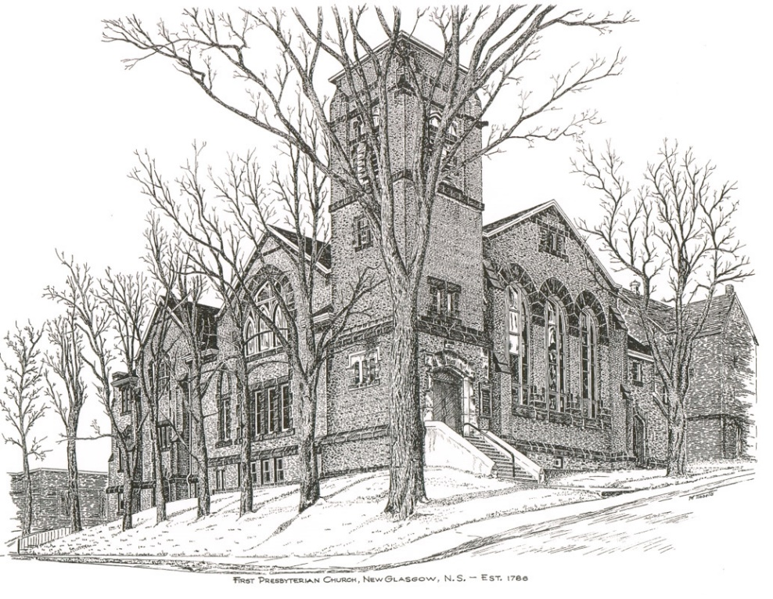

First Presbyterian Church
208 MacLean St., New Glasgow, NS
902-752-5691
first.church@ns.aliantzinc.ca
Reverend Grant Johnston
905-867-1914
grant.johnston@live.com
Order of Service
First Presbyterian Church, New Glasgow
Sunday, January 18th, 2026
**Please Rise**
Musical Prelude
Welcome and Announcements
**Entry of the Bible and lighting of the Christ Candle
**Musical Introit – #514 – “Jesus, we are gathered”
Call to Worship
**Hymn #330 – “O God, our help in ages past” vs.1-3,6

1 O God, our help in ages past,
our hope for years to come,
our shelter from the stormy blast,
and our eternal home.

2 Under the shadow of thy throne
thy saints have dwelt secure;
sufficient is thine arm alone,
and our defense is sure.

3 Before the hills in order stood,
or earth received its frame,
from everlasting thou art God,
to endless years the same.

6 O God, our help in ages past,
our hope for years to come,
still be our guard while troubles last,
and our eternal home.

Prayers of Approach and the Lord’s Prayer

Our Father which art in heaven, hallowed be thy name.

Thy kingdom come, thy will be done in earth,

as it is in heaven.

Give us this day our daily bread.

And forgive us our debts, as we forgive our debtors.

And lead us not into temptation, but deliver us from evil:

For thine is the kingdom, and the power, and the glory,

forever. Amen.

Assurance of Pardon
Passing of the Peace
**Hymn #573 – “I'll love the Lord” vs. 1-3
- I’ll love the Lord with all that lies inside me;
I’ll love the Lord with body, soul and mind.
I’ll love the Lord with all that lies inside me;
I’ll love the Lord with body, soul and mind,
and every goodness, every blessing in the Lord I’ll find,
and every goodness, every blessing in the Lord I’ll find.
I’ll love the Lord with all that lies inside me;
I’ll love the Lord with body, soul and mind.

- I’ll walk the path that Christ has walked before me;
I’ll give my yes to him who gave me all.
I’ll walk the path that Christ has walked before me;
I’ll give my yes to him who gave me all.
In every sound and every silence I will hear his call.
In every sound and every silence I will hear his call.
I’ll walk the path that Christ has walked before me;
I’ll give my yes to him who gave me all.

- I’ll let my life be open to God’s Spirit,
to make me new and set my faith on fire.
I’ll let my life be open to God’s Spirit,
to make me new and set my faith on fire.
More than all things, God’s peace and presence are what I desire.
More than all things, God’s peace and presence are what I desire.
I’ll let my life be open to God’s Spirit,
to make me new and set my faith on fire.
Children’s Time
Prayer of Illumination
Responsive Psalm –
RESPONSIVE PSALM (Psalm 40 selected verses, GNT)

LEADER: I waited patiently for the Lord's help; then he listened to me and heard my cry. He pulled me out of a dangerous pit, out of the deadly quicksand.

PEOPLE: He set me safely on a rock and made me secure.

LEADER: He taught me to sing a new song, a song of praise to our God.

PEOPLE: Happy are those who trust the Lord.

LEADER: You have done many things for us, O Lord our God; there is no one like you! You have made many wonderful plans for us.

PEOPLE: I could never speak of them all - their number is so great!

LEADER: How I love to do your will, my God! I keep your teaching in my heart.

PEOPLE: In the assembly of all your people, Lord, I told the good news that you save us. You know that I will never stop telling it.

LEADER: I have not kept the news of salvation to myself; I have always spoken of your faithfulness and help. I have not been silent about your loyalty and constant love.

PEOPLE: Lord, I know you will never stop being merciful to me. Your love and loyalty will always keep me safe.

First Lesson: Isaiah 49: 1-7
Epistle Lesson: 1 Corinthians 1: 1-9

**Gloria Patri

Glory be to the Father, and to the Son, and to the

Holy Ghost. As it was in the beginning, is now and ever shall be, world without end.

Amen, amen.

Gospel Lesson: John 1: 29-42
Anthem - “Give Thanks” - Henry Smith
Sermon: “He Takes Away the Sin of the World! (John 1:29)
**Reaffirmation of Faith – Apostles Creed

I believe in God, the Father Almighty, maker of Heaven and earth; and in Jesus Christ, His only Son, Our Lord, who was conceived by the Holy Ghost, born of the Virgin Mary,
suffered under Pontius Pilate, was crucified, died, and was buried. He descended into Hell. On the third day He arose again from the dead; He ascended into Heaven, and sits
at the right hand of God, the Father Almighty; from thence He shall come to judge the quick and the dead.
I believe in the Holy Ghost, the holy Catholic Church,
the communion of saints, the forgiveness of sins, the resurrection of the body, and the life everlasting. Amen.

**Hymn #682 - “Just as I am, without one plea” vs. 1,2,4,5
1 Just as I am, without one plea,
but that thy blood was shed for me,
and that thou biddest me come to thee,
O Lamb of God, I come, I come.

2 Just as I am, though tossed about
with many a conflict, many a doubt,
fightings and fears within, without,
O Lamb of God, I come, I come.

4 Just as I am, thou wilt receive,
wilt welcome, pardon, cleanse, relieve;
because thy promise I believe,
O Lamb of God, I come, I come.

5 Just as I am, thy love unknown
has broken every barrier down.
Now to be thine, yea, thine alone,
O Lamb of God, I come, I come.

Call to the Offering
Doxology
Praise God from whom all blessings flow. Praise Him all creatures here below. Praise Him above Ye Heavenly Host. Praise Father, Son, and Holy Ghost. Amen.

Offertory Prayer
Prayers of the People
**Hymn #298 - “Glory be to God the Father”
1 Glory be to God the Father,
glory be to God the Son,
glory be to God the Spirit,
God almighty, Three-in-One!
Glory, glory, glory, glory,
while eternal ages run.

2 Glory to the One who loved us,
washed us from each sin and stain,
glory to the One who bought us,
raised us up to serve and reign.
Glory, glory, glory, glory,
to the Lamb that once was slain.

3 Glory, blessing, praise eternal!
angel choirs their hymns prolong;
Honour, riches, power, dominion!
echoes all creation’s song.
Glory, glory, glory, glory,
praises to our God belong.

**Benediction
**Choral Response:
Go now in peace, never be afraid.
God will go with you each hour of ev’ry day.
Go now in faith, steadfast, strong and true.
Know He will guide you in all you do.
Go now in love and show you believe.
Reach out to others, so all the world can see.
God will be there, watching from above.
Go now in peace, in faith, and in love.
Amen, Amen, Amen

Recessional

ANNOUNCEMENTS

All are welcome at First Presbyterian Church. We hope you experience the love of God and of this congregation as we worship, celebrate, and serve one another.

PASTORAL CARE: In order to provide support to the people of First Church, when you or a loved one is sick or in hospital, we encourage you to contact the church office (902-752-5691) or your Elder to inform us. It is also important that you inform the hospital that you would welcome a visit from the minister and/or your Elder.

UPCOMING FIRST CHURCH EVENTS:
Meetings/events this week:

- Today – 12:15 p.m. – The Board of Managers will meet after service.
- Please join us for coffee time after service today.

EVENTS YOU MAY BE INTERESTED IN:

Tues., Jan. 20th – 10:00 a.m. – Pictou Presbytery will meet in Springville.

An Introduction to the Bible: A ten-session study on “The Acts of the Apostles” will take place at St. Andrew’s Presbyterian Church, New Glasgow (The Kirk), beginning Friday, Jan. 23, 2026, 10:00 – 11:30 a.m. or 2:00 – 3:30 p.m. To register, contact Rev. Grant Johnston: grant.johnston@live.com, or text/call: (905) 867-1914.
Fitness Classes:
- “Get Fit – 55 plus” -, Mondays, 10-11 a.m.
- “Chair yoga”: Classes Wednesdays, 10-11 a.m.

This week we honour Lois MacLellan as she celebrates her birthday, Fri., Jan. 23rd. Hope you have a great day Lois!

SCRIPTURE READERS & USHERS:
Reader: Sharon Mason
Ushers: Main Door (Office) – Cathy Lewis
James St. – Jackie and Gary Ross
MacLean St. (Main Entrance steps) – Ellen Jardine
Early Christian Educators: Lynne Ann & Lois MacLellan

Mission Statement: But he’s already made it plain how to live, what to do, what God is looking for in men and women. It’s quite simple. Do what is fair and just to your neighbor, be compassionate and loyal in your love, and don’t take yourself too seriously – take God seriously. Micah 6: 8-The Message

