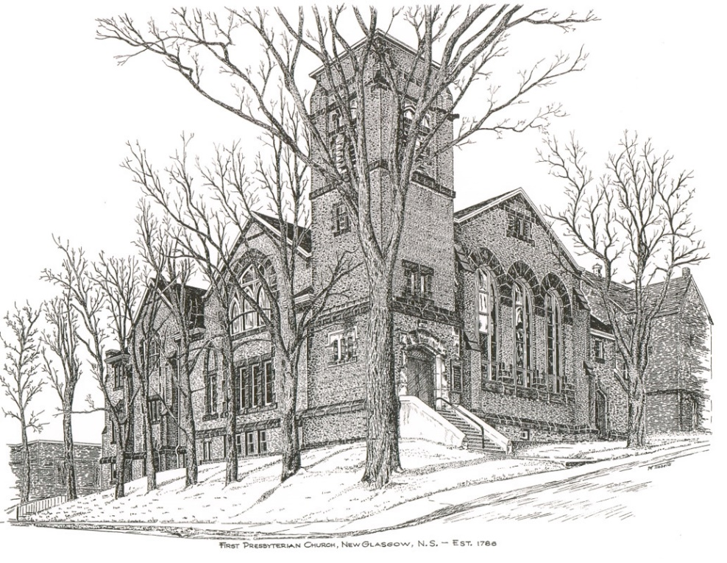

First Presbyterian Church
208 MacLean St., New Glasgow, NS
902-752-5691
first.church@ns.aliantzinc.ca
Reverend Grant Johnston
905-867-1914
grant.johnston@live.com

Order of Service
Sunday, January 4th , 2026

**Please Rise**
Musical Prelude
Welcome and Announcements
**Entry of the Bible
**Musical Introit – Hymn #152 – “Still, still, still” vs.2
Call to Worship
**Hymn #172 - “As with gladness men of old”
1 As with gladness men of old
did the guiding star behold;
as with joy they hailed its light,
leading onward, beaming bright;
so, most gracious Lord, may we
evermore be led to thee.

2 As with joyful steps they sped,
Saviour, to thy lowly bed,
there to bend the knee before
thee, whom heaven and earth adore,
so may we with willing feet
ever seek thy mercy seat.

3 As they offered gifts most rare
at thy cradle rude and bare,
so may we with holy joy,
pure and free from sins alloy,
all our costliest treasures bring,
Christ, to thee, our heavenly King.

4 Holy Jesus, every day
keep us in the narrow way,
and when earthly things are past,
bring our ransomed souls at last
where they need no star to guide,
where no clouds of glory hide.

5 In that heavenly country bright
need they no created light:
thou its light, its joy, its crown,
thou its sun which goes not down;
there forever may we sing
hallelujahs to our King.

Prayers of Approach and the Lord’s Prayer

Our Father which art in heaven, hallowed be thy name.

Thy kingdom come, thy will be done in earth,

as it is in heaven.

Give us this day our daily bread.

And forgive us our debts, as we forgive our debtors.

And lead us not into temptation, but deliver us from evil:

For thine is the kingdom, and the power, and the glory,

forever. Amen.
Assurance of Pardon
Passing of the Peace
**Hymn #173 - “We three kings” vs.1, 2, 5
1 We three kings of Orient are;
bearing gifts we traverse afar,
field and fountain, moor and mountain,
following yonder star.

CHORUS O star of wonder, star of light,
star of royal beauty bright,
westward leading, still proceeding,
guide us to thy perfect light.

2 Born a King on Bethlehem’s plain,
gold I bring to crown him again,
King forever, ceasing never,
over us all to reign.

5 Glorious now behold him arise,
King and God and sacrifice:
hallelujah, hallelujah,
sounds through the earth and skies.

Children’s Time
Prayer of Illumination
Responsive Psalm - Psalm 147: 12-20
LEADER: Praise the Lord, O Jerusalem! Praise your God, O Zion!
PEOPLE: He keeps your gates strong; he blesses your people.
LEADER: He keeps your borders safe and satisfies you with the finest wheat.
PEOPLE: He gives a command to the earth, and what he says is quickly done.
LEADER: He spreads snow like a blanket and scatters frost like dust.
PEOPLE: He sends hail like gravel; no one can endure the cold he sends!
LEADER: Then he gives a command, and the ice melts; he sends the wind, and the water flows.
PEOPLE: He gives his message to his people, his instructions and laws to Israel.
LEADER: He has not done this for other nations; they do not know his laws.
PEOPLE: Praise the Lord!
First Lesson: Jeremiah 31:10-14
Epistle Lesson: Ephesians 1:11-14
**Gloria Patri

Glory be to the Father, and to the Son, and to the

Holy Ghost. As it was in the beginning, is now and ever shall be, world without end.

Amen, amen.

Gospel Lesson: Matthew 2: 13-23
Anthem - “Colorful Creator, God of mystery”
Sermon: “What’s going to happen to King Herod?”
**Reaffirmation of Faith – Apostles Creed

I believe in God, the Father Almighty, maker of Heaven and earth; and in Jesus Christ, His only Son, Our Lord, who was conceived by the Holy Ghost, born of the Virgin Mary,
suffered under Pontius Pilate, was crucified, died, and was buried. He descended into Hell. On the third day He arose again from the dead; He ascended into Heaven, and sits
at the right hand of God, the Father Almighty; from thence He shall come to judge the quick and the dead.
I believe in the Holy Ghost, the holy Catholic Church,
the communion of saints, the forgiveness of sins, the resurrection of the body, and the life everlasting. Amen.

**Hymn #176 - “Songs of thankfulness and praise” vs. 1,2,5

1 Songs of thankfulness and praise
Jesus, Lord, to you we raise,
God revealed by guiding star
to the sages from afar,
branch of royal David’s stem,
in your birth at Bethlehem:
anthems be to you addressed,
God in Christ made manifest.

2 God revealed at Jordan’s stream
God’s beloved Son supreme,
and at Cana, wedding guest,
in your power manifest,
God revealed in works divine,
changing water into wine:
anthems be to you addressed,
God in Christ made manifest.

5 Grant us grace to see you, Lord,
mirrored in your holy word;
may we imitate you still
and obey your perfect will,
that we like to you may be,
at your great Epiphany:
may your glory be confessed,
God in Christ made manifest.

Call to the Offering
Doxology
Praise God from whom all blessings flow. Praise Him all creatures here below. Praise Him above Ye Heavenly Host. Praise Father, Son, and Holy Ghost. Amen.

Offertory Prayer
Prayers of the People
**Hymn #168 - “See amid the winter's snow” vs.1,3 4,5
- See amid the winter's snow,
born for us on earth below;
see the Lamb of God appears,
promised from eternal years.

Chorus: Hail, O ever-blessed morn!
Hail, redemption's happy dawn!
Sing through all Jerusalem,
Christ is born in Bethlehem.

3. Say, now holy shepherds, say
tell your joyful news today;
tell us why you left your sheep
on the lonely mountain steep?

4. “As we watched at dead of night,
lo, we saw a wondrous light;
angels, singing peace on earth,
told us of the Saviour's birth".

5. Sacred infant, all divine,
of God’s tender love the sign,
for you came from highest bliss,
down to such a world as this!

**Benediction
**Choral Response:
Recessional

Mission Statement: But he’s already made it plain how to live, what to do, what God is looking for in men and women. It’s quite simple. Do what is fair and just to your neighbor, be compassionate and loyal in your love, and don’t take yourself too seriously – take God seriously. Micah 6: 8-The Message

ANNOUNCEMENTS

All are welcome at First Presbyterian Church. We hope you experience the love of God and of this congregation as we worship, celebrate, and serve one another.

PASTORAL CARE: In order to provide support to the people of First Church, when you or a loved one is sick or in hospital, we encourage you to contact the church office (902-752-5691) or your Elder to inform us. It is also important that you inform the hospital that you would welcome a visit from the minister and/or your Elder.

UPCOMING FIRST CHURCH EVENTS:
Meetings: There are no meetings scheduled this week.

EVENTS YOU MAY BE INTERESTED IN:
Today – 3:00p.m., Trinity United Church – The Carillon Singers Present: “A Journey Around the World in Carols” - The Carillon Singers invite you to embark on a musical journey across continents this holiday season. This concert will feature beloved seasonal music in diverse languages, spanning from North America to Europe. This year’s celebration welcomes special guest flutist Allison Avery, the Carillon Youth Ensemble, and other talented performers who will join the Carillons in creating an unforgettable evening of harmony and joy. Following the performance, guests are invited to a festive reception with mulled cider and light treats.
Tues., Jan. 13th – 11a.m. – Songwriting Workshop - East Currents Music Circle is a program for people who are unhoused, insecurely housed or who have been unhoused. Music is a powerful tool for self-expression. These programs are intended for fun, connection, creative expression, empowerment, inspiration, self-knowledge and healing. No musical experience required. Registration is not necessary but encouraged. You can call 902-752-8233 or register at the library (back of the Aberdeen Business Centre) for more information.

An Introduction to the Bible: A ten-session study on “The Acts of the Apostles” will take place at St. Andrew’s Presbyterian Church, New Glasgow (The Kirk), beginning Friday, January 23, 2026, 10:00 – 11:30 a.m. or 2:00 – 3:30 p.m. To register, contact Rev. Grant Johnston: grant.johnston@live.com, or text/call: (905) 867-1914.

Today we send our best wishes to Shirley Cruickshank as she celebrates her birthday tomorrow, Jan. 5th. Have a great day Shirley!

SCRIPTURE READERS & USHERS:

Reader: Mark Thibeau
Ushers: Main Door (Office) – Cathy Lewis
James St. – Jackie and Gary Ross
MacLean St. (Main Entrance steps) – Ellen Jardine
Early Christian Educators: Lynne Ann & Lois MacLellan

