**First Presbyterian Church**

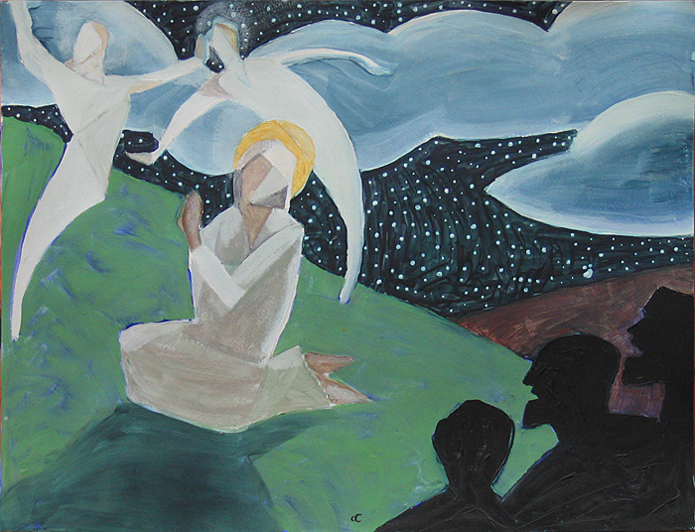

**Sunday, March 2nd, 2025**

Transfiguration Sunday

Minister:  **The Reverend Marianne Emig Carr**

Director of Music: **Kathleen Howard**

Reader: **David Paul**

**______________________________________________________________________________________________________________________________________________________________________________**

**Welcome to worship!** Thank you for joining us from wherever you are! In-person services of worship continue, with online options available for those who are more comfortable worshipping from home.

**Information for In-Person Worship**

**\* ACCESSIBLE WASHROOM FACILITIES** for all people are available **on the Sanctuary level**. These washrooms are found through the doors behind the Choir Loft - right turn - straight ahead. Please feel free to use these washrooms whenever necessary!

**\* CHILDREN’S MINISTRY –** TheChildren are invited to join our volunteers, in the Church Hall, for a time of fun and faith-centered activities, following the Children’s Message this morning.

**\* HEARING IN THE SANCTUARY -** First Church has available a system of FM RECEIVERS and HEADSETS. They are for use by those who find it difficult to hear in the Sanctuary. If you would like to use one this morning, visit our Sound Technician.

* **COFFEE HOUR** – Please join us this morning, in the Church Hall, for a light luncheon and the **ANNUAL MEETING** of our **CONGREGATION**, following worship. To volunteer to host, bake, or bring food to any coffee hour call Tamara Chapman.

**ASSISTING YOU THIS MORNING**

Greeter: **Janice Walroth** Elevator: **Bob Walroth**

Sound and Video Team **– Quentin Robinson, Kade LeBrun**

**Michel LaBonte and Mark Leslie**



**NEED A RIDE?**

**Call Executive Taxi!**

A free service provided by your M.O.V.E. Committee

**\*** Our website and social media accounts:

[**https://pccweb.ca/firstchurch-brockville/**](https://pccweb.ca/firstchurch-brockville/)[**https://www.facebook.com/Firstkirk/**](https://www.facebook.com/Firstkirk/)

[**www.instagram.com/firstpresbrockville/**](http://www.instagram.com/firstpresbrockville/)

[**https://twitter.com/firstkirk**](https://twitter.com/firstkirk)

**\*** YouTube Channel: [**https://www.youtube.com/ @firstpresbyterianchurchbro482/streams**](https://www.youtube.com/%20@firstpresbyterianchurchbro482/streams)

**\*** **Cogeco/Channel 10/700 Services** every Sunday at 7 am. and 5:30 pm.

**\* For pastoral care or assistance**, please call the Church Office at 613-345-5014 or 613-340-3310. You may also call or text Reverend Marianne at 613-449-5042.

***the people of God gather….***

***The liturgical colour for this Sunday is White. White is used for significant days or seasons***

***in the redemptive work of Jesus Christ, and for other theological commemorations.***

The Organ Prelude **My Faith Looks Up To Thee** *arr. Hal Hopson*

Welcome and Announcements

Call to Worship God

Minister: The church lives to praise God.

**All: We have no higher calling than to offer the worship that belongs to God, day by day, Sunday by Sunday.**

Minister: Through the preaching of the Word and the celebration of the Sacraments, in praise, prayer, teaching and fellowship, God sustains the life of the church.

**All: We worship God, offering ourselves in the service of Christ, rejoicing in the Holy Spirit.**

Opening Hymn # 490: **God of grace and God of glory** *Words & Music: Public Domain*

**1. God of grace and God of glory, on thy people pour thy power;**

**crown thine ancient church's story; bring its bud to glorious flower.**

**Grant us wisdom, grant us courage for the facing of this hour,**

**for the facing of this hour.**

**2. Lo! the hosts of evil round us, scorn thy Christ, assail his ways!**

**From the fears that long have bound us, free our hearts to love and praise.**

**Grant us wisdom, grant us courage for the living of these days,**

**for the living of these days.**

**3. Cure thy children's warring madness, bend our pride to thy control;**

**shame our wonton, selfish gladness, rich in things and poor in soul.**

**Grant us wisdom, grant us courage, lest we miss thy kingdom's goal,**

**lest we miss thy kingdom's goal.**

**4. Set our feet on lofty places; gird our lives that they may be**

**armoured with all Christ-like graces, pledged to set all captives free.**

**Grant us wisdom, grant us courage, that we fail not them nor thee,**

**that we fail not them nor thee!**

**5. Save us from weak resignation to the evils we deplore;**

**let the search for thy salvation be our glory evermore.**

**Grant us wisdom, grant us courage, serving thee whom we adore,**

**serving thee whom we adore.**

Prayer As We Approach God

Minister: God of grace and God of glory, you reveal your presence to the world in radiant glory and gentle whispers,

**All: on mountain tops and lowly plains, in classrooms and hospital beds, in homes and churches, in the silence of nature and the sounds of cities.**

Minister: Yours is the presence that pushes past our fears. Yours is the touch that transforms our doubts**.**

**All: We come before you to celebrate your goodness, to focus on your light, and offer you all praise, honour and thanksgiving, for you are our God and we are your people, now and always. Amen.**

The Chancel Choir **Transfigured Christ, none comprehends**

*Words: Alan Gaunt; Music: Jeremiah Clarke*

Prayer of Confession

Minister: Lord of eternal light, in your mercy, hear us as we confess our sins:

**All: God of mercy and forgiveness, facing the light of your goodness, we confess all that keeps us from sharing that goodness. We are distracted by the desire to have more than we need. We focus on our own disappointments rather than trust the future you create. We feel discouraged by the turmoil and violence in our world and fail to claim the hope you hold out to us in Christ. Transfigure us by your grace and shape us into disciples who follow Christ’s leading each day. Amen.**

Assurance of God’s Forgiveness

Minister: Do not be afraid. God’s forgiveness shines into the world. The morning star rises in our hearts, and we are made new. Know that you are forgiven and forgive one another in Christ’s name.

The Children’s Message **Mountaintop Experiences**

Minister: Have you ever had a day that was so wonderful that you wanted it to last forever? Did you know that Jesus' disciples had days like that, too? This Sunday is Transfiguration Sunday, and on this Sunday, we remember a special day for Jesus and his disciples.

One day, Jesus took Peter, James, and John with him up onto a mountain to pray. As Jesus was praying, something amazing happened. The Bible says that the appearance of his face began to change and that his clothing became as bright as a flash of lightning!! Then Moses and Elijah, two important people in the Old Testament, appeared with Jesus and were talking to him.

When Peter saw this, he could not believe his eyes. How could Moses and Elijah be here, standing and talking with Jesus?? It was so incredible, Peter told Jesus that he thought that they should stay up there on the mountain forever and build three homes - one for Jesus, one for Moses, and one for Elijah.

Peter did not understand that this wonderful experience on the mountain was not meant to last. Following this moment on the mountain, Jesus came down to earth, and later on, he died on a cross, was buried, and rose from the grave so that you and I could have eternal life in heaven. If they had stayed on that mountain, they would have missed out on everything that was still to come. They would have missed out on this wonderful gift of eternal life.

You and I have had, and will have in the future, many wonderful experiences as we follow Jesus. When we have a great "mountaintop experience" like Peter did in today’s story, we wish that it would never end. But remember, when we follow Jesus and accept him as our Saviour, the best is yet to come!

Children’s Prayer:

Dear God, we thank you for all of the wonderful experiences you allow us to enjoy as we walk each day with Jesus. Help us to follow Jesus wherever he leads us. In Jesus’ name. Amen.

Hymn # 186: **Swiftly pass the clouds of glory**

*Words ©Oxford University Press CCLI License # 20312607/20312614 Music: ©1985 Church Pension Fund*

**1. Swiftly pass the clouds of glory, heaven’s voice, the dazzling light;**

**Moses and Elijah vanish; Christ alone commands the height!**

**Peter, James and John fall silent, turning from the summit’s rise**

**downward toward the shadowed valley where their Lord has fixed his eyes.**

**2. Glimpsed and gone the revelation, they shall gain and keep its truth,**

**not by building on the mountain any shrine or sacred booth,**

**but by following the Saviour through the valley to the cross**

**and by testing faith’s resilience through betrayal, pain and loss.**

**3. Lord, transfigure our perception with the purest light that shines**

**and recast our life’s intentions to the shape of your designs,**

**till we seek no other glory than what lies past Calvary’s hill,**

**and our living and our dying and our rising by your will.**

***to hear God’s word….***

Prayer for Insight and Understanding

David: God of all wisdom and truth, we seek your guidance as we hear the Scriptures read and interpreted today. Send your Holy Spirit to open our minds and hearts, to give us fresh understanding and a renewed commitment to follow your Word. Amen.

Psalm 99 (read responsively)

David: The Lord reigns; let the peoples tremble!

**People: The Lord sits enthroned upon the cherubim; let the earth quake!**

David: The Lord is great in Zion, exalted over all the peoples. Let them praise your great and awesome name.

**People: Holy is the Lord!**

David: Mighty Ruler, lover of justice, you have established equity;

**People: you have executed justice and righteousness in Jacob.**

David: Extol the Lord our God; worship at God’s footstool.

**People: Holy is the Lord!**

David: Moses and Aaron were among God’s priests. Samuel also was among those who called on God’s name.

**People: They cried to the Lord, who answered them.**

David: The Lord spoke to them in the pillar of cloud;

**People: they kept God’s decrees, and the statutes that God gave them.**

David: O Lord our God, you answered them;

**People: you were a forgiving God to them, but an avenger of their wrongdoings.**

David: Extol the Lord our God, and worship at the holy mountain;

**People: for the Lord our God is holy.**

Reading from Scripture: **Luke 9: 28 - 36** *New International Version (NIV)*

David: **The Transfiguration**

About eight days later, Jesus took Peter, John and James with him and went up onto a mountain to pray. As he was praying, the appearance of his face changed, and his clothes became as bright as a flash of lightning. Two men, Moses and Elijah, appeared in glorious splendor, talking with Jesus. They spoke about his departure, which he was about to bring to fulfillment at Jerusalem. Peter and his companions were very sleepy, but when they became fully awake, they saw his glory and the two men standing with him. As the men were leaving Jesus, Peter said to him, “Master, it is good for us to be here. Let us put up three shelters - one for you, one for Moses and one for Elijah.” (He did not know what he was saying.)

While he was speaking, a cloud appeared and covered them, and they were afraid as they entered the cloud. A voice came from the cloud, saying, “This is my Son, whom I have chosen; listen to him.” When the voice had spoken, they found that Jesus was alone. The disciples kept this to themselves and did not tell anyone at that time what they had seen.

David: For the word of God in scripture, for the word of God within us, and for the word of God around us. **People: Thanks be to God.**

The Chancel Choir: **I Will Serve the Lord All My Days** *Nancy Price & Don Besig*

The Meditation **Glow Up**

Minister: Being around teenagers and young people, I hear slang expressions that are not always clear on their face. For example, to “slay” means you are doing something well, such as “you are ‘slaying’ that math class”. Or to “flex”, which means to brag about something. A third one, which I think applies to our story today, is “glow up”, which means “a physical or emotional makeover, a positive transformation”. In other words, to “glow up” means to make a change that reveals more closely who we are really meant to be.

In Luke 9:28-36, we see Jesus literally had undergone a “glow up”. His face changes, his clothes become dazzling white, and the disciples witness something extraordinary. This moment, known as the **Transfiguration**, was not just about Jesus looking different; it was about revealing his true identity as the Son of God. And just as Jesus shone with the glory of God, we too are invited to experience his transforming presence and undergo our own “glow up”.

The glow of Jesus did not happen randomly; it happened while he was praying. As he was communing with the Father, his appearance changed. This tells us something important: when we spend time with God, we are transformed. Prayer is not just about asking for things; it is about stepping into God’s presence and allowing God to change us from the inside out. In the Book of Exodus, you will recall that when Moses spent time with God on Mount Sinai, his face shone so brightly that people could hardly look at him. In the same way, when we consistently seek God in prayer, our lives begin to radiate that divine glow. We may not shine physically, but people will notice the difference in our words, our attitudes, and the peace that surrounds us.

As Jesus is glowing, something even more incredible happens - Moses and Elijah appear beside him. These two figures represent the Law and the Prophets, showing that Jesus is the fulfillment of everything God had been doing throughout history. They are talking with Jesus about his coming departure, meaning his death and resurrection. While Peter, James, and John watch in awe, Peter, in his usual impulsive way, suggests building shelters to keep the moment going. He wants to stay on the mountain, soaking in the glory. But that was not God’s plan.

Then, in the middle of this incredible scene, a cloud covers them, and a voice speaks: “*This is My Son, whom I have chosen; listen to him*.” This is the second time in Scripture that Jesus has been affirmed as God’s Son, the first being at his baptism. The command is simple but powerful: listen to Jesus. If we want to be transformed, to shine with the light of Christ, we must listen to Jesus, follow his voice, and align our lives with his truth. The world offers many sources of artificial light - things that claim to bring happiness, success, and fulfillment. But only Jesus offers a light that never fades, a light that positively changes us, to give us a “glow up”. When we listen to Jesus, our lives are filled with a glow that nothing in this world can take away. The Transfiguration was a glimpse of Jesus' divine glory, a preview of the resurrection and the Kingdom to come. It was a reminder that Jesus is not just another teacher or prophet - he is the very Son of God. And just as he was transformed before the disciples’ eyes, Jesus invites us to be transformed by his presence, to be “glowed up”.

Faith is not about staying in moments of spiritual “high”; it is about carrying that experience back into everyday life. While we all love “mountaintop” moments, we cannot stay there forever. Jesus came down from the mountain because God’s mission was for him to go to the cross. We, too, must take the glow we receive from God and bring it into our families, workplaces, and communities. In short, we need to “glow up”, to show how we have been positively changed by our relationship to God. This Sunday is Transfiguration Sunday, the last Sunday before the Season of Lent begins this week on Ash Wednesday. Lent is a season that is often viewed as being as dour and solemn, focusing on fasting, repentance and self-examination. However, I think Lent can be viewed as an opportunity for us to “glow up”, to be made over, by entering into a deeper intimacy with the Lord through prayer, reading scripture, and giving of ourselves to help others. In other words, to be more like Jesus. Right now, the world seems to be full of darkness, anxiety and despair. Sometimes that can be overwhelming, causing us to have doubts as to how we, as Christians, can change that. But we are called to shine in that darkness, to be people of light, to make a difference. When we walk closely with Jesus, we shine - not with our own glory, but with his, as we are made over in Jesus’ likeness. We shine, not with temporary light, but with the eternal, radiant presence of Christ shining through us. So, as we enter the season of Lent, let us see it as an opportunity for us to be positively changed, to be transformed, to “glow up”, as we walk in relationship with our Saviour. Amen.

Blessing the Word in our Lives

Minister: O creating God, the universe proclaims your truth, and your knowledge flows night and day! Through the Spirit open our ears to hear, our minds to comprehend, our hearts to receive, and our hands and feet to serve. Amen.

Hymn # 177: **Christ, whose glory fills the skies** *Words & Music: Public Domain*

**1. Christ, whose glory fills the skies, Christ, the true, the only Light,**

**Sun of righteousness arise, triumph o’er the shades of night.**

**Dayspring from on high, be near;**

**Daystar, in my heart appear.**

**2. Dark and cheerless is the morn unaccompanied by thee;**

**joyless is the day’s return, till thy mercy’s beams I see,**

**till thy inward light impart,**

**glad my eyes and warm my heart.**

**3. Visit, then, this soul of mine; pierce the gloom of sin and grief;**

**fill me, radiancy divine; scatter all my unbelief;**

**more and more thyself display,**

**shining to the perfect day.**

***Responding in love with thanksgiving***

Prayers of the People, the Lord’s Prayer and Choral Amen

Minister: Revealing God, you bless us with your presence and wisdom, and we marvel at the wonders of your love. You created a beautiful world that reveals your majesty. You sent your son to show us how to live with compassion. Your Holy Spirit guides us on our way. Thank you for opening our eyes to your presence each day. Help us to recognize you not only in mountaintop experiences, but also in everyday tasks and in times of great challenge. God, in your mercy,

**People: hear our prayer.**

Minister: Loving God, there is so much in this world needing the transformation only you can provide. Where there is violence, bring calm; where there is poverty, send sustenance; where there is confusion, bring wisdom; where there is chaos, create order; where minds and hearts are troubled, bring comfort; where pain is crippling, grant release. Move the hearts of the rich to share with those in need; and call the powerful to act with justice for those at risk, praying especially for Gaza, Ukraine, Afghanistan, Sudan, Yemen, Venezuela and Haiti. Give us all the will to work for the wellbeing of the earth and to live with respect for the fragile balances within your creation. Hear us now in this time of silence as we raise to you the names and situations on our hearts this day. Hear the cries of all who suffer and bring each one hope of new life with you. God, in your mercy,

**People: hear our prayer.**

Minister: Eternal God, we pray for your church around the world and for our congregation. Give your people the energy to shine wherever there is persecution, despair or discouragement. Bless each congregation with wisdom and vision, as we face the changes that we see around us. Renew our imagination and commitment to develop new forms of ministry and mission for the days ahead. Inspire us with greater delight in your mystery, and greater joy in seeking your presence. God, in your mercy,

**People: hear our prayer.**

Minister: We ask all these things through Christ Jesus, who revealed your will to us through your revolutionary love, and taught us to pray these words together:

**All: Our Father, who art in heaven,** **hallowed be thy name.** **Thy kingdom come.** **Thy will be done, on earth as it is in heaven.** **Give us this day our daily bread,** **and forgive us our debts,** **as we forgive our debtors.**  **Lead us not into temptation,** **but deliver us from evil,** **for thine is the kingdom, and the power,** **and the glory, forever and ever. Amen.**

The People’s Offering for the Work of Christ’s Church

Invitation to the Offering

Minister: God has been revealed in glory for the healing of the world. We have glimpsed that healing in the hope we share in Christ, even in these challenging times. Let us present our gifts to God so that this healing and hope will continue to spread in the world God loves.

You can give…..

**\*** by pre-authorized remittance (**P.A.R.**) (<https://presbyterian.ca/plannedgiving/pre-authorized-remittance-par-program/>). Contact the Church Office.

**\*** by **e-transfer** to [firstkirk@truespeed.ca](mailto:firstkirk@truespeed.ca)

**\*** by **mail** to First Presbyterian Church, P.O. Box 885, 10 Church Street, Brockville, Ont., K6V 5W1

Offering Praise Song

**Praise God from whom all blessings flow.**

**Praise him, all creatures here below.**

**Praise him above, ye heavenly host.**

**Praise Father, Son, and Holy Ghost.**

Prayer of Dedication

Minister: Gracious God, you have given us life and blessed us in Christ with new life. Bless the gifts we offer today, and bless our lives, so that others may see his grace at work in us and what we offer the world in Jesus’ name.

Sending Hymn # 355:  Light of the minds that know him

*Words: © Hope Publishing Co. CCLI License # 20312607/20312614 Music: Public domain*

**1. Light of the minds that know him, may Christ be light to mine!**

**My sun in risen splendour, my light of truth divine,**

**my guide in doubt and darkness, my true and living way,**

**my clear light ever shining, my dawn of heaven’s day.**

**2. Life of the souls that love him, may Christ be ours indeed!**

**The living bread from heaven on whom our spirits feed,**

**who died for love of sinners to bear our guilty load,**

**and make of life’s brief journey a new Emmaus Road.**

**3. Strength of the wills that serve him, may Christ be strength to me,**

**who stilled the storm and tempest, who calmed the tossing sea,**

**his Spirit’s power to move me, his will to master mine,**

**his cross to carry daily and conquer in his sign.**

**4. May it be ours to know him that we may truly love,**

**and loving, fully serve him as serve the saints above,**

**till in that home of glory with fadeless splendour bright,**

**we serve in perfect freedom our strength, our life, our light.**

The Benediction and Choral Amen

Minister: This Sunday marks the close of the season of Epiphany, yet God’s light continues to break into the world in Christ Jesus, and so: may the light of God lead you, the light of Christ embrace you, and the light of the Holy Spirit enliven you, so that you know both hope and peace this day and each coming day. Amen.

The Organ Postlude **Panis Angelicus** *Cesar Franck, arr. Hal H. Hopson*



We extend our love and sympathy to Dinie Moore on the death of her sister **CHRISTINE WILLAMINA WILSON** (nee TeKamp) on Monday, February 24th, 2025 at the Brockville General Hospital Palliative Care. A private celebration of Christine’s life will take place at a later date. Please remember Dinie and the Wilson and TeKamp families in your prayers. and their family in your prayers. Arrangements are entrusted to Eternal Care Ltd. – *www.eternalcare.ca*

Today, March 2nd **is LOAVES & FISHES Sunday -** Our Church supports the work of this restaurant with our donations of money and time. This ministry assists so many and we are thankful to be a part of it. Donations of food can be left in the basket at the rear of the Sanctuary or delivered to the Church Office (macaroni type pasta and coffee are great choices) during the week. Donations of money are welcome in your regular offering envelopes or online donations. Please mark all envelopes clearly. Thanks.



Josseling, an extroverted and enthusiastic 16-year-old, is committed and eager to get ahead. Beginning at 5 a.m., she and her mother have a stall selling fruits and vegetables at the Roberto Huembes Market in Nicaragua. Josseling attended entrepreneurship workshops run by PWS&D’s partner, which helped her establish her successful market stall. One of Josseling’s key principles is that “no one can leave the stand without buying,” so she carefully considers her customers’ budgets, asks about their specific needs, and adjusts the ingredients accordingly. This way, they can afford their purchases and will likely return to her for their next market visit. In addition to her market job, Josseling attends school, where she is currently a senior and dreams of becoming a doctor.



*A Mission Moment from The PCC*

**Nominations for SESSION**

SAVE the DATES!

**SHROVE TUESDAY**

**PANCAKE SUPPER!**

Tuesday, March 4th, 2025

**WORLD DAY of PRAYER**

Friday, March 7th, 2025

**HOLY WEEK**

April 13th to April 20th

**There will be three positions open on Session at the Annual Meeting on March 2nd. If you would like to be nominated for one of these positions, or would like to nominate another member of the church, please ask Quentin Robinson for a nomination form.**

**Email:** [**thesession@truespeed.ca**](mailto:thesession@truespeed.ca)**or message at 613-301-4159.**

**First Presbyterian Church**

**FEBRUARY CALENDAR**

**LOAVES & FISHES SUNDAY -** 1st Sunday of each month

**CRAFT & CHAT –** Tues. afternoons - Parlour – 1 to 4 pm.

**FPC HAND BELL CHOIR -** Thursday Afternoons at 4:30

**FPC CHANCEL CHOIR –** Thurs. Afternoons - 3 pm. – Choir Rm; Sun. Mornings - 9:30 am. - Choir Rm

**SUNDAY SUPPER MINISTRY** – 4th Sunday of each month – Church Hall

**ONGOING PROJECTS:** **Grocery Bags, Egg Cartons, Survival Kits** (Food Bank), **Pop Cans for Maintenance, Breakfast Bags (Food Bank), Sunday Supper Ministry**

**COMMUNITY GROUPS using the Church Building:**

EMBERS/GUIDES – Monday Evenings at 6 pm. in the Church Hall

DSLG Cooking Class - Thursday mornings – Thursday afternoons (with FB)  
DSLG Cricut Group - Tuesday afternoons

BGH DAY HOSPICE – Wednesday Mornings & Afternoons in the Parlour and Church Hall.

Mar 02 **MORNING WORSHIP (Transfiguration of the Lord) -** 11 am. in the Sanctuary

**Annual Meeting of the Congregation**

following Worship, in the Church Hall, Light Luncheon served.

Mar 04 **SHROVE TUESDAY PANCAKE SUPPER –** 6 pm. in the Church Hall

Tickets available in the Church Office - $10.00

Mar 06 **Meeting of the WORSHIP COMMITTEE - 11:30 am. in the Vestry.**

Mar 07 WORLD DAY of PRAYER

World Day of Prayer 2025: Please join us for World Day of Prayer. A prayer movement that invites everyone to enrich their faith experience with the experience of Christians from other countries and cultures and to bring hop to women touched by injustice. The service was written by the World Day of Prayer Committee of Cook Islands. **St. Paul’s Anglican Church, Brockville on Thursday, March 6th, 2025 at 7 pm**. This service is organized by members of churches who are part of the Brockville & Area Ministerial Association.

Mar 09 **MORNING WORSHIP (First Sunday in Lent) -** 11 am. in the Sanctuary - Communion

Coffee Hour, following worship, in the Church Hall.

**\*** Reverend Marianne leads worship at St. Lawrence Lodge

Mar 11 **Meeting of the M.O.V.E. COMMITTEE – 10 am. in the Hall.**

Mar 12 **Meeting of the SESSION – 7 pm. in the Red Room.**

**Office Hours** – March 3rd to 7th

**Monday, March 3rd – 10 am. to 11:30 and 1 pm. to 4:30 pm  
Tuesday, March 4th –** **10 am. to 4:30 pm.**

**Wednesday, March 5th – 10 am. to 4:30 pm.**

**Thursday, March 6th – 10 am. to 11:30 and 1 pm. to 4:30 pm  
Friday, March 7th – 10 am. to 1:30 pm.**

**The Church Building will be open as usual.**

Mar 16 **MORNING WORSHIP (Second Sunday in Lent) -** 11 am. in the Sanctuary

Coffee Hour, following worship, in the Church Hall.





**Happy Birthday** (**March 2nd to 8th)**

**MARGO STONE – March 4th**

**MARJORIE WOLTHAUSEN – March 4th**

**SHIRLEY HALL – March 5th**

**IT’S ALMOST TIME for ANOTHER EDITION!** The next edition of “THE CHALLENGE” is planned for distribution mid-March! Your stories and pictures of family times shared, friendship get-togethers, Lenten and Easter traditions, recipes, travels, and history anecdotes are such an important part of each publication! Also, stories and pictures of favourite memories of church events, projects, activities, and special services etc. are interesting. PICTURES ARE GREAT!!! Whatever you think might interest our readers. Email your stories and pictures to firstkirk@truespeed.ca or leave them at the Office! Thanks.



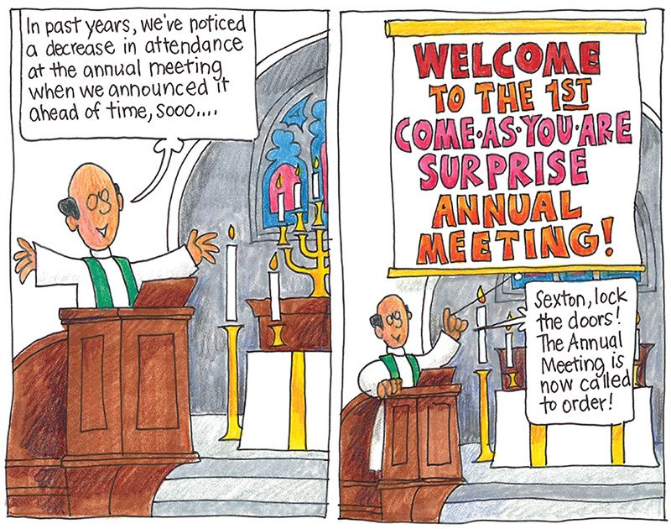



*The Sanctuary for Lent 2025* contains brief readings for each day in Lent, from Ash Wednesday through Easter Day, including a suggested Scripture, a short devotion, and a short prayer or practice - all based on the Revised Common Lectionary. This annual favourite will help you faithfully journey through Lent as you prepare to experience the joy of the Resurrection. Copies available on the table at the rear of the Sanctuary or in the Church Office.

**MEN’ BREAKFAST!**

**Saturday, APRIL 5th, 2025**

**at Stacked Restaurant**

**Email Quentin at** [thesesssion@truespeed.ca](mailto:thesesssion@truespeed.ca)

**if you can attend.**





**INTERNATIONAL WOMEN’S DAY 2025 (March 8th)**

**For ALL women and girls: Rights. Equality. Empowerment**

How PWS&D is bringing this year’s theme to life

and turning it into action.

**Meet Sapna in Pakistan**

Pakistan ranks as one of the worst countries in the world in terms of educational outcomes. Patriarchal norms prevent women and girls from accessing education and economic opportunities. Currently, 12 million girls are out of school in Pakistan, and only 13% of those in school advance beyond grade eight. In 2024, PWS&D began supporting a project in Pakistan to enhance girls’ access to education. Girls’ school enrolment and retention is incentivized by providing nutritious meals, in an area of the country where food insecurity can be severe. Additionally, communities and local leaders are educated on the importance of girls’ education.

Below, Sapna shares how being part of the project is changing lives in her community.

My name is Sapna, and I am 12 years old. My younger sister Raksha, who is 10, and I are part of a story that is reshaping our village’s future. In our quiet village of Ratnoor, where opportunities for girls once seemed distant, a remarkable transformation has taken place. Not long ago, the girls’ school in Ratnoor was closed, leaving many of us without a chance to learn. Our dreams seemed like fragile whispers, stifled by circumstances beyond our control. But everything changed when PWS&D’s partner (name withheld for security reasons) stepped in and reopened the girls’ school. From the moment the doors opened, a new chapter began, not just for us but for every girl in the village. Girls receive nutritious meals at their school in Pakistan, as part of an effort to ensure their enrolment and attendance.

Now, every morning, Raksha and I eagerly head to school with bright smiles and hearts full of hope. The school has become more than a place of learning - it is where our dreams are nurtured, our health is cared for and our spirits are lifted. One of the things we love most are the delicious meals we receive every day. We eat a variety of nutritious meals that have made us healthier and more energetic. Our favourite is biryani, served once a week, which we eagerly look forward to. It is not just food – it is a moment of joy that brings all of us together and makes studying even more enjoyable. Because of these meals, more girls in our village are coming to school. Enrolment has risen and the excitement to learn is growing every day. The school has become a hub of activity and aspirations. Our favorite subject is English, and we both love practicing new words and sentences. Raksha dreams of becoming a doctor to help those in need, and I hope to become a teacher to inspire others like our amazing school staff inspire us.

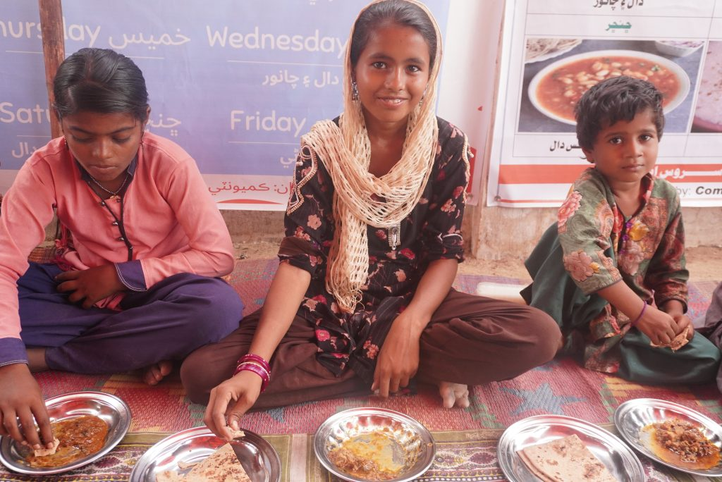

But this transformation is not just about the meals or the lessons. It is about the community coming together. Parents, teachers and even villagers without school-going children have taken ownership of this initiative. They contribute ideas, help with meal preparation and ensure the school remains a safe and welcoming place for all of us. The meals, prepared with local ingredients and care, are a reflection of this community spirit. Everyone feels a part of this journey, which is why the school is thriving. Our village has changed because of this project. Girls who once stayed home, unsure of their futures, now walk to school with purpose. The laughter, learning and shared meals have not only improved our health and education but have also brought our community closer.

Raksha and I are grateful for this opportunity. We know that our dreams of becoming a doctor and a teacher would have remained just dreams if not for the project and the support of our village. This school, these meals and the support of the community have given us hope for a brighter future. As we step into each new day, we do so with the belief that anything is possible when a community comes together for its children.

*This project receives support from Canadian Foodgrains Bank. PWS&D is a member of the Foodgrains Bank,*



*a partnership of 15 churches & agencies working together to end glob*

**Copies of OUR DAILY BREAD and the MARCH PRAYER CALENDAR are available this morning on the table at the rear of the Sanctuary.**

**Meet the Nominees for Moderator**

The nominees for Moderator of the 2025 General Assembly of the Presbyterian Church in Canada are the Reverend Jeffrey Murray, minister at St. Andrew's Presbyterian Church in Sackville, New Brunswick, and the Reverend Dan West, minister at Knox Presbyterian Church in Kincardine, Ontario.

Photos, biographies of the nominees and their responses to questions are available at:

**https://presbyterian.ca/2025/02/07/nominees-announced-for-moderator-of-the-2025-general-assembly-of-the-presbyterian-church-in-canada/**

Give thanks for Jeff and Dan and include each of them in your prayers.

The name of the Moderator-elect will be announced on Tuesday, April 1, 2025



[**Brockville Tall Ships Festival**](https://brockvilletourism.us14.list-manage.com/track/click?u=2ae57f531dfe2011812c21903&id=60a2316bb5&e=ba4513d26e)**returns to Brockville's waterfront on June 20-22, 2025! This incredible event happens every three years, drawing thousands of visitors to experience majestic tall ships, live music, entertainment, and more. Tickets now on sale! Visit:**

***https://tallshipsbrockville.com/tickets/***