**First Presbyterian Church**

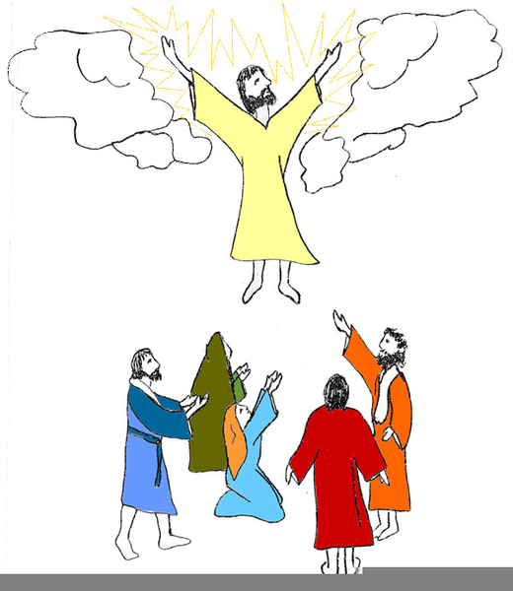

**Ascension Sunday, May 25th, 2025**

**The 6th Sunday of Easter**

Minister:  **The Reverend Marianne Emig Carr**

Director of Music: **Kathleen Howard**

Reader: **Lorraine Buck**

**_______________________________________________________________________________________________________________________________________________________________________________ ______________________________**

**Welcome to worship!** Thank you for joining us from wherever you are! In-person services of worship continue, with online options available for those who are more comfortable worshipping from home.

**Information for In-Person Worship**

**\* ACCESSIBLE WASHROOM FACILITIES** for all people are available **on the Sanctuary level**. These washrooms are found through the doors behind the Choir Loft - right turn - straight ahead. Please feel free to use these washrooms whenever necessary!

**\* CHILDREN’S MINISTRY –** TheChildren are invited to join Denise Kent, our C.E. Coordinator, and volunteers, in the Church School Room off the Church Hall, for a time of fun and faith-centered activities, following the Children & Youth Message this morning.

**\* HEARING IN THE SANCTUARY -** First Church has available a system of FM RECEIVERS and HEADSETS. They are for use by those who find it difficult to hear in the Sanctuary. If you would like to use one this morning, visit our Sound Technician.

* **COFFEE HOUR** – Due to the Sunday Supper today, there is **NO COFFEE HOUR** this morning. Please join us next Sunday, June 1st, in the Church Hall, for coffee, treats and great conversation following worship. To volunteer to host, bake, or bring food to any coffee hour call Tamara Chapman.

**ASSISTING YOU THIS MORNING**

Greeter: **Janet LeBrun** Elevator: **Francis LeBrun**

Sound and Video Team **– Quentin Robinson, Kade LeBrun**

**Michel LaBonte and Mark Leslie**



**NEED A RIDE?**

**Call Executive Taxi!**

A free service provided by your M.O.V.E. Committee



**\*** Our website and social media accounts:

[**https://pccweb.ca/firstchurch-brockville/**](https://pccweb.ca/firstchurch-brockville/)[**https://www.facebook.com/Firstkirk/**](https://www.facebook.com/Firstkirk/)

[**www.instagram.com/firstpresbrockville/**](http://www.instagram.com/firstpresbrockville/)

[**https://twitter.com/firstkirk**](https://twitter.com/firstkirk)

**\*** YouTube Channel: [**https://www.youtube.com/ @firstpresbyterianchurchbro482/streams**](https://www.youtube.com/%20@firstpresbyterianchurchbro482/streams)

**\*** **Cogeco/Channel 10/700 Services** every Sunday at 7 am. and 5:30 pm.

**\* For pastoral care or assistance**, please call the Church Office at 613-345-5014 or 613-340-3310. You may also call or text Reverend Marianne at 613-449-5042.

***the people of God gather….***

**The Organ Prelude** **Improvisation on Aberystwyth** *arr. Hal H. Hopson*

**Welcome and Announcements**

**Call to Worship God**

Minister: A new day has begun.

**All: Hope wins!**

Minister: A fresh start is granted.

**All: Faith wins!**

Minister: Today you have the opportunity to do something new.

**All: Hope wins!**

Minister: Christ is entering your life in a new way.

**All: Faith wins!**

Minister: Come, let us worship God, who is inviting us into life in a new way, a way that transcends death, a way of hope and faith.

**All: Love wins! Let us worship Christ, who overcame death to give us new life!**

**Opening Hymn # 265:** **Hail the day that sees Christ rise** *Words & Music: Public domain*

**1. Hail the day that sees Christ rise, hallelujah!**

**to the throne in paradise; hallelujah!**

**Christ the Lamb for sinners given, hallelujah!**

**enters now the highest heaven. Hallelujah!**

**2. Christ, for you high triumph waits, hallelujah!**

**lift your heads, eternal gates: hallelujah!**

**you have conquered death and sin: hallelujah!**

**enter, Sovereign, enter in. Hallelujah!**

**3. See the nail-marked hands above, hallelujah!**

**signs of God’s redeeming love; hallelujah!**

**hark, Christ’s words our hearts assure, hallelujah!**

**“I will send a Comforter!” Hallelujah!**

**4. Christ, for us still intercede; hallelujah!**

**by your suffering for us plead; hallelujah!**

**near yourself prepare a place, hallelujah!**

**as the first-fruits of God’s grace. Hallelujah!**

**5. Now, though parted from our sight, hallelujah!**

**in the depths of starry night, hallelujah!**

**may God raise us up again, hallelujah!**

**heirs of your eternal reign. Hallelujah!**

**Prayer As We Approach God**

Minister: Lord of life, we do not know the face of the future, any more than your disciples did.

**All: Like them, we have many questions - how to live, how to bear witness, how to be your faithful people in a harsh and unfriendly world.**

Minister: Like them, we thirst for the spring waters of the Spirit to inspire us in our living to give us a heart language in our testimony.

**All: You have been raised in glory that we might rise with dignity.**

Minister: You live in power that we might live in peace.

**All: You are present everywhere, that we might be fully present in our own lives. This we believe. This we step out on. This we proclaim.**

**The Chancel Choir** **Seek and You Will Find** *Natalie Sleeth*

**Prayer of Confession**

Minister: Almighty God, we confess that we have our eyes set in the clouds instead of on the earth you have given us. We desire heavenly treasure, but we keep believing that worldly means will help us attain it.

**All: Forgive us for our short sightedness. Draw us away from the temptations to seek worldly power and measures of success and call us to the down-to-earth message of your love, to care for the needs of those around us, especially the oppressed and marginalized. You have called us through scripture to care for the widows and orphans among us; help us to see all those who are left out by society and are in need. Help us to break down the dividing walls that we have placed, so that we may truly be one, as you and Christ are one. For it is in Christ’s name we pray. Amen.**

**Assurance of God’s Forgiveness**

Minister: We were made by God, brought forth from the earth, the earth that was called good when God created it. Your very being is good. You are blessed, earth-born, and called forth to care for the earth and all who dwell in it. Go, know that you are forgiven and loved by the God who made the earth, and made you, and share the Good News. Amen.

**A Message** and **Prayer for our Children** and **Youth** **Jesus Is Still With Us!**

Minister: Have you ever watched a balloon float up into the sky or seen a plane fly up, up, up until you cannot see it anymore? It is kind of exciting - but also a little sad when it disappears, right? Today we are learning about something amazing that happened after Jesus rose from the dead. He had been appearing to his disciples for 40 days - teaching them, encouraging them, and helping them understand God’s plan. Then something incredible happened!

Jesus was with his friends, talking to them, when suddenly, he started going **up** into the sky! Higher and higher, until a cloud hid Jesus and they could not see him anymore. The disciples just stood there, staring at the sky. I think I would have done the same! But then two angels appeared and said, **“Why are you looking up? Jesus has gone to heaven, but one day he will come back!”**

That is a big promise! Jesus went up to heaven, but he did not leave us alone. As we will learn in a couple of weeks, God sent the Holy Spirit to be with us at Pentecost, to help us and guide us. And he wants **us** to go and tell others about him - just like he told his disciples.

**What we can remember:**

Jesus is in heaven now, but he is still with us through the Holy Spirit.

Jesus gave us a job - to share God’s love and good news with others.

One day, Jesus will come back!

Let us be like those first disciples - excited to tell others about Jesus and filled with hope because he is always with us.

Let us pray: Dear Jesus, thank you for going to heaven to prepare a place for us. Thank you for sending your Holy Spirit to be with us. Help us to share your love with others and to remember that you will come back one day. Amen.

**Hymn # 271:** **Let all the world in every corner sing** *Words: Public domain*

*Music: Basil Harwood ©Estate of the late Dr. Basil Harwood*

**1. Let all the world in every corner sing: my God and King!**

**The heavens are not too high, his praise may thither fly.**

**The earth is not too low, his praises there may grow.**

**Let all the world in every corner sing: my God and King!**

**2. Let all the world in every corner sing: my God and King!**

**The church with psalms must shout; no door can keep them out,**

**but, above all, the heart must bear the longest part.**

**Let all the world in every corner sing: my God and King!**

***to hear God’s word….***

**Prayer for Insight and Understanding**

Lorraine: Let us pray. Gracious God, you meet us as we are, but do not leave us as you find us. Send your Spirit and open us to the transformative power of your living Word. We ask that you use this time of proclamation to form us more in the likeness of Jesus Christ, your Son and our Saviour. Amen.

**Psalm 93:** (read responsively)

Lorraine: The Lord reigns and is robed in majesty;

**All:** **the Lord is robed and is girded with strength.**

Lorraine: The Lord has established the world; it shall never be moved;

**All**: **your throne is established from of old; you are from everlasting.**

Lorraine: The floods have lifted up, O Lord, the floods have lifted up their voice; the floods lift up their roaring.

**All**: **More majestic than the thunders of mighty waters, more majestic than the waves of the sea, majestic on high is the Lord!**

Lorraine: Your decrees are very sure;

**All: holiness befits your house, O Lord, for evermore.**

**Reading from Scripture:** **Acts 1: 1 - 11** *New International Version (NIV)*

*®, NIV® Copyright ©1973, 1978, 1984, 2011 by Biblica, Inc.*

Lorraine: **Jesus taken up into heaven**

In my former book, Theophilus, I wrote about all that Jesus began to do and to teachuntil the day he was taken up to heaven, after giving instructions through the Holy Spirit to the apostles he had chosen. After his suffering, he presented himself to them and gave many convincing proofs that he was alive. He appeared to them over a period of forty days and spoke about the kingdom of God. On one occasion, while he was eating with them, he gave them this command: “Do not leave Jerusalem, but wait for the gift my Father promised, which you have heard me speak about. For John baptized with water, but in a few days, you will be baptized with the Holy Spirit.”

Then they gathered around him and asked him, “Lord, are you at this time going to restore the kingdom to Israel?”

He said to them: “It is not for you to know the times or dates the Father has set by his own authority. But you will receive power when the Holy Spirit comes on you; and you will be my witnesses in Jerusalem, and in all Judea and Samaria, and to the ends of the earth.”

After he said this, he was taken up before their very eyes, and a cloud hid him from their sight. They were looking intently up into the sky as he was going, when suddenly two men dressed in white stood beside them. “Men of Galilee,” they said, “why do you stand here looking into the sky? This same Jesus, who has been taken from you into heaven, will come back in the same way you have seen him go into heaven.”

Lorraine: For the word of God in scripture, for the word of God within us, and for the word of God around us. **People: Thanks be to God.**

**The Chancel Choir:** **Saints Bound for Heaven** *Susan Naus Dengler & Lee Dengler*

**The Meditation** **Lifted Up and Sent Out**

Today, we celebrate **Ascension Sunday** - one of the more overlooked holidays of the Christian calendar. The actual Ascension Day does not fall on a Sunday (it is on a Thursday); there are no disciplines of preparation ahead of time or rites of celebration on the day to usher it in. Fewer and fewer churches remember it, let alone hold any kind of a special worship service for it (unlike, say, Ash Wednesday or Maundy Thursday). It is no wonder that I, and so many others, forget about it, or are not even aware that there is a special day to mark Jesus’ ascension into heaven. But the Ascension **is** important! It is referenced in the Apostles’ Creed. So, if it is important enough to state in one of the foundational creeds of the Church, it certainly should have some significance to us.

We hear in our text for today that Jesus spent forty days appearing to the disciples, teaching them, encouraging them, and preparing them for what would come next. And then, in a moment both amazing and glorious, Jesus was taken up into the sky - lifted into the presence of God. Can you imagine what this must have been like for the disciples? It must have been overwhelming! The author of Acts tells us that they stood there, eyes fixed on the sky, trying to take in what had just happened.

But this moment is not just about Jesus leaving. It is about Jesus **sending**. It is about Jesus’ being **lifted up**, so the community of faith could be **sent out**. The Ascension is not the end of the story – it is the launching point of the church’s mission. And in it, we discover what it means to live in this time between Jesus’ departure and promised return.

As I mentioned last week, the writer of the Gospel of Luke also wrote the Book of Acts. The author opens this passage by reminding us that Jesus spent time with the disciples after the resurrection, speaking about one central theme: **the reign of God**.

This is important. Jesus did not change the message after rising from the grave. The focus remained the same - the reign of God, the renewal of all things, the coming of justice, mercy, and peace. Jesus came to reveal a new reality. A reign where the last are first, the lost are found, and where God’s love transforms everything.

And so, even now - after the resurrection, before the return - the call remains: **Live as citizens of this new reign**. Show the world what it looks like when love rules, when grace guides, when the gift of forgiveness and new life is available for all. One important instruction Jesus gave to his disciples before his ascension was this: “*Do not leave Jerusalem, but* ***wait****for the gift my Father promised, which you have heard me speak about. For John baptized with water, but in a few days, you will be baptized with the Holy Spirit*.”

Waiting is hard. Especially when we are eager to act. In our fast-paced world, with its emphasis on getting things done, waiting can feel like doing nothing. But to God, waiting can be a sacred act of preparation for God’s guidance and inspiration. So, following Jesus’ instruction, the disciples waited. They waited in community. They waited in prayer. And they waited with expectation. Despite the challenges of waiting, they followed Jesus’ command to wait. Some of us are in seasons of waiting right now - waiting for answers, for healing, for direction. If that is you, take heart: waiting is not a waste. God is not absent in the waiting. God is shaping you, preparing you, and planting something deep that will grow in time. Even after Jesus instructs them to wait, the disciples still could not press to make things happen. They asked, “Lord, are you at this time going to restore the kingdom to Israel? They were still thinking about political power, of getting out from under the yoke of the Roman oppressors. Still looking for a quick solution. But Jesus did not give them a timeline. Instead, Jesus gave them a task.

“You will receive power,” Jesus said, “and you will be my witnesses in Jerusalem, and in all Judea and Samaria, and to the ends of the earth.” Not analysts. Not spectators. Witnesses.

Jesus does not ask us to have all the answers. Jesus asks us to be witnesses - to tell the story of how grace found us, how love changed us, how hope pulled us through the challenges of this life. And this mission is not just for a few. It is for all of us. Wherever we are. In our cities, our neighbourhoods, our schools, and our workplaces. We are sent - not alone, but in the power of the Spirit - to embody good news in a suffering world.

As Jesus was taken up, the disciples stood there, looking toward the sky. It was a holy moment. But then two messengers appeared and asked a pointed question: “Why are you standing here, looking up?” It is as if they were saying, “Yes, something incredible just happened. But do not get stuck. Do not just stare into the clouds. Jesus is coming back. But for now, you have work to do.” We can relate. Sometimes we get stuck looking up - hoping, wondering, waiting for something dramatic. But the Ascension calls us back to earth - not away from hope, but toward action. The One who was lifted up has not left us alone. Jesus now reigns in glory, interceding for us, and has sent the Holy Spirit to be our companion and guide. We are not abandoned. We are **empowered**. So, we do not stand still. We do not keep looking at the sky. We go. We serve. We love. We speak. We heal. We act. Because Jesus is alive - and the world needs to know.

So, what does Ascension Sunday mean for us? It means:

* **Jesus reigns**—even when the world feels chaotic and hopeless.
* **The Spirit is coming**—to give us power we do not have on our own.
* **The mission is now**—not for someday, but today!
* **The story continues**—and we are an important part of it!

So may we lift our eyes with hope but not stand still. May we wait with trust and move forward with courage. Jesus was lifted up so we could be sent out, to continue Christ’s mission to the world. Are we ready? Amen.

**Blessing the Word in our Lives**

Minister: Holy Creator, as we hear your Word proclaimed today, fill us with the power of your love, that we may carry your Good News into the world and work for your justice, love and peace for all. Amen.

**Hymn # 275:**  **Jesus shall reign where’er the sun** *Words & Music: Public domain*

**1. Jesus shall reign where’re the sun**

**does its successive journeys run;**

**his kingdom stretch from shore to shore,**

**till moons shall wax and wane no more.**

**2. For him shall endless prayer be made,**

**and praises throng to crown his head;**

**his name like fragrance sweet shall rise**

**with every morning sacrifice.**

**3. People and realms of every tongue**

**dwell on his love with sweetest song,**

**and infant voices shall proclaim**

**their early blessings on his name.**

**4. Blessings abound where’re he reigns:**

**the prisoners leap to lose their chains;**

**the weary find eternal rest,**

**and all who suffer want are blest.**

**5. Let every creature rise and bring**

**the honours due our glorious King;**

**angels descend with songs again,**

**and earth repeat the long Amen.**

***Responding in love with thanksgiving***

**Prayers of the People, the Lord’s Prayer and Choral Amen**

Minister: God of care, we draw near to you in prayer, trusting that your love changes lives and your resurrection brings renewal and redemption into the world God loves. As we lay before you the concerns on our hearts, we pray that you will draw near to the people and situations we name and bring each one the gift that is needed. In your great mercy,

**People: Hear our prayers.**

Minister: We lay before you, Lord, the concerns we share from the news headlines and the many world situations where hope and change are desperately needed. We also pray for all those parts of the world where war and conflict are prevalent: Ukraine, Syria, Yemen, Gaza, the Democratic Republic of Congo, Sudan, Eritrea and Haiti. Inspire world leaders. In your great mercy,

**People: Hear our prayers.**

Minister: We lay before you, O God, those who are in hospital or care and all those who struggle with illness, pain or health burdens of any sort; and we remember those facing grief and loss, bearing burdens of sorrow and worry*.* In your great mercy,

**People: Hear our prayers.**

Minister: We lay before you, God of peace, families under stress, relationships that are strained, friends and neighbours in need of reconciliation, and we pray for the healing of divisions in our country, between countries, and around the world. On this Healing and Reconciliation Sunday, we especially pray for the ongoing work of healing and reconciliation between Indigenous people and settlers in this land known as Turtle Island, and that we know as Canada. In your great mercy,

**People: Hear our prayers.**

Minister: We lay before you, Creator, the earth itself, struggling in so many places to maintain its fruitfulness, and we pray for all the vulnerable creatures and communities who are finding it harder and harder to live on land, sea or sky. We pray those places where climate change and global warming are wreaking devastation on so many vulnerable people - flooding, fires, windstorm, and drought. Please help us to do all we can, no matter how small or insignificant our efforts may seem, to care for your creation. In your great mercy,

**People: Hear our prayers.**

Minister: Lord Jesus, we believe that you hear our prayers and will be faithful to our requests and concerns. Use us in every opportunity that presents itself to serve you by serving our neighbours near and far. And so, we pray together the words you gave us:

**All: Our Father, who art in heaven,** **hallowed be thy name.** **Thy kingdom come.** **Thy will be done, on earth as it is in heaven.** **Give us this day our daily bread,** **and forgive us our debts,** **as we forgive our debtors.**  **Lead us not into temptation,** **but deliver us from evil,** **for thine is the kingdom, and the power,** **and the glory, forever and ever. Amen.**

**The People’s Offering for the Work of Christ’s Church**

**Invitation to the Offering**

Minister: Our lives have been blessed by flowing waters and harvests of fruits. Yet, we also know that you accept whatever we render in faith, bless, and use it. In thanksgiving and joy, let us share our harvests with you and your world.

You can give…..

**\*** by pre-authorized remittance (**P.A.R.**) (<https://presbyterian.ca/plannedgiving/pre-authorized-remittance-par-program/>). Contact the Church Office.

**\*** by **e-transfer** to [firstkirk@truespeed.ca](mailto:firstkirk@truespeed.ca)

**\*** by **mail** to First Presbyterian Church, P.O. Box 885, 10 Church Street, Brockville, Ont, K6V 5W1

**Offering Praise Song # 79**

**Praise God from whom all blessings flow. Praise him, all creatures here below.**

**Praise him above, ye heavenly host. Praise Father, Son, and Holy Ghost.**

**Prayer of Dedication**

Minister: Glorious God, as we dedicate these gifts to you, may we shine with your glory and grace. Shine through our very lives, that others may experience the beauty of your love and the power of your presence. May these gifts further your will for justice, love, and peace. In Christ’s name we pray. Amen.

**Sending Hymn # 267:** **Rejoice, the Lord is King** *Words & Music: Public domain*

**1. Rejoice, the Lord is King; your sovereign Lord adore;**

**give thanks, O mortals, sing and triumph evermore.**

**Lift up your heart; lift up your voice;**

**rejoice, again I say, rejoice.**

**2. For Christ the Saviour reigns, the God of truth and love;**

**when Jesus purged our stains, he took his seat above.**

**Lift up your heart; lift up your voice;**

**rejoice, again I say, rejoice.**

**3. His reign can never fail; he rules o’er earth and heaven:**

**the keys of death and hell are to our Saviour given.**

**Lift up your heart; lift up your voice;**

**rejoice, again I say, rejoice.**

**4. He sits at God’s right hand till all his foes submit**

**and bow to his command and fall beneath his feet.**

**Lift up your heart; lift up your voice;**

**rejoice, again I say, rejoice.**

**5. Rejoice in glorious hope, for Christ the judge shall come**

**and take the faithful up to their eternal home.**

**We soon shall hear the archangel’s voice;**

**the trump of God shall sound: rejoice.**

**Benediction** and **Choral Amen**

Minister: As you go from here into the coming week, may God open your mind to his presence, so that you may truly come to know him; may he open the eyes of your heart so that you can experience the hope he offers to all who follow him; and may you come to understand the full extent of God’s power at work in your life - the very same power that raised Jesus Christ from the dead, and seated him at the right hand of God, so that we know more fully the grace, peace and hope of God, Parent, Son and Spirit today and always. Amen.

**The Postlude** **Sonata in D Major** *Domenico Scarlatti*

In Guatemala, Eladio Félix Marroquín’s family is learning to care for creation. With support from PWS&D and local partner AMMID, Eladio and his community are learning about tree planting, gardening, and how to strengthen forest nurseries and collect native seeds. Through the project, Eladio and his community joined a reforestation effort, along with other local communities, where 400 trees of various species were planted. Appreciative of the support, Eladio shared, “I am grateful for the support of AMMID and PWS&D for involving us in these activities to care for the natural assets of our community. Only by protecting water, forests and mother earth will we inherit a better future for new generations.” *A Mission Moment from The PCC*

**First Presbyterian Church**

**Office Hours** – May 26th to 30th

**Monday, May 26th – 10 am. to 11:25 & 1 pm. to 4:30 pm.  
Tuesday, May 27th –** **10 am. to 4:30 pm.**

**Wednesday, May 28th – 10 am. to 4:30 pm.**

**Thursday, May 29th –** **10 am. to 11:25 & 1 pm. to 4:30 pm.  
Friday, May 30th –** **10 am. to 1:30 pm.**

**MAY/JUNE CALENDAR**

**LOAVES & FISHES SUNDAY**

**-** 1st Sunday of each month

**CRAFT & CHAT -** Tues. afternoons

- Parlour – 1 to 4 pm.

**FPC HAND BELL CHOIR**

**-** Thursday Afternoons at 4:30

**Happy Birthday to:**

(**May 18th to May 24th**)

**ABBY VILLENEUVE – May 29th**

**Happy Anniversary to:**

**ROGER & BONNIE BURKE - May 20th**

**JIM & BARBARA BARBOUR - May 21st**

**FPC CHANCEL CHOIR -** Thursday Afternoons - 3 pm. Choir Rm; Sun. Mornings - 9:30 am. - Choir Rm

**SUNDAY SUPPER MINISTRY -** 4th Sunday of each month

**ONGOING PROJECTS:** **Grocery Bags, Egg Cartons,** **Pop Cans** (Maintenance)**, Breakfast Bags** (Food Bank)**, Sunday Supper Ministry, Socks for Warm Feet.**

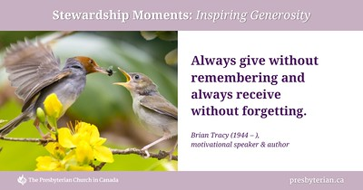

**COMMUNITY GROUPS using the Church Building:**

EMBERS/GUIDES

– Monday Evenings at 6 pm. in the Hall

DSLG Cooking Class - Thursday am & pm

DSLG Cricut Group - Tuesday afternoons

BGH DAY HOSPICE – Wednesday Mornings & Afternoons in the Parlour and Church Hall.

May 25 **MORNING WORSHIP – ASCENSION SUNDAY (6th Sunday of Easter)**

**-** 11 am. in the Sanctuary - No Coffee Hour – Sunday Supper Ministry.

Reverend Marianne leads worship at the Wedgewood.

May 26 Reverend Marianne leads worship at Rosedale and Sherwood Park Manor

May 30 **P. A. DAY CAMP** – 9 to 3 pm. in the Church Hall.

June 1 **MORNING WORSHIP (7th Sunday of Easter) - General Assembly Sunday**

**Members of Session leading Worship - Loaves & Fishes Sunday**

11 am. in the Sanctuary - Coffee Hour follows worship (Church Hall)

General Assembly begins at McMaster University in Hamilton – June 1st to 5th.

June 7 **THE BIG GIVE** – See details below.

June 8  **MORNING WORSHIP (8th Sunday of Easter) Day of Pentecost - Guest leader in Worship.**

11 am. in the Sanctuary - Coffee Hour follows worship (Church Hall)

Christina Duncan leads afternoon worship at St. Lawrence Lodge

June 10 The **M.O.V.E. COMMITTEE** meets in the Church Hall at 10 am.

**CRAFT & CHAT POTLUCK LUNCH** at the home of Brenda Fisk

June 11 The **SESSION** meets at the home of Brenda Fisk

**The 150th General Assembly**

**June 1st to 5th, 2025**

The 2025 GA [webpage](https://bbox.blackbaudhosting.com/webforms/linkredirect?srcid=58670366&srctid=1&erid=-1070447675&trid=dfbd307f-fd88-49ed-b6c3-6160d733328b&linkid=284860422&isbbox=1&pid=0) provides information about the General Assembly. Reports and information will be added over the coming weeks. Please check the page regularly for updated information. [**https://presbyterian.ca/gao/ga2025/**](https://presbyterian.ca/gao/ga2025/)

First Presbyterian Church is taking part in the **BIG GIVE** (a nation-wide opportunity for congregations to bless their communities with extravagant giving) on Saturday, June 7th, 2025. The M.O.V.E. Committee is planning a garage/yard “sale” and will also be handing out snack bags of cookies. Please set aside gently used household items, books, games, puzzles, pots, pans, dishes, and clothing (clean and smoke-free). Volunteers will be needed to help with sorting, set-up, and cleanup. We are also looking for donations of packaged snack bags of homemade cookies (nut-free, please!) to give out on the day. Items can be dropped off at the church (just ring the bell) and left in the Lower Hall. Call Janet LeBrun for more information or to volunteer.

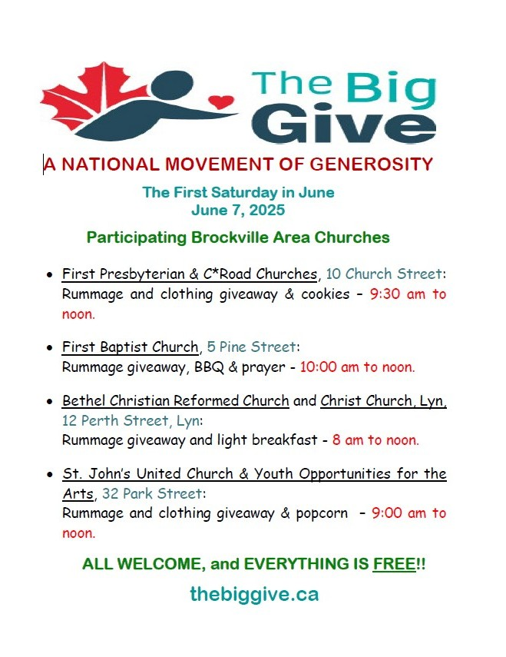

**P.A. DAY CAMP**

**Friday, May 30th, 2025**

Our Mission Project for this P.A. Day Camp is in support of the Brockville & Area Food Bank’s **Summer Snack Pack** program. The program supports families that are clients of the Food Bank during the summer months when school breakfast and lunch programs are not available. The Camp will be collecting items for the Snack Packs, including juice boxes, instant oatmeal packets, dried fruit, pudding cups, Jello cups, fruit cups, cheese crackers, Dunkaroos and instant noodles. If you would prefer to make a financial donation, please make out your cheque to First Presbyterian Church, send a donation by e-transfer, or include cash donations in an envelope. Please mark your donations “Brockville & Area Food Bank Summer Snack Pack Program” and provide a full name and address so the Church can issue you a tax receipt for your donation. Thank you!



JUNE 1st **- LOAVES & FISHES Sunday** Our Church supports the work of this restaurant with our donations of money and time. This ministry assists so many and we are thankful to be a part of it. Donations of food can be left in the basket at the rear of the Sanctuary or delivered to the Church Office (macaroni type pasta and coffee are great choices) during the week. Donations of money are welcome in your regular offering envelopes or online donations. Please mark all envelopes clearly. Thanks

**from the M.O.V.E. Committee NEEDED!**

**1)** At least one volunteer to assist with the Church School program on Sunday mornings.

**2) Volunteers to assist at the P.A. Day Camp on May 30th**

**To volunteer for any of these activities, please call the Church Office 613-345-5014.**

The summer issue of the **CHALLENGE** is almost right around the corner! It is time to write those stories about church life, find poems of inspiration, dream (in writing) about summer plans, find jokes and humorous articles and stories. Stories about recent travels would be really interesting! Please send your submissions to [firstkirk@truespeed.ca](mailto:firstkirk@truespeed.ca) or leave them at the Church Office.

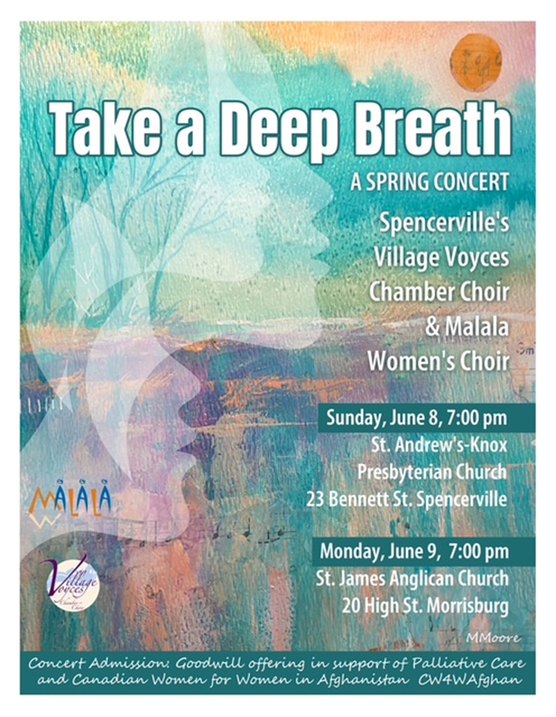

in support of the

**ST. LAWRENCE WRITERS FESTIVAL**

admission by cash donation at the door

Wall Street United Church, Brockville

**Wednesday, June 11th/25 at 7 pm.**

directed by Georgette Fry

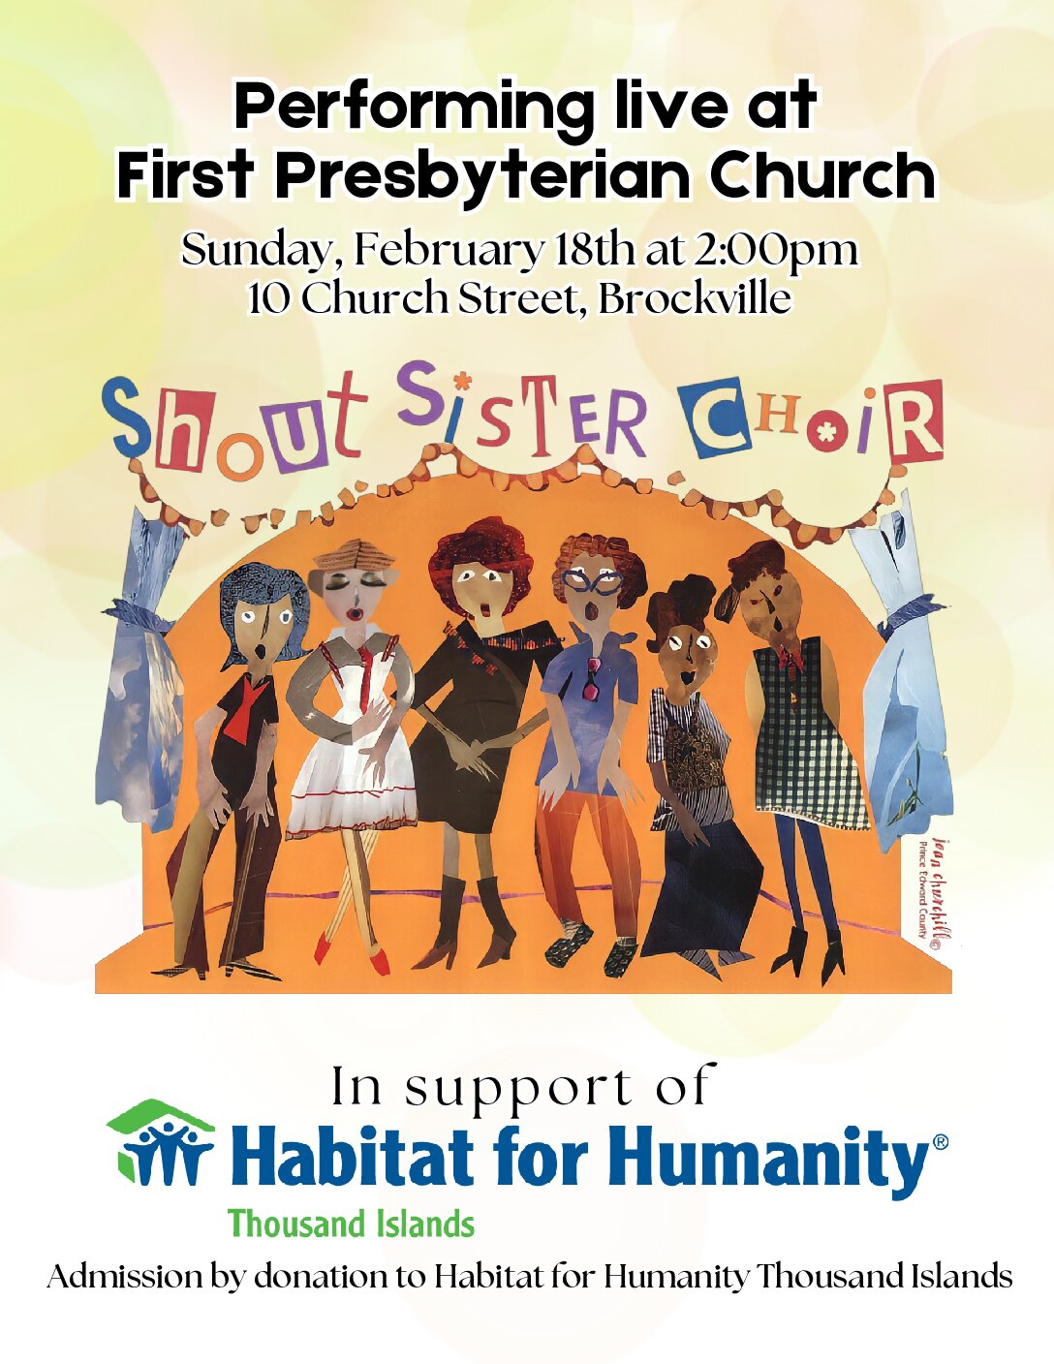

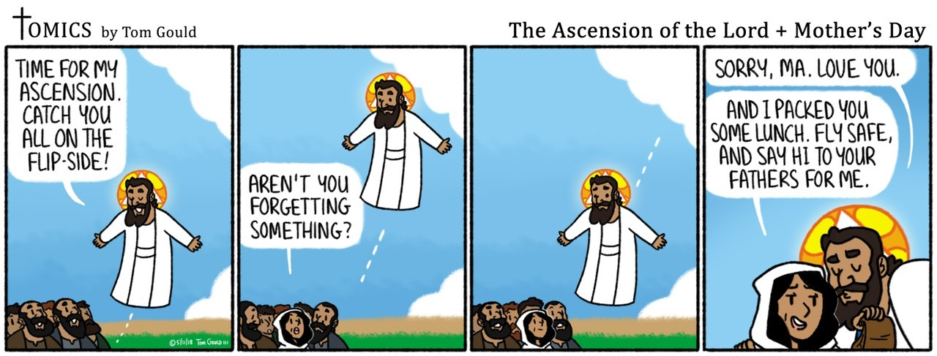

**Panel Discussion **

**Topic: *“Spiritual Empowerment of the Youth in Brockville; opportunities and challenges”***

**Saturday, May 31st, 2025**

at theBrockville Public Library– 23 Buell St.

**1pm. - 2:15 pm.** Welcome & Panel Discussion

**2:15 pm. - 3 pm.** Refreshments & Networking

Panelists; Councillor Katherine Hobbs, Suzan Hart, Kate McKinnon, Hannah Raudssus, and Connor Houle sharing tips and insights from their lives. Discussion is moderated by the Reverend Donald Wachenschwanz

Sponsored by the **Brockville Baháʼí Community**

**613-769-3123**



