Deuteronomy 30:19, 20 NLT

¹⁹ “Today I have given you the choice between life and death, between blessings and curses. Now I call on heaven and earth to witness the choice you make. Oh, that you would choose life, so that you and your descendants might live! ²⁰ You can make this choice by loving the Lord your God, obeying him, and committing yourself firmly to him. This is the key to your life. And if you love and obey the Lord, you will live long in the land the Lord swore to give your ancestors Abraham, Isaac, and Jacob.”

Matthew 11:28-30 NLT

²⁸ Then Jesus said, “Come to me, all of you who are weary and carry heavy burdens, and I will give you rest. ²⁹ Take my yoke upon you. Let me teach you, because I am humble and gentle at heart, and you will find rest for your souls. ³⁰ For my yoke is easy to bear, and the burden I give you is light.”

John 3:16, 17 NLT

¹⁶ “For this is how God loved the world: He gave his one and only Son, so that everyone who believes in him will not perish but have eternal life.¹⁷ God sent his Son into the world not to judge the world, but to save the world through him.

FORGIVEN

TO GLORIFY, WITNESS & SERVE

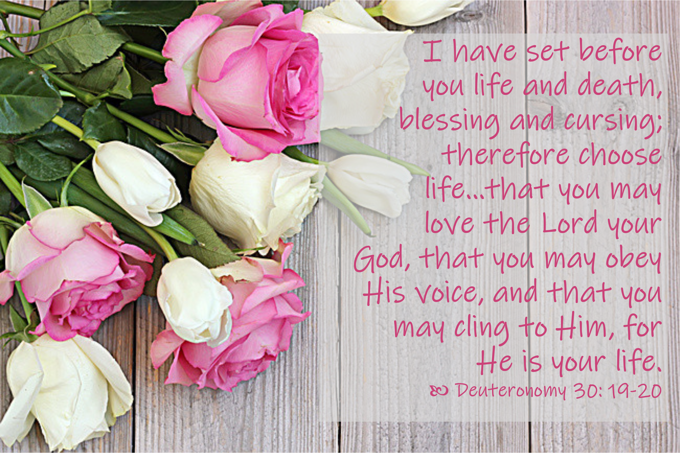KITCHENER EAST PRESBYTERIAN CHURCH
10 Zeller Drive, Kitchener, ON N2A 4A8
Telephone: 519-748-9786
kepc@golden.net
revmsr@golden.net
pccweb.ca/kitchenereast
https://www.facebook.com/groups/521222015471767/
https://www.instagram.com/kepc10/

Established 03rd May 1987

Minister: Rev. Dr. Mark S. Richardson

Minister in Association: Rev. Jeff Smith

Music Director: Sarah Pottier

Lent 2, Sunday 01st March 2026 10:30 am

The Church of Jesus the Saviour
Celebrates the Good News of God’s Love for the World
Made Manifest in Jesus His Son
as we learn to share Christ’s Love with everyone!!!

Celebrating the Truth of the Presence of God – Alleluia!
Call to Worship:
Praise: “And can it be?” vs 2 BP #173
Lenten Candle Liturgy: on screen
Welcome, and announcements:
Celebrating the Truth of Forgiveness – We Receive New Life!
Praise: “Thou didst leave Thy Throne” BP #165
Prayer, and the Lord’s prayer:
Celebrating the Truth of God’s Word! - We are Listening!
Scripture: Deuteronomy 30:19, 20; St. Matthew 11:28-30; John 3:1-17
Message: “Fence-builder or well-sharer?”
Celebrating the Truth of God’s gifts to us – We Are Accountable
The Welcoming of New Members
Praise: “I have decided to follow Jesus” SB #51
Presentation of our Tithes and Offerings:
+ Offertory
Doxology: “When I survey” vs 4 BP #178
Prayer of Dedication

Praise: “Lord Jesus, of You I will sing” SB #76
Celebrating the Truth of our Going Forth – We Leave for Ministry
Benediction:
Interpersonal Benediction: “May the Lord” SB #80
Worship & Sacraments Team: Prayer Requests
Bernice Baum – at home
Gladys Brown – at home
Frank De Vries – at home
Ann Gray – Trinity Village
Doug Greenwood – Huronview LTC, Clinton
Frank Ingold – at home
Bob Kenzie – Sunnyside Home
Hannelore Lemke – at home
Larry Mason – AgeCare West Williams LTC
Mary Master – A. R. Goudie LTC
Dolly McCormack – Court at Laurelwood Retirement Home
Marg & Terry McCorriston – at home
Curt Ryan – AgeCare West Williams LTC
Shirley Steinberg – Winston Park LTC
Dirk Vanderheide – at home

Sunday School 2025 – 2026:
Our regular bi-weekly Sunday School dates for 2026 are:
18th January; 01st & 15th February; 01st, 15th & 29th March; 12th & 26th April; 10th & 24th May; 07th & 21st June.
We are looking for more Sunday School teachers, helpers, or back-ups to join the team. If interested, please contact Cathrine (gcejtaylor@gmail.com), Nicolene (nclemens7@yahoo.ca).
We are thrilled to share and grow with the children this year.
Peace and Joy, Cathrine and Nicolene

World Day of Prayer:
World Day of Prayer 2026 will be held at St Matthew’s Lutheran Church, 54 Benton St. Kitchener, on Friday 06th March at 10:30 am. The service is written by women of Nigeria and is entitled "I Will Give You Rest: Come." All are welcome to attend.

Book Sale at KEPC:
We are collecting gently used books for a used book sale in June. Please consider donating any gently used books you have that you no longer want. Donations will be accepted starting March 1st. Thank you for your support. The Mission and Outreach Team.

Leading With Care: KEPC has been a Leading with Care congregation since its inception in 2004. However, we need to renew our understanding of this national church policy and our implementation of it in our congregation here in 2025/2026. Rob Gloin & Kerry Weir are spearheading this within our congregation.

Offering Envelopes: If you are interested in having assigned envelopes for 2026 and are not on PAR, please reach out to Chris at clemensc78@yahoo.ca. For anyone that has changed addresses, please let Chris and Mark know so that we can check our records and update them as required.

2025 Income Tax Receipts: are in your hanging files for your pick-up.

Grocery Cards:
We are participating in the grocery gift card program in our Region. If you would like to purchase grocery gift cards for the PC group of stores, and/or the Metro group of stores, please speak with Barb Cook, Rob Gloin, or Emmie Richardson. They are available every week. For each card we sell we receive a small amount back from the Community Charity Services.

From the Finance Team: options for financial giving to KEPC:
1) Canada Post: send your offering envelope in an envelope addressed to the Church: 10 Zeller Dr, Kitchener, ON, N2A 4A8
2) E – transfer: This involves using your online banking application using the e-transfer option & sending the transaction to the Church email: kepc@golden.net
3) PAR: pre-authorized remittance. This is set up once and an amount is withdrawn from your bank account monthly until you choose to stop it or change the amount. Contact Chris Clemens clemensc78@yahoo.ca and he can set you up.
4) Tithe.ly on our website, (click on the menu “Donate Now”) and donations can be through your Visa, Mastercard, or Debit.
5) The locked, black box on the wall of the sanctuary by the main doors for your offerings.
Thank-you for your ongoing and prayerful support of the mission and ministry of KEPC.

Events This Week: 01st – 08th March 2026
Sunday: 10:30 am – Lent 2 Worship Service with New Members joining; Sunday School; Coffee, cake, & Conversation in the Gray Hall.
Monday: 4 – 5 pm – Music Therapy
Tuesday: 9:30 – 11:30 am Bible study this week via Zoom; & in person in the McLean Fireside room.
12 – 6:30 pm – Music Therapy
6:30 – 8 pm – Sparks in the Gray Hall
Wednesday: 6:30 – 9 pm – Scouts in the Gray Hall
Thursday: 9 – 11 am – Sonshine Corner this week
Friday: 10:30 am – World Day of Prayer
12 – 5 pm – Music Therapy
Sunday: 10:30 am – Lent 3 Worship Service

VBS at KEPC this summer:

Dates are Monday 06th – Friday 10th July 2026, 9am-noon. The theme is Rainforest Falls.



Women of Worship:
The next meeting of WOW will be on Saturday, March 28th from 10:00 - noon in the Gray Hall. As you know, there is a lot of work put into VBS every year by a wonderful group of people. This month we are excited to be able to help with some of the VBS preparation. There is always lots to do, so there will be something for everyone. All ladies from KEPC are welcome. Coffee, tea and treats will be provided. If you have any questions about the meeting, please contact Jo Anne at 519-886-6559 or aitkenj09@gmail.com.

