The Lochwinnoch Lantern
Lochwinnoch Presbyterian Church
Welcoming – Worshipping – Reaching Out
JULY-AUGUST 2020

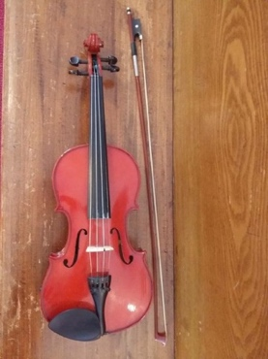
“Covid Co-writes”
Recently I saw a FaceBook post from Natalie MacMaster, the Cape Bretoner fiddler. She and her husband, Donnell Leahy, are in the process of creating a new CD. Natalie wrote “The other day we started a lovely melody that came quite naturally but getting into a second part required more effort.”
They had the thought of opening this piece up to others. Anyone interested in co-writing the tune with them, could listen to what they wrote, and then co-write the rest. They left folks with a reel, which for now, they call, “The COVID Co-write”.
It got me thinking what are “COVID Co-writes” we could use some help with during this time of the pandemic. The articles in this newsletter, tell how some of you have been living during COVID-19, as you read this newsletter, ask yourself, Where do I see God in these stories.
When the andemic hit in March, the first few weeks were kind of novel. We took time to clean, to write, to bake, to enjoy isolating at home with the immediate family. But the novelty has worn off for many of us.
I like Natalie and Donnell’s idea of a co-write. Imagine if there was a project you could enlist someone to “co-write” with you. Maybe it is not a fiddle tune, but imagine how might the eye or ear or hand of another person help you to approach a situation in your life differently.
This time has made me realize that as a community, we need the gifts of each other. We are the body of Christ, and each of us are different parts bringing to the body diversity and strength. I pray that we as a congregation will continue our “Covid Co-writes”, and build upon what we have learned together during this challenging time.
I find consolation in the verse “And I am certain that God, who began the good work within you, will continue his work until it is finally finished on the day when Christ Jesus returns.” Philippians 1:6
Thanks be to God.
Rev. Milton A Fraser
A Sacred Space for Creativity
If you like to have a creative and spiritual spot in your home, it’s important to have a space that is inspirational and feels safe. Sometimes it can be a tiny part of a bedroom or a living room or dining room. This type of space is important to carve out for yourself to enable your creative and spiritual development in daily life.
I am fortunate to have a space like this in our home and now I have a new sacred space in the form of a wee cabin very near our house, thanks to Bill, who spent last summer building it. I call it the MONC, named after a favourite bakery, we visited regularly in Haida Gwaii, BC, when we there in 2018.
The bakery is called Moon Over Naikoon Bakery…I just changed the last word to Cabin! The MONC has become a very special spot, especially this year during the pandemic. It is nestled in the trees on our property and looks out over a gentle slope in the bush. Every item in the cabin has meaning….a 135 year old front door that came from the stone house of my childhood farm home, some windows from there too, shells, rocks, from our beach scavenging hunts on Haida Gwaii, a fancy cream jug that my Grandma McGregor got me as a gift from her trip to Cape Breton in 1962, art work and books from good friends, a picture of Mom & Dad when they were young, antique store “finds” from our Nova Scotia trip last summer, books on art and spirituality, candles, a beautiful handmade quilt, etc etc. The feeling of love is everywhere. And now I have moved all my art and craft supplies out there for the summer.
Creative projects are happening each day at Bill’s handmade desk…or sometimes, I just sit at the desk and think about what I might like to create! It also feels good to mediate and pray there.
One of my favourite things to do is just sit in the comfy wicker chair in the tiny screened-in-porch and close my eyes and listen to the sounds of the birds and the trees…this creates a totally “grounded” feeling. Nature teaches us so much….how to be still and listen. In that stillness, I am reminded that I am not alone - that a force much bigger than all of us is around. I get the same sensation when I create a little book or a sketch or a craft….something bigger than me is guiding me. It is like a really cool prayer or meditation when that happens. When I enter the MONC, I feel transported to a beautiful oasis of calm, I know that it is a spiritual experience while I’m there…whether I’m resting on the couch, listening to the birds, drawing a picture, lighting a candle for departed loved ones or saying a prayer of gratitude, it all happens in a realm that is more heavenly than earthly. Thank you Bill, for the BEST GIVE EVER!
Jane McGregor
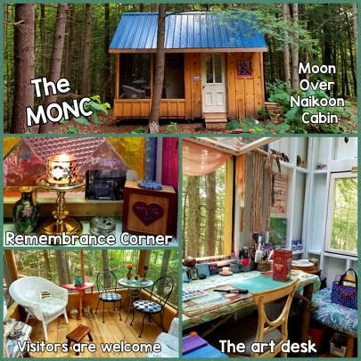

Lochwinnoch Nature Sightings
The Amazing Firefly
This little light of mine, I'm gonna let it shine.
Have you ever sat and watched in fascination as the fireflies danced above your lawn?
It's the male firefly that "flash" in the air using distinctive flying patterns to signal to females hiding in the grass below. The females then respond by flashing back.
There are predators out there that feed on the firefly. One type of predator is actually another species of firefly who sit in the grass and flash back at the males. The males fly down hoping to find a mate only to find themselves as the main course.
The firefly's light is produced by a chemical reaction that gives off 100% light but with no heat. By comparison a standard lightbulb gives off only 10% light and 90% heat.
Bill Birkens
Lochwinnoch Musings….
“Bookselling in a Pandemic….”
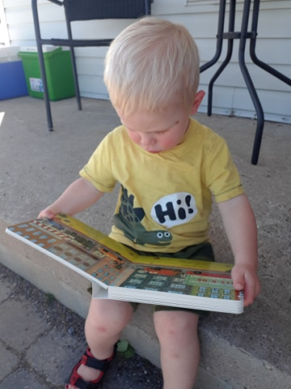
As a bookseller, I’m pleased to report Pandemics are good for at least one thing and that is people seem to be reading more. They are either discovering or returning to the joy books can bring to one’s life. I even know a few individuals well into their sixties who have never before considered reading for pleasure and are now hooked on the habit. I suppose there’s only so much Netflix a person can stand to watch. This all makes me very happy.
As a way to celebrate the end of the school year, the Congregation gave gifts of books to approximately 30 young people. Here Matthew Cameron reads his gift.
These last four months I have observed my older grandkids turn into avid readers. As a life- long reader myself I can’t tell you how much this thrills me.
My mother put Anne of Green Gables in front of me when I was eight years old and from that moment on there was no turning back. We had a well stocked book shelf at home and she introduced me to the Renfrew Public Library which I regarded as one of the seventh wonders of the world. I read all of L.M. Montgomery, Louisa May Alcott, Gene Stratton Porter, the Bobbsey Twins, Nancy Drew, Cherry Ames... and so much more. My first foray into the fantasy genre began with the book ‘The Ship that Flew”, one of the few books on the lending shelf at the Lochwinnoch Public School. It was a time travel book that absolutely blew my mind.
These days, young people have much different tastes from what we might have read back in the fifties and sixties, but it doesn’t matter, they’re reading. They tend to gravitate toward stories about boy wizards, female heroes with superpowers, dragons, time travel adventures, fairies, or graphic novels with surprisingly sophisticated themes. Happily, there are also many novels set in cultures from all over the world.
The reading habit gives us such opportunities. We get to live in worlds completely unconnected to our own, where we can escape from the day to day practicalities and mundaneness of our lives. Sneakily, they expand our understanding of others who we might have thought to be different from us and we see them in a more understanding light. In fact, it has been proven that reading fiction makes us more empathetic. In a world becoming increasingly fractured and polarized I would suggest introducing our children and grandchildren to reading is not only preferable but downright mandatory.
Perhaps this summer you might consider introducing your favourite small human to a library card. Not only will you be exposing them to a larger world but you will actually be making the world a better place. What an investment in our future and our children!
Happy Reading,
Gwen Storie.

Becoming parents to Violet during Covid-19
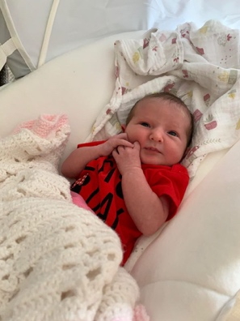
When we first learned that we were expecting a baby back in October of 2019, nothing could have prepared us for the journey ahead...

After two previous pregnancy losses, I was considered high risk. As a result, on January 16th, I went on partial bedrest. This meant a complete disconnection from all things work related – and a considerable distance from family and friends. I was social distancing before it become mainstream!

Up until Covid-19 was declared a pandemic, I had regularly scheduled doctor appointments at the General Hospital every two weeks. This consisted of an ultrasound and a checkup with the high-risk team. Graham was there for every appointment and got to attend every ultrasound. With Covid-19 this all came to a screeching halt. My appointments were spaced over 4 weeks and Graham was no longer able to accompany me. We tried getting ultrasound pictures for him but it just wasn’t the same. Walking through the General at the beginning of the pandemic felt post-apocalyptic. There were no people in what is during “normal” times an incredibly busy hospital. On that first trip in, I counted only 10 people that were not hospital staff and everyone seemed to be scurrying and avoiding eye contact.

Fast forward to 39 weeks and 6 days and we were making our way into the General. It was July 5th around 8:30 pm when we started out from our house on Poole Street, Arnprior. The Queensway was closed from Carling to Bronson and all we could think was thank goodness this isn’t happening during rush hour. Graham had to wait in the truck until we knew if I was going to be admitted. Around 10:30 that night the doctors told me that I was going to be admitted and that I could call Graham to come in. Because he was driving his truck, he had parked at the Eye Institute, which accommodates bigger vehicles. Unbeknownst to us, because of Covid-19 that entrance to the hospital was (is) closed on the weekends. Luckily, a nurse was exiting just as Graham was trying to get in and he snuck through! He had to deal with a somewhat grumpy triage nurse when he got to the eighth floor because he was supposed to have been stopped at the check-in. This was one of those better to ask for forgiveness situations.

We proudly welcomed Violet Carmelita Cavanagh to the world at 2:54 am on Monday July 6th. Since then we’ve been trying to adjust to having a baby in this new Covid-19 world. There were no visitors at the hospital and very few at home since then. Grandparents, siblings and close friends have been extra cautious about social distancing while visiting. It has been a strange way to introduce our little Miss Violet to the world but we are taking lots of pictures and recording tons of videos with our phones to share with loved ones. We are so blessed to have this little miracle girl with us and are grateful for God’s precious gift.

Violet is a little fighter and hopefully will someday be able look back on her birth as a strange time that did not last forever but is rather earmarked in our history as a year when the world faced and overcame the Sars-CoV-2 virus. A year that brought people together, reminded them of what is important in life, and made them stronger for it.

Erin, Graham and Violet Cavanagh

Experiencing Loss/Grief during a Pandemic
Our mother was living in a Seniors Residence in Kingston. In the first week of March, Mom, who was 90 years old, seemed well. Mom walked with a cane and a walker was always close by for longer journeys. My three brothers and our families did not realize that the first week in March would be the last time we would be able to see my mom for the next two months. NO visitors allowed due to Covid-19. Our contact was reduced to phone calls and texts only.
On May 7th a doctor called about a blood test results that had dramatically changed. Being blessed with a sister-in-law with the experience of long term care, Mom was pulled out of the residence to live with my brother and sister-in-law since many tests were expected in the near future. We noticed a significant deterioration during the 2 month lockdown.

Two days later, on Mother’s Day, my mom was rushed to the hospital. Once again, due to Covid-19 rules, our mom was without visitors while tests and procedures were performed for 6 days.

Unfortunately, the results were not what we hoped. By the end of the week a decision had to be made whether a permanent hospital stay (where there would be no visitors due to covid-19) followed by palliative care (one visitor at a time due to covid-19) would be the next step or getting a hospital bed at my brother’s home. My sister-in-law and mother always had a close relationship. My sister-in-law would have it only one way. So with the support of the rest of the family we were with our Mom day and night for the next 3 weeks. Given Covid-19 rules, we were so blessed to have a family member with the knowledge of caring right to the end.

Florence Irene O’Brien passed away June 10th, 2020 at home, surrounded by family.

Planning the funeral was also affected by Covid-19. On the initial planning guests could not exceed 10 including the minister and organist. This meant the local grandchildren and great grandchildren had to watch the service streamed online. The next day the province opened up churches and chapels to 30% of capacity. You have never seen so many happy smiles from the younger generations.

Impact of the covid-19 rules in grieving was most felt in terms of the lack of intimacy between family and friends, when the natural form of comfort is to touch and hug which goes against the guidelines. This created an awkwardness between loved ones that would not normally be present.

In the chapel we sat in pods 2 metres apart, individual family groups to a maximum of 30 people. We were fortunate with the timing of the rule changes, though still restricted. We were blessed by a beautiful service and cemetery burial on a sunny afternoon, overlooking a bay.

Our angel is now at peace.

Russell O’Brien
Russell lives in Arnprior.

Reconnecting during a Pandemic

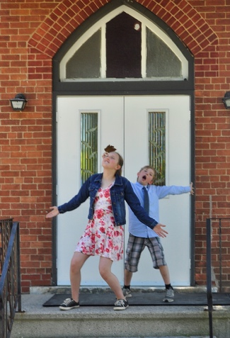
It’s been months of heartbreaking news, fear and uncertainty. The only thing we had to do and could do, was stay at home. That didn’t sound like much of a sacrifice compared to what those who lived through a pandemic before us. But it was a little scary and a whole lot lonely! The sky is blue, the grass is green, but the whole world was and is upside down. And it may be like that for a wee while yet.

Like everything in life, good and bad travel together. Sometimes we need to look a little harder for the good! For us, in amidst the Covid chaos, the ‘good’ shone brightly complete with angels singing the “Halleluiah” chorus. (That’s not an exaggeration!) Milton took Lochwinnoch Presbyterian Church online! We, being myself, daughter Katie and son Tristan were dancing in the kitchen. Covid had to have some perks. We were pretty excited to tune in at 9:00 (Manitoba time) on March 22nd.
It’s hard to find the words that convey how it felt to be with you all and able to see and hear Milton lead worship “live”. To hear the scripture and his message again was just the best Sunday ever since December 1, 2019…….when I was at Lochwinnoch last.

So here comes the good stuff and why I was excited to have this opportunity to write about reconnecting with our Lochwinnoch Church family. It’s short and sweet and a one liner – because it is a Church family!

I think it’s about 5 years ago Milton took over as Minister at Lochwinnoch. We had attended the Church in Arnprior where he had been Minister previously and had always felt like my spirit was replenished, that I was willing to take a ‘risk’ and check out this Lochwinnoch Church.

I remember driving up and thinking “Let’s see what happens. At least we know Milton and Jeannette will talk to us”. I have never, ever felt so welcome anywhere! It felt like we were home. We felt accepted and were immediately included. It was wonderful to be among people who took their Christian faith to heart in they everyday lives and hear Milton, who has the ‘uncanny’ ability to say the words that my being really needs to hear, every Sunday! How can you not be excited to reconnect with a gang like this?

Last spring, I accepted a job in southern Manitoba and we moved in July. It was a difficult decision! Unfortunately, it takes not having something to really and truly appreciate what you had. That’s exactly how I feel about leaving Lochwinnoch! You are the most wonderful, kind and generous community of people I have ever come to know. There has been no replacement for you! I have so much appreciated people sending a message and checking in. Last fall we received a ‘collection of Lochwinnoch Sundays’ from Kim Flynn. And we just received a pretty snazzy parcel with some summertime books. It means so much coming from Lochwinnoch.

As much as I want to see the doors of Lochwinnoch Presbyterian Church open, there is a little part of me that still says “Yes Covid!” at 8:55 every Sunday morning! And Milton you still have the uncanny ability to say exactly what I need to hear! Know that we are watching each of your names come up, saying good morning to you and wishing you well on your week ahead. Big hugs and many blessings to each of you. We miss you dearly and are very grateful to be able to join you for worship on Sunday mornings again!

Shawna Phillipson

Family Time on the Mountain

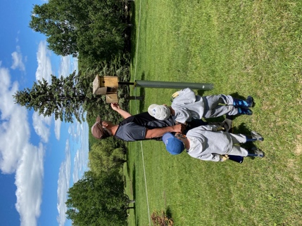
Three years ago our family moved to a small, rural community in Thorne, Quebec. Our home is high on a hill, fondly referred to as “The Mountain”. We are surrounded by trees and rolling hills for as far as the eye can see. Neighbours are few and hidden from view, which provides a complete escape from the hustle and bustle of everyday life. We moved here with the dream of providing our children with a safe place to grow up, learn the value of hard work, and feel connected to nature.

When we moved here we often talked about Jeremy staying home to raise the kids, but we never seemed to make it happen. We feared the financial risks, the social stigmas, and the potential for Jeremy to feel isolated. Not anymore. Covid forced us to take that plunge and realize our dream.

Everyday “The Mountain” brings new opportunities for our family to spend time together. In March we spent time sliding, snowshoeing and cross-country skiing in our bush. In April we collected sap to make maple syrup. In May we built nest boxes for tree swallows and bluebirds. For weeks after, we watched the birds carry nesting materials, incubate their eggs, and eventually witnessed the young fledge from the boxes. In June we celebrated Austin’s 4th Birthday, stayed up late with the kids to watch fireflies, and picked wild strawberries in our field. In July we headed to the Ottawa River to enjoy some cottage time and fishing.

We have found a new sense of balance. We are present for our children. We feel connected as a family. The pace of life is more manageable and offers the kids more time for free-play. We have learned to work together to accomplish a common goal. We have learned that everyday is what you make it.

We will look back on this pandemic with fond memories of time well spent with the little people we love most.

Amy Cameron & Jeremy Cavanagh, Texas (Age 5), Austin (Age 4), and Rose (Age 1)

Treasurer Update – JULY 2020
Thank you for your continued financial support of Lochwinnoch Church. Monies that have been received have allowed us to meet the financial commitments of the Church. This includes having our minister, Rev. Milton Fraser, offer ministry to our congregation and provide online worship services, as well we are paying our utility bills and insurance.

A portion of funds received has been designated to community outreach projects. Our minister, Rev. Milton Fraser, led in the design and delivery of newsletters, The Lochwinnoch Lantern. Encouragement was offered to the young people in our Church by means of providing books and a letter.
Furthermore, as a Church, we have made monetary donations to the Arnprior and Renfrew Food Banks.

Funds received have also allowed us to afford our annual fees to the PCC (Pension Adjustment Fund and Presbyterian Sharing). The Presbytery of Lanark-Renfrew has waived our dues this calendar year, so that has been one less obligation required.

We look forward to the installation of a new Church roof this year, another blessing that is occurring as a result of Church donations that have been invested and with careful decision making by the Board of Managers. If you wish to contribute to the costs of the roof replacement, please include the gift with your regular givings.

Below are the 2 main ways you can donate to the Church.
- Send an E-transfer to lochwinnochpresbyterianfinance@gmail.com
- Mail or deliver a cheque made payable to Lochwinnoch Presbyterian Church: c/o Kim Flynn, 134 Goshen Rd, Renfrew, ON K7V 3Z4
*If you have questions, please give me a call. I can be reached at (613) 432-1594
Blessings to you All! With sincere gratitude,

Kim Flynn, Lochwinnoch Church Treasurer

Faces of Faith
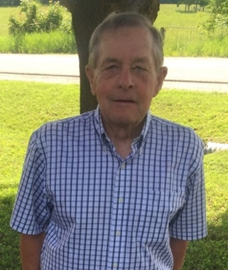
At a recent Session Meeting the elders participated in a faith sharing exercise. Beginning this month, we will introduce you to an Elder using the “Faces of Faith” exercise in our newsletters.

Our Clerk of Session, Burt Virgin, was ordained as an Elder in December 1978. He has served as Clerk of Session since February 1999. He is married to Melissa, he is a father, grandfather, a retired educator, and an active community member.

What is your earliest memory of church life?
Christmas Sunday School Concerts is one of my earliest memories at the Renfrew Baptist Church. I remember, as well, the caretaker of the church building, always getting up and leaving to check the fire in the basement when the minister started the sermon, and would return just as he finished.
What is your favourite hymn?
What a friend we have in Jesus. Another song I like is “Save a little spot in heaven”.
Where do you find inspiration to sustain your faith?
I find inspiration in nature, Scripture Readings and sermons.

Who has played a major role in your faith journey?
Older people who have set an example have played a role in faith.
If you could invite anyone (past or present) to a dinner party, who would you invite?
From the past, I would invite Melissa’s Mom and Dad. From the present our family, along with Milton and Jeannette.
What is one hope you have for Lochwinnoch Church?
That Milton will stay as pastor, and that more young people can join us, so that our congregation will continue into the future.
Write your own epitaph?
He cared for others.

Milton’s Contact Information:
Cell Phone: 613-914-2675. Email: miltonafraser@gmail.com

