The Lochwinnoch Lantern
Lochwinnoch Presbyterian Church
Welcoming – Worshipping – Reaching Out
Fall 2020

“Giving Thanks During a Pandemic”
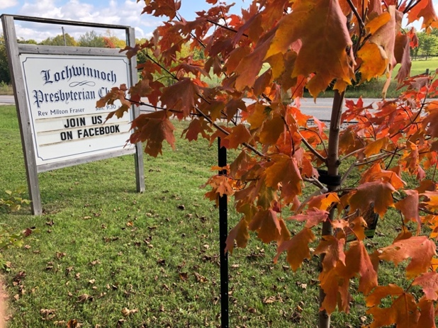
Who would have thought that when the pandemic was declared in mid March of 2020 that we would still be away from our beloved church building? The Session has been meeting regularly and have decided that that the building will remain closed until further notice, and will continue to monitor the situation.
Thankfully, as a congregation, many of us continue to meet online for worship. For those who are not online we strive to keep in touch by phone and newsletter.
Thanksgiving has always been a favourite season of mine. The beautiful display of coloured leaves in our forests, the bountiful fall harvests, the Canadian Geese flying over and the taste and aroma of Thanksgiving Meals, inspire us to count our blessings.
A few weeks ago, I polled a few friends about Thanksgiving, and asked their thoughts on gratitude especially when we have lived so much this year. The majority of those asked, sensed they have grown in their gratitude.
Charles Spurgeon an English Preacher from the 1800’s , wrote, “The greater our present trials, the louder will our future songs be, and the more intense our joyful gratitude.”

I would say, that the pandemic has prompted us as a church community and as a society to consider what is most important in our lives. This time, has led us not to take for granted the numerous blessings we enjoy.

The following pages of Lochwinnoch Lantern are filled with expressions of gratitude, may your hearts overflow with your own expressions of gratitude as you as read.

Thanksgiving Blessings to you and yours.

Rev. Milton A Fraser
Minister of Lochwinnoch Church

World Communion Sunday:
October 4 at 10 a.m. EST online..have bread/wine/ juice ready to partake with Lochwinnoch Church online.

Thanksgiving Sunday October 11, online worship at 10 a.m. EST
THANKFUL HANDS:

In preparation for THANKSGIVING SUNDAY we are asking the Lochwinnoch Community to create thankful hands. Each person draws their own hand on construction paper or whatever you have - and writes on it what they are thankful for and you can some add glitz or art to it, if you want!

Gail Cameron is willing to receive them by mail or drop them off to her. If they are to Gail Cameron by October 5th, the THANKFUL HANDS will be pictorially displayed for Thanksgiving Sunday, October 11. Hoping we will rise to the challenge - and give us a hand! Don't delay !

Gail Cameron's address is 1595A Stevenson Drive, Braeside, ON K0A 1G0.

THOUGHTS ON GRATITUDE FROM TWO AUTHORS

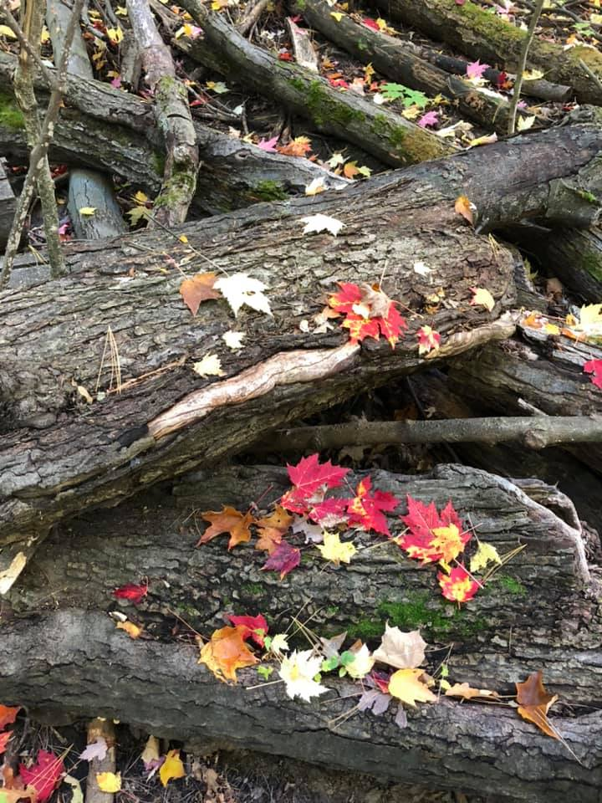
Many books have been written about gratitude and the benefits of living a grateful life. I thought I would share what two authors have to say about gratitude. Their words have been very helpful so I thought you might find them encouraging too.
The first author is Richard Wagamese. He is an Ojibway from the Wabaseemoong First Nation in northwestern Ontario. He has been recognized as one of Canada’s foremost First Nations authors and storytellers. Here are some quotes from his book “Embers”:
“With my eyes closed, I give thanks to the Life Giver and ask for strength to be humble through the course of the day. I give thanks for the blessings that are already present in my life. I ask for nothing. I only offer thanks. Then, in gratitude and humility, I enter the journey of each day.” “Can you think of a better way to live than in gratitude? Can you think of a better way to be than to be kind, loving, compassionate, respectful, courageous, truthful and forgiving? Even if that’s wrong, can you think of a better way to breathe than through all that?

In the end, we come out better people.” “It’s not the big things that make me grateful and bring me joy. It’s more the glory of the small: a touch, a smile, a kind word spoken or received, that first morning hug, the sound of friends and family talking, the quiet that surrounds prayer, sunlight on my face, the sound of birds, and walking mindfully, each footfall planted humbly on the earth.”

“Be thankful... offer prayers of gratitude for the blessings already in your life, whether health, prosperity or productivity, and more blessings will come.”

The second author that has encouraging quotes about gratitude is Sue Patton Thoele. Here are some of her own words on the subject: “Gratitude is the finest prayer our souls can utter. Gratitude is also an attitude. As with any attitude, it can be nurtured, cultivated, and changed if need be. Gratitude, like laughter and humour, lifts our spirits and hearts and encourages us to ascend into realms of joy and appreciation. It makes us thankful for the incredible life that we’ve been given and for the people who have chosen to share it with us. Gratitude is communion with God and graces our relationships with a high and holy soul-connection. Gratitude is meditation in action. Gratitude is the single most powerful medicine for physical, mental, and spiritual health for us individually and for our planet as a whole.”
Jane McGregor
Lochwinnoch Nature Sightings
Fall Bird Migration in the Lochwinnoch area.
Bird migration in this area usually starts in mid-August with warblers heading south as the insects they depend on die-off.

The local nectar producing flowers that hummingbirds depend on eventually die back which forces the hummingbirds to head south for food. Ours leave early September every year.

Keep an eye out for Kestrels on telephone or power lines. This mini-hawk dines on warblers as they head south.

Also watch for Hawks and Turkey Vultures as they migrate further south in search of food. To tell them apart Turkey Vulture's glide with wings in a V shape. Hawks’ wings are usually more horizontal when gliding.

Canada’s Arctic Tern has the honour of holding the record for the farthest migration. A 30,000 km round trip from the Arctic Circle to the Antarctic Circle and back.

So keep your eye on nature.
Bill Birkins

On Keeping a Gratitude Journal

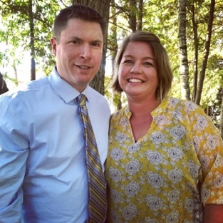
For the past few years, I have been intermittently writing a gratitude journal.

I had been listening to a few different podcasts on mental health, happiness and personal growth and the one theme throughout most of them was that acknowledging gratefulness can be very powerful. Simply put, it can easily make a person happier. The daunting part for me was that writing in a journal every day wasn’t something that stuck with me in my busy life and I had many starts and stops. I would write in a paper journal but I could never keep track of it and it was personal to me so I really didn’t want anyone else to read it. I slowly realized that making it simpler with less pressure on myself was key.

Last March, I made a promise to myself that I would commit to writing just 3 things each day that I was grateful for (or more). This felt “right” during these pandemic days. It could be short and sweet with no limitations. I also decided that maybe I like writing on my ipad or laptop….in a document compared to a paper journal. It has stuck. I have made it work for myself, by making it easy and enjoyable for me. It doesn’t matter how I do it, just that I do it. There’s no pressure to write long sentences or elaborate items. Some days I can make my list quickly and some days I have to think long and hard.

There is no doubt that we’ve all had difficult days, weeks or months during this pandemic but by writing in my gratitude journal has helped me pay tribute to the good things in life of which there are many. Taking the time to be grateful and to thank God, has carried me through some of the hard times and made me happier during the good times.
Deb McGregor

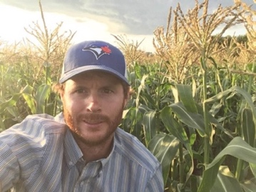
Reflections on Gratitude
When Milton asked me to provide thoughts on gratitude for this newsletter, my mind has focused on a single line written by a 20th century hymnist. Ira B. Wilson wrote, “Give as ‘twas given to you in your need”. These words help us to reflect on our own blessings, whether physical or spiritual, while encouraging us to be mindful of the needs of those around us.
In March and April of this past year I became keenly aware of the level of blessings in my life when many of the normalcies of life faded with the rise of COVID-19. Aspects of our family’s life, which we definitely took for granted, were no longer available: our local church, extended family, community and friends. Even in these times of upheaval, there are many things to be thankful for.
This unusual time provided an opportunity to connect with others outside of our church circle. I am very grateful for Milton who regularly took the time to check-in on us with a quick Facebook message. From time-to-time we were able to join the Lochwinnoch service through Facebook, something that I have only ever had the opportunity to do on a select few occasions throughout my life, despite deeply-rooted community ties. How enjoyable and encouraging it is to watch Milton play the old hymns at the piano, many of which I have song throughout my life.
Our boys were also ministered to by another local church, which we have very little connection to, through the form of a virtual Vacation Bible School. The activities and lessons, combined with the personalized elements of the program, gave our oldest son something that he has been lacking since not being able to attend Sunday school over the past 6 months.
We have an abundance of blessings to be thankful for today. I have mentioned a few very personal blessings from the past few months. We truly all share a blessing having a connection to Lochwinnoch.
May we show our gratitude by being mindful of the needs of those along our path.
Luke McLaren

My Gratitude...
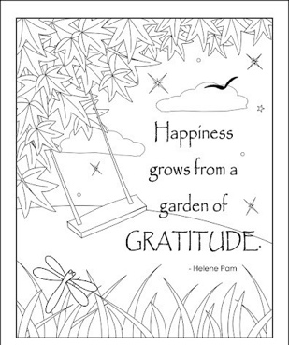
I have created a life that has simple pleasures and I am truly grateful for it all. My blessings are: A roof over my head, good food on my table, a God and people who love me, fulfilling employment and a backyard to nurture plants, people and pets.

My blessings are probably ordinary to most who are connected to Lochwinnoch Church. But in 2020, my backyard has been a beautiful blessing that I am especially grateful for.

My childhood years were on a farm. My memories are of more blessings than challenges. And one of the best memories was a big garden and yard to play in. In summer: there was the warm sun on my face, the soft grass under my bare feet, a swing on the big maple tree and so much space for biking, running, skipping and playing ball.
My father, Steve liked the natural beauty of maple trees for their summer shade, autumn colours and every spring he worked at his small maple syrup production. I like the beauty of maple trees too.

My mother, Noreen liked geraniums. For years she would fill the farm flower barrels with red geraniums and white petunias. And I like the beauty of flowers too.

In September 2014, I found a Renfrew house that felt like home. The real estate agent took me to the backyard first. It had 6 maple trees, perennial flower beds and many geraniums. Immediately, I experienced a flood of grateful emotions as I had found a little bit of country in the backyard of an affordable Renfrew house. It felt like the yard Mom & Dad had created for our family on the farm.
My parents are both gone now, but my gardening hours with the many flowers and beautiful maple trees makes me feel close to them.

I am reminded of their spiritual faith, love and strength that supported them during some difficult years and reminds me that I can also lean on God's love for strength during this unsettling year. My parents would also appreciate that my adult children (and their families) had their COVID camping holiday in my backyard among the bright red geraniums and many maple trees; just like they did at the farm many years ago.

Anne McGregor-Prince

Thanksgiving Thoughts from Nova Scotia
Thanksgiving will soon be upon us. It is a time to reflect on all the gifts that we have been given. I have so many! I am so thankful to all the men and women who worked so many long hours to help us get through the trying times of the pandemic.

I have been blessed with my beautiful children and grandchildren and I never take them for granted as we are here for such a short while and I treasure each moment I can be with them.

I was also blessed growing up with parents and grandparents who were devote to the church. They showed me steadfast love and nurturing which I try hard to share with others today.

Looking around I feel very grateful for living in the beautiful province with very caring neighbours and friends who helped shape my family to what they are today.

The hardest thing during our lockdown because of the Covid19 virus was not seeing and enjoying my church family. But it will pass and I can’t wait to sit in the choir again and sing those beautiful hymns.

Brenda Fraser,
Clerk of Session, Blair Presbyterian Church, Garden of Eden, NS. (The congregation in which Milton grew up)

Treasurer Update – September 2020
On behalf of the Session, Board of Managers, and Rev. Milton Fraser, thank you for your financial donations to Lochwinnoch Presbyterian Church. Your contributions are greatly appreciated, and I am pleased to report that they have allowed us to sustain as a Church and meet our financial responsibilities.
I am also happy to share that, as the Church Treasurer, I have initiated a new recording system to keep up with changes that have occurred with receiving of offerings. It is called the Donarius Church Management Software program.

We will continue to receive donations to the Church with the two most common methods being the following:
1.Sending a bank e-transfer to lochwinnochpresbyterianfinance@gmail.com or
2. Mailing a cheque made out to Lochwinnoch Presbyterian Church, to my home address: Lochwinnoch Presbyterian Church, c/o Kim Flynn, 134 Goshen Road, Renfrew, ON K7V 3Z4

Please feel free to give me a call at 613-432-1594 or contact me by email if you have any questions.

Wishing you All Good Health and Wellness!
Kim Flynn, Lochwinnoch Church Treasurer

Faces of Faith
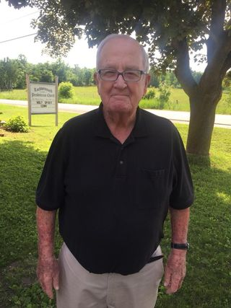
The elders recently participated in a faith sharing exercise. This month, we introduce you to Bert Miller using the “Faces of Faith” exercise.

Bert Miller, was ordained as an Elder in February 1992. Bert was born in Lochwinnoch, and has been married to Betty since June 5, 1954, they are parents to Deb, John, Andy and Rosemary. Bert had a career with Ontario Hydro from 1950 – 1987. Over the years Bert has enjoyed curling and golf.

What is your earliest memory of church life?
Sunday School, Rev. Walter Brett, and John Hutton (a minister’s son).

What is your favourite hymn?
What a friend we have in Jesus. It is nice to know that you can take everything to God in prayer. Such knowledge brings me comfort.

Where do you find inspiration to sustain your faith?
I find inspiration in church and when I look at the stars, rivers and fields. I know that God created all these things.

Who has played a major role in your faith journey?
Milt Fraser, is the minister that I remember the most and the one that I know best. His church services inspire me.
If you could invite anyone (past or present) to a dinner party, who would you invite?
I would invite my family. They are very important to me. I love them.
What is one hope you have for Lochwinnoch Church?
I hope it will grow and flourish in the future. With Milt at the helm I think it will.

Write your own epitaph?
UNTIL WE MEET AGAIN –
There are a lot of people I would like to meet again.
---------------------------------

Your Minister loves to hear from you whether it be by phone, email or by mail.

Milton’s Contact Information:
Cell Phone: 613-914-2675. Email: miltonafraser@gmail.com Civic Address: 205 Mill Ridge Road, McNab Braeside, ON. K7S3G8

