The Lochwinnoch Lantern
Lochwinnoch Presbyterian Church
Welcoming – Worshipping – Reaching Out
Advent 2021

In Person and Online Worship: Incarnational Ministry
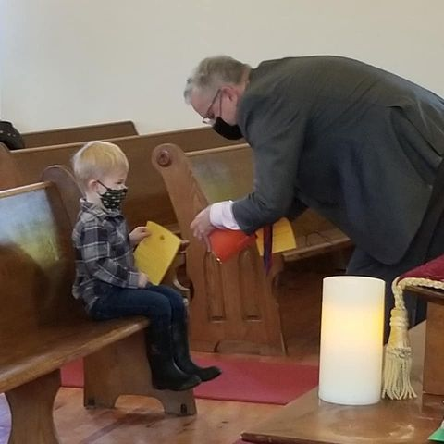
For a year and a half, during the pandemic, we, as a congregation worshipped solely online. It was a steep learning curve, using FaceBook Live, and eventually moving to a weekly pre-recorded service. Soon, we discovered that our reach was much broader, and that friends and family joined us from across the country.

In October 2021, the Session believed it was safe for “in person” worship to resume. Many congregations continue to see the additional benefit of offering online services as well.

As with anything, there are pro and cons. There are somethings about online services from home, that I really enjoyed. It was a bonding time for our small family, and I am most grateful to Jeannette, Kyle, Hannah and Eric for all their support and willing participation to take part in our literal “home church”. Most Sundays, we had brunch ready to enjoy following the service. Another benefit of online worship was the connection with friends, family and church members, who are not always able to make it to services in person, but who joined with us online.

Amazingly, each week FaceBook reports that two hundred people, click on our FaceBook page. Whether they stay for a few seconds, or watch the whole service we don’t know, but imagine, over 200 people connect with our little Lochwinnoch Church.

On the other hand, there is something about “being together” in community that is truly special and holy. The opportunity to see, hear, and touch each other, as brothers and sisters in Christ is significant. Jesus says, “Wherever two or three are gathered in my name, I am there”. Matthew 18:20

Advent Season is almost upon us. Since the birth of Jesus over two thousand years ago, we still proclaim, Jesus, the Word of Life, the one who is Eternal Life, the One who was revealed, seen, touched, and heard.
We can imagine how the people from the first Christmas Story, experienced seeing, hearing, touching, knowing Jesus the infant, as “God with us”, as “Emmanuel”. He was the One who came into the world, to be our Saviour, and to show us the way. We continue to share in that fellowship with God and Jesus, and by the Spirit, as we worship and serve together, as the body of Christ. We pray that in some way, Jesus continues to be revealed through us, whether it be online or “in person”.
Blessings to you and yours this Advent Season!

Rev. Milton A Fraser
Minister of Lochwinnoch Church

Unexpected Blessings

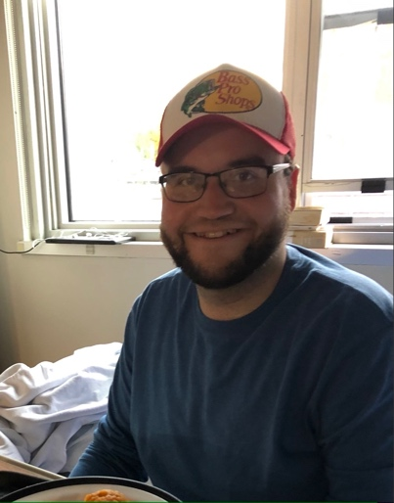
When I am writing articles for the Lochwinnoch Lantern, my original ideas are often way off from where my articles end up going, so we will see how this one goes. Sometimes life also like my articles end up going somewhere different than we originally thought it would be. It’s funny how being forced to slow down, makes you stop and think about EVERYTHING and ANYTHING. This fall being laid up with a broken leg and ankle, between countless hours of Netflix and reading, has given me A LOT of time to think, which comes with both its pros and cons! If you had told me that I was going to be in bed for most of 2 months, I would have heartily declined and although it has been a struggle sometimes, I know I will come out a stronger person from this experience. In the busyness of our lives’, we make thousands of split decisions throughout the day and there are so many small basic things that we often take for granted but when your ability to do those things is taken away it is amazing how much you miss those things you never stopped to think about for a second.

Leading into the Christmas season when I will be back on my feet, I know there will be so many things I will be living in gratitude for including, for my mental health, access to reliable health care and the amazing nurses and doctors who work there, time with friends and family, Christmas food and baking, going to church and so many other multitudes of things. This time has been a reminder of how lucky I am for my friends, family and church family. Thanks to everyone who have been sending their well wishes, keeping me in your prayers and for sending so many treats, it has meant so much to me and truly reminds me what a lucky guy I am and how lucky we are to have the Lochwinnoch church community.

Thinking about the Christmas story it makes me wonder how much time Mary and Joseph had to think about what was asked of them. I’m sure that they had a lot of thoughts about God’s plan, about themselves, about each other and about what other people would think of them! But they had faith and were patient despite not knowing what the future would hold. Mary and Joseph’s life, much like my articles, probably had a very different vision of their lives than where they ended up, but look at the place that it landed them in. I’m sure Mary had lots of thoughts when she was told that she would be giving birth in a manger. It is often in these stressful, confusing, frustrating situations that our faith is put to the test and our relationship with Jesus and God becomes strengthened. It has been faith like that which has helped me get through my experience and has helped me to be open to all life has to offer and teach, despite how frustrating it can be sometimes.

This Christmas may we be open to all the experiences that God has planned for us. May we be grateful for all the blessing big and small in our lives, may we embrace the time we have with our loved ones and may we enjoy all the good things that the Season has to offer and may we be open to being lead wherever life takes us even if it is unexpected. I look forward to connecting with you over the Christmas season and continue to give thanks for the Lochwinnoch community!

Kyle Fraser

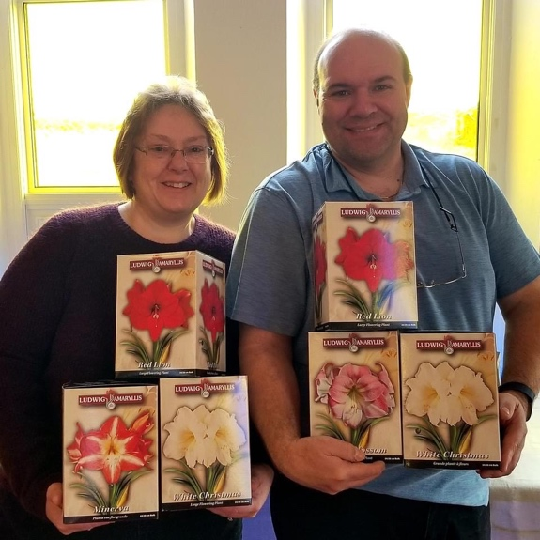

Thank You for your support of the Advent Amaryllis fundraiser for Presbyterian World Service and Development.
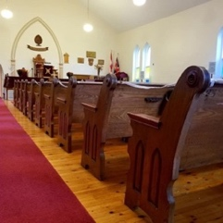
Home

On Sunday, October 3, 2021, the doors of Lochwinnoch Church were opened, for the first time for “in person” worship since, March 8, 2020. Online worship had been provided since March 22, 2020. Although technology had kept the congregation together, “in person worship expresses on a deep level the “incarnation” of the body of Christ, where two or three are gathered in his name, there Jesus is.

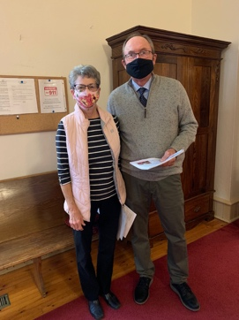
As the congregation gathered for worship Jane McGregor, was present, at the keyboard, Jim and Ann McGregor were greeting. Rev Milton Fraser was preparing to lead worship. The worship community began to gather, twenty eight people in total, ages ranged from three months to 90 years old.

During worship, all those gathered expressed with honesty what the past year and seven months had been like, words like frustrating, safe, lonely and rollercoaster were used to describe the past year and a half.

The week following worship some of the gathered expressed what it was like to be back together as a congregation in person in the building.

Sarah Cameron writes: It was an amazing feeling, I actually had a hard time with the online services the past six months or so- just being able to find time to myself to sit down and watch, without being interrupted. So I’m thankful to be back into the church for that reason. Matthew is another year older and was well behave during worship. It was an emotional service for me because it touched on so many emotions what we went through as a family, and what others went through during the last 18 months. Few times I found myself tearing up. Both my mom and I were unable to bring up the loss of my Oma and Opa.

Sarah’s mother, Margaret Ennett wrote, It was a very moving service, seeing how Covid has affected everyone in different ways. It was also nice to be together again.

Peggy Pultz was in attendance, Peggy wrote, Honestly it just felt like going home. To me, our church always made me feel safe. Home is where you are supposed to feel safe. It was a good feeling. Oh, I only cried once. Lol.

Elizabeth Miller travels from Eganville for worship, wrote, My heart felt at peace. I was home. I missed my Sunday mornings connected to the past and looking forward. I feel like I can face anything when I leave the service.

Lochwinnoch resident, Fern Storie reflected. I was just grateful to be back in the church, adoring the stained-glass windows, when the sun shone on them, seeing familiar face. Most important starting my week with a positive feeling. I have always tried to attend church services on Sunday, and that gave me peace and confidence.

Eric Sweet, wrote : I thought it was very nice to be back! Very nice to see everyone again of course. It was a completely different feel than it did sitting behind the scenes for the online services, you could feel the energy and the love at the church I found. It was nice to hear everyone singing together again too!

Jeannette Fraser
I felt at home, safe and so glad to see people return. Especially the people we did not see online. Nice to see folks, like Bert Miller and Alice in person. Of course, to see the growth in the children, Rylie, Matthew and to welcome Baby Hudson. I recognize the importance for these young people to have more than a virtual church family.

Jane McGregor
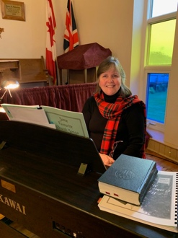
Reflections of our first day back at church,
I made it a point to be there really early so I could take photos inside and out….that felt familiar and fun to do. The inside of the church building was so nicely decorated by our usual “décor elves”! Being back inside the church felt very comforting , even though it felt a wee bit different not being able to hug people as they arrived. I felt shaky in the early part of the service as I played the piano. At first, I thought it was because of my broken shoulder but not I’m not so sure. It could have been because of the impact of the pandemic on all of us and realizing how we all have changed by our experiences during the past eighteen months. I think the bottom line is being back in church was comforting, but it had a bitter-sweetness to it as well.

Kim Flynn, our treasurer wrote, Lochwinnoch Church is a place, where I feel the presence of God. A place of beauty and where I feel peace. Being at worship, I felt a strong sense of together and so many memories of being together celebrating life as a community. Through Church breakfasts and social gatherings, funerals, weddings, anniversaries, showers, etc. – a place to share happy and sad times, and a place of honesty. Thank you to Milton for all he does as our minister, sharing God’s word and bringing us together.

Love is Sweet @ Lochwinnoch Church

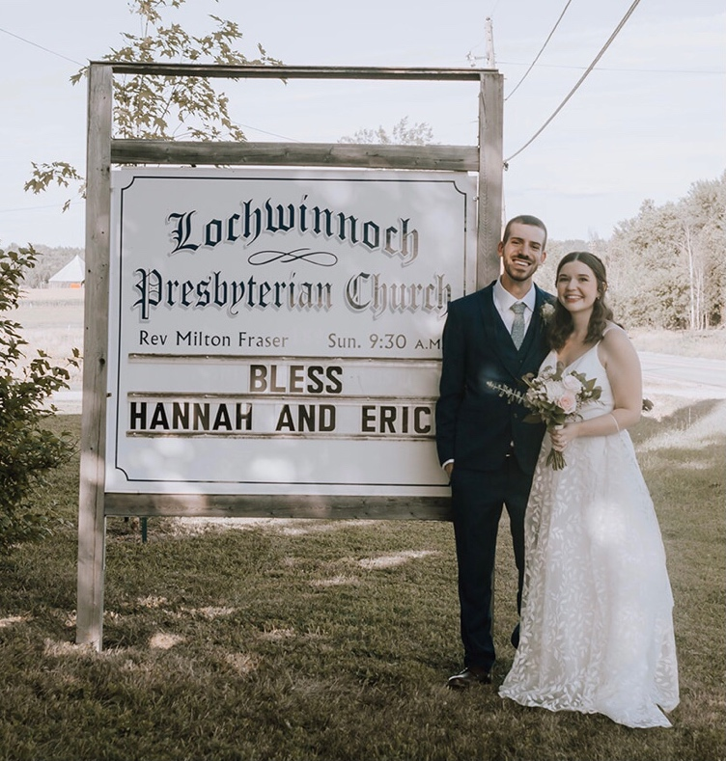

There are places where we can feel that goodness and peace reside, since I was a child I have felt this about Lochwinnoch Presbyterian. It was a sacred place to introduce to Eric, and has become our mutual place of worship, somewhere we come to ground ourselves and feel our cups filled. Next to saying “Yes” to Eric’s proposal choosing to get married at our country church was the second easiest decision to make for the wedding.

As we have all experienced, living in pandemic times has many unpredictable aspects. During the wedding planning process, we learned to be adaptable- changing dates, vendors, and guest numbers. When I heard about the water damage in the sanctuary, I was fearful that we would need to compromise on being at the church too.

Thankfully, we have some very resourceful and dedicated members of the Lochwinnoch community. It was encouraging to see progress pictures of the work, and knowing that a team was working hard to see the projects completed!

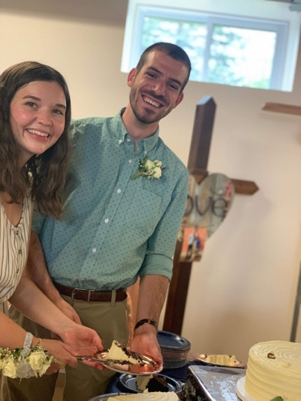
Despite construction continuing upstairs, many helping hands created a beautiful and safe space in the downstairs hall for us to be celebrated on August 8th, 2021. Thank you to everyone who showered us with support and joy! Such precious memories, as a couple we are so lucky to have a place of belonging.

On September 4th, 2021 Eric and I were joined in marriage, surrounded by people we love in a place
we love. Made even more special having my father as our officiant!

The Church was stunningly beautiful in its humbleness, sun shining through the stained-glass windows. We felt completely ourselves that day, we will treasure our photos against the beautiful brick and encircled by rolling farm fields.

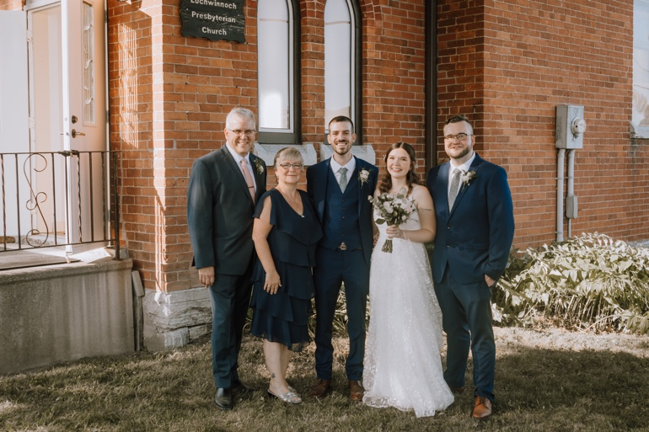

One of the verses we chose for our wedding was Ephesians 4:2-3: "With all humility and gentleness, with patience, bearing with one another in love, eager to maintain the unity of the Spirit in the bond of peace." We desire to live our lives with these values, so many of which I have seen witnessed in members of this church family.

To our Lochwinnoch Community, thank you for surrounding us with love. We have felt so honoured by the celebrations and well-wishes this past year. Eric and I are looking forward to our future years in this community and have so much gratitude.

- Hannah Fraser-Sweet

Treasurer Update – November 2021
Thank you to all who continue to support Lochwinnoch Church’s mission and ministry.
Your GENEROSITY
funds God’s work.

From Rev. Milton Fraser’s online and in-person ministry to the upgrades to our church building (both a new steel roof and interior work to the floors, walls and ceiling). Your donations continue to allow us to afford our utility costs and our obligations to the Presbyterian Church in Canada.

Thank you to all those who do behind the scenes work to maintain the grounds of the Church and maintain and beautify our Church for worship and special thanks go to those who make decisions about the future of Church and how to use our donations.

Your generosity has allowed the Church Elders to plan for a sharing of our gifts, with the proceeds of an upcoming sale of Amaryllis bulbs going to Presbyterian World Service and Development and Church members are planning for an Advent Food Bank Drive early December.

I am grateful to announce that one of our Church member’s, Michelle Miller, will assume the role of Church Treasurer in 2022. Michelle and I have been meeting to discuss Treasurer duties and responsibilities as she prepares to serve in this position. I have been blessed to serve as the Church Treasurer since Jan 2018 and look forward to supporting Michelle in the new year.
Blessings to All,

Kim Flynn, Lochwinnoch Church Treasurer

Ways to give to Lochwinnoch
1.Sending a bank e-transfer to lochwinnochpresbyterianfinance@gmail.com

2. Mailing a cheque made out to Lochwinnoch Presbyterian Church, to my home address: Lochwinnoch Presbyterian Church, c/o Kim Flynn, 134 Goshen Road, Renfrew, ON K7V 3Z4

3. On the offering plate at In Person Worship.

Please feel free to give Kim a call at 613-432-1594 or contact her by email if you have any questions.

Flood the Path with Light

God of our Life,
there are days when the burdens we carry
chafe our shoulders and weigh us down:
when the road seems dreary and endless,
the skies grey and threatening.
when our lives have no music in them,
and our hearts are lonely
and our souls have lost their courage.
Flood the path with light,
Turn our eyes to where
The skies are full of promise;
Tune our hearts to brave music;
Give us the sense of comradeship
With heroes and saints of every age;
And so quicken our spirits
That we may be able to encourage
The souls of all who journey with us
On the road of life, to your honour and glory.

Attributed to St Augustine (354-430)
Thanks to Joe Lamorie for sharing this prayer with us.

Online Prayer
Join in prayer, on the Lochwinnoch FaceBook Page, Wednesday and Sunday evenings.
Thanks to Anne-Marie, Kim, Jane, Shawna and Hannah
who host these prayer moments.

Faces of Faith:
Meeting the Elders of Lochwinnoch Church

In this edition of the Lochwinnoch Lantern we meet, Marg Whyte.

Margaret was born in Renfrew. She graduated as a Registered Nurse. She married Jim Whyte is 1970, who worked as a licenced electrician. Blessed with many years of nursing and raising a family. Worshipped from an early in many churches, depending on family moves.

So blessed to be back at Lochwinnoch after many years, relocating to Lochwinnoch in 1997.

What is your earliest memory of church life? My early memory is when I came to Lochwinnoch Church with my grandparents, and being in church whenever my parents moved to Kitchener, Hamilton, Burlington, and Haley’s.

What is your favourite hymn?

The Lord’s Prayer.

Where do you find inspiration to sustain your faith?

When I reflect on my strong spiritual heritage and lay my worries at Jesus’ feet.

Who has played a major role in your faith journey?

So many but most of all my mother’s unwavering faith and her conviction to the promise of eternal life.

If you could invite anyone (past or present) to a dinner party who would you invite?

My whole family as a tradition to Sunday dinners, reflection on our unconditional love for each other.

What is one hope you have for Lochwinnoch Church?

We as a congregation can continue to strive in the new direction covid has forced us into.

Write your own epitaph? (a phrase or form of words written in memory of a person who has died as an inscription on a tombstone).

If I wasn’t kind to you, forgive me.

Advent Calendar for Lochwinnoch Church

Sunday, November 28, First Sunday of Advent – Communion Service at 9:30 a.m. and on FaceBook pre-recorded.

Saturday, December 4, Lochwinnoch Food Bank Drive – 10 a.m. – 12 p.m. Drop Food off at the church, pick up available by calling 613-914-2675

FaceBook Service for those who find Christmas a Sad and Lonely Time – December 21, at 7 p.m.

First Annual “Impromptu Christmas Program”. – aired on FaceBook December 22, at 7 p.m. recordings sent to Milton by December 16.

Christmas Eve Service, December 24 at 7 p.m.

