**Worship on May 17, 2020**

**Order of worship**

1. Announcements
2. Song – Still
3. Prayer for worship
4. Scripture reading
5. Message
6. Prayer of the people
7. Song – BOP 64 – Be still and know that I am God
8. Benediction
9. Ponder Upon Questions

**Announcements:**

. This recording is for the worship of Sunday, May 17 2020 because of the closure of church building due to Coronavirus Pandemic. Tomorrow is Victoria Day. I hope and pray that you can go out and enjoy the fresh air and keep the safe distance. May your hearts and minds and bodies are well in the Lord.

. Thank you for the offerings dropped off at the office door and through Pre-Authorized Remittance. We can still collect your giving to the Lord through different ways. May God continue to provide your needs.

. This is the 3rd sermon of the series called The Armour of God. With the Belt of the Truth in Armour of God, let us continue to stand strong in the Lord

Let us worship God with singing!

**SONG – Still**

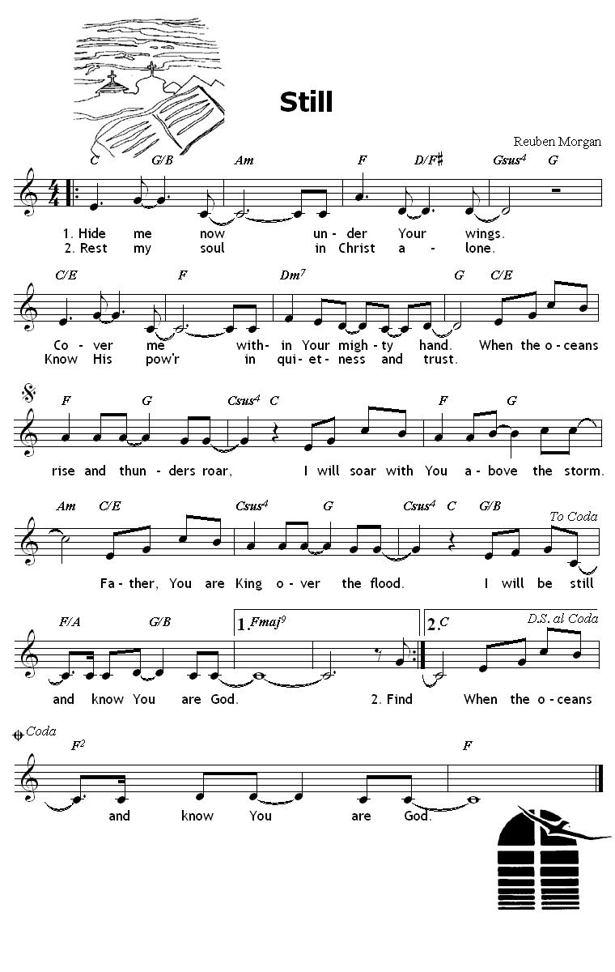

Prayer for worship

Most merciful and gracious God, we come to you in our weakness. We come to you in our fear. We come to you with trust. For you alone are our hope.   
We place before you this coronavirus changing the entire world and each of our person life. We turn to you in our time of need and fear. Hide us under your wings and cover us with your mighty hands. Father God, through this worship, help us know that you are God of everything. You are the Creator and the Sustainer of the whole world and of the life of each person. We are going to talk about the Belt of Truth today. Open our ears and hearts, so we may come close to you and to your truth, so we may stand strong with your power and love. We thank you for being who you are and what you are doing in our lives. Be praised and be glorified through this worship and through our lives. In Jesus’ precious and powerful, we pray. Amen.

Scripture: Ephesians 6:10-18

10 Finally, be strong in the Lord and in the strength of his power.   
11 Put on the whole armour of God, so that you may be able to stand against the wiles of the devil.   
12 For our struggle is not against enemies of blood and flesh, but against the rulers, against the authorities, against the cosmic powers of this present darkness, against the spiritual forces of evil in the heavenly places.   
13 Therefore take up the whole armour of God, so that you may be able to withstand on that evil day, and having done everything, to stand firm.   
14 Stand therefore, and fasten the belt of truth around your waist, and put on the breastplate of righteousness.   
15 As shoes for your feet put on whatever will make you ready to proclaim the gospel of peace.   
16 With all of these, take the shield of faith, with which you will be able to quench all the flaming arrows of the evil one.   
17 Take the helmet of salvation, and the sword of the Spirit, which is the word of God.   
18 Pray in the Spirit at all times in every prayer and supplication. To that end keep alert and always persevere in supplication for all the saints.

**This is the word of the Lord / Thanks be to God.**

Title: The Belt of Truth

The first piece of the armour of God is the Belt of Truth. We are going to talk about the function of the belt and the meaning of the truth.

The function of the belt was very important at that time. They dressed long flowing clothing. So, in order to do some activity, they had to tie up their flowing clothing. They used the belt for activities like working, walking long distances, officiating for a priest or a judge, or fighting in an arena or in war.

Their belt was different than nowadays. These days, it is very thin and narrow, but their belt was very thick and wide because the purpose of the belt was to protect their lower abdomen. This was one of the most important functions of the belt. And they wore sword belt, which was buckled on together with the sword so they could carry around their swords without carrying it with hands. And sometimes, they wore special belt or sash to distinguish the highly positioned officers and noblemen, or military clerks in the front line. So, the belt held their flowing clothing, protected their lower abdomen, helped carrying around their swords, and sometimes it was the sign of different positions and functions.

As you might notice, the belt could be their everyday must have item, not just a special battle equipment in war time. It’s a preparatory item. Where the belt goes is loin. And the loins are the central balancing support of our whole body. It’s like the foundation of the body. All things are built up from there. It secures the strength within us. As the function informs us, we tie around the waist or loins to be ready to do something. And it supports our whole body like the foundation.

So far, we took a look at the function of the belt at that time. So, the belt of truth means to be strengthened by God’s truth in the gospel so that we can live out the truth through our lives. Then, what is the truth? It is called the belt of truth in the armour of God. This could be understood the truth of God. The meaning of the truth is the word of God. God’s true words inspired by the Holy Spirit spoken to us and handed down to us is the truth of God. And we put our faith in it. It is the foundation of our faith. This is the general understanding of the Christian truth, the foundation of the faith, and the word of God.

Then, what does it mean to gird up our loins with the belt of truth? It is to read the word of God, listen to the interpretations of the word of God, sermons, and engrave the word of God on our hearts. So, what does it mean? To fill up our heads and hearts with God related knowledge! God’s feelings! God’s wills! Then, what does it mean to be filled with God?

The meaning of the truth in the belt of truth is our truthfulness, veracity, and our integrity. In other words, where do we put our hearts? What foundation do we take? What do we take as the truth? Which side do we take? **Romans 12:2 says, “Do not be conformed to the pattern of this world, but be transformed by the renewing of your mind. Then you will be able to test and approve what God’s will is – his good, pleasing and perfect will.”** As we talked about the evil power, the world is filled with evil power, the whole world from top to bottom. We are all influenced by it. That’s why Paul urges us to resist the worldly patterns. “The world we live in teaches that truth is what we make. The good and bad are subjective and there are no absolutes, only equally valid opinions. But the Bible teaches that truth is God’s Word – that good and bad are defined by God and there are eternal and unchangeable absolutes, uninfluenced by opinions.”

The truth is God’s word according to the Bible. But, the world we live in says the opposite. In these two extremes, what do we trust with our hearts and minds? With our thoughts and actions? What is the truth we are holding onto and what is the truth we fight for?

God’s word is the absolute truth. The problem is, is this my truth as well? Is this the truth I am going to take with my whole heart and life?!?

Imagine that you are getting ready for the battle. You are going to take up the whole pieces of armour. One by one, very carefully, you are putting each piece. When you are putting each piece of the armour, what would you think? Why are you going to the war? Are your hearts filled with fear? Doubts? Anger? Hatred? Or confidence? Trust for the leader? The value that you are fighting for? What is the truth you are holding in your hearts? In the Gospel of John Chapter 8, Jesus said to the Jews who believed in him, “If you hold to my teaching, you are really my disciples. You will know the truth, and the truth will set you free.” They answered Jesus, “We are Abraham’s descendants and we have never been slaves of anyone. How can you say that we shall be set free when we’ve been free for all our lives?” Jesus answered them. “Very truly I tell you, everyone who sins is a slave to sin.” “Everyone who sins is a slave to sin.”

Are we holding the teachings of Jesus? Yes. Of course. That’s why we are here today. **But, really?** Do we really take the teachings of Jesus within our hearts and lives and do we live out our lives accordingly?

This is our own belt of truth. What is our truth? Apostle Paul wrote this not because to teach us the word of God is the truth. We heard it so many times and we already know it. Paul wrote this, to us, because to urge us to choose our own truth. Choose God! Stand on God’s side! Take the firm foundation of the Word of God. “You heard it so many times and now it’s time for you to take a strong stand for God. As you take up the armour of God, put your foundation on something reliable, secure, and not perishable. As you go into the fight, don’t fight for your own judgments, your own feelings, or your own knowledge. Don’t fight for your own desires! Don’t fight for your own sake! These – our own knowledge, judgments, desires, and ourselves – cannot be our firm foundation. They are not secure. They are not perfect. They are like the house built on the sand. Take the firm foundation of the word of God. Take it with your whole hearts and make it your own truth. Be free in the truth. Don’t be the slave of sin anymore. Don’t be the instruments of sins anymore.” This is the message of Paul through the Belt of Truth.

The belt of truth. For soldiers, when they put the armour, when did they put the belt? First or last? They put their belt first before putting anything. The first item of the whole armour of God is the belt of truth. Why does it come first? Because it’s about our hearts. It’s about which side we take. It’s about where we put our hearts. Whose fight are we fighting?!

Where are your hearts? Are you putting your hearts on the truth of God’s word or your own selfish desires, knowledge, or something what this world teaches? As I briefly mentioned, there is no absolute truth in the teaching of this world. There are only equally valid opinions. Jesus clearly said to us. Take my teachings they are the truth you need to hold onto. And the truth will set you free. Why did Jesus say that to us? Because he loves us. Because he cares for us, because he wants us to live meaningful lives. Because that was the intention of creating us. The faith guide in PCC, called Westminster Shorter Catechism, teaches us the purpose of human being, or the chief end of man: It is to glorify God and to enjoy him forever. Unless we are set free, we can’t glorify God. If we are bound to something, we can’t enjoy our lives fully. God asks us today. Will you give your heart to me? Will you stand on my side of truth? Will you be my instrument and take my truth in your heart and fight for me? With my truth, will live for me?

Sisters and brothers in St. Andrew’s, I hope and pray that you can take up the belt of truth of God’s word and gird up your loins with it. It will become the foundation of your faith, it will make you ready to take up other pieces of the armour of God, it will protect your hearts, and support your faith. Please refer “Ponder Upon Questions” when you have time with God.

Let us pray

God of truth, we thank you and praise you for today’s message. We thank you for your love and care for us that you want us to take your side. You want us to follow your teachings and have truth in our hearts. Lord God, please strengthen us so that we can take your teaching, the truth. Give us wisdom to discern what your truth is and what is not. Give us courage to say NO to the things that is not your truth. We long to live meaningful lives for you. We want to live the fullest and the most pleasing life for you because you already provided us what we need. You gave us the best already. God Almighty, open our hearts and eyes so that we are aware of your presence in our lives, all the time. Protect us with your truth through the week and let us glorify you through our lives. Guide us and be with us. In Jesus’ precious and powerful name, we pray Amen.

**Continue to pray for the Prayer of the people**

Father God, we continue to pray for the people of God and for this world.

We give this coronavirus to your hands and please help all human being from this disease.   
Bring wisdom to doctors. Give understanding to scientists. Help them to develop the vaccine.

Bring healing to those who are ill with the coronavirus and other diseases. Give strength to those are fighting against their illness. Also, we pray for the people who are with mental health challenges. God, provide them necessary support.

Protect those who are most at risk. Provide them proper protection equipment.

Give comfort and peace to those who have lost their loved ones. Help families in distance.

Stabilize our communities. Unite us in our compassion. Remove all fear from our hearts. Fill us with confidence in your care.

We pray for our congregation. There are many who need prayer. In silence, let us pray for the people we know their prayer needs. (30 seconds)

With our prayer for each other, Lord God, build our community stronger. Help us love each other and care for each other. In our action of love, may our church, as an individual person in our personal daily lives, display your love and grace to the surroundings of our lives.

And we thank you for the offering we are offering up to you. We bring our hearts and lives to you along with our money, time, energy, focus, attention, body, minds, relationships, commitment, and our life itself. Lord, when we give to you, fill our hearts with thankfulness and fulfillment. It is the expression of our love for you. Use us and use our gift to you.

Jesus, we trust in you. Be lifted up and show your love and power. In Jesus’ precious and powerful name, we pray. Amen.

Song – **Be still and know that I am God**

**Benediction**

May the grace of our Lord Jesus Christ, And the Love of God, And the intimate fellowship of the Holy Spirit, Be with us all, now and always. Amen.

Ponder Upon Questions:

1. What is my foundation of faith?
2. Where is my life built on?
3. What is the way to free my life and live the most meaningful and the fullest life?