ANNOUNCEMENTS

A very warm welcome to everyone worshiping with us online or reading the transcript of our service. As Reverend Huh is on vacation, enjoying some family time with his wife and three sons, we welcome Robert Hayashi who will be leading us in worship this week.

Announcements can be viewed in the Clerk of Session’s weekly email.

The St. Andrew’s Prayer Chain offers daily prayers for those in need of God’s help. If you would like to request our prayers for yourself or for a loved one, please call Cheryl Daddis, 905-841-3674 or email cheryl@pathcom.com. Your prayer requests are a sacred trust and will be kept entirely confidential.

--------------------------------------------------------------------------------
St. Andrew’s Presbyterian Church
www.pccweb.ca/standrewsaurora
32 Mosley Street, Aurora, Ontario, L4G 1G9
office email: standrewsaurora@gmail.com
Telephone: 905-727-5011

Minister: The Rev. Soong Huh
revsoonghuh@hotmail.com

Clerk of Session: Adele Samuel
Email: clerkstandrewsaurora@gmail.com
Home Phone: 647-554-8534

Envelope Secretary: Don Hutchinson
Phone: 905-727-6567
Rentals: Nigel Samuel
Email: nigelsamuel14@gmail.com
Treasurer: Anne Neuman
Phone: 905-888-1278
Director of Music: Paul Townshend
CCLI: License Number #3156883

THIS WEEK AT A GLANCE

In person programs suspended until further notice unless otherwise arranged and communicated

St. Andrew’s Presbyterian Church

Aurora, Ontario

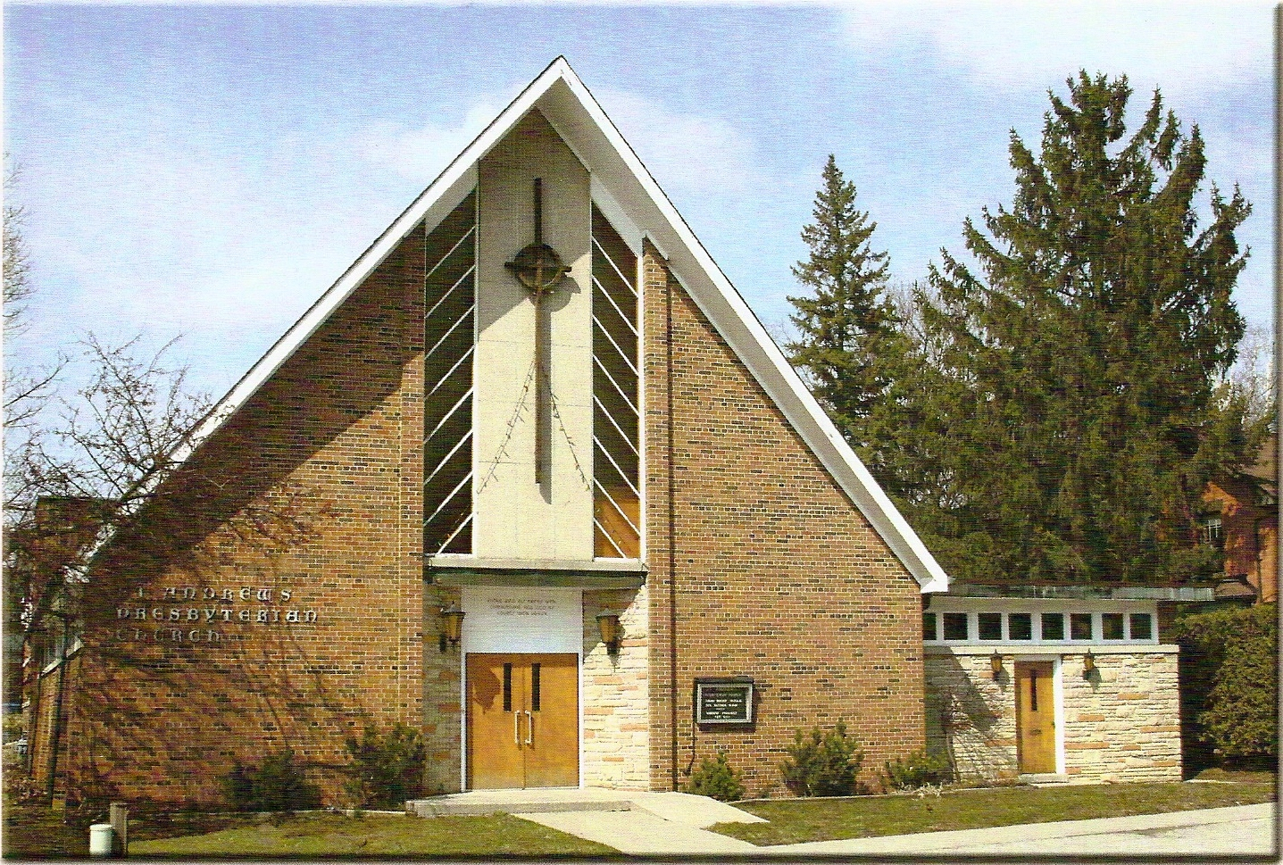
Sunday August 30th, 2020

Guest Preacher: Robert Hayashi
Welcoming Elder: Adele Samuel

Greeter: Victoria Heath

Our Reason Why

This is why we as a community of believers in Jesus Christ exist in this place and time. It is our purpose, cause, or belief.

Our reason why St. Andrew’s Aurora exists is:
- to be in relationship (with God and with one another),
- to feel cared for and connected,
- to belong,
- to participate with others to serve a larger purpose.

ST. ANDREW’S PRESBYTERIAN CHURCH
WE GATHER
Prelude
“Glorious Day”
Take a moment to prepare yourself for online worship

Welcome and Call to Worship
Responsive call to worship song:
“Holy, holy, holy” BOP #299

Prayer of Adoration and Confession:
The Lord’s Prayer in unison
Our Father in heaven, hallowed be your name, your kingdom come, your will be done, on earth as in heaven. Give us today our daily bread. Forgive us our sins as we forgive those who sin against us. Save us from the time of trial and deliver us from evil. For the kingdom, the power and the glory are yours, now and forever. Amen.

Words of Assurance & Christ’s Peace:
One: May the peace of the Lord Jesus Christ be with you!

WE LISTEN
Prayer for Illumination

Scripture Reading
Ecclesiastes 1:1-3; 3:1-8 Christopher Hayashi
One: The Word of the Lord, Thanks be to God

The Message: "Your Kairos Moment"

WE RESPOND
Responsive Song
"God is coming" Reverend William Min

Dedication of our Offering

Prayers of the People Pastor Rita

Song of Encouragement
“Death was arrested”
Reverend William Min accompanied by Ross Compton

WE SERVE
Benediction and Sung Blessing
“Go now in peace”
Go now in peace. Never be afraid.
God will go with you each hour of everyday.
Go now in faith, steadfast strong and true
Know He will guide you in all you do
Go now in love and show you believe
Reach out to others so all the world can see
God will be there, watching from above
Go now in peace, in faith and in love.
Amen, Amen, Amen

After the sung blessing, please take a moment in silence to
be mindful of the new possibilities offered to you in Jesus Christ.
Postlude “Lift High the Cross”

Bible Verse for the week:

“For everything there is a season and a time for every matter under heaven”

Ecclesiastes 1:1

Reflection for the week:

- What situations, people or thoughts make you feel that life is meaningless and why?
- How can you change those situations, your interactions with those people and those thoughts to live more fully and richly as God intends you to live?
- What season are you living in right this moment?
- How can you live more deeply in your “Kairos Moment” as God intends you to live?
- How can you encourage and invite another person to live in their “Kairos Moment?”

