POINSETTAS
The Poinsettias are in memory of loved ones who were either members of our church or friends of our church family.
. In loving memory of Enid Maze, from the church family.
. In loving memory of Donald Wilson, from the church family.
. In loving memory of Ralph Jessup, from the church family.
. In loving memory of Mary Duthie, from the church family.
. And, in loving memory of Jean Buchanan, from the church family.

Here I am to Worship

Light of the world
You step down into darkness
Opened my eyes let me see
Beauty that made this heart adore You
Hope of a life spent with You

And here I am to worship
Here I am to bow down
Here I am to say that You're my God
You're altogether lovely
Altogether worthy
Altogether wonderful to me

King of all days
Oh so highly exalted
Glorious in heaven above
Humbly You came to the earth You created
All for love's sake became poor

I'll never know how much it cost
To see my sin upon that cross

ANNOUNCEMENTS
A warm welcome to all who come to worship the Christmas Eve worship.

The next Lord’s Supper will be celebrated on Sunday, January 9th, 2022.

The St. Andrew’s Prayer Chain offers daily prayers for those in need of God’s help. If you would like to request our prayers for yourself or for a loved one, please call Cheryl Daddis, 905-841-3674 or email cheryl@pathcom.com. Your prayer requests are a sacred trust and will be kept entirely confidential.

--------------------------------------------------------------------------------
St. Andrew’s Presbyterian Church
www.pccweb.ca/standrewsaurora
32 Mosley Street, Aurora, Ontario, L4G 1G9
office email: standrewsaurora@gmail.com
Telephone: 905-727-5011

Minister: The Rev. Soong Huh
647-208-5381
revsoonghuh@hotmail.com

Clerk of Session: Adele Samuel
Email: clerkstandrewsaurora@gmail.com
Home Phone: 647-554-8534

Envelope Secretary: Don Hutchinson
Phone: 905-727-6567
Rentals: Nigel Samuel
Email: nigelsamuel14@gmail.com
Treasurer: Anne Neuman
Phone: 905-888-1278
CCLI: License Number #315688

St. Andrew’s Presbyterian Church

Aurora, Ontario

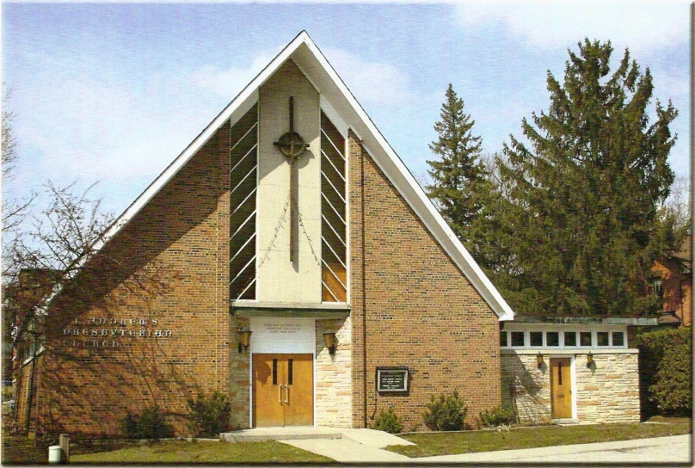
Saturday, December 24, 2021 – 7:00 PM
Rev. Soong Huh
Welcoming Member: Mehdi Sarder

Our Reason Why

This is why we as a community of believers in Jesus Christ exist in this place and time. It is our purpose, cause, or belief.

Our reason why St. Andrew’s Aurora exists is:
- to be in relationship (with God and with one another),
- to feel cared for and connected,
- to belong,
- to participate with others to serve a larger purpose.

ST. ANDREW’S PRESBYTERIAN CHURCH
Christmas Eve
WE GATHER
*You are invited to stand BOP = Book of Praise
Prelude
Welcome and Announcements
After the announcements, we pause for a moment of silence to prepare our hearts and minds for worship.
Responsive call to worship:
One: In this silent night,
All: We ponder your mystery with Mary and Joseph.
One: On this holy night,
All: We come with the shepherds to worship.
One: On this night of joy for the world,
All: We sing praises with choirs of angels.
One: In the darkness of this night,
All: We celebrate the Light of the World.

Opening song: " The First Nowell” BOP 136
Prayer of Adoration and Confession in unison

God of grace and mercy,
you give us the greatest gift of all, your Son Jesus,
but we confess we get caught up in our own gift giving on this holy night.
You offer us new life in the babe of Bethlehem,
but we smile at the baby and forget the new direction he offers.
Jesus was born in human flesh,
but we fail to see the dignity in the human lives around us.
Forgive us, O God,
and help us cherish the meaning in your gifts of wonder in the Christ Child.

The Lord’s Prayer in unison
Our Father in heaven, hallowed be your name, your kingdom come, your will be done, on earth as in heaven. Give us today our daily bread. Forgive us our sins as we forgive those who sin against us. Save us from the time of trial and deliver us from evil. For the kingdom, the power and the glory are yours, now and forever. Amen.

Words of Assurance:
WE LISTEN
Prayer for Illumination
First reading – Isaiah 9:2-7 (RSV)
2 The people who walked in darkness have seen a great light; those who dwelt in a land of deep darkness, on them has light shined. 3 Thou hast multiplied the nation, thou hast increased its joy; they rejoice before thee as with joy at the harvest, as men rejoice when they divide the spoil. 4 For the yoke of his burden, and the staff for his shoulder, the rod of his oppressor, thou hast broken as on the day of Mid′ian. 5 For every boot of the tramping warrior in battle tumult and every garment rolled in blood will be burned as fuel for the fire. 6 For to us a child is born, to us a son is given; and the government will be upon his shoulder, and his name will be called “Wonderful Counselor, Mighty God, Everlasting Father, Prince of Peace.” 7 Of the increase of his government and of peace there will be no end, upon the throne of David, and over his kingdom, to establish it, and to uphold it with justice and with righteousness from this time forth and for evermore. The zeal of the Lord of hosts will do this.

Second reading – Luke 2:1-15 (RSV)
1 In those days a decree went out from Caesar Augustus that all the world should be enrolled. This was the first enrollment, when Quirin′i-us was governor of Syria. 3 And all went to be enrolled, each to his own city. 4 And Joseph also went up from Galilee, from the city of Nazareth, to Judea, to the city of David, which is called Bethlehem, because he was of the house and lineage of David, 5 to be enrolled with Mary, his betrothed, who was with child. 6 And while they were there, the time came for her to be delivered. 7 And she gave birth to her first-born son and wrapped him in swaddling cloths, and laid him in a manger, because there was no place for them in the inn. 8 And in that region there were shepherds out in the field, keeping watch over their flock by night. 9 And an angel of the Lord appeared to them, and the glory of the Lord shone around them, and they were filled with fear. 10 And the angel said to them, “Be not afraid; for behold, I bring you good news of a great joy which will come to all the people; 11 for to you is born this day in the city of David a Savior, who is Christ the Lord. 12 And this will be a sign for you: you will find a babe wrapped in swaddling cloths and lying in a manger.” 13 And suddenly there was with the angel a multitude of the heavenly host praising God and saying, 14 “Glory to God in the highest, and on earth peace among men with whom he is pleased!” 15 When the angels went away from them into heaven, the shepherds said to one another, “Let us go over to Bethlehem and see this thing that has happened, which the Lord has made known to us.”

One: This is the Word of the Lord
All: Thanks be to God
Meditation music: Here I am to Worship
(Words on other side)
Message: “Here I am to Worship "
WE RESPOND
Prayers of the People
Offering Our Gifts
WE SERVE
* Song for the Journey: "Silent Night" BOP 154

* Blessing (By St. Augustine of Hippo)
One: Let the just rejoice
All: for the Justifier is born.
One: let the sick and infirm rejoice,
All: For their Saviour is born.
One: Let the captives rejoice
All: For their Redeemer is born.
One: Let slaves rejoice,
All: For their Master is born.
One: Let free men rejoice,
All: For their Liberator is born.
One: Let All Christians rejoice,
All: Jesus Christ is born.

Postlude

