ANNOUNCEMENTS

A warm welcome to all who come to worship this Sunday. Please join us after worship for refreshments and fellowship

Please note
Welcome to Rev Tim Walker who will lead our worship service today

Martha's Table closed for Summer Recess

Aurora Community Café closed for Summer Recess

Welcome Table Wednesday, 5:30, Trinity Anglican Church
79 Victoria street, Aurora, is still active.

The Summer Edition of “Presbyterian Connection” is available for pick up in the Church Narthex.

“Our Daily Bread” (daily devotional) can also be picked up in the Church Narthex

PRAYERS: Prayers are unseen, yet powerful. Please remember and continue to pray for Ukraine, Middle East and other areas of the world in crisis. Donations may be designated on your envelope or sent directly to PWSD indicating your Church name

St. Andrew’s Presbyterian Church
www.pccweb.ca/standrewsaurora
32 Mosley Street, Aurora, Ontario, L4G 1G9
Office email: standrewsaurora@gmail.com
Telephone: 905-727-5011

Minister: The Rev. Soong Huh
revsoonghuh@hotmail.com

Clerk of Session: Kevin Johnston
Email: clerkstandrewsaurora@gmail.com

Envelope Secretary: Don Hutchinson
Phone: 905-727-6567
Rentals: Nigel Samuel
Email: nigelsamuel14@gmail.com
Maintenance: Edwin Webster
Email: edwebster1945@gmail.com

Treasurer: Anne Neuman

Phone: 905-888-1278
Organist: Justine Song
Email: Danada514@gmail.com
CCLI: License Number #3156883

St. Andrew’s Presbyterian Church

Aurora, Ontario

Sunday July 7, 2024 - 10:30 AM

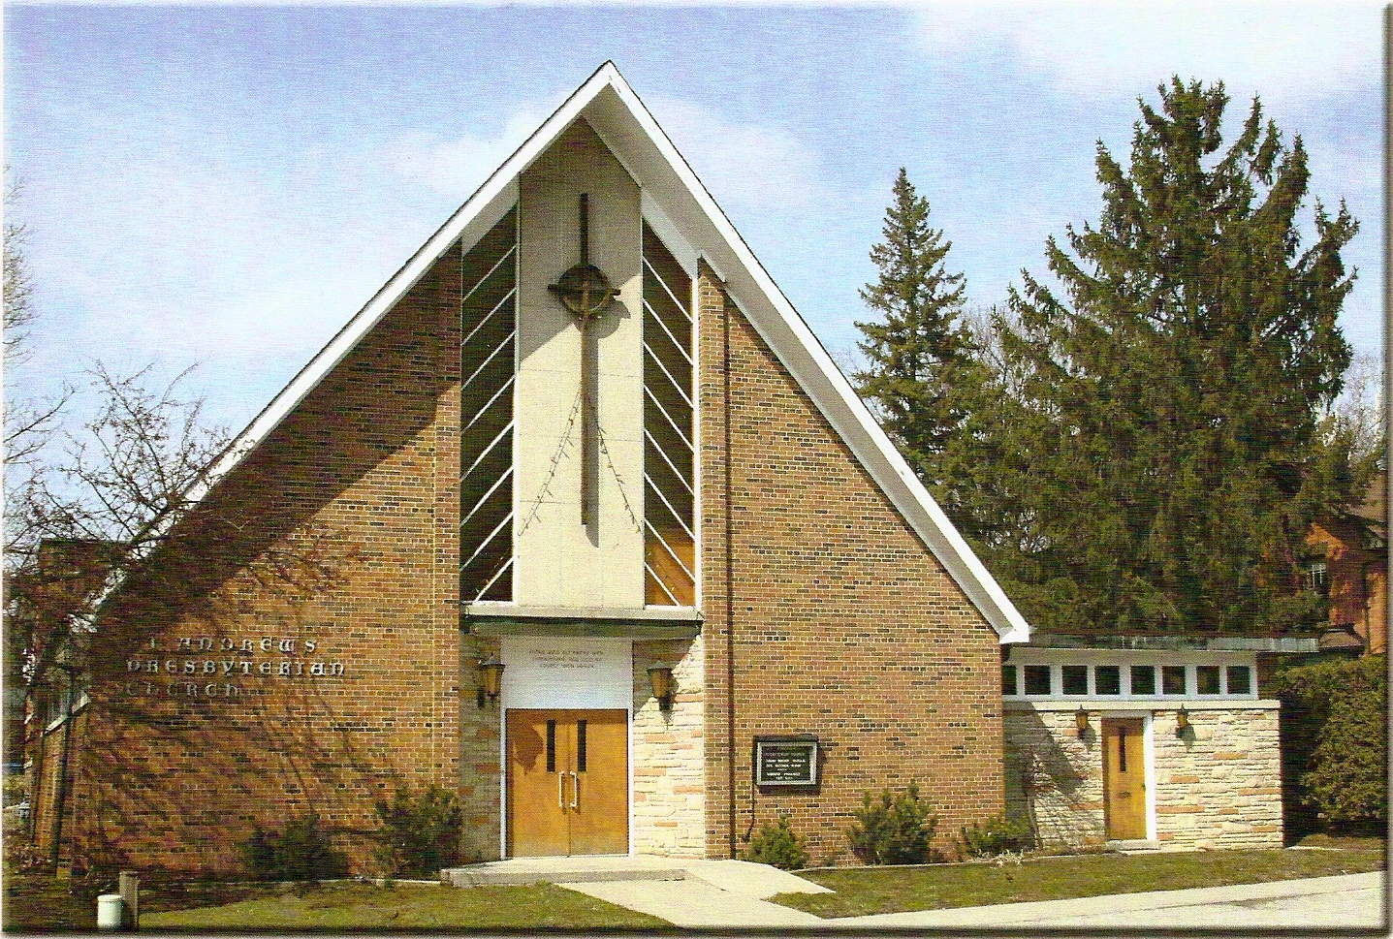

Rev. Tim Walker
Welcoming Elder: Gordon Osborne

Our Reason Why
As a community of believers in Jesus Christ we wish:
- to be in relationship (with God and with one another),
- to belong, feel cared for and connected,
- to participate with others to serve a larger purpose.

ST. ANDREW’S PRESBYTERIAN CHURCH
WE GATHER
*You are invited to stand BOP = Book of Praise
Prelude
Welcome and Announcements
After the announcements, we pause for a moment of silence to prepare our hearts and minds for worship.

Responsive Call to Worship:

Great is the Lord;
and greatly to be praised.

Praise God in cities and towns,
praise God in all quiet places.

Praise God on mountains and hilltops,
praise God in every valley, on every plain and in the deeps.

Let us raise our praise with all God's creation,
We will praise God's holy name, here and everywhere,
now and always.

“Morning has broken.” BOP 814

Prayer for Worship

The Lord’s Prayer in unison
Our Father in heaven, hallowed be your name, your kingdom come, your will be done, on earth as in heaven. Give us today our daily bread. Forgive us our sins as we forgive those who sin against us. Save us from the time of trial and deliver us from evil. For the kingdom, the power and the glory are yours, now and forever. Amen.
Words of Assurance

*Hymn
“Saviour like a shepherd lead us BOP 485

Prayer for the Children

WE LISTEN
Sung Prayer for Illumination BOP 445
Open our eyes, Lord, we want to see Jesus,
to reach out and touch him, and say that we love him.
Open our ears, Lord, and help us to listen.
Open our eyes, Lord, we want to see Jesus.

Scripture reading:
First Reading: Isaiah 6:1-13

Second Reading: Philippians 2:1-11

One: This is the word of the Lord.
All: Thanks be to God

Message: “Love to serve, Serve to love”

*Hymn:
“Humble King.” (See insert)
Prayer for the people

WE RESPOND

Offering Our Gifts (Offering Plate is at the Narthex Door)
Doxology
“Praise God from whom all blessings flow.” BOP 830

Offering Prayer
WE SERVE
*Song for the Journey:
“Stand up and bless the Lord” BOP 411

*The Benediction
*A Sung Blessing. BOP 726
May the God of hope go with us every day.
Filling all our lives with love and joy and peace.
May the God of justice speed us on our way, bringing light and hope to every land and race
Praying, let us work for peace. Singing, share our joy with all. Working for a world that’s new, faithful when we hear Christ’s call.
(Please be seated and in silence, be mindful of the new possibilities offered to you in Jesus Christ)
Postlude

