**ANNOUNCEMENTS**

**A warm welcome** to all who come to worship this Sunday. Please join us after worship for refreshments and fellowship

*** **NOTE**: With no Projector we will be using the Pew Hymn Book and Bible

Please give **Christine Samuel** a warm welcome as our visiting speaker.

**Martha's Table**, and **Aurora Community Café** are closed for the Summer.

**Welcome Table:** Wednesday, 5:00 p.m. meal, at Trinity Anglican Church 79 Victoria street, Aurora, is still active.

**Next COMMUNION**: Sunday, September 8th, 2024.

The **St. Andrew’s Prayer Chain** offers daily prayers for those in need of God’s help. If you would like to request our prayers for yourself or for a loved one, please call **Mary Becker**, 416-709-4921 or email: [**mabecker@rogers.com**](mailto:mabecker@rogers.com). Your prayer requests are a sacred trust and will be kept entirely confidential.

**Here are some Prayers for this week:**

* We pray that God would speak to the hearts of those who have gifts and graces for ordained ministry and challenge them to consider service in the church as ordained ministers of the Word and Sacraments.
* We pray for the General Assembly of The Presbyterian Church of Ghana as they meet from August 14–18.

**St. Andrew’s Presbyterian Church**

www.pccweb.ca/standrewsaurora

32 Mosley Street, Aurora, Ontario, L4G 1G9

Office email: [standrewsaurora@gmail.com](mailto:standrewsaurora@gmail.com)

Telephone: 905-727-5011

**Minister: The Rev. Soong Huh**

revsoonghuh@hotmail.com

**Clerk of Session: Kevin Johnston**

Email: clerkstandrewsaurora@gmail.com

**Envelope Secretary: Don Hutchinson**

Phone: 905-727-6567

**Rentals: Nigel Samuel**

Email: nigelsamuel14@gmail.com

**Maintenance: Edwin Webster**

Email: [edwebster1945@gmail.com](mailto:edwebster1945@gmail.com)

**Treasurer: Anne Neuman**

Phone: 905-888-1278

**Organist: Justine Song**

Email: Danada514@gmail.com

CCLI: License Number #3156883

**St. Andrew’s Presbyterian Church**

**Aurora, Ontario**

***Sunday August 11, 2024 - 10:30 AM***

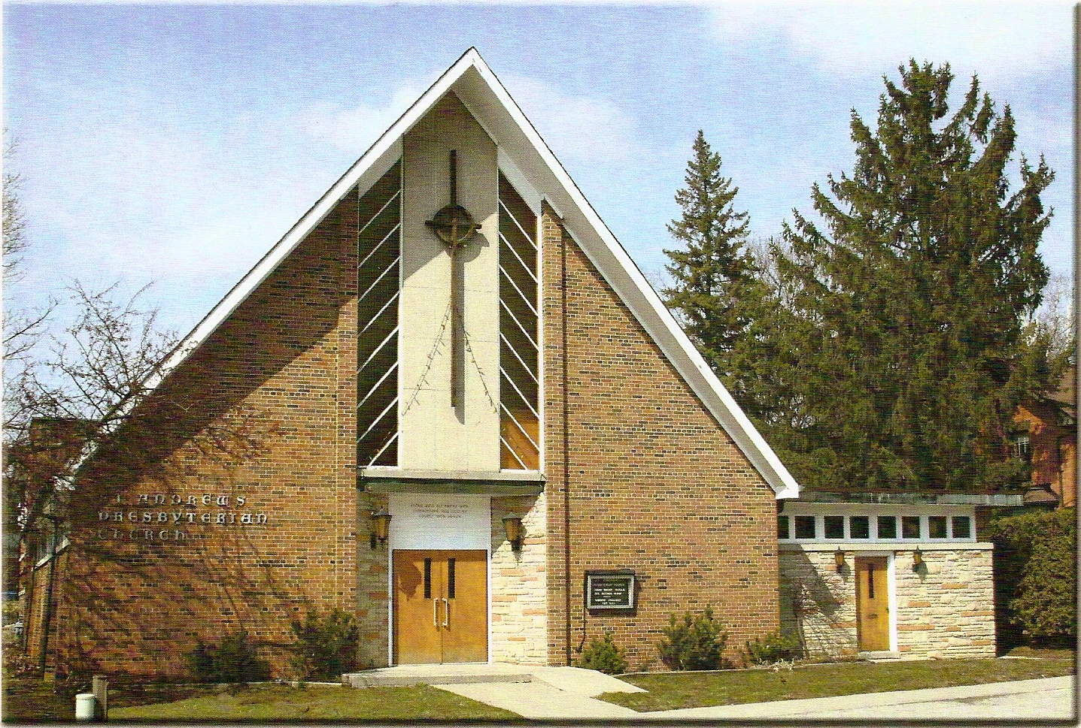

*Christine Samuel*

Welcoming Elder: *Christine Tian*

**Our Reason Why**

*As a community of believers in Jesus Christ we wish:*

* to be in relationship (with God and with one another),
* to belong, feel cared for and connected,
* to participate with others to serve a larger purpose.

**ST. ANDREW’S PRESBYTERIAN CHURCH**

**12th Sunday After Pentecost**

**August 11, 2024**

**WE GATHER**

*\*You are invited to stand BOP = Book of Praise*

**Prelude**

**Welcome and Announcements**

*After the announcements, we pause for a moment of silence to prepare our hearts and minds for worship.*

**\*Hymn:** “*Amigo DeCristo/Friends of the Lord* “ BOP 476

**Responsive Call to Worship:**

Let us bless God at all times;

**We will praise God’s holy name.**

Let us look to God, and be radiant;

**For God has delivered us from all our fears.**

Jesus has promised whoever comes to him will never be hungry, those who believe in him will never thirst.

**Let us taste the Bread of Life in scripture and song as we worship God!**

**\*Hymn:** “*I. the Lord of the sea and Sky* “ BOP 592

***Prayer of Adoration:***

**Prayer of Confession:**

**The Lord’s Prayer** *in unison*

**Our Father in heaven, hallowed be your name, your kingdom come, your will be done, on earth as in heaven.  Give us today our daily bread.  Forgive us our sins as we forgive those who sin against us.  Save us from the time of trial and deliver us from evil.  For the kingdom, the power and the glory are yours, now and forever.  Amen.**

**Words of Assurance:**

**\*Hymn:** *“The Church’s One Foundation”*  BOP 479

**WE LISTEN**

**Sung Prayer for Illumination:** BOP 445

 Open our eyes, Lord, we want to see Jesus,

  to reach out and touch him, and say that we love him.

  Open our ears, Lord, and help us to listen.

  Open our eyes, Lord, we want to see Jesus.

**Scripture reading:**

First reading: Genesis 12: 1-9 Pew Bible p. 10

Responsive Psalm: Psalm 133 (Refrain 1)

Third reading: 1 Corinthians 12: 12-28 Pew Bible p. 174

**One:** This is the word of the Lord.

**All: Thanks be to God**

**Message: “*The Body of Christ*”**

**\*Hymn:** “*I am the Church, You are the Church”* BOP 475

**Prayers of the people:**

**WE RESPOND**

**Offering Our Gifts** (*Offering Plate is at the Narthex Door*)

**\*Doxology**

*“Praise God from whom all blessings flow.”*  BOP 830

**Offering Prayer**

**WE SERVE**

*\****Song for the Journey***:*

*“We are God’s People”*  BOP 472

**\*The Benediction**

**\*A Sung Blessing.** BOP 726

May the God of hope go with us every day.

Filling all our lives with love and joy and peace.

May the God of justice speed us on our way, bringing light and hope to every land and race

Praying, let us work for peace. Singing, share our joy with all. Working for a world that’s new, faithful when we hear Christ’s call.

*(Please be seated and in silence, be mindful of the new possibilities offered to you in Jesus Christ)*

**Postlude**