ANNOUNCEMENTS
A warm welcome to all who come to worship this Sunday. Please join us for refreshments and fellowship in Guild Hall after worship.

2nd Aurora Scouting
Monday April 20, 6pm – 8pm
Spaghetti Supper Fundraiser - $15. Per person

April 26 – Annual General Meeting after worship service. Soup and sandwich lunch provided.

NEW ISSUES: Available in the Narthex for pickup:
- The Spring Presbyterian Connection Newspaper
- Our Daily Bread Devotionals for March, April and May
Martha’s Table - Thursdays 11:30 – 1:00pm
Everyone welcome
Volunteer Opportunity
Aurora Community Café is available every Wednesday in the Guild Hall from 10:00am – 2:00pm. Volunteers are needed to keep this initiative going. Please contact Rev. Soong if you are able to help
The St. Andrew’s Prayer Chain offers daily prayers for those in need of God’s help. If you would like to request our prayers for yourself or for a loved one, please call Mary Becker, 416-709-4921 or email: mabecker@rogers.com. Your prayer requests are a sacred trust and will be kept entirely confidential.

St. Andrew’s Presbyterian Church
www.pccweb.ca/standrewsaurora
32 Mosley Street, Aurora, Ontario, L4G 1G9
Office email: standrewsaurora@gmail.com
Telephone: 905-727-5011

Minister: The Rev. Soong Huh
revsoonghuh@hotmail.com

Clerk of Session: Kevin Johnston
Email: clerkstandrewsaurora@gmail.com

Envelope Secretary: Don Hutchinson
Phone: 905-727-6567
Rentals: Nigel Samuel
Email: nigelsamuel14@gmail.com

Maintenance: TBA
Email: standrewsaurora@gmail.com
Treasurer: Anne Neuman
Phone: 905-888-1278
Organist: Justine Song
Email: Danada514@gmail.com
CCLI: License Number #3156883

This Week at a Glance

Wednesday Aurora Community Café 10:00am – 2:00pm

Thursday Martha’s Table 11:30 am – 1:00 pm

Saturday Rise & Shine Breakfast (Trinity Anglican) 9:30 -10:30 am

St. Andrew’s Presbyterian Church

Aurora, Ontario

Sunday April 5, 2026 - 10:30 AM

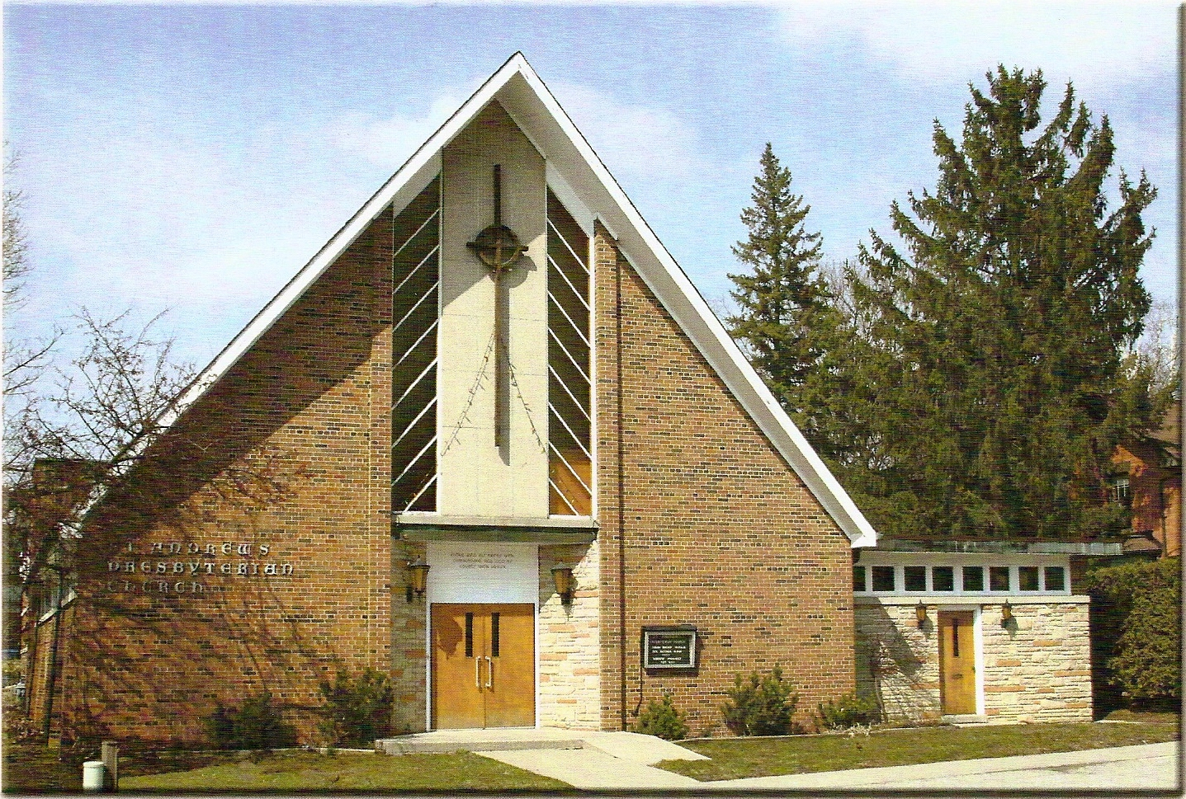
Rev Soong Huh

Welcoming Elder: Kevin Johnston

Our Reason Why
As a community of believers in Jesus Christ we wish:
- to be in relationship (with God and with one another),
- to belong, feel cared for and connected,
- to participate with others to serve a larger purpose.

ST. ANDREW’S PRESBYTERIAN CHURCH
Easter Sunday
WE GATHER
*You are invited to stand BOP = Book of Praise
Prelude
Welcome and Announcements
Responsive call to worship:
On Friday, we stood at the cross, and we did not understand.
Today, we come to the empty tomb, and we begin to see.
Christ is risen from the dead.
He is risen indeed! Alleluia!
What looked like the end has become a new beginning.
What seemed like defeat has become victory.
God has been at work even when we could not see it.
Now we rejoice in the life that cannot be overcome.
Christ is risen! He is risen indeed! Alleluia!
*Hymn: “Jesus Christ is risen today.” BOP 243
Prayer of Adoration
Prayer of Confession (in unison)
Risen Lord, you bring life out of death, yet we confess that we still live in fear. We hold on to worry instead of trusting your promises. We stay in places of doubt instead of stepping into hope. Forgive us, O God. Open our eyes to see your work in our lives. Lead us out of our tombs and into the new life you have prepared for us. In Jesus’ name, we pray. Amen.
The Lord’s Prayer (in unison)
Our Father in heaven, hallowed be your name, your kingdom come, your will be done, on earth as in heaven. Give us today our daily bread. Forgive us our sins as we forgive those who sin against us. Save us from the
time of trial and deliver us from evil. For the kingdom, the power and the glory are yours, now and forever. Amen.
Assurance of Pardon:
One: May the peace of the Lord Jesus Christ be with you!
All: and, also with you!
*Hymn:“I Danced in the Morning(Lord of the Dance)”BOP 250
Prayer for the children
WE LISTEN
Sung Prayer for Illumination: BOP 445
Open our eyes, Lord, we want to see Jesus,
to reach out and touch him, and say that we love him.
Open our ears, Lord, and help us to listen.
Open our eyes, Lord, we want to see Jesus.
- First reading: Acts 10:34-43
- Second reading: Psalm 118:1-2, 14-24 (Refrain 1)
- Third reading: Luke 24:1-12
One: This is the word of the Lord.
All: Thanks be to God
Message: “Now We Begin to See”
*Hymn: “At the Dawning of Salvation.” BOP 248
WE TASTE
The Lord’s Table Invitation
The Apostle’s Creed (in unison) BOP 539
Great Prayer of Thanksgiving:
L: The Lord be with you.
P: And also with you.
L: Lift up your hearts.
P: We lift them to the Lord
L: Let us give thanks to the Lord our God.
P: It is right to give God thanks and praise.
L: Continues... We join with the whole creation
to lift up our hearts in joyful praise
Sanctus
Holy, holy, holy Lord,
God of pow’r and might,
Heaven and earth are full of your glory,
Hosanna in the highest
Blessed is he who comes in the name of the Lord
Hosanna in the highest
L: … as we proclaim the mystery of faith:
P: Christ has died, Christ is risen, Christ will come again.
Breaking of the Bread
Communion of the people
(Please hold the elements until you return to your seats, where we will partake together)
Prayer after Communion
WE RESPOND
Offering Our Gifts (Offering Plate is at the Narthex Door) Doxology: “Praise God from whom all blessings flow.“ BOP 830
Offertory Prayer
WE SERVE
*Song for the Journey:
*Hymn: “Because he lives.”
*The Benediction:
*A Sung Blessing BOP 726
May the God of hope go with us every day,
filling all our lives with love and joy and peace.
May the God of justice speed us on our way,
bringing light and hope to every land and race.
Praying, let us work for peace; singing, share our joy with all;
working for a world that's new, faithful when we hear Christ's call.
(Please be seated and in silence, be mindful of the new possibilities offered to you in Jesus Christ)
Postlude

