ANNOUNCEMENTS
A warm welcome to all who come to worship this Sunday. Please join us for a soup and sandwich lunch in Guild Hall after worship.

*********************************************
Please stay and participate in the Annual General Meeting after worship service. Soup and sandwich lunch provided.
+++++++++++++++++++++++++++++++++++++++++++++
The St. Andrew’s Prayer Chain offers daily prayers for those in need of God’s help. If you would like to request our prayers for yourself or for a loved one, please call Mary Becker, 416-709-4921 or email: mabecker@rogers.com. Your prayer requests are a sacred trust and will be kept entirely confidential.

St. Andrew’s Presbyterian Church
www.pccweb.ca/standrewsaurora
32 Mosley Street, Aurora, Ontario, L4G 1G9
Office email: standrewsaurora@gmail.com
Telephone: 905-727-5011

Minister: The Rev. Soong Huh
revsoonghuh@hotmail.com

Clerk of Session: Kevin Johnston
Email: clerkstandrewsaurora@gmail.com

Envelope Secretary: Don Hutchinson
Phone: 905-727-6567
Rentals: Nigel Samuel
Email: nigelsamuel14@gmail.com

Maintenance: TBA
Email: standrewsaurora@gmail.com
Treasurer: Anne Neuman
Phone: 905-888-1278
Organist: Justine Song
Email: Danada514@gmail.com
CCLI: License Number #3156883

This Week at a Glance

Wednesday Aurora Community Café 10:00am – 2:00pm

Thursday Martha’s Table 11:30 am – 1:00 pm

Saturday Rise & Shine Breakfast (Trinity Anglican) 9:30 -10:30 am

St. Andrew’s Presbyterian Church

Aurora, Ontario

Sunday April 26, 2026 - 10:30 AM

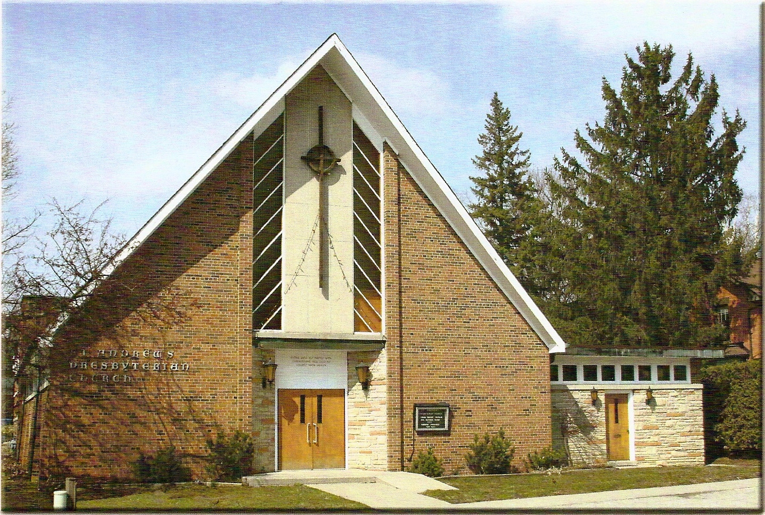

Rev Soong Huh

Welcoming Elder: Anne Neuman

Our Reason Why
As a community of believers in Jesus Christ we wish:
- to be in relationship (with God and with one another),
- to belong, feel cared for and connected,
- to participate with others to serve a larger purpose.

ST. ANDREW’S PRESBYTERIAN CHURCH
Fourth Sunday of Easter
WE GATHER
*You are invited to stand BOP = Book of Praise
Prelude
Welcome and Announcements
Responsive call to worship:
God, our Shepherd, offers us abundant life.
God, you are with us!
God, our Shepherd, leads us by still waters.
God, restore our souls!
God, our Shepherd, walks with us through every dark valley.
God, we will not be afraid!
God, our Shepherd, we praise you for your goodness and mercy with us every day.
*Hymn: “Let Christian hope and faith dispel.” BOP 368
Prayer of Adoration
Prayer of Confession (in unison)
God of love, we confess that too often we let the events around us shatter our trust in your love. When terror strikes and innocents fall, we wonder if love can defeat violence. When truth gets lost among misleading claims, we wonder if love can prevail over lies.
Forgive us, God, when we lose our trust in the power of your love so soon after it raised Jesus from death’s grip.

The Lord’s Prayer (in unison)
Our Father in heaven, hallowed be your name, your kingdom come, your will be done, on earth as in heaven. Give us today our daily bread. Forgive us our sins as we forgive those who sin against us. Save us from the
time of trial and deliver us from evil. For the kingdom, the power and the glory are yours, now and forever. Amen.
Assurance of Pardon:
One: May the peace of the Lord Jesus Christ be with you!
All: and, also with you!
*Hymn: “This is my Father’s world.” BOP 328
Prayer for the children
WE LISTEN
Sung Prayer for Illumination: BOP 445
Open our eyes, Lord, we want to see Jesus,
to reach out and touch him, and say that we love him.
Open our ears, Lord, and help us to listen.
Open our eyes, Lord, we want to see Jesus.
- First reading: Ezekiel 34:7-15
- Second reading: Psalm 23 (Refrain 1)
- Third reading: John 10:1-10
One: This is the word of the Lord.
All: Thanks be to God

Message: “Listening for the Voice That Gives Life”
*Hymn: “Worthy is the lamb.” (See Insert)
Prayer for the people

WE RESPOND
Offering Our Gifts (Offering Plate is at the Narthex Door)
Doxology: “Praise God from whom all blessings flow.“ BOP 830
Offertory Prayer

WE SERVE
*Song for the Journey:
*Hymn: “Who’s going to tell the story.” BOP 761
*The Benediction:

*A Sung Blessing BOP 726
May the God of hope go with us every day,
filling all our lives with love and joy and peace.
May the God of justice speed us on our way,
bringing light and hope to every land and race.
Praying, let us work for peace; singing, share our joy with all;
working for a world that's new, faithful when we hear Christ's call.

(Please be seated and in silence, be mindful of the new possibilities offered to you in Jesus Christ)

Postlude

Please join us in the Guild Hall for a light lunch and stay to participate in AGM to follow.

