Unison Prayer:
Eternal God, we have stood at the cross today. We have heard words of forgiveness, hope,
love, and trust. Yet, we still do not fully understand.
Teach us to wait. Teach us to trust. Teach us to remain with you, even in silence.
We call this day good, and we wait for you to show us why.
Be with us. In Jesus’ name, we pray. Amen.

Closing Hymn: “Beneath the cross of Jesus.” BOP 238

**************

You are invited to sit in silence and reflect the possibilities offered to you in Jesus Christ

Please leave silently
**************

St. Andrew’s Presbyterian Church
www.pccweb.ca/standrewsaurora
32 Mosley Street, Aurora, Ontario, L4G 1G9
Office email: standrewsaurora@gmail.com
Telephone: 905-727-5011

Minister: The Rev. Soong Huh
revsoonghuh@hotmail.com

Clerk of Session: Kevin Johnston
Email: clerkstandrewsaurora@gmail.com

Envelope Secretary: Don Hutchinson
Phone: 905-727-6567
Rentals: Nigel Samuel
Email: nigelsamuel14@gmail.com
Maintenance: TBA
Email: standrewsaurora@gmail.com
Treasurer: Anne Neuman
Phone: 905-888-1278
Organist: Justine Song
Email: Danada514@gmail.com
CCLI: License Number #3156883

St. Andrew’s Presbyterian Church

Aurora, Ontario

Friday April 3, 2026 - 10:30 AM

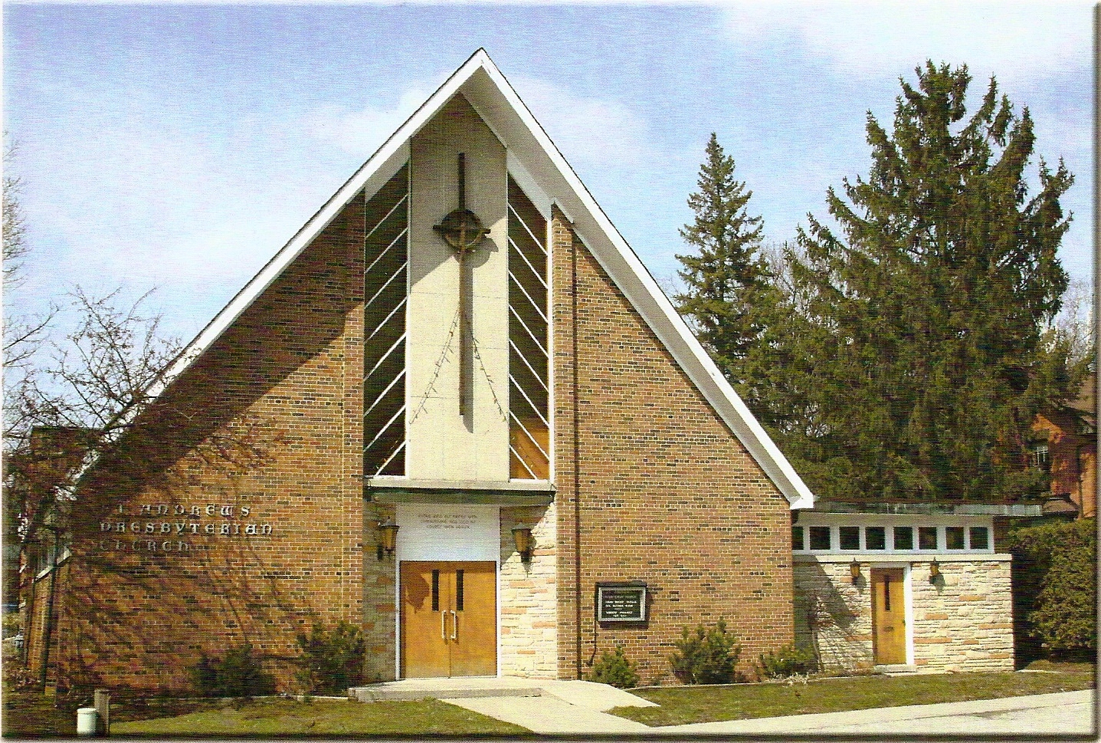
Rev Soong Huh

Welcoming Elder: Anne Neuman

Our Reason Why
As a community of believers in Jesus Christ we wish:
- to be in relationship (with God and with one another),
- to belong, feel cared for and connected,
- to participate with others to serve a larger purpose.

ST. ANDREW’S PRESBYTERIAN CHURCH
Good Friday
WE GATHER
*You are invited to stand BOP = Book of Praise
Prelude
Responsive call to worship:
We gather at the cross of Christ, on this day we call Good Friday.
We come, not with answers, but with open hearts.
We remember the suffering of Jesus, his love poured out for the world.
We stand in silence, in awe of his sacrifice.
On this day of sorrow, we hear words of forgiveness and mercy.
Even here, grace is given.
On this day of darkness, we see glimpses of hope.
Even here, God is at work.
We do not yet understand why this day is called good.
But we trust the One who gave himself for us.
Blessed be the name of the Lord, now and forever. Amen.
*Hymn: “When I survey the wondrous cross.” BOP 231
Opening Prayer
Sung response: “O come and mourn with me awhile.” BOP 237
First Reading: Luke 23:32-34
Keep silence for 20-30 seconds before leading in the prayer

Unison Prayer: Heavenly Father, on this solemn Good Friday, we reflect on your Son’s sacrifice. As Simon carried the cross and the women wept, we see the weight of our sins. Jesus, crucified with sinners, you prayed, “Father, forgive them.” Grant us hearts of repentance and compassion. May we walk in your mercy, forgiven and renewed. Unite us in your love, as we mourn your suffering and await your resurrection. Thank you for your boundless grace. We pray this in Jesus’ holy name. Amen.

Sung Response: “Behold the Lamb of God.” BOP 525

Second Reading: Luke 23:39-43
Keep silence for 20-30 seconds before leading in the prayer
Unison Prayer:
Merciful God, we remember the criminal beside Jesus, who turned to him in his final moments. When all seemed lost, Jesus spoke hope. In our brokenness, teach us to turn to you. In our weakness, help us to trust your promise. Even here, hope is given. This is part of why we call this day good. In Jesus’ name, we pray. Amen
Sung Response: ”Jesus remember me.” BOP 206

Third Reading: John 19:25-27
Keep silence for 20-30 seconds before leading in the prayer
Unison Prayer:
Loving God, at the foot of the cross, Jesus forms a new family. In his suffering, he draws people together. Bind us together in your love. Make us a community of care, supporting one another in times of sorrow and hope. Even here, a new family is formed. This is part of why we call this day good. In Jesus’ precious name, we pray. Amen.
Sung Response: “Behold the Lamb of God.” BOP 525
Fourth Reading: Matthew 27:45-46
Keep silence for 20-30 seconds before leading in the prayer
Unison Prayer:
Holy God, we hear Jesus cry, “My God, my God, why have you forsaken me?” In his suffering, we enter into our deepest pain. When we feel alone, remind us that you are near. When we feel abandoned, hold us firmly in your presence. Even here, we are not alone. This is part of why we call this day good. In Jesus’ name we pray. Amen.

Sung response: “Were you there.” (Vs. 1) BOP 233

Fifth Reading: John 19:28-29
Keep silence for 20-30 seconds before leading in the prayer
Unison Prayer:
Gracious God, we hear Jesus say, “I thirst.” He shares in our weakness, our need, and our humanity. Open our eyes to those who thirst today. Give us hearts of compassion and hands ready to serve. Even here, our need is carried. This is part of why we call this day good. In Jesus’ precious name, we pray. Amen.Hymn: “Alas, and did my Saviour bleed.” (seated) BOP 235
Sixth Reading: John 19:30
Keep silence for 20-30 seconds before leading in the prayer
Unison Prayer
Almighty God, we hear Jesus declare, “It is finished.” Not defeat, but completion. No failure, but fulfillment. Give us faith to trust that your work is complete, even when we do not fully understand. Even here, salvation is accomplished. This is part of why we call this day good. In Jesus’ holy name, we pray. Amen.
Hymn: “Jesus remember me.” BOP 206
Seventh Reading: Luke 23:44-49

Words of Reflection: “Why Do We Call This Day Good?

