ANNOUNCEMENTS
A warm welcome to all who come to worship this Sunday. Please join us for refreshments and fellowship in Guild Hall after worship.

Next Session Meeting
Thursday June 4th

Martha’s Table – Thursdays 11:30 – 1:00pm

Aurora Community Café is available every Wednesday in Guild Hall from 10:00am to 2:00pm

The St. Andrew’s Prayer Chain offers daily prayers for those in need of God’s help. If you would like to request our prayers for yourself or for a loved one, please call Mary Becker, 416-709-4921 or email: mabecker@rogers.com. Your prayer requests are a sacred trust and will be kept entirely confidential.

St. Andrew’s Presbyterian Church
www.pccweb.ca/standrewsaurora
32 Mosley Street, Aurora, Ontario, L4G 1G9
Office email: standrewsaurora@gmail.com
Telephone: 905-727-5011

Minister: The Rev. Soong Huh
revsoonghuh@hotmail.com

Clerk of Session: Kevin Johnston
Email: clerkstandrewsaurora@gmail.com

Envelope Secretary: Don Hutchinson
Phone: 905-727-6567
Rentals: Nigel Samuel
Email: nigelsamuel14@gmail.com

Maintenance: TBA
Email: standrewsaurora@gmail.com
Treasurer: Anne Neuman
Phone: 905-888-1278
Organist: Justine Song
Email: Danada514@gmail.com
CCLI: License Number #3156883

This Week at a Glance

Wednesday Aurora Community Café 10:00am – 2:00pm

Thursday Martha’s Table 11:30 am – 1:00 pm

Saturday Rise & Shine Breakfast (Trinity Anglican) 9:30 -10:30 am

St. Andrew’s Presbyterian Church

Aurora, Ontario

Sunday May 3, 2026 - 10:30 AM

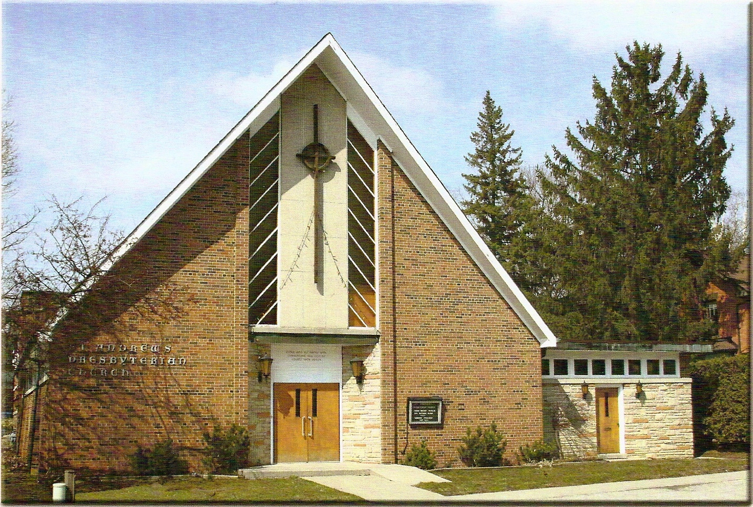

Rev Soong Huh

Welcoming Elder: Kevin Johnston

Our Reason Why
As a community of believers in Jesus Christ we wish:
- to be in relationship (with God and with one another),
- to belong, feel cared for and connected,
- to participate with others to serve a larger purpose.

ST. ANDREW’S PRESBYTERIAN CHURCH
Presbyterian 150th Anniversary Sunday
WE GATHER
*You are invited to stand BOP = Book of Praise
Prelude
Welcome and Announcements
Responsive call to worship:
Lord, open our lips.
And our mouths shall proclaim your praises.
Serve God with gladness; Come before God’s presence with singing
Glory be to you O God: Creator, Christ and Holy Spirit:
as it was in the beginning is now and ever shall be.
*Hymn: “Holy, holy, holy.” BOP 299
Prayer of Adoration
Prayer of Confession (in unison)
Merciful God, in your gracious presence we confess our sin and the sin of this world. Although we have found peace in Christ, we are a people divided against ourselves as we cling to the values of a broken world. The profit and pleasures we pursue lay waste the land and pollute the seas. The fears and jealousies that we harbour set neighbour against neighbour and nation against nation. We abuse your good gifts of imagination and freedom, intellect and reason, and have turned them into bonds of oppression. Lord have mercy upon us. Heal us, forgive us and set us free to serve you in the world as agents of your reconciling love in Jesus Christ.

The Lord’s Prayer (in unison)
Our Father in heaven, hallowed be your name, your kingdom come, your will be done, on earth as in heaven. Give us today our daily bread. Forgive us our sins as we forgive those who sin against us. Save us from the
time of trial and deliver us from evil. For the kingdom, the power and the glory are yours, now and forever. Amen.
Assurance of Pardon:
One: May the peace of the Lord Jesus Christ be with you!
All: and, also with you!
*Hymn: “Softly and tenderly.” BOP 640
Prayer for the children
WE LISTEN
Sung Prayer for Illumination: BOP 445
Open our eyes, Lord, we want to see Jesus,
to reach out and touch him, and say that we love him.
Open our ears, Lord, and help us to listen.
Open our eyes, Lord, we want to see Jesus.
- Scripture reading: Exodus 3:1-6
One: This is the word of the Lord.
All: Thanks be to God
Message: “Yet It Was Not Consumed” (Dr. Robert Revington)
*Hymn: “Those who wait on the Lord (Vs. 1-4) BOP 662
WE TASTE
The Lord’s Table Invitation
Great Prayer of Thanksgiving:
L: The Lord be with you.
P: And also with you.
L: Lift up your hearts.
P: We lift them to the Lord
L: Let us give thanks to the Lord our God.
P: It is right to give God thanks and praise.
L: Continues... We join with the whole creation
to lift up our hearts in joyful praise
Sanctus
Holy, holy, holy Lord,
God of pow’r and might,
Heaven and earth are full of your glory,
Hosanna in the highest
Blessed is he who comes in the name of the Lord
Hosanna in the highest
L: … as we proclaim the mystery of faith:
P: Christ has died, Christ is risen, Christ will come again.
Breaking of the Bread
Communion of the people
(Please hold the elements until you return to your seats, where we will partake together)
Prayer after Communion

WE RESPOND
Offering Our Gifts (Offering Plate is at the Narthex Door)
Doxology: “Praise God from whom all blessings flow.“ BOP 830
Offertory Prayer
WE SERVE
*Song for the Journey:
*Hymn: “I am the church! You are the church!” BOP 475
*The Benediction:
*A Sung Blessing BOP 726
May the God of hope go with us every day,
filling all our lives with love and joy and peace.
May the God of justice speed us on our way,
bringing light and hope to every land and race.
Praying, let us work for peace; singing, share our joy with all;
working for a world that's new, faithful when we hear Christ's call.
(Please be seated and in silence, be mindful of the new possibilities offered to you in Jesus Christ)
Postlude

