ANNOUNCEMENTS
A warm welcome to all who come to worship this Sunday. Please join us for refreshments and fellowship in Guild Hall after worship.

***********
Welcome Table on Wednesday night 5:00 – 6:00 is ongoing in the summer. Trinity Anglican Church, 79 Victoria street.
Rev Soong says the Grace there on Wednesday, July 22.
***********
Summertime Community BBQ Luncheon
Every Thursday 11:30 – 12:30 July 12 – Sept 3
Aurora Cornerstone Church
390 Industrial Parkway South
Sponsored by Welcoming Arms – Aurora
***********

The St. Andrew’s Prayer Chain offers daily prayers for those in need of God’s help. If you would like to request our prayers for yourself or for a loved one, please call Mary Becker, 416-709-4921 or email: mabecker@rogers.com. Your prayer requests are a sacred trust and will be kept entirely confidential.

St. Andrew’s Presbyterian Church
www.pccweb.ca/standrewsaurora
32 Mosley Street, Aurora, Ontario, L4G 1G9
Office email: standrewsaurora@gmail.com
Telephone: 905-727-5011

Minister: The Rev. Soong Huh
revsoonghuh@hotmail.com

Clerk of Session: Kevin Johnston
Email: clerkstandrewsaurora@gmail.com

Envelope Secretary: Don Hutchinson
Phone: 905-727-6567
Rentals: Nigel Samuel
Email: nigelsamuel14@gmail.com
Maintenance: TBA
Email: standrewsaurora@gmail.com
Treasurer: Anne Neuman
Phone: 905-888-1278
Organist: Justine Song
Email: Danada514@gmail.com
CCLI: License Number #3156883

This Week at a Glance

Wednesday Aurora Community Café Closed

Thursday Martha’s Table see Summertime Community BBQ

Saturday Rise & Shine Breakfast (Trinity Anglican) Closed

St. Andrew’s Presbyterian Church

Aurora, Ontario

Sunday July 19, 2026 - 10:30 AM
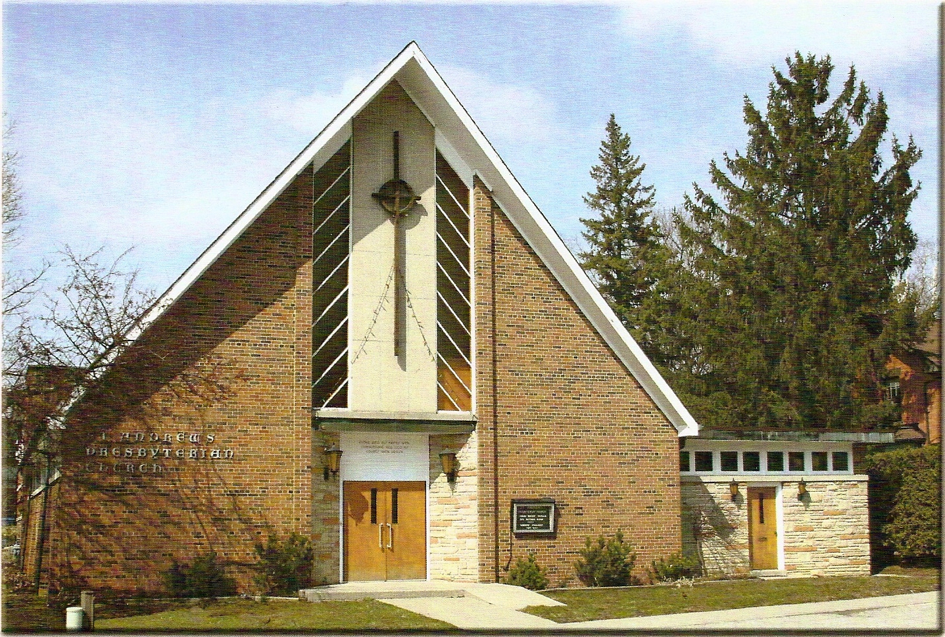

Rev. Soong Huh

Welcoming Person: Gordon Osborne

Our Reason Why
As a community of believers in Jesus Christ, we wish:
- to be in relationship (with God and with one another),
- to belong, feel cared for and connected,
- to participate with others to serve a larger purpose.

ST. ANDREW’S PRESBYTERIAN CHURCH

WE GATHER
*You are invited to stand BOP = Book of Praise
Prelude
Welcome and Announcements
After the announcements, we pause for a moment of silence to prepare our hearts and minds for worship
Responsive Call to Worship
One: We come as people who have been called by God.
All: We come to worship the One who has called us into Christ.
One: We come as many people with different gifts and different stories.
All: Yet in Christ we are one body.
One: We come carrying joys and burdens, hopes and fears.
All: And Christ gathers us together in love.
One: Come, let us worship the God who is still building his church.
All: We come to grow together into Christ.
*Hymn: “Joyful, joyful we adore you." BOP 410
Prayer of Adoration
Prayer of Confession (in unison)
Merciful God, you call us to humility, gentleness, patience, and love, yet we confess that we often choose pride, impatience, and self-interest instead. You call us to protect the unity of the Spirit,

yet we sometimes contribute to division. You call us to carry one another's burdens, yet we can become preoccupied with our own concerns. You call us to grow into Christ, yet we often settle for comfort rather than transformation. Forgive us for the ways we have failed to love you fully and love our neighbours faithfully. Renew us by your Holy Spirit. Teach us to walk worthy of the calling we have received.
The Lord’s Prayer (in unison)
Our Father in heaven, hallowed be your name, your kingdom come, your will be done, on earth as in heaven. Give us today our daily bread. Forgive us our sins as we forgive those who sin against us. Save us from the
time of trial and deliver us from evil. For the kingdom, the power and the glory are yours, now and forever. Amen.
Assurance of Pardon:
One: May the peace of the Lord Jesus Christ be with you!
All: and, also with you!
*Hymn: “Praise Him all ye little children."
Prayer for the children
WE LISTEN
Sung Prayer for Illumination: BOP 445
Open our eyes, Lord, we want to see Jesus,
to reach out and touch him, and say that we love him.
Open our ears, Lord, and help us to listen.
Open our eyes, Lord, we want to see Jesus.
Prayer for Understanding:
Scripture reading: Ephesians 4:1-16

One: This is the word of the Lord.
All: Thanks be to God

Message: “Growing together into Christ“

*Hymn: "We are one in the Spirit." BOP 471
Prayer for the People
WE RESPOND
Invitation to the Offering:
Offering Our Gifts (Offering Plate is at the Narthex Door)
Doxology: “Praise God from whom all blessings flow. “ BOP 830
Offertory Prayer:
WE SERVE
*Song for the Journey:
*Hymn: "Who’s goin’ to tell the story." BOP 761
*The Benediction:
*A Sung Blessing BOP 726
May the God of hope go with us every day,
filling all our lives with love and joy and peace.
May the God of justice speed us on our way,
bringing light and hope to every land and race.
Praying, let us work for peace; singing, share our joy with all;
working for a world that's new, faithful when we hear Christ's call.
(Please be seated and in silence, be mindful of the new possibilities offered to you in Jesus Christ)

Postlude

Please join us in the Guild Hall for refreshments and fellowship.

