ANNOUNCEMENTS
A warm welcome to all who come to worship this Sunday. Please join us for refreshments and fellowship in Guild Hall after worship.

***********
We pray for The Presbyterian Church in Canada as it marks its 151st anniversary. In recognition of God’s continuing faithfulness, may we walk boldly in faith, love deeply, and press forward in hope
***********
Please join us for the Barbeque after Worship Service today Cost $5.00

June 25 – Last day for Martha’s Table join us for a barbeque before summer break
***********

The St. Andrew’s Prayer Chain offers daily prayers for those in need of God’s help. If you would like to request our prayers for yourself or for a loved one, please call Mary Becker, 416-709-4921 or email: mabecker@rogers.com. Your prayer requests are a sacred trust and will be kept entirely confidential.

St. Andrew’s Presbyterian Church
www.pccweb.ca/standrewsaurora
32 Mosley Street, Aurora, Ontario, L4G 1G9
Office email: standrewsaurora@gmail.com
Telephone: 905-727-5011

Minister: The Rev. Soong Huh
revsoonghuh@hotmail.com

Clerk of Session: Kevin Johnston
Email: clerkstandrewsaurora@gmail.com

Envelope Secretary: Don Hutchinson
Phone: 905-727-6567
Rentals: Nigel Samuel
Email: nigelsamuel14@gmail.com
Maintenance: TBA
Email: standrewsaurora@gmail.com
Treasurer: Anne Neuman
Phone: 905-888-1278
Organist: Justine Song
Email: Danada514@gmail.com
CCLI: License Number #3156883

This Week at a Glance

Thursday Martha’s Table 11:30 am – 1:00 pm

St. Andrew’s Presbyterian Church

Aurora, Ontario

Sunday June 21, 2026 - 10:30 AM

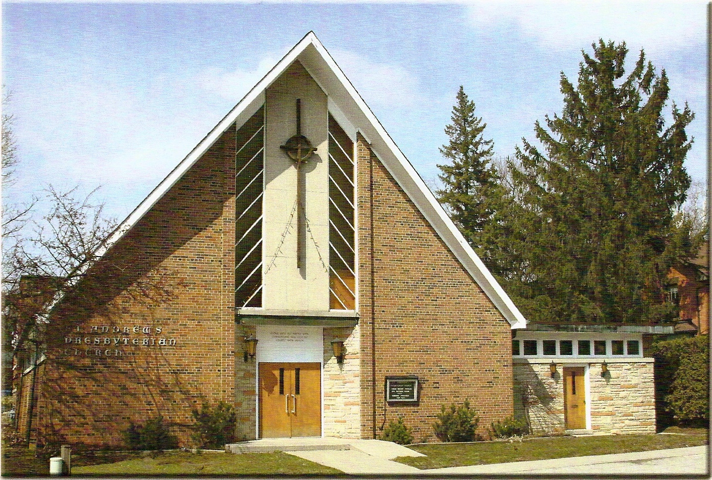

Rev. Soong Huh
Welcoming Elder: Kevin Johnston

Our Reason Why
As a community of believers in Jesus Christ, we wish:
- to be in relationship (with God and with one another),
- to belong, feel cared for and connected,
- to participate with others to serve a larger purpose.

ST. ANDREW’S PRESBYTERIAN CHURCH
Father’s Day
WE GATHER
*You are invited to stand BOP = Book of Praise
Prelude
Welcome and Announcements
After the announcements, we pause for a moment of silence to prepare our hearts and minds for worship
Responsive Call to Worship
One: We come today seeking God's guidance for the journey ahead.
All: We come trusting the One who calls us forward.
One: When the future seems uncertain, God remains faithful.
All: When we cannot see the whole path, God gives us the next step.
One: God called Abraham to walk by faith and not by sight.
All: God calls us also to trust his promises.
One: Come, let us worship the God who goes before us.
All: We will worship the Lord with thankful and hopeful hearts.

*Hymn: "Great is thy faithfulness " BOP 324
Prayer of Adoration

Prayer of Confession (in unison)
Merciful God, you call us to walk by faith, yet we often choose fear. You invite us to trust your promises, yet we focus on our limitations. Too often we allow disappointment to become discouragement and uncertainty to become doubt. We confess that we sometimes expect too little from you. We confess that we have allowed "never" to speak louder than your promises. Forgive us for the times we have trusted our circumstances more than your faithfulness. Renew our hearts, strengthen our faith, and help us to take the next faithful step wherever you may lead. Through Jesus Christ our Lord, we pray. Amen
The Lord’s Prayer (in unison)
Our Father in heaven, hallowed be your name, your kingdom come, your will be done, on earth as in heaven. Give us today our daily bread. Forgive us our sins as we forgive those who sin against us. Save us from the
time of trial and deliver us from evil. For the kingdom, the power and the glory are yours, now and forever. Amen.
Assurance of Pardon:
One: May the peace of the Lord Jesus Christ be with you!
All: and, also with you!
*Hymn: “Wherever I may wander." BOP 319
Prayer for the children
WE LISTEN
Sung Prayer for Illumination: BOP 445
Open our eyes, Lord, we want to see Jesus,
to reach out and touch him, and say that we love him.
Open our ears, Lord, and help us to listen.
Open our eyes, Lord, we want to see Jesus.
Prayer for Understanding:
Scripture Reading
- Genesis 12:1-9

One: This is the word of the Lord.
All: Thanks be to God

Message: “The Next Faithful Step”

*Hymn: "Take my life, and let it be consecrated." BOP 637

Prayer for the People
WE RESPOND
Invitation to the Offering:
Offering Our Gifts (Offering Plate is at the Narthex Door)
Doxology: “Praise God from whom all blessings flow. “ BOP 830
Offertory Prayer:
WE SERVE
*Song for the Journey:
*Hymn: "How firm a foundation." BOP 685
*The Benediction:
*A Sung Blessing BOP 726
May the God of hope go with us every day,
filling all our lives with love and joy and peace.
May the God of justice speed us on our way,
bringing light and hope to every land and race.
Praying, let us work for peace; singing, share our joy with all;
working for a world that's new, faithful when we hear Christ's call.
Postlude

