ANNOUNCEMENTS
A warm welcome to all who come to worship this Sunday. Please join us for refreshments and fellowship in Guild Hall after worship.

Welcome back Rev Soong Huh to lead us in worship
***********
Next Session Meeting: Thursday June 4th
***********
Congratulations and Best Wishes to
Alan and Deborah Simerson who are celebrating their
50th Wedding Anniversary
***********
Martha’s Table – Thursdays 11:30 – 1:00pm
Aurora Community Café is closed for the summer.
***********
The Summer issue of the Presbyterian Connection is available in the Narthex
***********
The June, July August copies of the Our Daily Bread devotionals are available in the Narthex

The St. Andrew’s Prayer Chain offers daily prayers for those in need of God’s help. If you would like to request our prayers for yourself or for a loved one, please call Mary Becker, 416-709-4921 or email: mabecker@rogers.com. Your prayer requests are a sacred trust and will be kept entirely confidential.

St. Andrew’s Presbyterian Church
www.pccweb.ca/standrewsaurora
32 Mosley Street, Aurora, Ontario, L4G 1G9
Office email: standrewsaurora@gmail.com
Telephone: 905-727-5011

Minister: The Rev. Soong Huh
revsoonghuh@hotmail.com

Clerk of Session: Kevin Johnston
Email: clerkstandrewsaurora@gmail.com

Envelope Secretary: Don Hutchinson
Phone: 905-727-6567
Rentals: Nigel Samuel
Email: nigelsamuel14@gmail.com
Maintenance: TBA
Email: standrewsaurora@gmail.com
Treasurer: Anne Neuman
Phone: 905-888-1278
Organist: Justine Song
Email: Danada514@gmail.com
CCLI: License Number #3156883

This Week at a Glance

Wednesday Aurora Community Café Closed

Thursday Session meeting 7:00pm

Thursday Martha’s Table 11:30 am – 1:00 pm

Saturday Rise & Shine Breakfast (Trinity Anglican) Closed

St. Andrew’s Presbyterian Church

Aurora, Ontario

Sunday May 31, 2026 - 10:30 AM

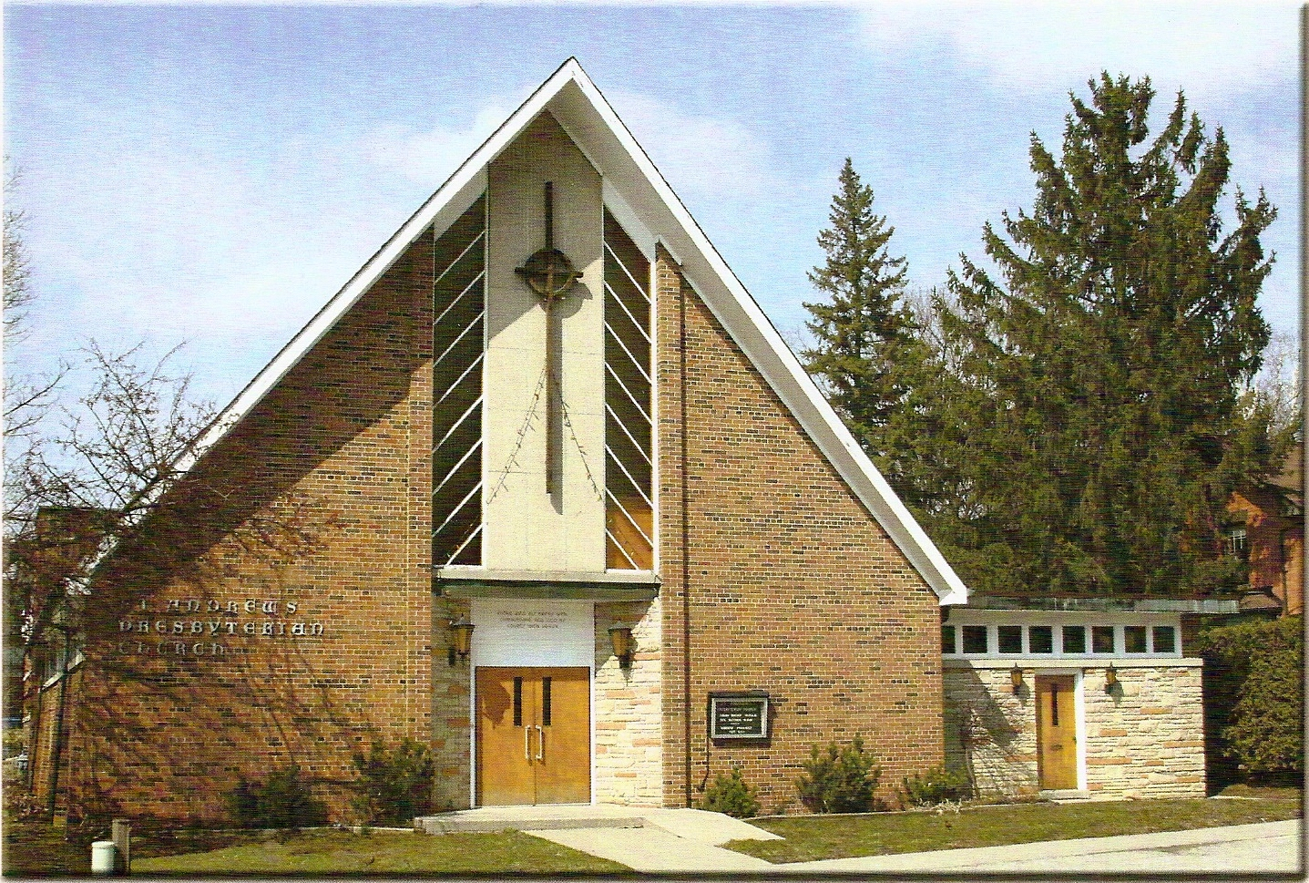

Rev. Soong Huh
Welcoming Elder: Don Hutchinson

Our Reason Why
As a community of believers in Jesus Christ, we wish:
- to be in relationship (with God and with one another),
- to belong, feel cared for and connected,
- to participate with others to serve a larger purpose.

ST. ANDREW’S PRESBYTERIAN CHURCH
Trinity Sunday
WE GATHER
*You are invited to stand BOP = Book of Praise
Prelude
Welcome and Announcements
Responsive call to worship:
One: Come, let us worship the living God.
All: We come seeking grace, hope, and renewal.
One: God gathers strangers and makes us one family.
All: Christ welcomes us with love and mercy.
One: The Spirit breathes new life into weary hearts.
All: We open ourselves to God’s renewing presence.
One: This is not only a place we attend.
All: This is a people we are becoming together.
One: Let us worship God.
All: With grateful hearts, we worship the Lord.
*Hymn: "The Church’s One Foundation (Vs. 1-3) " BOP 479
Prayer of Adoration
Prayer of Confession (in unison)
Merciful God, we confess that we often live at a distance from you and from one another. We become distracted, impatient, and self-focused. Too often we fail to notice those who are lonely, discouraged, or in need of kindness. We have sometimes treated church as a place to attend rather than a people to love. Forgive us for the ways we have fallen short of your calling. Renew our hearts through your Holy Spirit. Teach us to walk in humility, compassion, and grace. Help us become a community shaped by the love of Christ, in whose name we pray. Amen.

The Lord’s Prayer (in unison)
Our Father in heaven, hallowed be your name, your kingdom come, your will be done, on earth as in heaven. Give us today our daily bread. Forgive us our sins as we forgive those who sin against us. Save us from the
time of trial and deliver us from evil. For the kingdom, the power and the glory are yours, now and forever. Amen.

Assurance of Pardon:
One: May the peace of the Lord Jesus Christ be with you!
All: and, also with you!
*Hymn: "Sing them over again to me." BOP 498
Prayer for the children

WE LISTEN
Sung Prayer for Illumination: BOP 445
Open our eyes, Lord, we want to see Jesus,
to reach out and touch him, and say that we love him.
Open our ears, Lord, and help us to listen.
Open our eyes, Lord, we want to see Jesus.
Prayer for Understanding:
Scripture Reading
- Acts 2:42-47

One: This is the word of the Lord.
All: Thanks be to God
Message: “What makes a church alive?”

*Hymn: "Brother, sister let me Serve you." BOP 635

Prayer for the People
Move within us and renew our faith.

WE RESPOND
Invitation to the Offering:
Offering Our Gifts (Offering Plate is at the Narthex Door)
Doxology: “Praise God from whom all blessings flow. “ BOP 830
Offertory Prayer:

WE SERVE
*Song for the Journey:
*Hymn: "I, the Lord of sea and sky." BOP 592
*The Benediction:
*A Sung Blessing BOP 726
May the God of hope go with us every day,
filling all our lives with love and joy and peace.
May the God of justice speed us on our way,
bringing light and hope to every land and race.
Praying, let us work for peace; singing, share our joy with all;
working for a world that's new, faithful when we hear Christ's call.
(Please be seated and in silence, be mindful of the new possibilities offered to you in Jesus Christ)
Postlude

