ANNOUNCEMENTS
A warm welcome to all who come to worship this Sunday. Please join us for refreshments and fellowship in Guild Hall after worship.

We are looking for new members of the St. Andrew’s Prayer Chain to pray for fellow members of our church. Are you willing to give some time in prayer each day to pray for fellow members, family, and friends? Prayer is a wonderful way to see God blessing others through your prayers. If you would like to join our prayer chain, please call Mary Becker,
416-709-4921 or email: mabecker@rogers.com.
***********
Welcome Table on Wednesday night 5:00 – 6:00 is ongoing in the summer. Trinity Anglican Church, 79 Victoria street.
Rev Soong says the Grace there on Wednesday, Sept. 2.
Summer Community BBQ – Thursday 11:30 to 12:30 Cornerstone Church, 390 Industrial Parkway S.
***********
Gather In Grace; In Every Season, Breakfast & Worship September 19, 9 a.m. to 12 p.m.
Speaker Rev. Dr. Kristine O’Brien
St. Andrew’s Presbyterian Church, King City
Tickets: $5.00, see Rev. Soong
The St. Andrew’s Prayer Chain offers daily prayers for those in need of God’s help. If you would like to request our prayers for yourself or for a loved one, please call Mary Becker, 416-709-4921 or email: mabecker@rogers.com. Your prayer requests are a sacred trust and will be kept entirely confidential.

St. Andrew’s Presbyterian Church
www.pccweb.ca/standrewsaurora
32 Mosley Street, Aurora, Ontario, L4G 1G9
Office email: standrewsaurora@gmail.com
Telephone: 905-727-5011

Minister: The Rev. Soong Huh
revsoonghuh@hotmail.com

Clerk of Session: Kevin Johnston
Email: clerkstandrewsaurora@gmail.com

Envelope Secretary: Don Hutchinson
Phone: 905-727-6567
Rentals: Nigel Samuel
Email: nigelsamuel14@gmail.com
Maintenance: TBA
Email: standrewsaurora@gmail.com
Treasurer: Anne Neuman
Phone: 905-888-1278
Organist: Justine Song
Email: Danada514@gmail.com
CCLI: License Number #3156883

This Week at a Glance

Wednesday Aurora Community Café Closed

Thursday Martha’s Table see Summertime Community BBQ

Saturday Rise & Shine Breakfast (Trinity Anglican) Closed

St. Andrew’s Presbyterian Church

Aurora, Ontario

Sunday Aug 16, 2026 - 10:30 AM

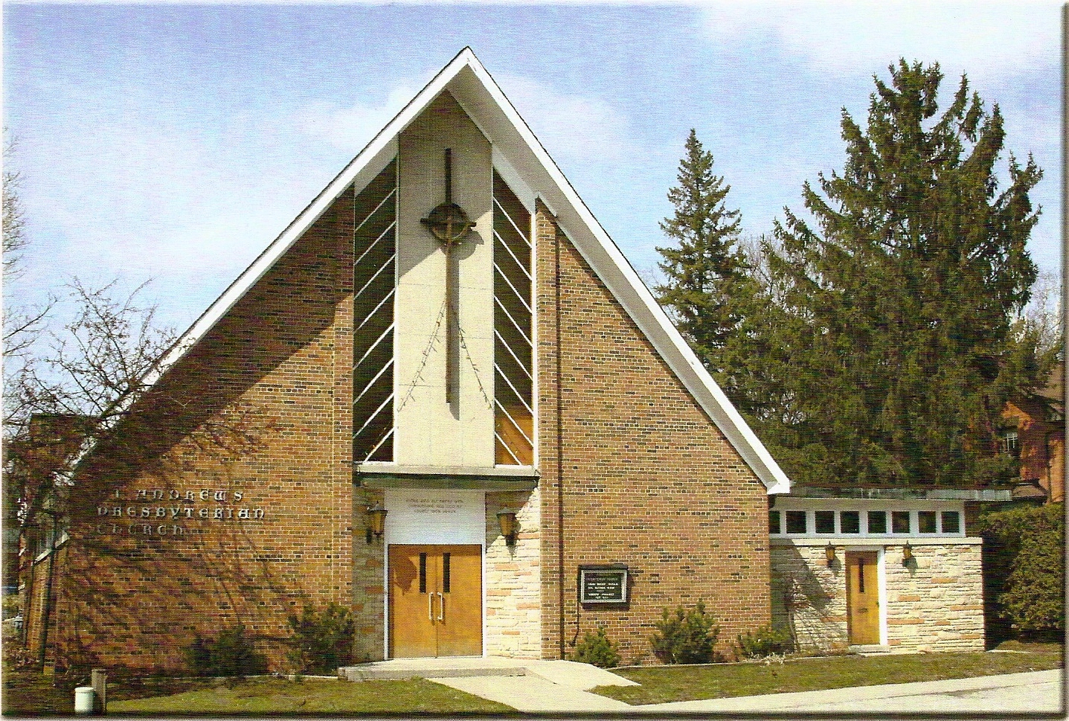

Rev. Soong Huh

Welcoming Person: Dr. Robert Revington, PhD

Our Reason Why
As a community of believers in Jesus Christ, we wish:
- to be in relationship (with God and with one another),
- to belong, feel cared for and connected,
- to participate with others to serve a larger purpose.

ST. ANDREW’S PRESBYTERIAN CHURCH
12th Sunday after Pentecost
WE GATHER

*You are invited to stand BOP = Book of Praise
Prelude
Welcome and Announcements
After the announcements, we pause for a moment of silence to prepare our hearts and minds for worship
Responsive Call to Worship
One: Come, let us worship the Lord, for Jesus Christ is the foundation of our faith.
All: We come to worship Jesus Christ, the Son of the living God.
One: Many people have opinions about Jesus. But Jesus asks us, “Who do you say that I am?”
All: You are the Messiah, the Son of the living God.
One: He is the One God promise, the One God sent, and the One who came to save us.
All: We come not only to learn about Jesus, but to know him, trust him, and follow him.
One: Let us turn our hearts toward Christ, our Lord and our Saviour.
All: Jesus Christ is our foundation. We worship him with all that we are.
*Hymn: “All hail the power of Jesus’ name." BOP 363
Prayer of Adoration

Prayer of Confession (in unison)
Merciful God, we confess that we often know about Jesus without truly following him. We hear his word, but do not always obey. We call him Lord, but still want to remain in control. We worship with our lips, while our hearts can be far from you. Forgive us when we trust ourselves more than we trust Christ. Forgive us when we choose comfort over faithfulness, and when our lives do not reflect the faith we profess. Lord Jesus, bring us back to yourself. Help us to know you, trust you, and follow you each day.
The Lord’s Prayer (in unison)
Our Father in heaven, hallowed be your name, your kingdom come, your will be done, on earth as in heaven. Give us today our daily bread. Forgive us our sins as we forgive those who sin against us. Save us from the time of trial and deliver us from evil. For the kingdom, the power and the glory are yours, now and forever. Amen.
Assurance of Pardon:
One: May the peace of the Lord Jesus Christ be with you!
All: and, also with you!
*Hymn: “What a friend we have in Jesus.” BOP 746
Prayer for the children
WE LISTEN
Sung Prayer for Illumination: BOP 445
Open our eyes, Lord, we want to see Jesus,
to reach out and touch him, and say that we love him.
Open our ears, Lord, and help us to listen.
Open our eyes, Lord, we want to see Jesus.
Prayer for Understanding:

Scripture reading: Matthew 16: 13-17
One: This is the word of the Lord.
All: Thanks be to God
Message: “The Foundations of the Christian Life Series“
Week 2 – Who Is Jesus?
*Hymn: “I have decided to follow Jesus” BOP 570
Prayer for the People
WE RESPOND
Invitation to the Offering:
Offering Our Gifts (Offering Plate is at the Narthex Door)
Doxology: “Praise God from whom all blessings flow.“ BOP 830
Offertory Prayer:
WE SERVE
*Song for the Journey:
*Hymn: "The church’s one foundation." BOP 479
*The Benediction:
*A Sung Blessing BOP 726
May the God of hope go with us every day,
filling all our lives with love and joy and peace.
May the God of justice speed us on our way,
bringing light and hope to every land and race.
Praying, let us work for peace; singing, share our joy with all;
working for a world that's new, faithful when we hear Christ's call.
(Please be seated and in silence, be mindful of the new possibilities offered to you in Jesus Christ)
Postlude
Please join us in the Guild Hall for refreshments and fellowship.

