ANNOUNCEMENTS
A warm welcome to all who come to worship this Sunday. Please join us for refreshments and fellowship in Guild Hall after worship.

We are looking for new members of the St. Andrew’s Prayer Chain to pray for fellow members of our church. Are you willing to give some time in prayer each day to pray for fellow members, family, and friends? Prayer is a wonderful way to see God blessing others through your prayers. If you would like to join our prayer chain, please call Mary Becker,
416-709-4921 or email: mabecker@rogers.com.
***********
Welcome Table on Wednesday night 5:00 – 6:00 is ongoing in the summer. Trinity Anglican Church, 79 Victoria street.
Rev Soong says the Grace there on Wednesday, Sept. 2.
Summer Community BBQ – Thursday 11:30 to 12:30 Cornerstone Church, 390 Industrial Parkway S.
***********
Gather In Grace; In Every Season, Breakfast & Worship September 19, 9 a.m. to 12 p.m.
Speaker Rev. Dr. Kristine O’Brien
St. Andrew’s Presbyterian Church, King City
Tickets: $5.00, see Rev. Soong
The St. Andrew’s Prayer Chain offers daily prayers for those in need of God’s help. If you would like to request our prayers for yourself or for a loved one, please call Mary Becker, 416-709-4921 or email: mabecker@rogers.com. Your prayer requests are a sacred trust and will be kept entirely confidential.

St. Andrew’s Presbyterian Church
www.pccweb.ca/standrewsaurora
32 Mosley Street, Aurora, Ontario, L4G 1G9
Office email: standrewsaurora@gmail.com
Telephone: 905-727-5011

Minister: The Rev. Soong Huh
revsoonghuh@hotmail.com

Clerk of Session: Kevin Johnston
Email: clerkstandrewsaurora@gmail.com

Envelope Secretary: Don Hutchinson
Phone: 905-727-6567
Rentals: Nigel Samuel
Email: nigelsamuel14@gmail.com
Maintenance: TBA
Email: standrewsaurora@gmail.com
Treasurer: Anne Neuman
Phone: 905-888-1278
Organist: Justine Song
Email: Danada514@gmail.com
CCLI: License Number #3156883

This Week at a Glance

Wednesday Aurora Community Café Closed

Thursday Martha’s Table see Summertime Community BBQ

Saturday Rise & Shine Breakfast (Trinity Anglican) Closed

St. Andrew’s Presbyterian Church

Aurora, Ontario

Sunday Aug 23, 2026 - 10:30 AM

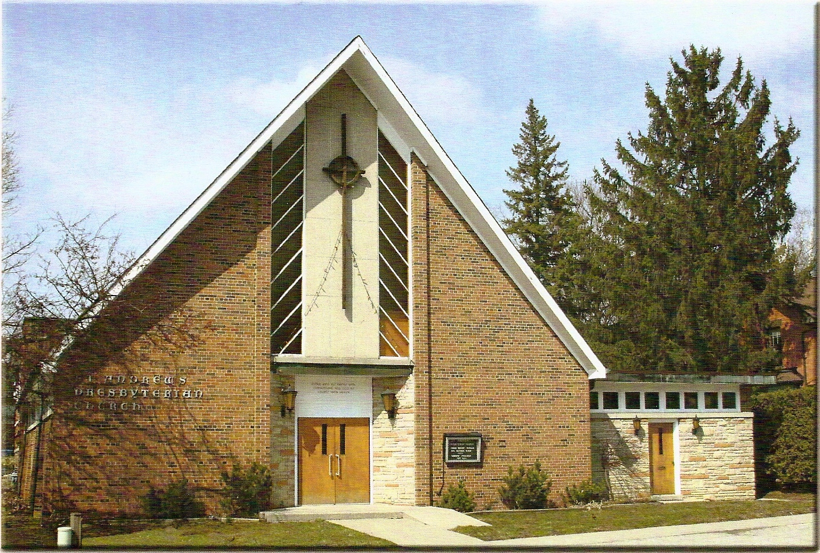

Rev. Soong Huh

Welcoming Person: Donald Hutchinson

Our Reason Why
As a community of believers in Jesus Christ, we wish:
- to be in relationship (with God and with one another),
- to belong, feel cared for and connected,
- to participate with others to serve a larger purpose.

ST. ANDREW’S PRESBYTERIAN CHURCH
13th Sunday after Pentecost

WE GATHER
*You are invited to stand BOP = Book of Praise
Prelude
Welcome and Announcements
After the announcements, we pause for a moment of silence to prepare our hearts and minds for worship
Responsive Call to Worship
One: Come, let us worship the God who created us and calls us by name.
All: We come, trusting in the love of God.
One: Jesus promised, “I will not leave you as orphans.”
All: We come, knowing that Christ has not left us alone.
One: The Holy Spirit is with us, teaching us, guiding us, and reminding us of Jesus’ words.
All: We open our hearts to the presence of the Holy Spirit.
One: Let us worship the Triune God—Father, Son, and Holy Spirit.
All: We worship God, who is with us, among us, and within us. Amen.
*Hymn: “Holy, holy, holy." BOP 299
Prayer of Adoration
Prayer of Confession (in unison)

Gracious God, we confess that we often live as though we are alone. You have promised to be with us, yet we try to carry everything ourselves. You have promised to guide us, yet we insist on our own way. Forgive us when fear replaces trust, when our hearts resist your leading, and when our lives fail to reflect your love. Holy Spirit, renew us from within and teach us to listen, trust, and follow. Amen.
The Lord’s Prayer (in unison)
Our Father in heaven, hallowed be your name, your kingdom come, your will be done, on earth as in heaven. Give us today our daily bread. Forgive us our sins as we forgive those who sin against us. Save us from the time of trial and deliver us from evil. For the kingdom, the power and the glory are yours, now and forever. Amen.
Assurance of Pardon:
One: May the peace of the Lord Jesus Christ be with you!
All: and, also with you!
*Hymn: “Holy Spirit, Hear Us.” Public Domain (Hymnary.org)
Prayer for the children
WE LISTEN
Sung Prayer for Illumination: BOP 445
Open our eyes, Lord, we want to see Jesus,
to reach out and touch him, and say that we love him.
Open our ears, Lord, and help us to listen.
Open our eyes, Lord, we want to see Jesus.
Prayer for Understanding:
Scripture reading: John 14: 15-18, 25-27
One: This is the word of the Lord.
All: Thanks be to God

Message: “The Foundations of the Christian Life Series“
Week 3 – Who Is the Holy Spirit?
*Hymn: “Spirit of the Living God” BOP 400
Prayer for the People
WE RESPOND
Invitation to the Offering:
Offering Our Gifts (Offering Plate is at the Narthex Door)
Doxology: “Praise God from whom all blessings flow.“ BOP 830
Offertory Prayer:
WE SERVE
*Song for the Journey:
*Hymn: "Take my life, and let it be consecrated." BOP 637
*The Benediction:
*A Sung Blessing BOP 726
May the God of hope go with us every day,
filling all our lives with love and joy and peace.
May the God of justice speed us on our way,
bringing light and hope to every land and race.
Praying, let us work for peace; singing, share our joy with all;
working for a world that's new, faithful when we hear Christ's call.
(Please be seated and in silence, be mindful of the new possibilities offered to you in Jesus Christ)
Postlude
Please join us in the Guild Hall for refreshments and fellowship.

