ANNOUNCEMENTS
A warm welcome to all who come to worship this Sunday. Please join us for refreshments and fellowship in Guild Hall after worship.

We are looking for new members of the St. Andrew’s Prayer Chain to pray for fellow members of our church. Are you willing to give some time in prayer each day to pray for fellow members, family, and friends? Prayer is a wonderful way to see God blessing others through your prayers. If you would like to join our prayer chain, please call Mary Becker,
416-709-4921 or email: mabecker@rogers.com.
***********
Welcome Table on Wednesday night 5:00 – 6:00 is ongoing in the summer. Trinity Anglican Church, 79 Victoria street.
Rev Soong says the Grace there on Wednesday, Sept. 2.
Summer Community BBQ – Thursday 11:30 to 12:30 Cornerstone Church, 390 Industrial Parkway S.
***********
Gather In Grace; In Every Season, Breakfast & Worship September 19, 9 a.m. to 12 p.m.
Speaker Rev. Dr. Kristine O’Brien
St. Andrew’s Presbyterian Church, King City
Tickets: $5.00, see Rev. Soong
The St. Andrew’s Prayer Chain offers daily prayers for those in need of God’s help. If you would like to request our prayers for yourself or for a loved one, please call Mary Becker, 416-709-4921 or email: mabecker@rogers.com. Your prayer requests are a sacred trust and will be kept entirely confidential.

St. Andrew’s Presbyterian Church
www.pccweb.ca/standrewsaurora
32 Mosley Street, Aurora, Ontario, L4G 1G9
Office email: standrewsaurora@gmail.com
Telephone: 905-727-5011

Minister: The Rev. Soong Huh
revsoonghuh@hotmail.com

Clerk of Session: Kevin Johnston
Email: clerkstandrewsaurora@gmail.com

Envelope Secretary: Don Hutchinson
Phone: 905-727-6567
Rentals: Nigel Samuel
Email: nigelsamuel14@gmail.com
Maintenance: TBA
Email: standrewsaurora@gmail.com
Treasurer: Anne Neuman
Phone: 905-888-1278
Organist: Justine Song
Email: Danada514@gmail.com
CCLI: License Number #3156883

This Week at a Glance

Wednesday Aurora Community Café Closed

Thursday Martha’s Table see Summertime Community BBQ

Saturday Rise & Shine Breakfast (Trinity Anglican) Closed

St. Andrew’s Presbyterian Church

Aurora, Ontario

Sunday Aug 30, 2026 - 10:30 AM

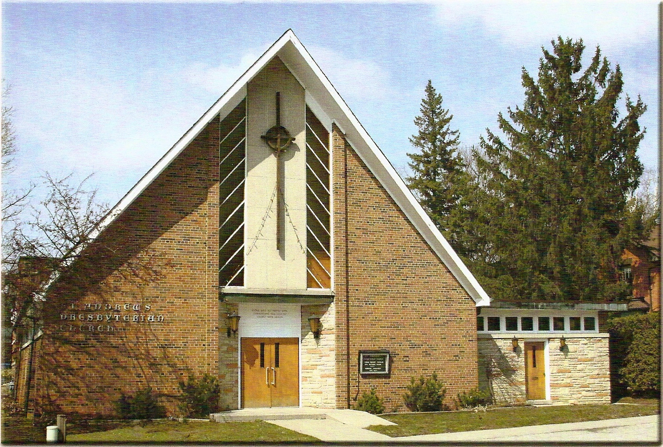

Rev. Soong Huh

Welcoming Person: Anne Neuman

Our Reason Why
As a community of believers in Jesus Christ, we wish:
- to be in relationship (with God and with one another),
- to belong, feel cared for and connected,
- to participate with others to serve a larger purpose.

ST. ANDREW’S PRESBYTERIAN CHURCH
14th Sunday after Pentecost

WE GATHER
*You are invited to stand BOP = Book of Praise
Prelude
Welcome and Announcements
After the announcements, we pause for a moment of silence to prepare our hearts and minds for worship
Responsive Call to Worship
One: Come, let us worship the God who guides his people.
All: We come with open hearts and willing spirits.
One: God does not always show us the whole road ahead.
All: But he promises to walk with us.
One: When we have questions, God invites us to listen.
All: When we have differences, God invites us to seek him together.
One: When we do not know what comes next, where will we turn?
All: We will turn to Christ, listen for the Spirit, and trust God.
One: Come, then, with your questions, your hopes, and even your uncertainty.
All: We come ready to listen for where God is leading us.
*Hymn: “Come thou fount of every blessing." Insert
Prayer of Adoration

Prayer of Confession (in unison)
Merciful God, we confess that we often want to know the answer before we are willing to listen. We can become attached to our own opinions, our own preferences, and our own plans. Forgive us when we mistake our desires for your will. Forgive us when we listen only to people who agree with us. Give us humble hearts, patient spirits, and the courage to seek your wisdom together.
The Lord’s Prayer (in unison)
Our Father in heaven, hallowed be your name, your kingdom come, your will be done, on earth as in heaven. Give us today our daily bread. Forgive us our sins as we forgive those who sin against us. Save us from the time of trial and deliver us from evil. For the kingdom, the power and the glory are yours, now and forever. Amen.
Assurance of Pardon:
One: May the peace of the Lord Jesus Christ be with you!
All: and, also with you!
*Hymn: “Holy Spirit, Hear Us.” Insert
Prayer for the children
WE LISTEN
Sung Prayer for Illumination: BOP 445
Open our eyes, Lord, we want to see Jesus,
to reach out and touch him, and say that we love him.
Open our ears, Lord, and help us to listen.
Open our eyes, Lord, we want to see Jesus.
Prayer for Understanding:
Scripture reading: Acts 15:1-29
One: This is the word of the Lord.
All: Thanks be to God

Message: “The Foundations of the Christian Life Series
Week 4 – What is God doing with us next?

*Hymn: “Guide me O thou great Redeemer” BOP 651
Prayer for the People
WE RESPOND
Invitation to the Offering:
Offering Our Gifts (Offering Plate is at the Narthex Door)
Doxology: “Praise God from whom all blessings flow.“ BOP 830
Offertory Prayer:
WE SERVE
*Song for the Journey:
*Hymn: " Will you come and follow me." BOP 634
*The Benediction:
*A Sung Blessing BOP 726
May the God of hope go with us every day,
filling all our lives with love and joy and peace.
May the God of justice speed us on our way,
bringing light and hope to every land and race.
Praying, let us work for peace; singing, share our joy with all;
working for a world that's new, faithful when we hear Christ's call.

(Please be seated and in silence, be mindful of the new possibilities offered to you in Jesus Christ)
Postlude
Please join us in the Guild Hall for refreshments and fellowship.

