ANNOUNCEMENTS
A warm welcome to all who come to worship this Sunday.

***********
We welcome Rev. Han who will lead us in worship today
***********
Financials to June 2026
Income - $34,516.73, Expenses - $56,419.23
Deficit ($21,902.50)
***********
We are looking for new members of the St. Andrew’s Prayer Chain to pray for fellow members of our church. Are you willing to give some time in prayer each day to pray for fellow members, family, and friends? Prayer is a wonderful way to see God blessing others through your prayers. If you would like to join our prayer chain, please call Mary Becker,
416-709-4921 or email: mabecker@rogers.com.
***********
Welcome Table on Wednesday night 5:00 – 6:00 is ongoing in the summer. Trinity Anglican Church, 79 Victoria street.
Rev Soong says the Grace there on Wednesday, Sept. 2.
***********
Gather In Grace; In Every Season, Breakfast & Worship September 19, 9 a.m. to 12 p.m.
Speaker Rev. Dr. Kristine O’Brien
St. Andrew’s Presbyterian Church, King City
Tickets: $5.00, see Rev. Soong
The St. Andrew’s Prayer Chain offers daily prayers for those in need of God’s help. If you would like to request our prayers for yourself or for a loved one, please call Mary Becker, 416-709-4921 or email: mabecker@rogers.com. Your prayer requests are a sacred trust and will be kept entirely confidential.

St. Andrew’s Presbyterian Church
www.pccweb.ca/standrewsaurora
32 Mosley Street, Aurora, Ontario, L4G 1G9
Office email: standrewsaurora@gmail.com
Telephone: 905-727-5011

Minister: The Rev. Soong Huh
revsoonghuh@hotmail.com

Clerk of Session: Kevin Johnston
Email: clerkstandrewsaurora@gmail.com

Envelope Secretary: Don Hutchinson
Phone: 905-727-6567
Rentals: Nigel Samuel
Email: nigelsamuel14@gmail.com
Maintenance: TBA
Email: standrewsaurora@gmail.com
Treasurer: Anne Neuman
Phone: 905-888-1278
Organist: Justine Song
Email: Danada514@gmail.com
CCLI: License Number #3156883

This Week at a Glance

Wednesday Aurora Community Café Closed

Thursday Martha’s Table see Summertime Community BBQ

Saturday Rise & Shine Breakfast (Trinity Anglican) Closed

St. Andrew’s Presbyterian Church

Aurora, Ontario

Sunday Aug 9, 2026 - 10:30 AM

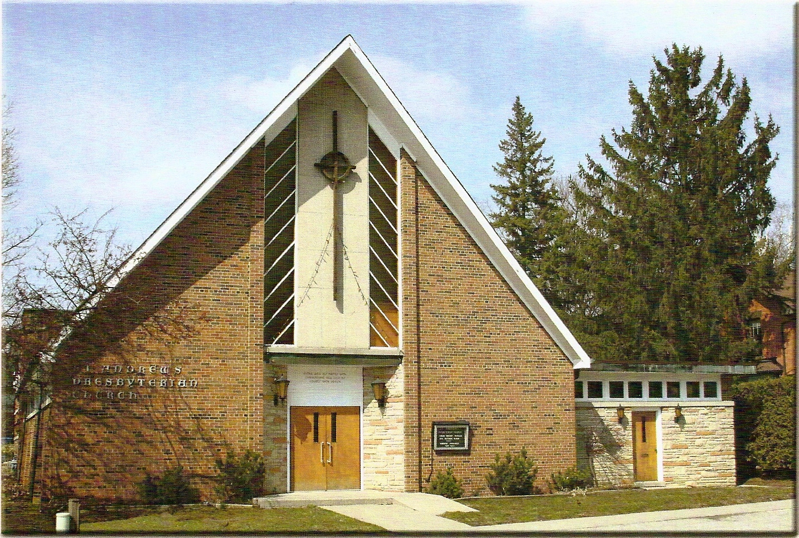

Rev. Shinsung Han

Welcoming Person: James Chapman

Our Reason Why
As a community of believers in Jesus Christ, we wish:
- to be in relationship (with God and with one another),
- to belong, feel cared for and connected,
- to participate with others to serve a larger purpose.

ST. ANDREW’S PRESBYTERIAN CHURCH

WE GATHER
*You are invited to stand BOP = Book of Praise
Prelude
Welcome and Announcements
After the announcements, we pause for a moment of silence to prepare our hearts and minds for worship
Responsive Call to Worship
Give thanks to God!
We will tell the world what God has done.
Let us bring praise to the name of our Creator.
We will honour God’s name with shouts of joy!
Recall all that God provides.
Let us give thanks for all the wonders God has made!

*Hymn: “Come, Thou, Almighty King” BOP 293
Prayer of Adoration
Prayer of Confession (in unison)
Merciful and patient God, we confess our fear, doubt and anger and all the ways we are less than you call us to be. You call us to live with courage and perseverance, yet we give up too easily and opt for the safer route. You encourage us to be bold in our struggles for justice, yet we remain silent in the face of unfairness. You command us to love, yet we are too often thoughtless and cruel. Forgive us our sins and renew our lives through your mercy and grace. Amen.

The Lord’s Prayer (in unison)
Our Father in heaven, hallowed be your name, your kingdom come, your will be done, on earth as in heaven. Give us today our daily bread. Forgive us our sins as we forgive those who sin against us. Save us from the
time of trial and deliver us from evil. For the kingdom, the power and the glory are yours, now and forever. Amen.
Assurance of Pardon:
One: May the peace of the Lord Jesus Christ be with you!
All: and, also with you!
*Hymn: “Jesus loves me, this I know.” BOP 373
Prayer for the children
WE LISTEN
Sung Prayer for Illumination: BOP 445
Open our eyes, Lord, we want to see Jesus,
to reach out and touch him, and say that we love him.
Open our ears, Lord, and help us to listen.
Open our eyes, Lord, we want to see Jesus.
Prayer for Understanding:
Scripture reading: Genesis 37:18–28

One: This is the word of the Lord.
All: Thanks be to God

Message: “(Un)expected Plans"

*Hymn: "O Master, let me walk with thee" BOP 642
Prayer for the People

WE RESPOND
Invitation to the Offering:
Offering Our Gifts (Offering Plate is at the Narthex Door)
Doxology: “Praise God from whom all blessings flow. “ BOP 830
Offertory Prayer:
WE SERVE
*Song for the Journey:
*Hymn: "Crown him with many crowns" BOP 274

*The Benediction:
*A Sung Blessing BOP 726
May the God of hope go with us every day,
filling all our lives with love and joy and peace.
May the God of justice speed us on our way,
bringing light and hope to every land and race.
Praying, let us work for peace; singing, share our joy with all;
working for a world that's new, faithful when we hear Christ's call.
(Please be seated and in silence, be mindful of the new possibilities offered to you in Jesus Christ)

Postlude

