ANNOUNCEMENTS
A warm welcome to all who come to worship this Sunday. Please join us for refreshments and fellowship in Guild Hall after worship.

Welcome Rev. Shinsung Han for leading our service today. Rev. Soong Huh has been called home to Korea, due to the health of his father.
***********
The Discernment Workshop for October 17th, has been postponed.
***********
Aurora Community Café: Wednesdays 10:00 am – 2:00 pm. At St. Andrew’s Guild Hall.
Welcome Table: Wednesday night 5:00 – 6:00pm. At Trinity Anglican Church, 79 Victoria street.
Martha’s Table: Thursdays 11:30 am-12:30pm. At St. Andrew’s Guild Hall.
The 'Rise and Shine Breakfast' Saturdays 9:30 am to 10:30 am. The breakfast will be at St. Andrew's Guild Hall.
***********
St. Andrew’s PC

Operating Account to August 31, 2026
Expenses: $75,984.04
Income: $45,011.12
Deficit: - $30,972.92

The St. Andrew’s Prayer Chain offers daily prayers for those in need of God’s help. If you would like to request our prayers for yourself or for a loved one, please call Mary Becker, 416-709-4921 or email: mabecker@rogers.com. Your prayer requests are a sacred trust and will be kept entirely confidential.

St. Andrew’s Presbyterian Church
www.pccweb.ca/standrewsaurora
32 Mosley Street, Aurora, Ontario, L4G 1G9
Office email: standrewsaurora@gmail.com
Telephone: 905-727-5011

Minister: The Rev. Soong Huh
Email: revsoonghuh@hotmail.com

Clerk of Session: Kevin Johnston
Email: clerkstandrewsaurora@gmail.com

Envelope Secretary: Don Hutchinson
Phone: 905-727-6567
Rentals: Nigel Samuel
Email: nigelsamuel14@gmail.com
Maintenance: TBA
Email: standrewsaurora@gmail.com
Treasurer: Anne Neuman
Phone: 905-888-1278
Organist: Justine Song
Email: Danada514@gmail.com
CCLI: License Number #3156883

This Week at a Glance

Wednesday Welcome Table (Trinity Anglican) 5:00-6:00

Aurora Community Café 10:00-2:00

Thursday Martha’s Table 11:30 – 12:30

Saturday Rise & Shine Breakfast (St. Andrew’s) 9:30 – 10:30

St. Andrew’s Presbyterian Church

Aurora, Ontario

Sunday Oct 11, 2026 - 10:30 AM

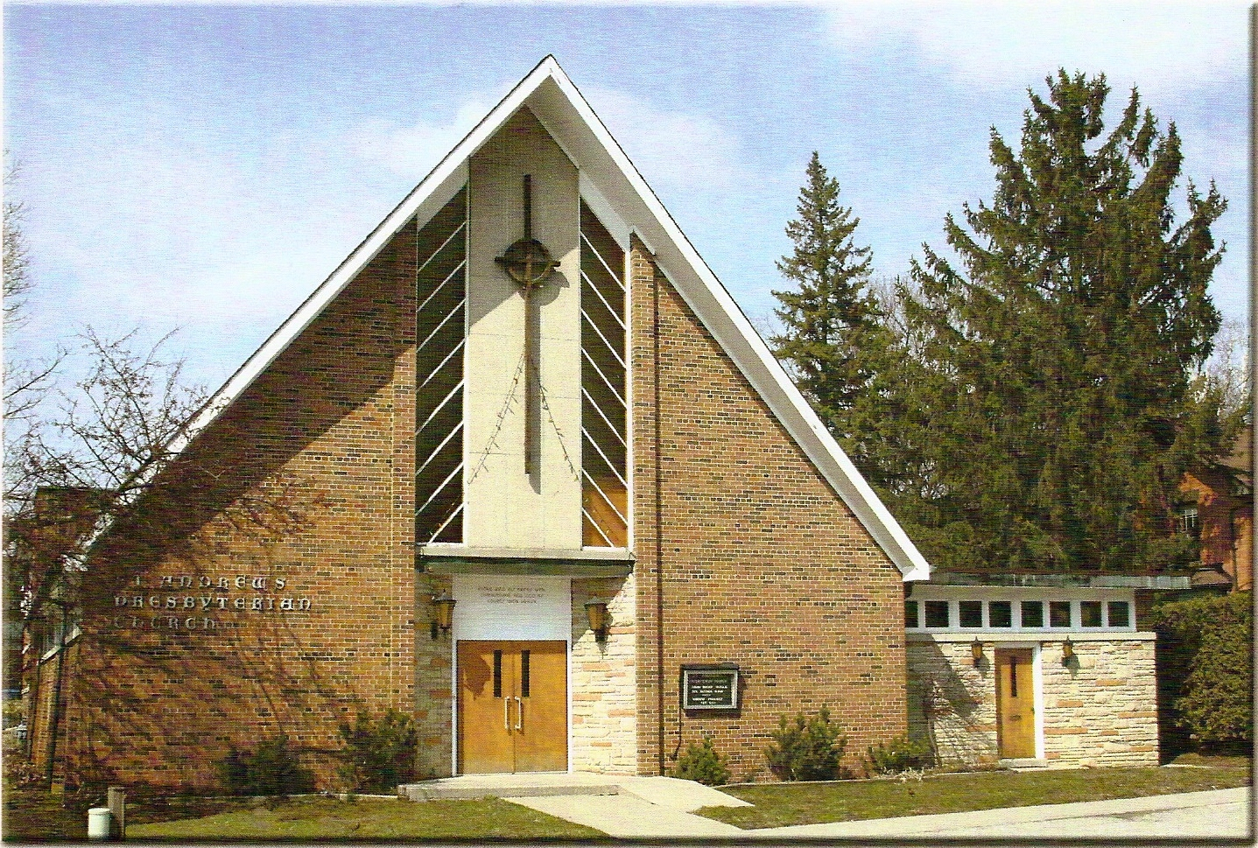

Rev. Shinsung Han

Welcoming Person: Anne Neuman

Our Reason Why
As a community of believers in Jesus Christ, we wish:
- to be in relationship (with God and with one another),
- to belong, feel cared for and connected,
- to participate with others to serve a larger purpose.

ST. ANDREW’S PRESBYTERIAN CHURCH
20th Sunday after Pentecost
Harvest Sunday
WE GATHER
*You are invited to stand BOP = Book of Praise
Prelude
Welcome and Announcements
After the announcements, we pause for a moment of silence to prepare our hearts and minds for worship

Responsive Call to Worship
One: We gather in God’s holy presence, where God embraces us with grace.
All: Here God will transform us into disciples.
One: We glorify God, who yearns for justice for the last and the least.
All: Here God will write compassion on our hearts.
One: We give thanks to God for God’s persistent love that seeks us out.
All: Here God will breathe the Word of Life into our lives, and so we will praise our God!

*Hymn: “Come, Thou, Almighty King” BOP 293

Prayer of Adoration

Prayer of Confession (in unison)
God of all life and each life,
you know all about us, our deepest concerns and our fondest hopes.
We confess we are often anxious to see results.
We lose patience when we cannot see progress.
We blame others rather than seek solutions.
Forgive us.
Help us claim your peace when our hearts are anxious.
We pray in the name of Jesus, Amen.
The Lord’s Prayer (in unison)
Our Father in heaven, hallowed be your name, your kingdom come, your will be done, on earth as in heaven. Give us today our daily bread. Forgive us our sins as we forgive those who sin against us. Save us from the time of trial and deliver us from evil. For the kingdom, the power and the glory are yours, now and forever. Amen.
Assurance of Pardon
One: May the peace of the Lord Jesus Christ be with you!
All: and, also with you!
*Hymn: “Can a little Child like me.” BOP 441
Prayer for the children
WE LISTEN
Sung Prayer for Illumination: BOP 445
Open our eyes, Lord, we want to see Jesus,
to reach out and touch him, and say that we love him.
Open our ears, Lord, and help us to listen.
Open our eyes, Lord, we want to see Jesus.

Scripture reading: Luke 17:11–19

One: This is the word of the Lord.
All: Thanks be to God
Message: “Remembering Grace, Returning to Jesus”
*Hymn: “Word of God, across the ages.” BOP 497
WE RESPOND
Invitation to the Offering:
Offering Our Gifts (Offering Plate is at the Narthex Door)
Doxology: “Praise God from whom all blessings flow.” BOP 830
Offertory Prayer:
WE SERVE
*Song for the Journey:
*Hymn: "Guide me, O Thou Great Redeemer.” BOP 651
*The Benediction:
*A Sung Blessing BOP 726
May the God of hope go with us every day,
filling all our lives with love and joy and peace.
May the God of justice speed us on our way,
bringing light and hope to every land and race.
Praying, let us work for peace; singing, share our joy with all;
working for a world that's new, faithful when we hear Christ's call.
Postlude

