ANNOUNCEMENTS
A warm welcome to all who come to worship this Sunday. Please join us for refreshments and fellowship in Guild Hall after worship.

Rev Soong Huh’s father, died last weekend in Korea just after he arrived. Have him and his family in your hearts and prayers at this time.
Lynn Stenabaugh, a long-time member of St. Andrew’s died October 14, 2026. Keep her family in your prayers.
***********
Aurora Community Café: Wednesdays 10:00 am – 2:00 pm. At St. Andrew’s Guild Hall.
Welcome Table: Wednesday night 5:00 – 6:00 pm. At Trinity Anglican Church, 79 Victoria street.
Martha’s Table: Thursdays 11:30 am - 12:30 pm. At St. Andrew’s Guild Hall.
The 'Rise and Shine Breakfast' Saturdays 9:30 - 10:30 am. At St. Andrew's Guild Hall.
***********
St. Andrew’s PC

Operating Account to August 31, 2026
Expenses: $75,984.04
Income: $45,011.12
Deficit: - $30,972.92

The St. Andrew’s Prayer Chain offers daily prayers for those in need of God’s help. If you would like to request our prayers for yourself or for a loved one, please call Mary Becker, 416-709-4921 or email: mabecker@rogers.com. Your prayer requests are a sacred trust and will be kept entirely confidential.

St. Andrew’s Presbyterian Church
www.pccweb.ca/standrewsaurora
32 Mosley Street, Aurora, Ontario, L4G 1G9
Office email: standrewsaurora@gmail.com
Telephone: 905-727-5011

Minister: The Rev. Soong Huh
Email: revsoonghuh@hotmail.com

Clerk of Session: Kevin Johnston
Email: clerkstandrewsaurora@gmail.com

Envelope Secretary: Don Hutchinson
Phone: 905-727-6567
Rentals: Nigel Samuel
Email: nigelsamuel14@gmail.com
Maintenance: TBA
Email: standrewsaurora@gmail.com
Treasurer: Anne Neuman
Phone: 905-888-1278
Organist: Justine Song
Email: Danada514@gmail.com
CCLI: License Number #3156883

This Week at a Glance

Wednesday Aurora Community Café 10:30 – 1:30

Welcome Table (Trinity Anglican) 5:00 – 6:00

Thursday Martha’s Table 11:30 – 12:30

Saturday Rise & Shine Breakfast (St. Andrew’s) 9:30 – 10:30

St. Andrew’s Presbyterian Church

Aurora, Ontario

Sunday Oct 18, 2026 - 10:30 AM

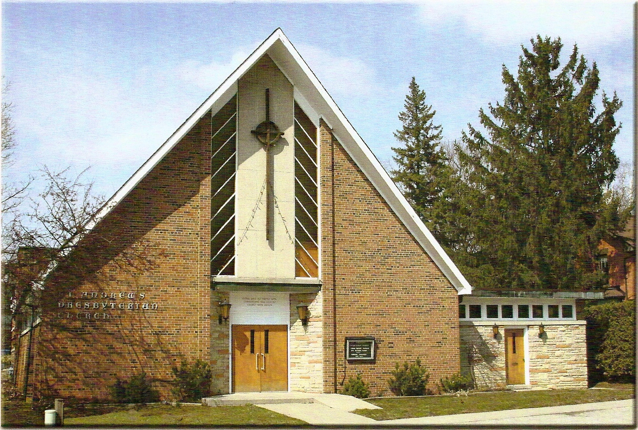

Welcoming Person: Dr Robert Revington PhD

Our Reason Why
As a community of believers in Jesus Christ, we wish:
- to be in relationship (with God and with one another),
- to belong, feel cared for and connected,
- to participate with others to serve a larger purpose.

ST. ANDREW’S PRESBYTERIAN CHURCH
21st Sunday after Pentecost
Student and Colleges Sunday
WE GATHER
*You are invited to stand BOP = Book of Praise
Prelude
Welcome and Announcements
After the announcements, we pause for a moment of silence to prepare our hearts and minds for worship
Responsive Call to Worship
Let us sing to the LORD a new song.
We will bless God’s name from day to day.

Let us declare God’s marvelous deeds among all the people;
For God is great and greatly to be praised.

Let us praise God for God’s strength and beauty.
We will bring God honour and glory as we worship God’s holy name.

*Hymn: “O worship the King” BOP 313
Prayer of Adoration
Prayer of Confession (in unison)
Patient God, we confess we need your mercy. We claim to be your people, but we forget to love as you do. We claim to seek your guidance, but we follow our own ways. Forgive us, O God, amend who we are and direct who you would have us be for the sake of Christ, our Saviour and Friend.

The Lord’s Prayer (in unison)
Our Father in heaven, hallowed be your name, your kingdom come, your will be done, on earth as in heaven. Give us today our daily bread. Forgive us our sins as we forgive those who sin against us. Save us from the time of trial and deliver us from evil. For the kingdom, the power and the glory are yours, now and forever. Amen.
Assurance of Pardon
One: May the peace of the Lord Jesus Christ be with you!
All: and, also with you!
*Hymn: “Father we love you.” BOP 300
Prayer for the children
WE LISTEN
Sung Prayer for Illumination: BOP 445
Open our eyes, Lord, we want to see Jesus,
to reach out and touch him, and say that we love him.
Open our ears, Lord, and help us to listen.
Open our eyes, Lord, we want to see Jesus.

Scripture reading:
First reading: Isaiah 45:1-17
Second reading: Psalm 96:10-13 R2 (Responsive)
Third Reading: 1 Thessalonians 1:1-10

One: This is the word of the Lord.
All: Thanks be to God

Message: “Giving Thanks”
*Hymn: “Lord of all power.” BOP 626
Prayers of Thanksgiving and Intercession
WE RESPOND
Invitation to the Offering:
Offering Our Gifts (Offering Plate is at the Narthex Door)
Doxology: “We give thee but thine own.” BOP 661
Offertory Prayer:
WE SERVE
*Song for the Journey:
*Hymn: "Sing a new song unto the Lord.” BOP 422
*The Benediction:
*A Sung Blessing BOP 726
May the God of hope go with us every day,
filling all our lives with love and joy and peace.
May the God of justice speed us on our way,
bringing light and hope to every land and race.
Praying, let us work for peace; singing, share our joy with all;
working for a world that's new, faithful when we hear Christ's call.
(Please be seated and in silence, be mindful of the new possibilities offered to you in Jesus Christ.)
Postlude
Please join us in the Guild Hall for refreshments and fellowship.

