ANNOUNCEMENTS
A warm welcome to all who come to worship this Sunday. Please join us for refreshments and fellowship in Guild Hall after worship.

Keep the families of the Princess Patricia Regiment in your thoughts and prayers at this time for their loss and injury of others at CFB Wainwright.
***********
Aurora Community Café: Wednesdays 10:30 am – 1:30 pm. At St. Andrew’s Guild Hall.
Welcome Table: Wednesday night 5:00 – 6:00 pm. At Trinity Anglican Church, 79 Victoria street.
Martha’s Table: Thursdays 11:30 am - 12:30 pm. At St. Andrew’s Guild Hall.
The 'Rise and Shine Breakfast' Saturdays 9:30 - 10:30 am. At St. Andrew's Guild Hall.
***********

Up Coming Events:
November 1, St. Andrew’s 155th Anniversary Service.
November 11, Remembrance Day service is November 8. Please take this time to be thoughtful for those who fought for our freedom and did not come home.

The St. Andrew’s Prayer Chain offers daily prayers for those in need of God’s help. If you would like to request our prayers for yourself or for a loved one, please call Mary Becker, 416-709-4921 or email: mabecker@rogers.com. Your prayer requests are a sacred trust and will be kept entirely confidential.

St. Andrew’s Presbyterian Church
www.pccweb.ca/standrewsaurora
32 Mosley Street, Aurora, Ontario, L4G 1G9
Office email: standrewsaurora@gmail.com
Telephone: 905-727-5011

Minister: The Rev. Soong Huh
Email: revsoonghuh@hotmail.com

Clerk of Session: Kevin Johnston
Email: clerkstandrewsaurora@gmail.com

Envelope Secretary: Don Hutchinson
Phone: 905-727-6567
Rentals: Nigel Samuel
Email: nigelsamuel14@gmail.com
Maintenance: TBA
Email: standrewsaurora@gmail.com
Treasurer: Anne Neuman
Phone: 905-888-1278
Organist: Justine Song
Email: Danada514@gmail.com
CCLI: License Number #3156883

This Week at a Glance

Wednesday Aurora Community Café 10:30 – 1:30

Welcome Table (Trinity Anglican) 5:00 – 6:00

Thursday Martha’s Table 11:30 – 12:30

Saturday Rise & Shine Breakfast (St. Andrew’s) 9:30 – 10:30

St. Andrew’s Presbyterian Church

Aurora, Ontario

Sunday Oct 25, 2026 - 10:30 AM

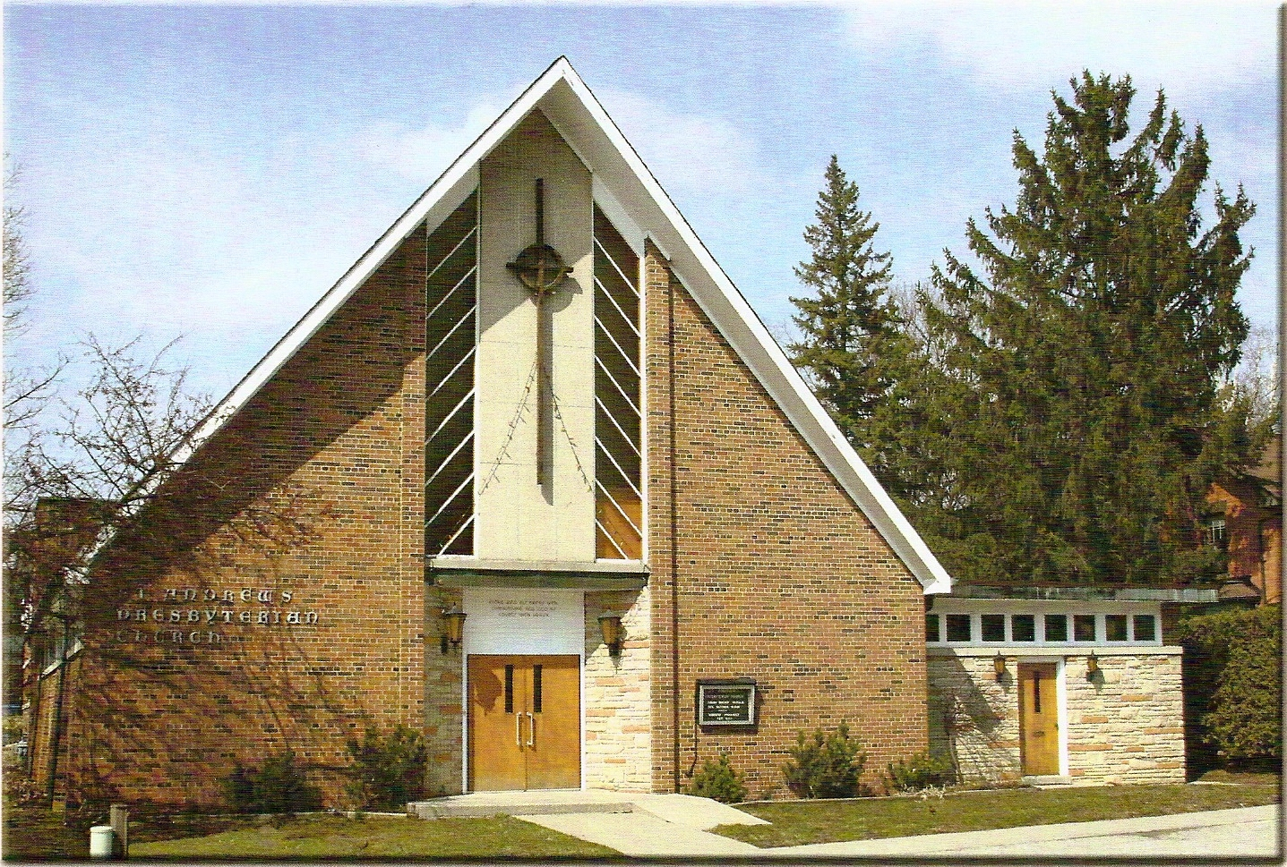

Rev. Soong Huh

Welcoming Person: Anne Neuman

Our Reason Why
As a community of believers in Jesus Christ, we wish:
- to be in relationship (with God and with one another),
- to belong, feel cared for and connected,
- to participate with others to serve a larger purpose.

ST. ANDREW’S PRESBYTERIAN CHURCH
22nd Sunday after Pentecost
Reformation Sunday
WE GATHER
*You are invited to stand BOP = Book of Praise
Prelude
Welcome and Announcements
After the announcements, we pause for a moment of silence to prepare our hearts and minds for worship
Responsive Call to Worship
One: Jesus calls us to follow him, not only in the familiar places, but wherever his love may lead us.
All: We come to worship the One who knows us and walks beside us.
One: We may not know everything that lies ahead, but we know the One who holds our future.
All: We place our trust in God's faithfulness and grace.
One: Come, let us open our hearts to God's presence and our lives to Christ's calling.
*Hymn: “Great is thy faithfulness” BOP 324
Prayer of Adoration
Prayer of Confession (in unison)
Merciful God, you call us to follow Jesus, yet we often prefer our own ways. We seek comfort when you call us to serve, and we seek certainty when you invite us to trust. We sometimes allow fear to shape our decisions more than faith. Forgive us when our words speak of love but our actions fall short. Renew our hearts, strengthen our courage, and teach us to follow Christ with humility and love.

The Lord’s Prayer (in unison)
Our Father in heaven, hallowed be your name, your kingdom come, your will be done, on earth as in heaven. Give us today our daily bread. Forgive us our sins as we forgive those who sin against us. Save us from the time of trial and deliver us from evil. For the kingdom, the power and the glory are yours, now and forever. Amen.
Assurance of Pardon
One: May the peace of the Lord Jesus Christ be with you!
All: and, also with you!
*Hymn: “Can a little Child like me.” BOP 441
Prayer for the children
WE LISTEN
Sung Prayer for Illumination: BOP 445
Open our eyes, Lord, we want to see Jesus,
to reach out and touch him, and say that we love him.
Open our ears, Lord, and help us to listen.
Open our eyes, Lord, we want to see Jesus.

Scripture reading:
First reading: Mark 8:34-35

One: This is the word of the Lord.
All: Thanks be to God
Message: “What does it actually mean to follow Jesus?”

*Hymn: “Will you come and follow me.” BOP 634
Prayers of Thanksgiving and Intercession
WE RESPOND
Invitation to the Offering:
Offering Our Gifts (Offering Plate is at the Narthex Door)
Doxology: “Praise God from who all blessings flow.” BOP 830
Offertory Prayer:
WE SERVE
*Song for the Journey:
*Hymn: "I am the church! You are the church.” BOP 475
*The Benediction:
*A Sung Blessing BOP 726
May the God of hope go with us every day,
filling all our lives with love and joy and peace.
May the God of justice speed us on our way,
bringing light and hope to every land and race.
Praying, let us work for peace; singing, share our joy with all;
working for a world that's new, faithful when we hear Christ's call.
(Please be seated and in silence, be mindful of the new possibilities offered to you in Jesus Christ.)
Postlude
Please join us in the Guild Hall for refreshments and fellowship.

