ANNOUNCEMENTS
A warm welcome to all who come to worship this Sunday. Please join us for refreshments and fellowship in Guild Hall after worship.

***********
Welcome Table on Wednesday night 5:00 – 6:00 is ongoing in the summer. Trinity Anglican Church, 79 Victoria street.
Thursday September 17 Martha's Table 11:30 am-12:30pm.
***********
Gather In Grace; In Every Season, Breakfast & Worship September 19, 9 a.m. to 12 p.m.
Speaker Rev. Dr. Kristine O’Brien
St. Andrew’s Presbyterian Church, King City
Tickets: $5.00, (tickets in Church Office)

St. Andrew’s PC
Operating Account to July 31, 2026
Expenses: $68,340.64
Income: $38, 625.79
Deficit: - $29,714.85

The St. Andrew’s Prayer Chain offers daily prayers for those in need of God’s help. If you would like to request our prayers for yourself or for a loved one, please call Mary Becker, 416-709-4921 or email: mabecker@rogers.com. Your prayer requests are a sacred trust and will be kept entirely confidential.

St. Andrew’s Presbyterian Church
www.pccweb.ca/standrewsaurora
32 Mosley Street, Aurora, Ontario, L4G 1G9
Office email: standrewsaurora@gmail.com
Telephone: 905-727-5011

Minister: The Rev. Soong Huh
revsoonghuh@hotmail.com

Clerk of Session: Kevin Johnston
Email: clerkstandrewsaurora@gmail.com

Envelope Secretary: Don Hutchinson
Phone: 905-727-6567
Rentals: Nigel Samuel
Email: nigelsamuel14@gmail.com
Maintenance: TBA
Email: standrewsaurora@gmail.com
Treasurer: Anne Neuman
Phone: 905-888-1278
Organist: Justine Song
Email: Danada514@gmail.com
CCLI: License Number #3156883

This Week at a Glance

Wednesday Aurora Community Café Closed

Thursday Martha’s Table 11:30 – 12:30

Saturday Rise & Shine Breakfast (Trinity Anglican) Closed

St. Andrew’s Presbyterian Church

Aurora, Ontario

Sunday Sept 13, 2026 - 10:30 AM

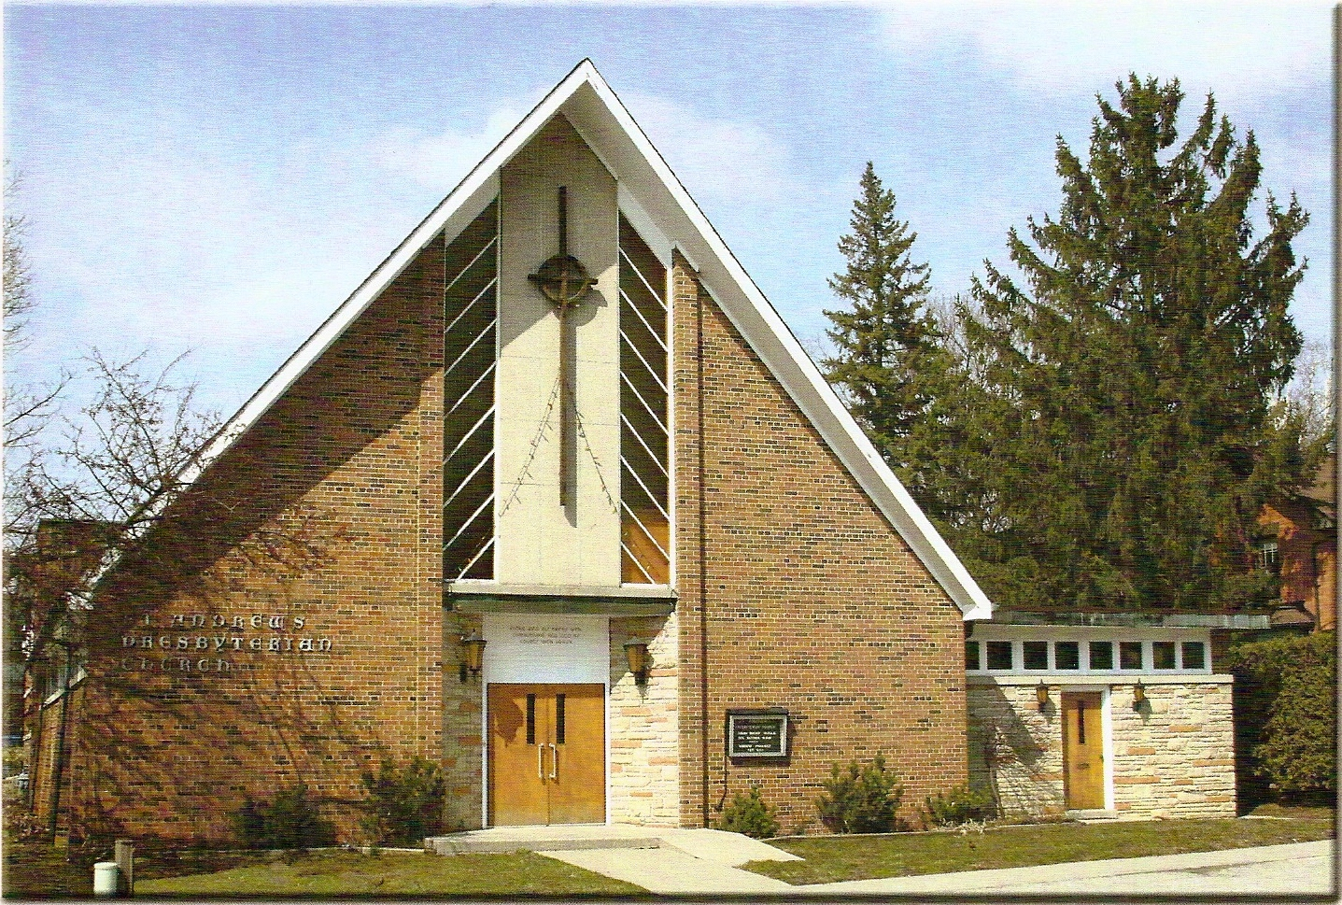

Rev Soong Huh

Welcoming Person: Anne Neuman

Our Reason Why
As a community of believers in Jesus Christ, we wish:
- to be in relationship (with God and with one another),
- to belong, feel cared for and connected,
- to participate with others to serve a larger purpose.

ST. ANDREW’S PRESBYTERIAN CHURCH
16th Sunday after Pentecost

WE GATHER
*You are invited to stand BOP = Book of Praise
Prelude
Welcome and Announcements
After the announcements, we pause for a moment of silence to prepare our hearts and minds for worship
Responsive Call to Worship
One: Come, let us worship the God who speaks.
All: We come with open hearts, ready to listen.
One: God’s Word is living and active, teaching us the truth and showing us the way.
All: Speak, Lord. We are listening.
One: When we are uncertain, God’s Word gives us wisdom. When we are lost, God’s Word gives us direction.
All: When we are weak, God’s Word gives us strength.
One: Come, then, not simply to hear words, but to encounter the living God.
All: We worship the God who speaks, transforms, and leads us into life. Amen.
*Hymn: “Open my eyes, that I may see” BOP 500
Prayer of Adoration

Prayer of Confession (in unison)
Merciful God, we confess that we often read your Word without allowing it to read us. We seek information but resist transformation. We hear your call to forgive, yet hold on to resentment. We hear your call to trust, yet cling to control. We hear your call to love, yet protect ourselves from those who hurt us. Forgive us. Open our hearts today, and give us humility to hear your Word and courage to live it. Amen.
The Lord’s Prayer (in unison)
Our Father in heaven, hallowed be your name, your kingdom come, your will be done, on earth as in heaven. Give us today our daily bread. Forgive us our sins as we forgive those who sin against us. Save us from the time of trial and deliver us from evil. For the kingdom, the power and the glory are yours, now and forever. Amen.
Assurance of Pardon:
One: May the peace of the Lord Jesus Christ be with you!
All: and, also with you!
*Hymn: “Holy Spirit, Hear Us” (see insert)
Prayer for the children
WE LISTEN
Sung Prayer for Illumination: BOP 445
Open our eyes, Lord, we want to see Jesus,
to reach out and touch him, and say that we love him.
Open our ears, Lord, and help us to listen.
Open our eyes, Lord, we want to see Jesus.
Prayer for Understanding:
Scripture reading: 2 Timothy 3:14–17
One: This is the word of the Lord.
All: Thanks be to God

Message: “Why do we read the Bible?”

*Hymn: “Thy word is the lamp unto my feet.” BOP 496
Prayer for the people
WE RESPOND
Invitation to the Offering:
Offering Our Gifts (Offering Plate is at the Narthex Door)
Doxology: “Praise God from whom all blessings flow.” BOP 830
Offertory Prayer:
WE SERVE
*Song for the Journey:
*Hymn: “Speak, Lord, in the stillness.” BOP 442
*The Benediction:
*A Sung Blessing BOP 726
May the God of hope go with us every day,
filling all our lives with love and joy and peace.
May the God of justice speed us on our way,
bringing light and hope to every land and race.
Praying, let us work for peace; singing, share our joy with all;
working for a world that's new, faithful when we hear Christ's call.
(Please be seated and in silence, be mindful of the new possibilities offered to you in Jesus Christ)
Postlude

Please join us in the Guild Hall for refreshments and fellowship.

