ANNOUNCEMENTS
A warm welcome to all who come to worship this Sunday. Please join us for refreshments and fellowship in Guild Hall after worship.

Let us thank Robert Revington for all the work he did for St. Andrew’s Aurora’s participation in last Sunday’s DOORS OPEN ONTARIO. Well, done Robert.
***********
Welcome Table: Wednesday night 5:00 – 6:00pm. At Trinity Anglican Church, 79 Victoria street.
Martha’s Table: Thursdays 11:30 am-12:30pm. At St. Andrew’s Guild Hall.
***********
There will be Discernment Workshops led by Rev. Alison Agnew from 10 am - 12 noon, on; September 26th, October 17th, and October 31st.
***********
The next Session Meeting, Monday, September 28 at 7 pm.

St. Andrew’s PC

Operating Account to July 31, 2026
Expenses: $68,340.64
Income: $38,625.79
Deficit: - $29,714.85

The St. Andrew’s Prayer Chain offers daily prayers for those in need of God’s help. If you would like to request our prayers for yourself or for a loved one, please call Mary Becker, 416-709-4921 or email: mabecker@rogers.com. Your prayer requests are a sacred trust and will be kept entirely confidential.

St. Andrew’s Presbyterian Church
www.pccweb.ca/standrewsaurora
32 Mosley Street, Aurora, Ontario, L4G 1G9
Office email: standrewsaurora@gmail.com
Telephone: 905-727-5011

Minister: The Rev. Soong Huh
revsoonghuh@hotmail.com

Clerk of Session: Kevin Johnston
Email: clerkstandrewsaurora@gmail.com

Envelope Secretary: Don Hutchinson
Phone: 905-727-6567
Rentals: Nigel Samuel
Email: nigelsamuel14@gmail.com
Maintenance: TBA
Email: standrewsaurora@gmail.com
Treasurer: Anne Neuman
Phone: 905-888-1278
Organist: Justine Song
Email: Danada514@gmail.com
CCLI: License Number #3156883

This Week at a Glance

Wednesday Welcome Table (Trinity Anglican) 5:00-6:00

Aurora Community Café Closed

Thursday Martha’s Table 11:30 – 12:30

Saturday Rise & Shine Breakfast (St. Andrew’s) Closed

St. Andrew’s Presbyterian Church

Aurora, Ontario

Sunday Sept 27, 2026 - 10:30 AM

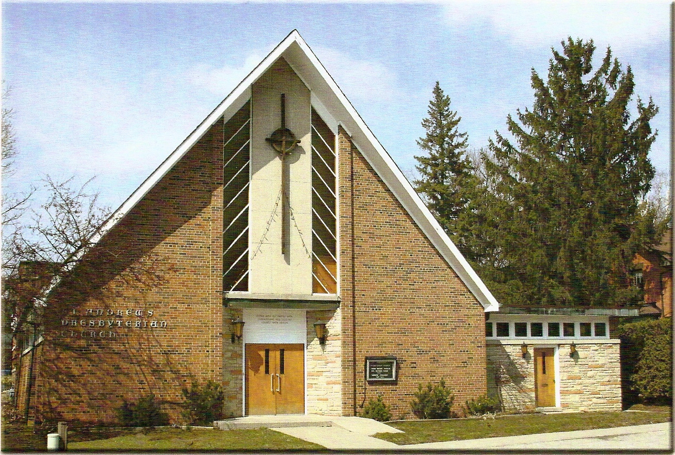

Rev Soong Huh

Welcoming Person: James Chapman

Our Reason Why
As a community of believers in Jesus Christ, we wish:
- to be in relationship (with God and with one another),
- to belong, feel cared for and connected,
- to participate with others to serve a larger purpose.

ST. ANDREW’S PRESBYTERIAN CHURCH
18th Sunday after Pentecost
Truth and Reconciliation Sunday
WE GATHER
*You are invited to stand BOP = Book of Praise

Prelude
Welcome and Announcements
After the announcements, we pause for a moment of silence to prepare our hearts and minds for worship
Responsive Call to Worship
One: We gather today as many people, but one body.
All: We belong to Christ and to one another.
One: We come with different stories, different gifts, and different experiences.
All: Yet God calls us together.
One: We do not see everything, and we do not know everything.
All: So we come ready to listen.
One: Let us listen to God’s Word and to one another.
All: Let us seek together what God is doing among us.
One: Come, let us worship the God who makes us one.
All: We are one body of Christ. Let us worship together.
*Hymn: “I am the church! You are the church!” BOP 475
Prayer of Adoration

Prayer of Confession (in unison)
Gracious God, we confess that we sometimes think we can do everything on our own. We hold tightly to our own opinions and forget that we need one another. We can listen only to those who agree with us and become impatient with those who see things differently. Forgive us. Teach us humility, patience, and love. Help us listen with open hearts and help us seek not simply our own way, but your way.
The Lord’s Prayer (in unison)
Our Father in heaven, hallowed be your name, your kingdom come, your will be done, on earth as in heaven. Give us today our daily bread. Forgive us our sins as we forgive those who sin against us. Save us from the time of trial and deliver us from evil. For the kingdom, the power and the glory are yours, now and forever. Amen.
Assurance of Pardon:
One: May the peace of the Lord Jesus Christ be with you!
All: and, also with you!
*Hymn: “I’ve got the joy.” Insert
Prayer for the children
WE LISTEN
Sung Prayer for Illumination: BOP 445
Open our eyes, Lord, we want to see Jesus,
to reach out and touch him, and say that we love him.
Open our ears, Lord, and help us to listen.
Open our eyes, Lord, we want to see Jesus.
Prayer for Understanding:
Scripture reading: 1 Corinthians 12:12-14, 25-27
One: This is the word of the Lord.
All: Thanks be to God

Message: Why do we need the church?

*Hymn: “We are one in the Spirit.” BOP 471
Prayer for the people
WE RESPOND
Invitation to the Offering:
Offering Our Gifts (Offering Plate is at the Narthex Door)
Doxology: “Praise God from whom all blessings flow.” BOP 830
Offertory Prayer:
WE SERVE
*Song for the Journey:
*Hymn: “The church’s one foundation.” BOP 479
*The Benediction:
*A Sung Blessing BOP 726
May the God of hope go with us every day,
filling all our lives with love and joy and peace.
May the God of justice speed us on our way,
bringing light and hope to every land and race.
Praying, let us work for peace; singing, share our joy with all;
working for a world that's new, faithful when we hear Christ's call.
(Please be seated and in silence, be mindful of the new possibilities offered to you in Jesus Christ)
Postlude

Please join us in the Guild Hall for refreshments and fellowship.

