ANNOUNCEMENTS
A warm welcome to all who come to worship this Sunday. Please join us for refreshments and fellowship in Guild Hall after worship.

It is with regret that we announce the passing of our long-time member (83 years) Vera Wilson on August 28, 2026.
***********
Welcome Table on Wednesday night 5:00 – 6:00 is ongoing in the summer. Trinity Anglican Church, 79 Victoria street.
Thursday September 10 Martha's Table reopen. 11:30 am-12:30pm.
***********
Gather In Grace; In Every Season, Breakfast & Worship September 19, 9 a.m. to 12 p.m.
Speaker Rev. Dr. Kristine O’Brien
St. Andrew’s Presbyterian Church, King City
Tickets: $5.00, (tickets in Church Office)

St. Andrew’s PC
Operating Account to July 31, 2026
Expenses: $68,340.64
Income: $38, 625.79
Deficit: - $29,714.85

The St. Andrew’s Prayer Chain offers daily prayers for those in need of God’s help. If you would like to request our prayers for yourself or for a loved one, please call Mary Becker, 416-709-4921 or email: mabecker@rogers.com. Your prayer requests are a sacred trust and will be kept entirely confidential.

St. Andrew’s Presbyterian Church
www.pccweb.ca/standrewsaurora
32 Mosley Street, Aurora, Ontario, L4G 1G9
Office email: standrewsaurora@gmail.com
Telephone: 905-727-5011

Minister: The Rev. Soong Huh
revsoonghuh@hotmail.com

Clerk of Session: Kevin Johnston
Email: clerkstandrewsaurora@gmail.com

Envelope Secretary: Don Hutchinson
Phone: 905-727-6567
Rentals: Nigel Samuel
Email: nigelsamuel14@gmail.com
Maintenance: TBA
Email: standrewsaurora@gmail.com
Treasurer: Anne Neuman
Phone: 905-888-1278
Organist: Justine Song
Email: Danada514@gmail.com
CCLI: License Number #3156883

This Week at a Glance

Wednesday Aurora Community Café Closed

Thursday Martha’s Table 11:30 – 12:30

Saturday Rise & Shine Breakfast (Trinity Anglican) Closed

St. Andrew’s Presbyterian Church

Aurora, Ontario

Sunday Sept 6, 2026 - 10:30 AM

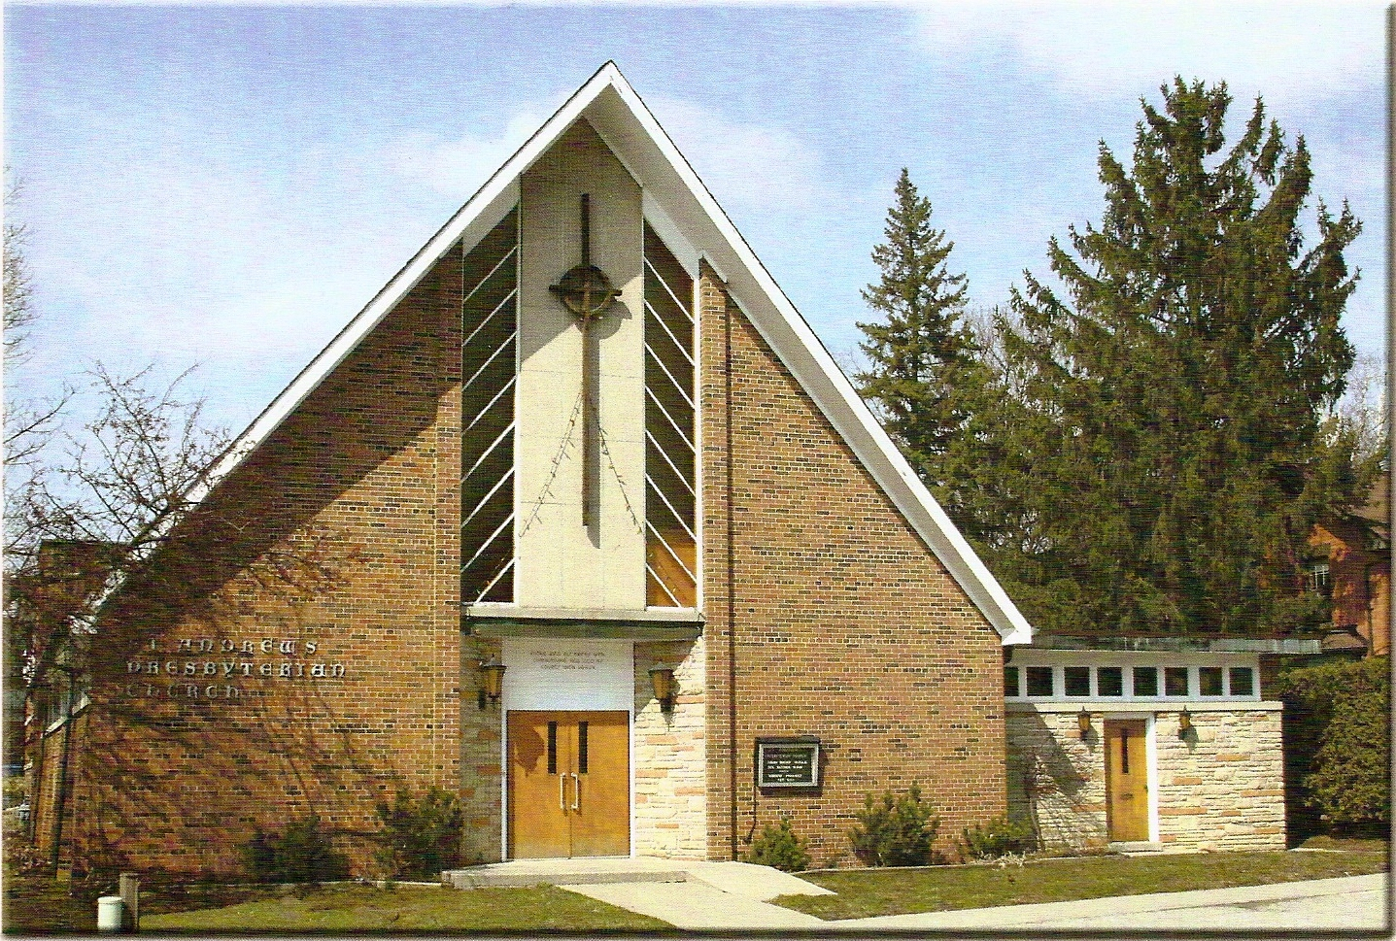

Dr Robert Revington PhD

Welcoming Person: Kevin Johnston

Our Reason Why
As a community of believers in Jesus Christ, we wish:
- to be in relationship (with God and with one another),
- to belong, feel cared for and connected,
- to participate with others to serve a larger purpose.

ST. ANDREW’S PRESBYTERIAN CHURCH
15th Sunday after Pentecost

WE GATHER
*You are invited to stand BOP = Book of Praise
Prelude
Welcome and Announcements
After the announcements, we pause for a moment of silence to prepare our hearts and minds for worship
Responsive Call to Worship
One: Sing to God a new song
All: We will worship God, our Maker!
One: Let us praise God with song and dance
All: For God is gracious and loving!
One: Let us bring God glory and honour
All: Praise the Lord.
*Hymn: “O God Beyond All Praising” BOP 448
Prayer of Adoration
Prayer of Confession (in unison)
Although Christ offers peace, we confess we are a people divided; we harbour fears and jealousy which set neighbour against neighbour, group against group and nation against nation. We pursue profit and pleasures which harm creation and the wellbeing of all people. Have mercy upon us. Set us free from our old ways to serve you as agents of your reconciling love. Help us to remember not to look down on the vulnerable. We join our voices with all those who pray the words Jesus taught us:

The Lord’s Prayer (in unison)
Our Father in heaven, hallowed be your name, your kingdom come, your will be done, on earth as in heaven. Give us today our daily bread. Forgive us our sins as we forgive those who sin against us. Save us from the time of trial and deliver us from evil. For the kingdom, the power and the glory are yours, now and forever. Amen.
Assurance of Pardon:
One: May the peace of the Lord Jesus Christ be with you!
All: and, also with you!
*Hymn: “Lord, Listen to Your Children Praying” BOP 449

Prayer for the children

WE LISTEN
Sung Prayer for Illumination: BOP 445
Open our eyes, Lord, we want to see Jesus,
to reach out and touch him, and say that we love him.
Open our ears, Lord, and help us to listen.
Open our eyes, Lord, we want to see Jesus.
Prayer for Understanding:

Scripture Reading: Obadiah 1:1-21
One: This is the word of the Lord.
All: Thanks be to God
Message: ““Good and Bad Laughter”
*Hymn: “Joyful, Joyful, We Adore You” BOP 410

Prayer for the People

WE RESPOND
Invitation to the Offering:
Offering Our Gifts (Offering Plate is at the Narthex Door)
Doxology: “Praise God from whom all blessings flow.” BOP 79
Offertory Prayer:
WE SERVE
*Song for the Journey:
*Hymn: “O Lord, Our Lord, How Majestic Is Your Name”
BOP 409
*The Benediction:
*A Sung Blessing BOP 726
May the God of hope go with us every day,
filling all our lives with love and joy and peace.
May the God of justice speed us on our way,
bringing light and hope to every land and race.
Praying, let us work for peace; singing, share our joy with all;
working for a world that's new, faithful when we hear Christ's call.

(Please be seated and in silence, be mindful of the new possibilities offered to you in Jesus Christ)
Postlude

Please join us in the Guild Hall for refreshments and fellowship.

