**Christian Family Sunday**

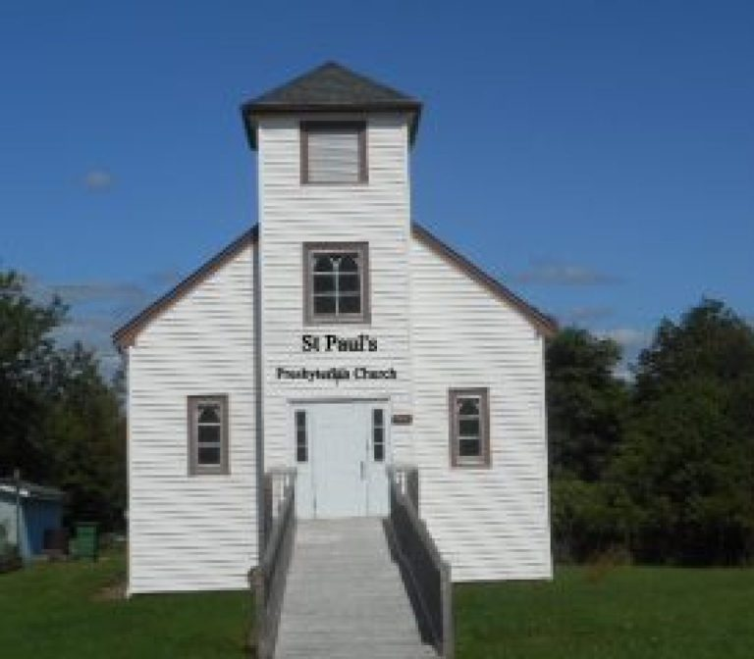**Sunday, May 11th, 2025**

*St. Paul’s Presbyterian Church*

<https://pccweb.ca/stpauls>

Interim Moderator: Rev. Robert Lyle 902-549-6411 Clerk of Session: Jan Alchorn

Music Director: Linda Giddens

**THE ORDER OF WORSHIP**

**Call to Worship**

With all those in heaven and on earth, let us say together:

**Salvation belongs to our God who is seated on the throne, and to the Lamb!**

Let us praise God with joyful hearts:

**We come before the throne of God to worship day and night.**

Called together by the Holy Spirit, let us rejoice and sing:

**We will hunger and thirst no more; Christ brings us eternal life.**

**Prayers of Adoration and Confession**

**God of the ages, God of today, you are compassion; our cup overflows. You are hope; you lead us into green pastures. You are truth; you lead us beside quiet streams. You are life; you restore our souls. Morning, noon and night, O God, you are the source of our joy. We gather to worship you as one family of your people, honouring you as our Creator, trusting you as our Saviour, celebrating you as the Spirit who gives us life.**

**Trusting in your compassion and grace, we confess to you our sins: Merciful God, we confess we stray from your ways like lost sheep; we follow the devices and desires of our own hearts, ignoring the needs of others and seeking more for ourselves. We judge ourselves more generously than others and fail to offer others the forgiveness we seek from you. Forgive the ways we betray your love and return us to your paths of truth and mercy.**

**Assurance of Pardon**

Christ dwells in our hearts through faith, for we are being rooted and grounded in his love. The forgiveness he offers is a gift of this love. Receive God’s forgiveness with faithful hearts, and be at peace with God, with yourself and with each other.

**Hymn 98 For the beauty of the earth**

**Prayer for Understanding**

**God of wisdom, as we listen to your Word recorded by generations of your people, fill us with understanding by the power of your Holy Spirit. Reveal the mysteries of faith to us, so that we may grow in faithfulness, following Jesus, your Living Word. Amen.**

**First Reading: Acts 9:36-43 p. 778**

**Psalm 23**

**Reading: Revelation 7:9-17 p. 871**

**Gospel Reading: John 10:22-30 p. 760**

**Hymn 9 The Lord’s my shepherd**

**Sermon Mother’s and family**

**Hymn 124 SoG Saviour, like a shepherd lead us**

**Offering**

**Doxology**

**Prayer of Dedication**

**The Apostle’s Creed (616)**

**Prayer of Thanksgiving & Intercession**

**Hymn 635 NBP Brother, sister, let me serve you**

**Benediction & Choral Amen**

**MISSION MOMENT: Sunday, May 11**

“I could not get medical help in time because we did not have enough money,” says 65-year-old Ruqaiya, who lives in Afghanistan. Ruqaiya’s life took a challenging turn ten years ago when she fell on ice, resulting in partial paralysis. Despite her impairment, she helps care for her youngest son, who has a hand impairment, two daughters-in-law, and two young grandchildren while her two oldest sons work as porters in Kabul, struggling to earn enough. Before her injury, Ruqaiya was known for her skill in weaving and was able to earn a decent income. Now unable to weave, she faces significant financial hardship, made worse by the political and economic situation in the country. Relief came when Ruqaiya received cash assistance through a PWS&D-supported project. She purchased essentials like oil, pulses, flour, rice and salt, meeting her family’s food needs during the harsh winter.

**Upcoming Services**

**May 18th.  Brad Little 5th Sunday of Easter**

**May 25th Maryann Skinner 6th Sunday of Easter**

**Fellowship Sunday**

**June 1st Bob Lyle 7th Sunday of Easter**